EDEXCEL GCSE MATHS · FOUNDATION & HIGHER
3D solids
Transformations and constructions · Lesson 1 of 8
Teacher copy - includes the notes for whoever is teaching from it.
Warm-up
Answer each one, then check.
1. How many faces does a cube have?
6
2. What is the name of a 3D shape with a circular base and one curved surface ending at a point?
A cone
3. What is the volume of a cuboid 2 by 3 by 4?
24
4. What shape is the cross-section of a cylinder cut straight across?
A circle
5. What is a polygon with 6 sides called?
A hexagon
Learning Objectives
1. Name common 3D solids.
2. Count faces, edges and vertices.
3. Draw and interpret plans and elevations.
4. Use a 3D drawing to work out how many cubes make a solid.
Faces, Edges and Vertices
A face is a flat surface, an edge is where two faces meet, and a vertex is a corner.
Solid | Faces | Edges | Vertices
Cuboid | 6 | 12 | 8
Triangular prism | 5 | 9 | 6
Square-based pyramid | 5 | 8 | 5
Cylinder | 3 | 2 | 0
Cone | 2 | 1 | 1
Sphere | 1 | 0 | 0
Naming Solids
The name comes from the shape of the base or cross-section.
▸ Prism. The same cross-section all the way along: a triangular prism, a hexagonal prism.
▸ Pyramid. A polygon base with triangular faces that meet at one apex.
▸ Cylinder, cone, sphere. Solids with curved surfaces; a sphere is a perfect ball.
▸ Tetrahedron. A pyramid with four triangular faces.
Euler's Formula
For any solid with flat faces, faces plus vertices minus edges equals 2.
Cuboid: 6 + 8 − 12 = 2. Square-based pyramid: 5 + 5 − 8 = 2.
Plan and Elevations
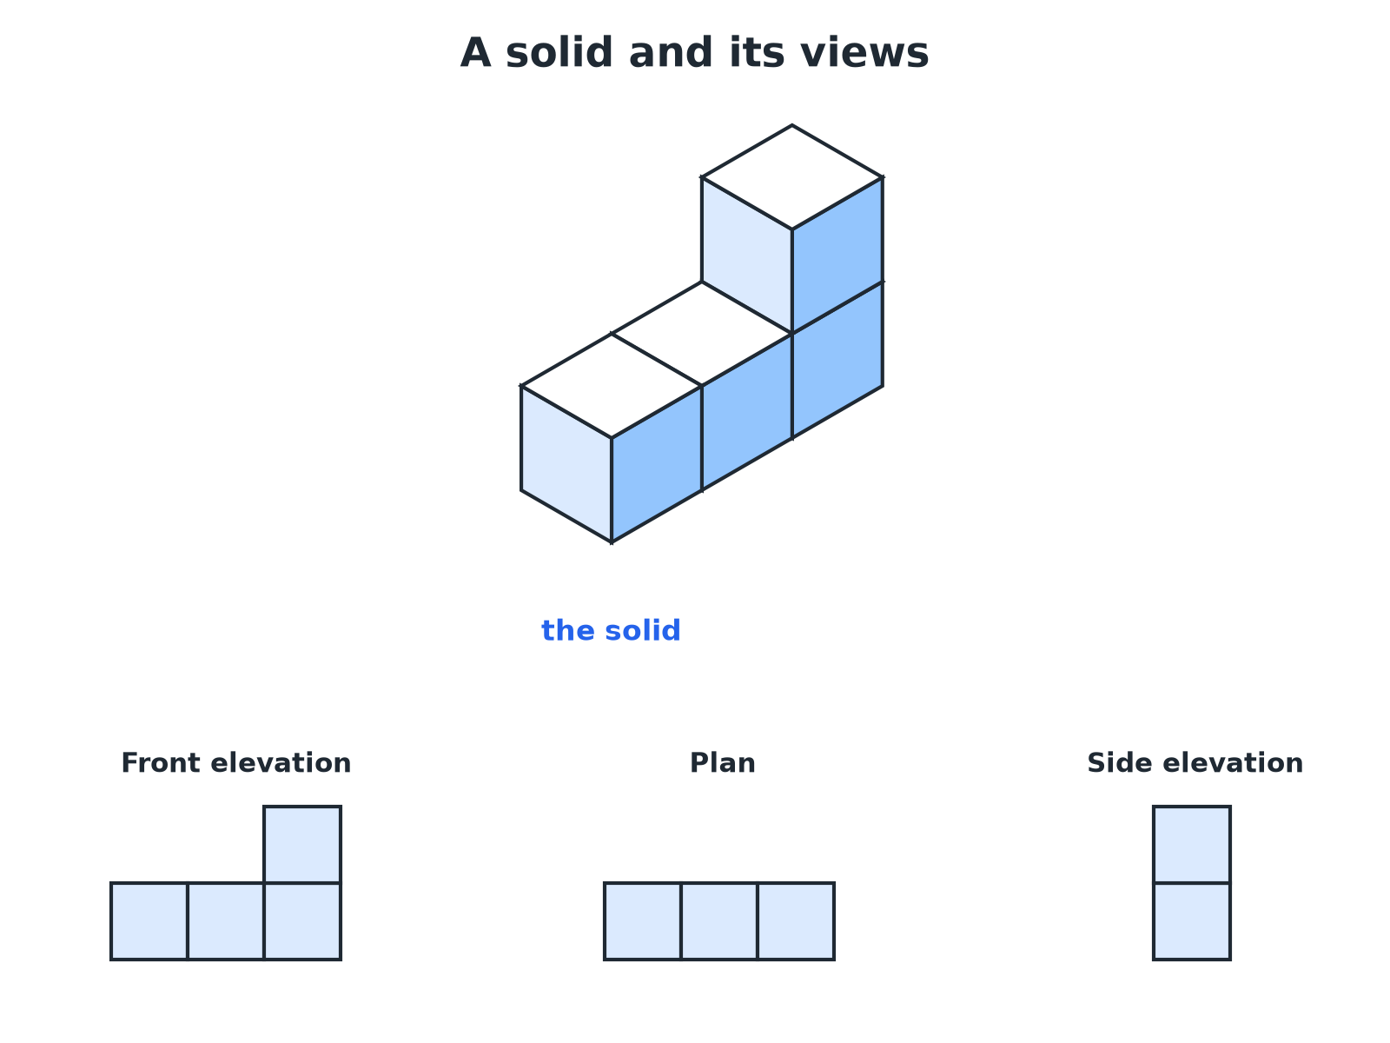
The plan is the view from above; elevations are views from the front and the side.
An isometric solid of four cubes with its front elevation, plan and side elevation drawn on grids.
The Three Views
Plan  The view from directly above. | Front elevation  The view from the front, looking straight at the face you choose to call the front.
Side elevation
The view from one side, usually the right, looking straight at that face.
Drawing the Elevations
A solid is made from four cubes: a row of three, with one more cube on top of the right-hand cube. Draw the front elevation, the plan and the side elevation viewed from the right.

1. Front elevation: what you see facing the row
Three squares wide; the right column is two high
2. Plan: look down from above
Three squares in a row (the top cube is hidden above the right one)
3. Side elevation from the right: you see the end
One square wide and two squares high
Answer: Front elevation: an L-shape of 4 squares. Plan: 3 squares in a row. Side elevation: 2 squares in a column.
Tips for Elevations
Draw only what you can see, with straight lines.
▸ Hidden edges. Do not draw edges you cannot see from that direction.
▸ Use a grid. One square on the grid stands for one edge of a cube.
▸ Check your views agree. The front elevation and plan must have the same width; the front and side must have the same height.
Key Terms
Face  A flat surface of a solid. | Edge  A line where two faces meet.
Vertex  A corner where edges meet (plural: vertices). | Plan  The view of a solid from above.
Elevation  The view of a solid from the front or side. | Prism  A solid with the same cross-section all the way through.
Your Task: Build and Draw
12 minutes
Build a solid from 5 cubes: a row of three cubes, a fourth cube placed directly behind the middle cube of the row, and a fifth cube on top of the left-hand cube of the row. Draw its plan and its front elevation.
1. Build the solid.
2. Look from each direction.
3. Draw only what you see.
A good answer shows: Plan: a row of three squares with a fourth square behind the middle one (a T-shape). Front elevation: three squares wide, with the left column two squares high and the other two columns one square high.
Note: Ask students to compare with a partner and check the three views agree.
Can I...?
☐ Name the common solids.
☐ Count faces, edges and vertices.
☐ Check with Euler's formula.
☐ Say what a plan is.
☐ Draw a front elevation.
☐ Draw a side elevation.
☐ Match views to a solid.
☐ Work out the volume of a cube solid from its views.
Summary
✓ Faces, edges, vertices: count carefully and check with F + V − E = 2.
✓ Plan is from above; elevations are from the sides.
✓ Draw with straight lines on a grid.
✓ Compare your views for consistency.

EXAM FOCUS
A solid is made of 4 cubes: a row of three cubes with one cube on top of the right-hand cube. Draw the front elevation of the solid on a square grid. (2 marks)
Look at the solid from the front only and draw what is visible: an L-shape here. Do not add depth lines.
Exam Practice: 3D Solids
Answer all questions. · 20 minutes
▸ Question 1 · 2 marks · Non-calculator. Write down the number of faces, edges and vertices of a square-based pyramid.
▸ Question 2 · 2 marks · Non-calculator. A solid has 5 faces, 9 edges and 6 vertices. Two of its faces are triangles. Write down the name of the solid.
▸ Question 3 · 2 marks · Non-calculator. Write down the shape of the plan of a cylinder standing on a flat table.
▸ Question 4 · 2 marks · Non-calculator. The diagram shows a solid made from four identical cubes. On the grid, draw the front elevation of the solid, viewed from the direction of…
▸ Question 5 · 2 marks · Non-calculator. For the solid in the last question, draw the plan.
▸ Question 6 · 3 marks · Non-calculator. For the same solid, draw the side elevation viewed from the right.
Question 1 · 2 marks · Non-calculator
“Write down the number of faces, edges and vertices of a square-based pyramid.”
HOW TO ANSWER IT Command word: Non-calculator. Worth 2 marks, so plan before writing.
Question 1 · mark scheme
2 marks available. Award a mark for each point made.
▸ Two correct. B1
▸ All three correct. B1
▸ Model answer. 5 faces, 8 edges and 5 vertices.
Question 2 · 2 marks · Non-calculator
“A solid has 5 faces, 9 edges and 6 vertices. Two of its faces are triangles. Write down the name of the solid.”
HOW TO ANSWER IT Command word: Non-calculator. Worth 2 marks, so plan before writing.
Question 2 · mark scheme
2 marks available. Award a mark for each point made.
▸ Triangular prism. B2
▸ Model answer. A triangular prism.
Question 3 · 2 marks · Non-calculator
“Write down the shape of the plan of a cylinder standing on a flat table.”
HOW TO ANSWER IT Command word: Non-calculator. Worth 2 marks, so plan before writing.
Question 3 · mark scheme
2 marks available. Award a mark for each point made.
▸ Circle. B2
▸ Model answer. A circle.
Question 4 · 2 marks · Non-calculator
The diagram shows a solid made from four identical cubes. On the grid, draw the front elevation of the solid, viewed from the direction of the arrow F. (2 marks) | 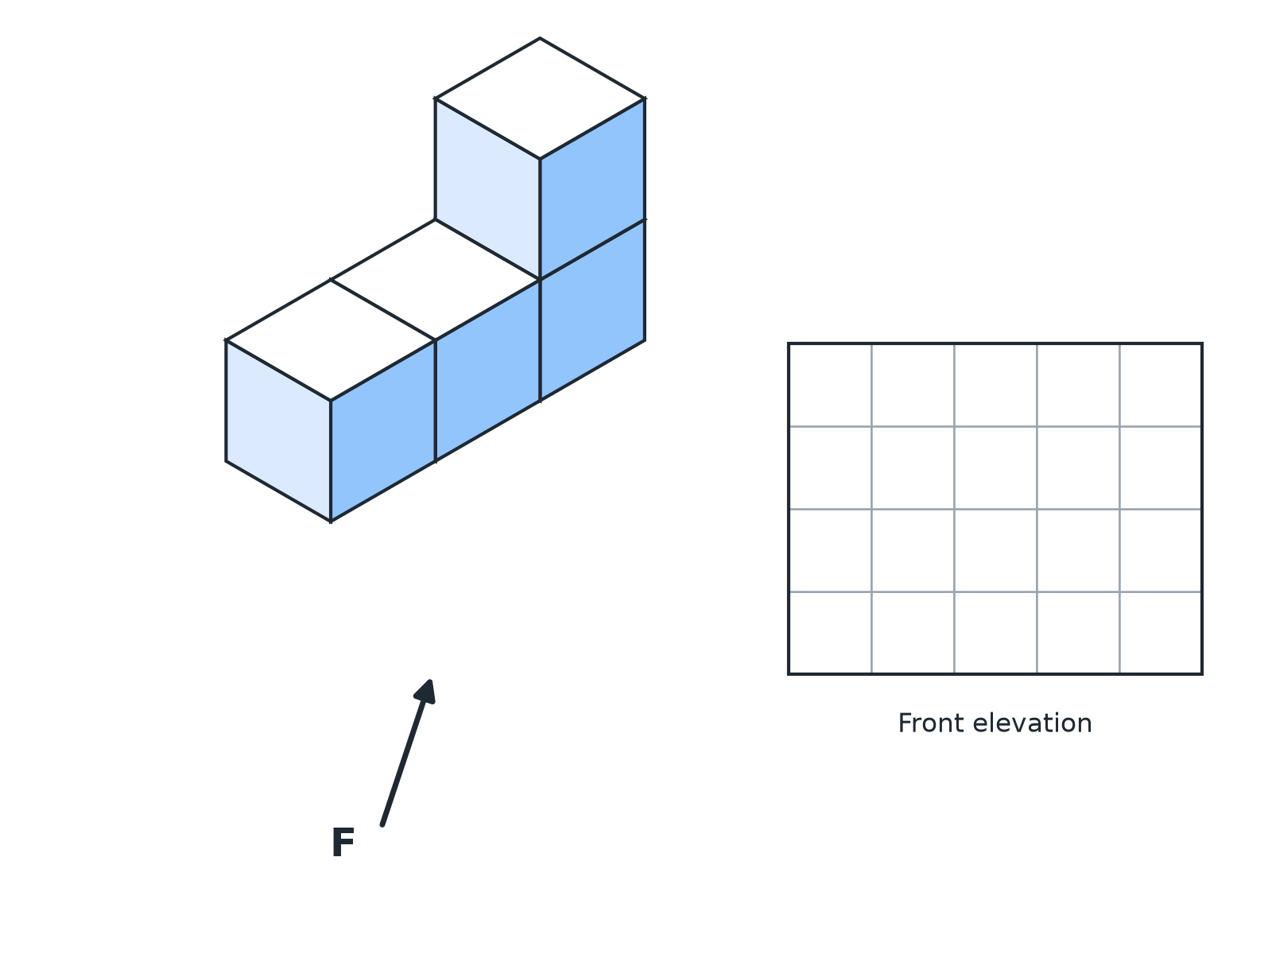

Question 4 · mark scheme
2 marks available. Award a mark for each point made.
▸ Correct number of columns and heights. M1
▸ A fully correct front elevation. A1
▸ Model answer. An L-shape made of 4 squares: a row of 3 squares with one more square above the right-hand square.
Question 5 · 2 marks · Non-calculator
“For the solid in the last question, draw the plan.”
HOW TO ANSWER IT Command word: Non-calculator. Worth 2 marks, so plan before writing.
Question 5 · mark scheme
2 marks available. Award a mark for each point made.
▸ Three squares in a row. B2
▸ Model answer. A row of 3 squares.
Question 6 · 3 marks · Non-calculator
“For the same solid, draw the side elevation viewed from the right.”
HOW TO ANSWER IT Command word: Non-calculator. Worth 3 marks, so plan before writing.
Question 6 · mark scheme
3 marks available. Award a mark for each point made.
▸ One square wide. M1
▸ Two squares high. M1
▸ A fully correct drawing. A1
▸ Model answer. A column of 2 squares (one square wide, two squares high).

