EDEXCEL GCSE MATHS · FOUNDATION & HIGHER
Scale drawings and bearings
Transformations and constructions · Lesson 5 of 8
Teacher copy - includes the notes for whoever is teaching from it.
Warm-up
Answer each one, then check.
1. How many centimetres are in a kilometre?
100 000
2. What do the angles round a point add up to?
360°
3. What do co-interior angles add up to?
180°
4. Work out 3.2 × 50 000.
160 000
5. What is the compass direction opposite to north-east?
South-west
Learning Objectives
1. Use a scale in the form 1 : n to change between drawing and real lengths.
2. Measure and write three-figure bearings.
3. Find the bearing back from B to A.
4. Solve problems using bearings and right-angled triangles.
Map Scales
A scale of 1 : 50 000 means 1 cm on the map is 50 000 cm in real life.
▸ Map to real. Multiply by the scale, then change units. 3.2 cm on a 1 : 50 000 map is 160 000 cm, which is 1.6 km.
▸ Real to map. Divide by the scale. 4.5 km is 450 000 cm, so on a 1 : 25 000 map it is 450 000 ÷ 25 000 = 18 cm.
▸ Units. 100 000 cm = 1 km and 100 cm = 1 m.
Bearings
A bearing is an angle measured clockwise from north, always written with three figures.
North is 000°, east is 090°, south is 180° and west is 270°.
Reading a Bearing
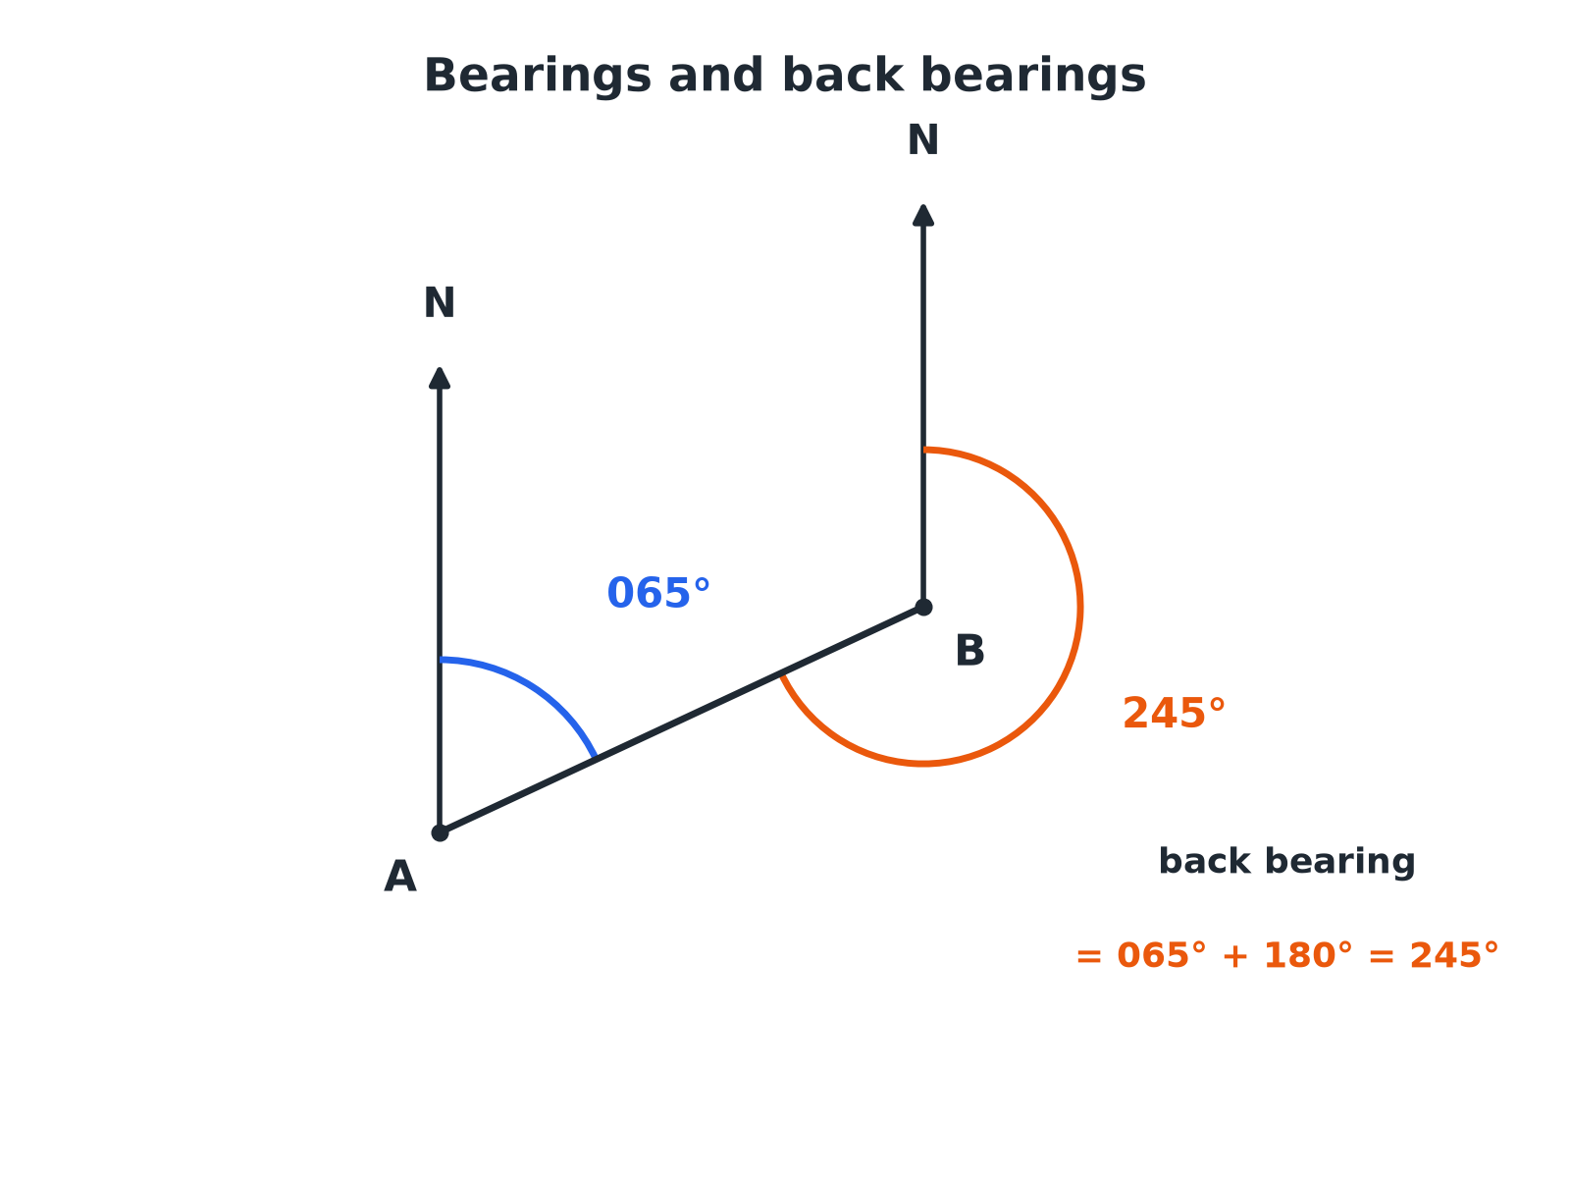
Measure clockwise from north, at the point you are travelling from.
Two points A and B with parallel north lines, the bearing of B from A as 065 degrees and the bearing of A from B as 245 degrees.
Measuring a Bearing
Follow the same steps every time.
1  Find the starting point  The bearing of B from A starts at A. | 2  Draw or imagine a north line at A  It points straight up the page. | 3  Measure clockwise  From the north line round to the line AB. | 4  Write three figures  Add zeros at the front, e.g. 065°.
A Back Bearing
The bearing of B from A is 065°. Work out the bearing of A from B.

1. The north lines at A and B are parallel
Co-interior angles add up to 180°
2. Add 180° to a bearing under 180°
065 + 180
3. Work it out
245
Answer: 245°
A Journey with Bearings
A ship sails 8 km on a bearing of 070° and then 6 km on a bearing of 160°. How far is it from its starting point?

1. The two bearings differ by
160 − 70 = 90, so the path turns through a right angle
2. Use Pythagoras
8² + 6² = 64 + 36 = 100
3. Distance
√100 = 10
Answer: 10 km
Using a Map Scale
Two towns are 3.2 cm apart on a map with scale 1 : 50 000. How far apart are they in real life?

1. Real length in cm
3.2 × 50 000 = 160 000
2. Change to kilometres
160 000 ÷ 100 000
Answer: 1.6 km
Back Bearings
Add or subtract 180 so the answer stays between 0 and 360.
Bearing of B from A | Rule | Bearing of A from B
065° | + 180° | 245°
130° | + 180° | 310°
250° | − 180° | 070°
305° | − 180° | 125°
Key Terms
Bearing  An angle measured clockwise from north, written with three figures. | Scale  The ratio of a length on a drawing to the real length.
Back bearing  The bearing of A from B when you know the bearing of B from A. | Clockwise  The direction the hands of a clock turn.
Three-figure bearing  A bearing written with hundreds, tens and units, such as 045°. | Compass point  One of N, E, S, W and their combinations.
Your Task: Treasure Trail
15 minutes
Start at a point marked A. Draw the route: 5 cm on a bearing of 050°, then 4 cm on a bearing of 140°, then 6 cm on a bearing of 230°. Measure the final distance and bearing back to A. If the scale is 1 cm to 100 m, work out the real distance.
1. Draw a north line at each point.
2. Use a protractor from north.
3. Convert with the scale.
A good answer shows: Students should end near the start; the route back to A is roughly 3 to 4 cm on a bearing near 300°. Real distance is about 300 to 400 m.
Note: Check students measure clockwise from a north line drawn at each turning point.
Can I...?
☐ Use a map scale 1 : n.
☐ Convert between cm, m and km.
☐ Measure a bearing.
☐ Write a bearing with three figures.
☐ Find a back bearing.
☐ Draw a bearing accurately.
☐ Use bearings with Pythagoras.
☐ Explain why the north lines are parallel.
Summary
✓ Bearings are measured clockwise from north, with three figures.
✓ Back bearing: ± 180°.
✓ Scale 1 : n: multiply to get the real length; divide to get the drawing length.
✓ Draw a sketch and mark north lines.

EXAM FOCUS
The bearing of B from A is 072°. Work out the bearing of A from B. (3 marks)
Add 180 when the bearing is less than 180, and subtract 180 when it is more. Draw a north line at both points and mark the co-interior angles.
Exam Practice: Scale Drawings and Bearings
Answer all questions. Show your working. · 30 minutes
▸ Question 1 · 2 marks · Non-calculator. The scale on a map is 1 : 50 000. Two towns are 3.2 cm apart on the map. Work out the real distance between the towns, in kilometres.
▸ Question 2 · 2 marks · Non-calculator. Two villages are 4.5 km apart. Work out the distance between them on a map with scale 1 : 25 000. Give your answer in centimetres.
▸ Question 3 · 3 marks · Non-calculator. The diagram shows two points, A and B. The bearing of B from A is 072°. Work out the bearing of A from B.
▸ Question 4 · 4 marks · Calculator. A ship sails 8 km on a bearing of 070°. It then sails 6 km on a bearing of 160°. Work out the distance of the ship from its starting point.
▸ Question 5 · 2 marks · Non-calculator. A lighthouse is due south-west of a harbour. Write down the bearing of the lighthouse from the harbour.
▸ Question 6 · 2 marks · Non-calculator. The bearing of Q from P is 250°. Work out the bearing of P from Q.
Question 1 · 2 marks · Non-calculator
“The scale on a map is 1 : 50 000. Two towns are 3.2 cm apart on the map. Work out the real distance between the towns, in kilometres.”
HOW TO ANSWER IT Command word: Non-calculator. Worth 2 marks, so plan before writing.
Question 1 · mark scheme
2 marks available. Award a mark for each point made.
▸ 3.2 × 50 000. M1
▸ 1.6. A1
▸ Model answer. 3.2 × 50 000 = 160 000 cm = 1.6 km.
Question 2 · 2 marks · Non-calculator
“Two villages are 4.5 km apart. Work out the distance between them on a map with scale 1 : 25 000. Give your answer in centimetres.”
HOW TO ANSWER IT Command word: Non-calculator. Worth 2 marks, so plan before writing.
Question 2 · mark scheme
2 marks available. Award a mark for each point made.
▸ 450 000 seen. M1
▸ 18. A1
▸ Model answer. 4.5 km = 450 000 cm. 450 000 ÷ 25 000 = 18 cm.
Question 3 · 3 marks · Non-calculator
The diagram shows two points, A and B. The bearing of B from A is 072°. Work out the bearing of A from B. (3 marks) | 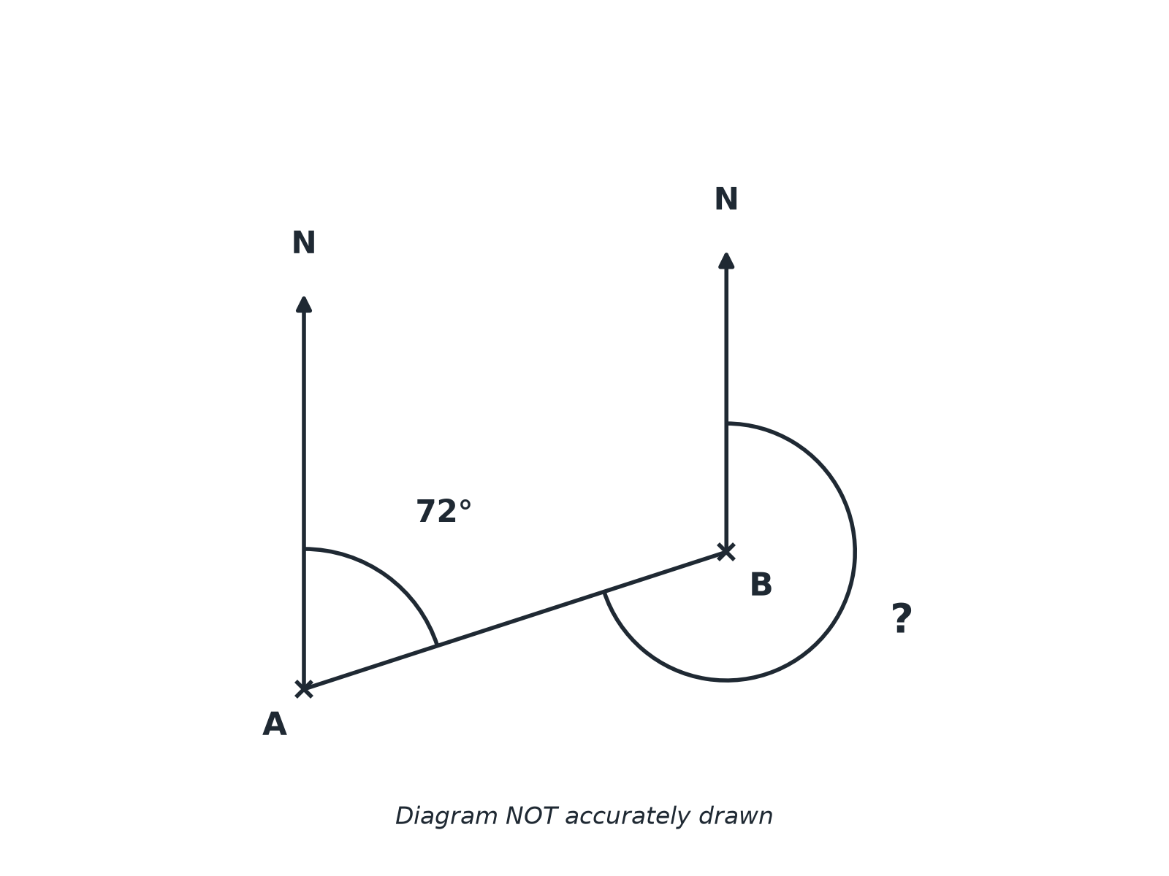

Question 3 · mark scheme
3 marks available. Award a mark for each point made.
▸ 180 + 72 or 360 − (180 − 72). M1
▸ 252. A1
▸ A reason: parallel lines or back bearing. C1
▸ Model answer. 72 + 180 = 252°. The north lines are parallel, so the co-interior angles add up to 180°.
Question 4 · 4 marks · Calculator
“A ship sails 8 km on a bearing of 070°. It then sails 6 km on a bearing of 160°. Work out the distance of the ship from its starting point.”
HOW TO ANSWER IT Command word: Calculator. Worth 4 marks, so plan before writing.
Question 4 · mark scheme
4 marks available. Award a mark for each point made.
▸ Right angle found. M1
▸ 8² + 6². M1
▸ 100. A1
▸ 10. A1
▸ Model answer. The two bearings differ by 160 − 70 = 90°, so the path forms a right angle. Distance = √(8² + 6²) = √100 = 10 km.
Question 5 · 2 marks · Non-calculator
“A lighthouse is due south-west of a harbour. Write down the bearing of the lighthouse from the harbour.”
HOW TO ANSWER IT Command word: Non-calculator. Worth 2 marks, so plan before writing.
Question 5 · mark scheme
2 marks available. Award a mark for each point made.
▸ 225. B2
▸ Model answer. 225°.
Question 6 · 2 marks · Non-calculator
“The bearing of Q from P is 250°. Work out the bearing of P from Q.”
HOW TO ANSWER IT Command word: Non-calculator. Worth 2 marks, so plan before writing.
Question 6 · mark scheme
2 marks available. Award a mark for each point made.
▸ 250 − 180. M1
▸ 070. A1
▸ Model answer. 250 − 180 = 070°.

