EDEXCEL GCSE MATHS · FOUNDATION & HIGHER
Loci
Transformations and constructions · Lesson 8 of 8
Teacher copy - includes the notes for whoever is teaching from it.
Warm-up
Answer each one, then check.
1. What is the distance round a circle called?
The circumference
2. What is a perpendicular bisector?
A line at 90° through the midpoint of a segment
3. What does an angle bisector do?
Cuts an angle in half
4. What is the radius of a circle with diameter 8 cm?
4 cm
5. What does equidistant mean?
The same distance from
Learning Objectives
1. Explain what a locus is.
2. Draw the four standard loci.
3. Combine loci to find a region.
4. Solve problems in context, using a scale.
Locus
A locus is the set of all points that follow a rule.
The plural is loci.
The Standard Loci
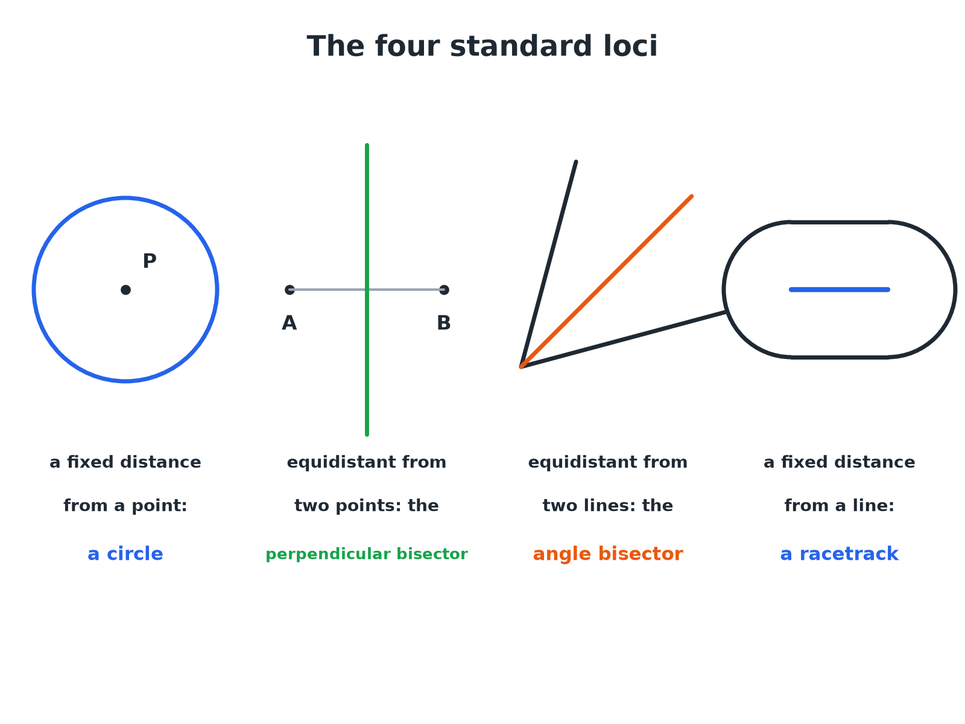
Learn these four and you can solve most locus questions.
Four diagrams showing a circle, a perpendicular bisector, an angle bisector and a racetrack shape as standard loci.
The Four Standard Loci
A fixed distance from a point  A circle, centred on the point. | Equidistant from two points  The perpendicular bisector of the line joining the points.
Equidistant from two lines  The angle bisector of the angle between them. | A fixed distance from a line  A racetrack: two parallel lines with semicircular ends.
A Region Bounded by Two Loci
ABCD is a rectangle with A at (0, 0), B at (8, 0), C at (8, 5) and D at (0, 5), with 1 cm representing 1 m. A tree is nearer to AB than to AD and less than 4 m from C. Describe the region where the tree can be.

1. Equidistant from AB and AD
The bisector of angle DAB, the line from A at 45°
2. Nearer to AB than AD
The side of the bisector next to AB (below the line y = x)
3. Less than 4 m from C
Inside a circle of radius 4 cm centred on C
4. Combine
The part of the rectangle that is both below the bisector and inside the circle
Answer: The region inside the rectangle, below the bisector from A and inside the circle of radius 4 cm centred on C.
Tackling a Locus Question
Split the rule into simple loci.
1  Read the rule  Underline each condition. | 2  Draw the standard locus for each  Circle, bisector, perpendicular bisector, or parallel lines. | 3  Decide which side  Use a test point. | 4  Shade the region  Or mark the route required.
Equidistant from Two Points
P and Q are 6 cm apart. Draw the locus of points equidistant from P and Q, and within 4 cm of P.

1. The locus of points equidistant from P and Q
The perpendicular bisector of PQ
2. Within 4 cm of P
Inside a circle of radius 4 cm centred on P
3. The part of the bisector inside the circle
A line segment where the bisector crosses the circle
Answer: The segment of the perpendicular bisector of PQ that lies inside the circle of radius 4 cm centred on P.
A Fixed Distance from a Line
A path is 6 m long. A dog is allowed within 2 m of the path. Describe the boundary of the area.

1. The set of points 2 m from a line
Two parallel lines, 2 m either side
2. Ends of the path
Two semicircles of radius 2 m
3. Together
A racetrack shape around the path
Answer: A racetrack: two parallel lines 2 m either side of the path with a semicircle of radius 2 m at each end.
Key Terms
Locus  A set of points that all obey a rule. | Loci  More than one locus.
Equidistant  The same distance from two points or lines. | Region  An area of the plane described by one or more rules.
Perpendicular bisector  The locus of points equidistant from two points. | Angle bisector  The locus of points equidistant from two lines.
Your Task: Where Should the Mast Go?
15 minutes
Three villages A, B and C form a triangle. A phone mast must be equidistant from A and B, and no more than 5 km from C. Draw the triangle (AB = 8 cm, AC = 6 cm, BC = 7 cm, where 1 cm = 1 km), construct the perpendicular bisector of AB, draw the circle of radius 5 cm about C, and shade the possible positions.
1. Construct the triangle.
2. Draw the two loci.
3. Identify the overlap.
A good answer shows: The possible positions lie along the segment of the perpendicular bisector of AB that lies within the circle. Students should show construction arcs for the bisector and mark the two points where it meets the circle.
Note: Ask what would change if the mast had to be closer to A than to B.
Can I...?
☐ Explain what a locus is.
☐ Draw a circle locus.
☐ Draw a perpendicular bisector locus.
☐ Draw an angle bisector locus.
☐ Draw a racetrack locus.
☐ Combine two loci.
☐ Use a scale in a locus problem.
☐ Shade the correct region.
Summary
✓ Circle: a fixed distance from a point.
✓ Perpendicular bisector: equidistant from two points.
✓ Angle bisector: equidistant from two lines.
✓ Racetrack: a fixed distance from a line segment.

EXAM FOCUS
ABCD is a rectangle with AB = 8 cm and BC = 5 cm. A point is nearer to AB than to AD, and is less than 4 cm from C. Shade the region that contains all such points. (4 marks)
Draw each locus, then use one test point in the rectangle to decide which side of each locus to shade.
Exam Practice: Loci
Answer all questions. Use ruler and compasses and show all construction lines. · 30 minutes
▸ Question 1 · 2 marks · Draw. P is a point. Draw the locus of all the points that are 3 cm from P.
▸ Question 2 · 3 marks · Construct. A and B are two points 6 cm apart. Using ruler and compasses only, construct the locus of points that are the same distance from A and from…
▸ Question 3 · 4 marks · Construct. The diagram shows a rectangle ABCD. The scale is 1 cm to 1 m. A tree will be planted nearer to AB than to AD and less than 4 m from C…
▸ Question 4 · 2 marks · Describe. A robot moves so that it is always 2 m from a straight fence 6 m long. Describe the shape of its path.
▸ Question 5 · 3 marks · Construct. Two straight roads meet at a point O. A phone mast must be the same distance from both roads. Describe how to find the possible positions…
Question 1 · 2 marks · Draw
“P is a point. Draw the locus of all the points that are 3 cm from P.”
HOW TO ANSWER IT Command word: Draw. Worth 2 marks, so plan before writing.
Question 1 · mark scheme
2 marks available. Award a mark for each point made.
▸ A circle drawn, centre P. M1
▸ Radius 3 cm. A1
▸ Model answer. A circle of radius 3 cm with centre P.
Question 2 · 3 marks · Construct
“A and B are two points 6 cm apart. Using ruler and compasses only, construct the locus of points that are the same distance from A and from B.”
HOW TO ANSWER IT Command word: Construct. Worth 3 marks, so plan before writing.
Question 2 · mark scheme
3 marks available. Award a mark for each point made.
▸ Equal arcs from A and B. M1
▸ Crossings joined. M1
▸ A correct line with arcs shown. A1
▸ Model answer. The perpendicular bisector of AB, with construction arcs.
Question 3 · 4 marks · Construct
The diagram shows a rectangle ABCD. The scale is 1 cm to 1 m. A tree will be planted nearer to AB than to AD and less than 4 m from C. Shade the region where the tree can be planted. (4 marks) | 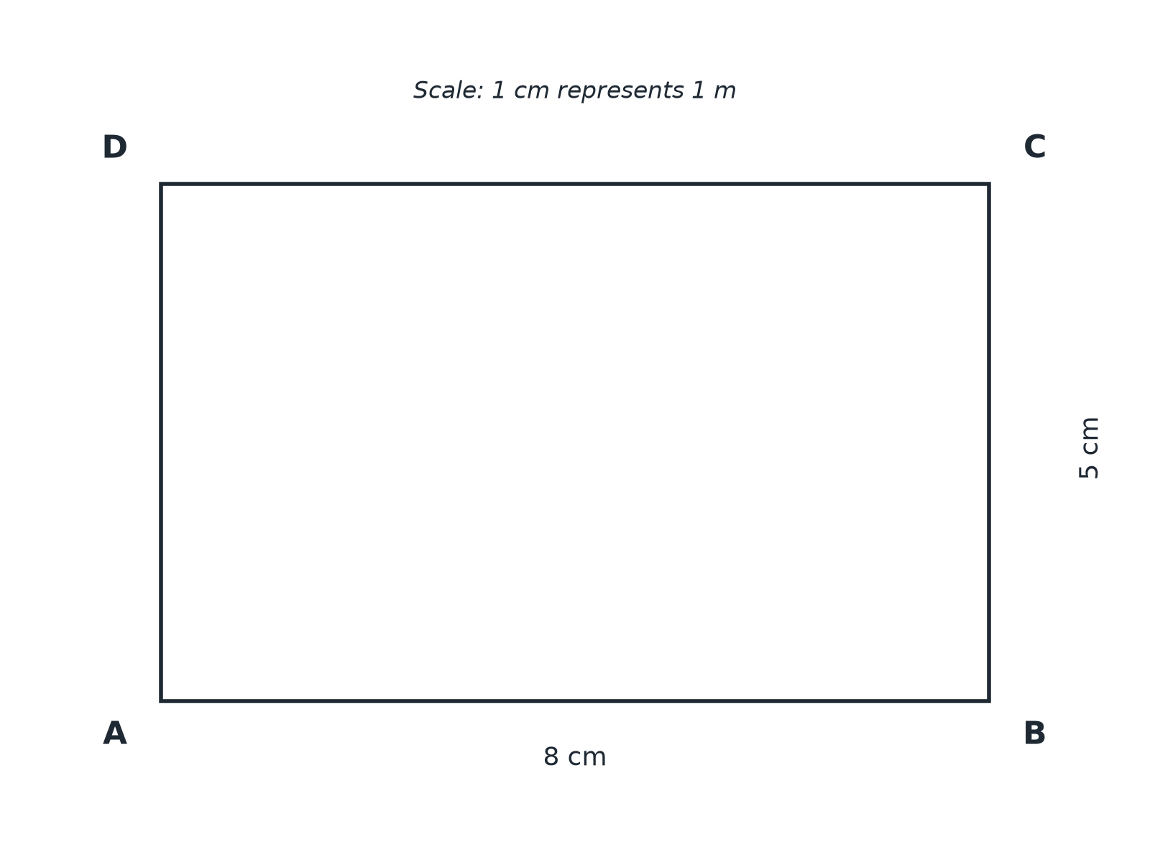

Question 3 · mark scheme
4 marks available. Award a mark for each point made.
▸ Bisector of angle DAB. M1
▸ Circle of radius 4 cm centred on C. M1
▸ Correct side of each locus. M1
▸ Correct region shaded. A1
▸ Model answer. The bisector of angle DAB is drawn from A, a circle of radius 4 cm is drawn centred on C, and the region inside the rectangle below the bisector and inside the circle is shaded.
Question 4 · 2 marks · Describe
“A robot moves so that it is always 2 m from a straight fence 6 m long. Describe the shape of its path.”
HOW TO ANSWER IT Command word: Describe. Worth 2 marks, so plan before writing.
Question 4 · mark scheme
2 marks available. Award a mark for each point made.
▸ Two parallel lines 2 m from the fence. B1
▸ Semicircular ends. B1
▸ Model answer. A racetrack: two straight lines parallel to the fence, 2 m from it, joined by a semicircle of radius 2 m at each end.
Question 5 · 3 marks · Construct
“Two straight roads meet at a point O. A phone mast must be the same distance from both roads. Describe how to find the possible positions of the mast on a map.”
HOW TO ANSWER IT Command word: Construct. Worth 3 marks, so plan before writing.
Question 5 · mark scheme
3 marks available. Award a mark for each point made.
▸ Angle bisector. B1
▸ Construction method: arcs from O, then from the crossings. M1
▸ The mast can be anywhere on the bisector. A1
▸ Model answer. Construct the bisector of the angle between the two roads. The mast can be anywhere on this line.

