EDEXCEL GCSE MATHS · FOUNDATION & HIGHER
Solving linear inequalities
Equations and inequalities · Lesson 1 of 7
Teacher copy - includes the notes for whoever is teaching from it.
Warm-up
Answer each one, then check.
1. Solve 2x + 3 = 11.
x = 4
2. Solve 5x = −20.
x = −4
3. Which is bigger, −3 or −5?
−3
4. What is the symbol for "less than or equal to"?
≤
5. Solve x/3 = 6.
x = 18
Learning Objectives
1. Use the inequality symbols <, >, ≤ and ≥.
2. Show inequalities on a number line.
3. Solve linear inequalities, including reversing the sign.
4. Write down integer solutions and solve double inequalities.
Inequality Symbols
The open end of the symbol points at the bigger number.
Symbol | Meaning | Circle on a number line
x > 3 | x is greater than 3 | Open circle at 3
x ≥ 3 | x is greater than or equal to 3 | Filled circle at 3
x < 3 | x is less than 3 | Open circle at 3
x ≤ 3 | x is less than or equal to 3 | Filled circle at 3
Inequalities on a Number Line
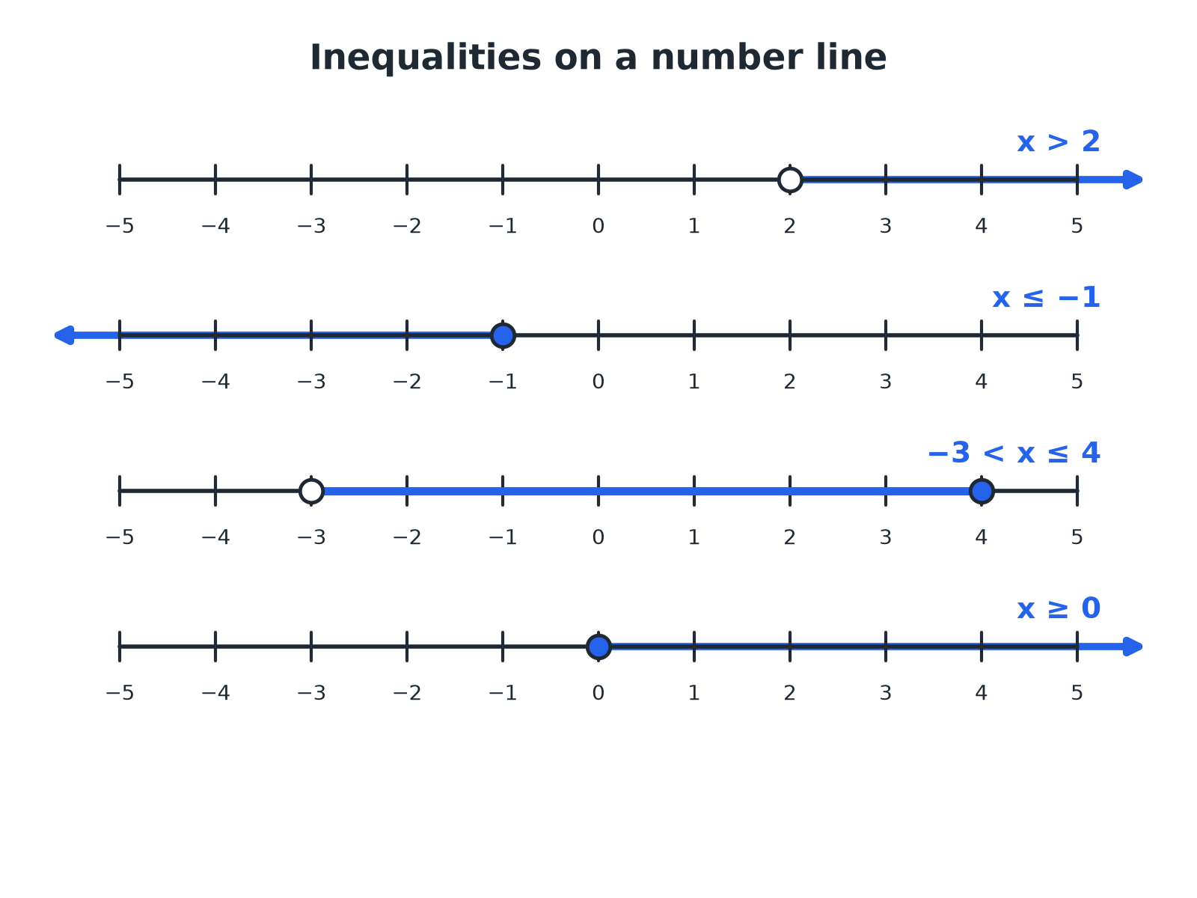
Open circle: not included. Filled circle: included.
Four number lines showing x greater than 2, x less than or equal to minus 1, minus 3 less than x less than or equal to 4, and x greater than or equal to 0.
Solving an Inequality
Solve 3x + 2 ≤ 14.

1. Subtract 2 from both sides
3x ≤ 12
2. Divide both sides by 3
x ≤ 4
Answer: x ≤ 4
The One New Rule
When you multiply or divide an inequality by a negative number, reverse the inequality sign.
Otherwise solve exactly as you would an equation.
A Negative Coefficient
Solve 5 − 2x > 11.

1. Subtract 5 from both sides
−2x > 6
2. Divide by −2 and reverse the sign
x < −3
3. Check with a value, x = −4
5 − 2(−4) = 13 > 11
Answer: x < −3
A Double Inequality
Solve 5 < 2x − 1 ≤ 9.

1. Add 1 to all three parts
6 < 2x ≤ 10
2. Divide all three parts by 2
3 < x ≤ 5
Answer: 3 < x ≤ 5
Integer Solutions
List the integers that satisfy −2 < x ≤ 3.

1. −2 itself is not included
Start at −1
2. 3 is included
End at 3
Answer: −1, 0, 1, 2, 3
HIGHER TIER
Inequalities on a Graph
Shading regions.
Shading a Region
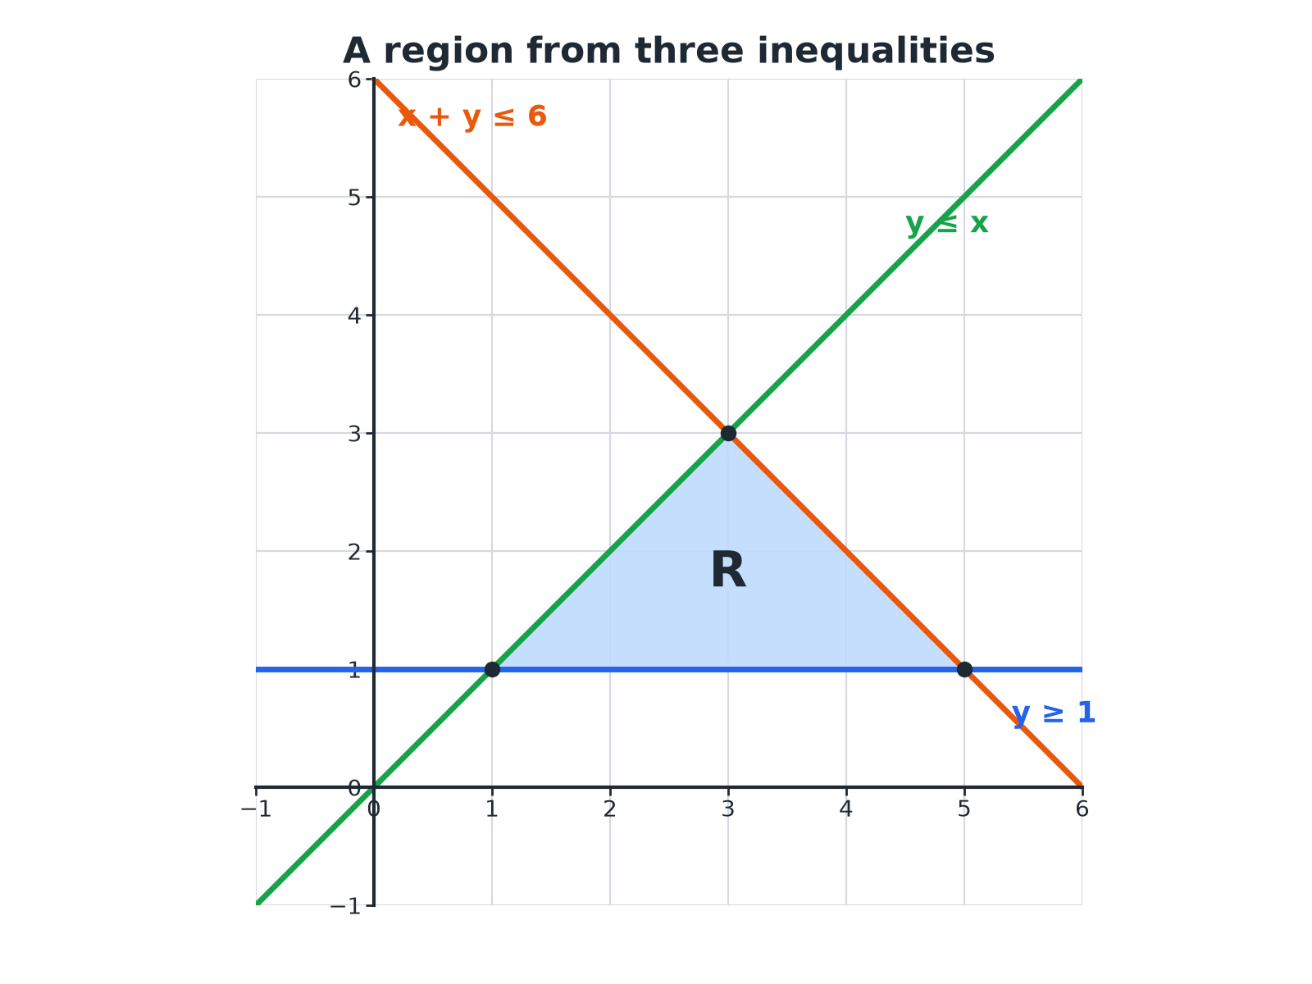
Solid line for ≤ or ≥, dashed line for < or >.
A triangle labelled R bounded by the lines y equals 1, y equals x and x plus y equals 6, satisfying y at least 1, y at most x and x plus y at most 6.
Showing an Inequality on a Graph
Draw the boundary, then decide which side to shade.
1  Draw the line  Replace the inequality sign with = and draw it | 2  Solid or dashed  Solid for ≤ and ≥; dashed for < and > | 3  Test a point  For example (0, 0), if it is not on the line | 4  Shade the side that works  Shade the wanted region, or the unwanted region, as the question asks
A Region from Three Inequalities HIGHER
A region R satisfies y ≥ 1, y ≤ x and x + y ≤ 6. Find the vertices of R.

1. y = 1 meets y = x
(1, 1)
2. y = 1 meets x + y = 6
(5, 1)
3. y = x meets x + y = 6
x + x = 6, so (3, 3)
Answer: R is a triangle with vertices (1, 1), (5, 1) and (3, 3).
A Quadratic Inequality HIGHER
Solve x² − x − 6 < 0.

1. Factorise
(x − 3)(x + 2) < 0
2. The roots are
x = 3 and x = −2
3. The graph is U-shaped, below the axis between the roots
−2 < x < 3
Answer: −2 < x < 3
Key Terms
Inequality  A statement that compares two values using <, >, ≤ or ≥. | Integer  A whole number, positive, negative or zero.
Solution set  All the values that make an inequality true. | Boundary line  The line that separates a region on a graph.
Region  An area of a graph that satisfies one or more inequalities. | Strict inequality  One with < or >, not including the boundary.
Your Task: True or False?
10 minutes
Decide whether each statement is true or false, and correct it if it is false. (a) −3 > −2 (b) x ≥ 5 includes 5 (c) if −x < 4 then x < −4 (d) the integers satisfying 1 ≤ x < 4 are 1, 2, 3, 4.
1. Use a number line.
2. Test values.
A good answer shows: (a) False: −3 < −2. (b) True. (c) False: reversing the sign gives x > −4. (d) False: 4 is not included, so the integers are 1, 2, 3.
Note: Ask students to test with numbers on a number line.
Can I...?
☐ Use the four inequality symbols.
☐ Draw an inequality on a number line.
☐ Solve a linear inequality.
☐ Reverse the sign when multiplying by a negative.
☐ Solve a double inequality.
☐ List integer solutions.
☐ Shade a region on a graph (Higher).
☐ Solve a quadratic inequality (Higher).
Summary
✓ Open circle for < and >; filled circle for ≤ and ≥.
✓ Solve like an equation, but reverse the sign when dividing by a negative.
✓ Double inequality: do the same to all three parts.
✓ Higher: solid boundary for ≤, ≥; dashed for <, >.

EXAM FOCUS
Solve 5 − 2x > 11. (3 marks)
Dividing by a negative number flips the sign. Check your answer with a test value.
Exam Practice: Solving Linear Inequalities
Answer all questions. Show your working. · 30 minutes
▸ Question 1 · 2 marks · Non-calculator. Solve 3x + 2 ≤ 14.
▸ Question 2 · 3 marks · Non-calculator. Solve 5 − 2x > 11.
▸ Question 3 · 2 marks · Non-calculator. The number line shows an inequality. Write down the inequality.
▸ Question 4 · 2 marks · Non-calculator. n is an integer. Write down all the possible values of n when −2 < n ≤ 3.
▸ Question 5 · 3 marks · Non-calculator. Solve 5 < 2x − 1 ≤ 9.
▸ Question 6 · 4 marks · Non-calculator. On the grid, the region R satisfies y ≥ 1, y ≤ x and x + y ≤ 6. Mark the region R with an R.
Question 1 · 2 marks · Non-calculator
“Solve 3x + 2 ≤ 14.”
HOW TO ANSWER IT Command word: Non-calculator. Worth 2 marks, so plan before writing.
Question 1 · mark scheme
2 marks available. Award a mark for each point made.
▸ 3x ≤ 12. M1
▸ x ≤ 4. A1
▸ Model answer. 3x ≤ 12, so x ≤ 4.
Question 2 · 3 marks · Non-calculator
“Solve 5 − 2x > 11.”
HOW TO ANSWER IT Command word: Non-calculator. Worth 3 marks, so plan before writing.
Question 2 · mark scheme
3 marks available. Award a mark for each point made.
▸ −2x > 6. M1
▸ Dividing by −2. M1
▸ x < −3. A1
▸ Model answer. −2x > 6, so x < −3.
Question 3 · 2 marks · Non-calculator
The number line shows an inequality. Write down the inequality. (2 marks) | 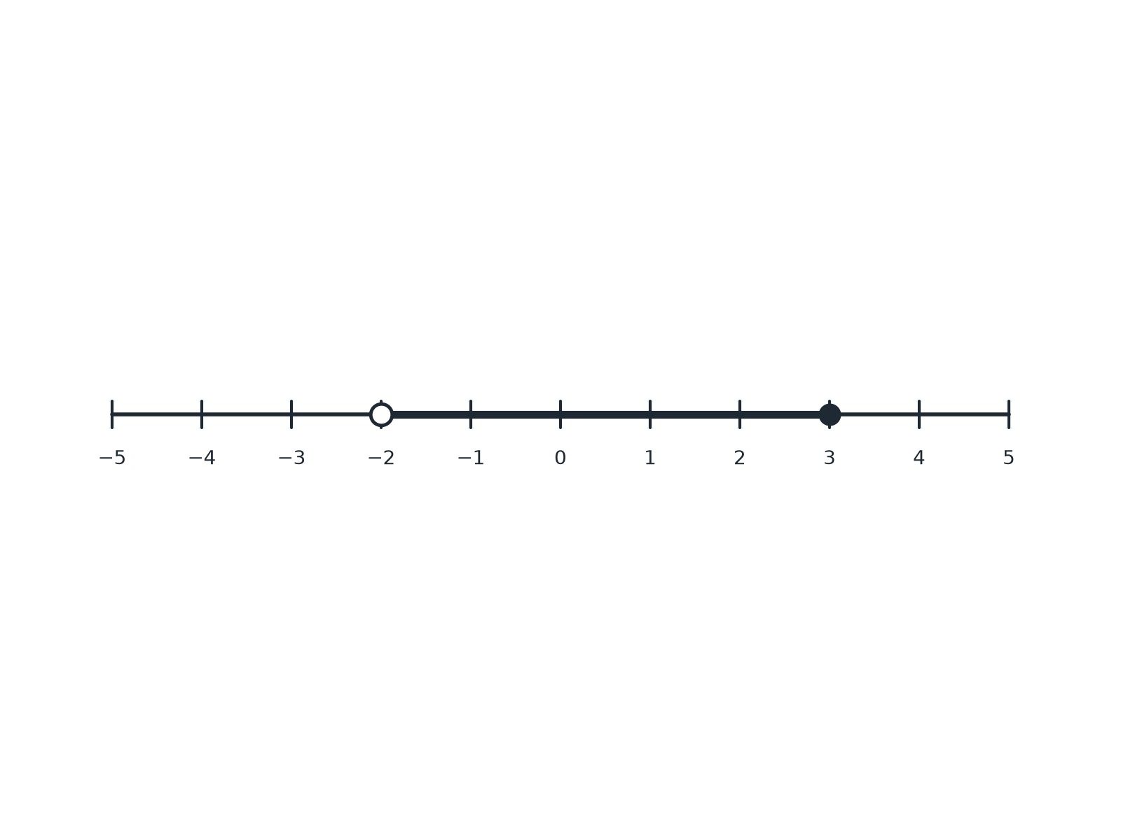

Question 3 · mark scheme
2 marks available. Award a mark for each point made.
▸ x ≤ 3 or x > −2. B1
▸ −2 < x ≤ 3. B1
▸ Model answer. −2 < x ≤ 3.
Question 4 · 2 marks · Non-calculator
“n is an integer. Write down all the possible values of n when −2 < n ≤ 3.”
HOW TO ANSWER IT Command word: Non-calculator. Worth 2 marks, so plan before writing.
Question 4 · mark scheme
2 marks available. Award a mark for each point made.
▸ At least four correct values. M1
▸ All correct. A1
▸ Model answer. −1, 0, 1, 2, 3.
Question 5 · 3 marks · Non-calculator
“Solve 5 < 2x − 1 ≤ 9.”
HOW TO ANSWER IT Command word: Non-calculator. Worth 3 marks, so plan before writing.
Question 5 · mark scheme
3 marks available. Award a mark for each point made.
▸ Adding 1 to all parts. M1
▸ Dividing all parts by 2. M1
▸ 3 < x ≤ 5. A1
▸ Model answer. 6 < 2x ≤ 10, so 3 < x ≤ 5.
Question 6 · 4 marks · Non-calculator
On the grid, the region R satisfies y ≥ 1, y ≤ x and x + y ≤ 6. Mark the region R with an R. (4 marks) | 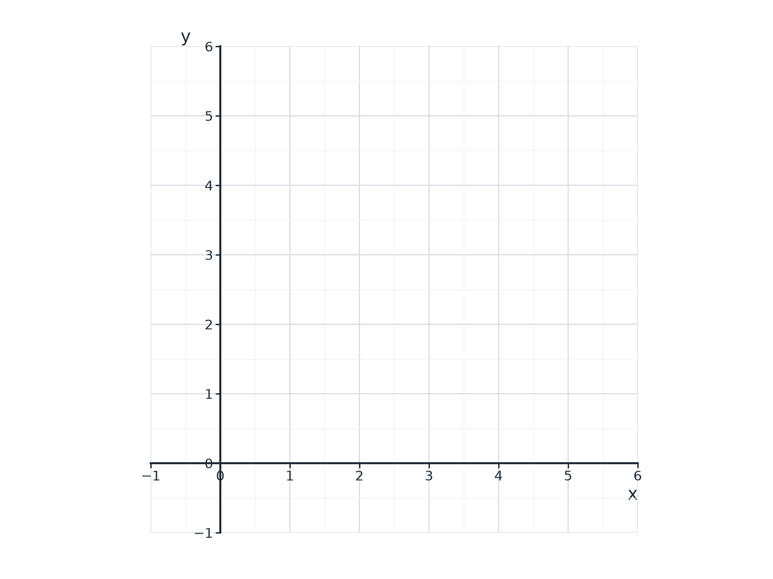

Question 6 · mark scheme
4 marks available. Award a mark for each point made.
▸ One line drawn correctly. M1
▸ All three lines drawn correctly. M1
▸ The correct region. M1
▸ R labelled. A1
▸ Model answer. The lines y = 1, y = x and x + y = 6 are drawn; the triangle with vertices (1, 1), (5, 1) and (3, 3) is labelled R.

