EDEXCEL GCSE MATHS · FOUNDATION & HIGHER
Combined events
Probability · Lesson 1 of 6
Teacher copy - includes the notes for whoever is teaching from it.
Warm-up
Answer each one, then check.
1. What is the probability of rolling a 3 on a fair dice?
1/6
2. What is the probability of getting tails on a fair coin?
½
3. Simplify 6/36.
1/6
4. What do all the probabilities of an event add up to?
1
5. If P(rain) = 0.3, what is P(not rain)?
0.7
Learning Objectives
1. Use the probability scale and the formula for equally likely outcomes.
2. List the outcomes of two events systematically.
3. Draw and use a sample space diagram.
4. Work out probabilities of combined events.
The Formula
For equally likely outcomes, probability is the number of successful outcomes divided by the total number of possible outcomes.
P(event) = (number of ways the event can happen)/(total number of equally likely outcomes)
Listing Outcomes
A fair coin is flipped and a fair dice is rolled. List all the possible outcomes, and find the probability of a head and a 6.

1. Write each coin outcome with each dice outcome
H1, H2, H3, H4, H5, H6, T1, T2, T3, T4, T5, T6
2. Count the outcomes
12
3. Only one of these is a head with a 6
H6
Answer: There are 12 outcomes, so P(head and 6) = 1/12.
A Sample Space Diagram
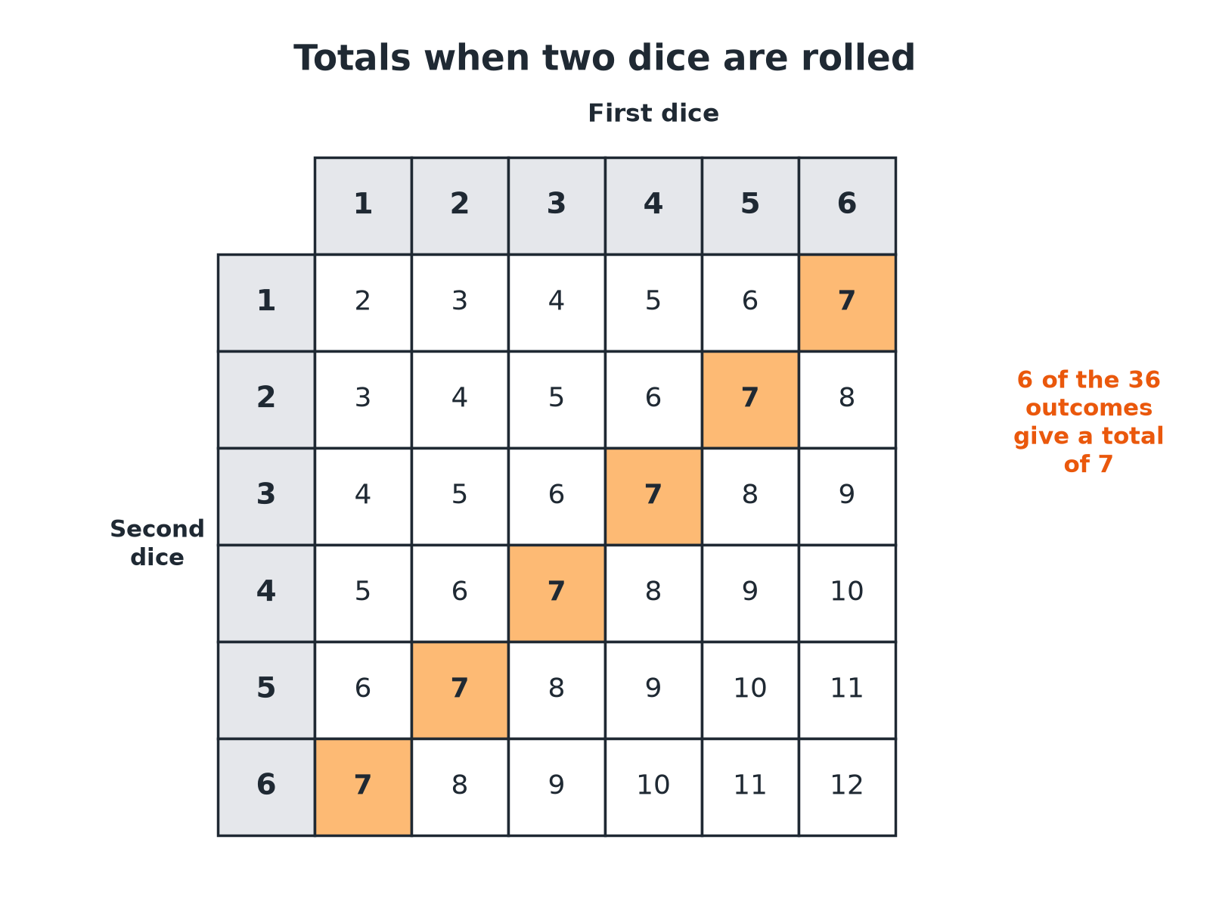
A sample space diagram shows every outcome, so nothing is missed.
A table of the 36 possible totals from rolling two dice, with the six totals equal to 7 highlighted.
Totals from Two Dice
Each cell is the sum of the two dice.
First dice | 1 | 2 | 3 | 4
1 | 2 | 3 | 4 | 5 | 6 | 7
2 | 3 | 4 | 5 | 6 | 7 | 8
3 | 4 | 5 | 6 | 7 | 8 | 9
4 | 5 | 6 | 7 | 8 | 9 | 10
5 | 6 | 7 | 8 | 9 | 10 | 11
6 | 7 | 8 | 9 | 10 | 11 | 12
Using the Table
Two fair dice are rolled and the scores are added. Find (a) P(total is 7) and (b) P(total is at least 10).

1. (a) Count the 7s in the table
6 out of 36
2. (a) Simplify
6/36 = 1/6
3. (b) Count the totals 10, 11 or 12
3 + 2 + 1 = 6
4. (b) Probability
6/36 = 1/6
Answer: (a) 1/6 (b) 1/6
Two Spinners
Spinner A has three equal sections numbered 1, 2, 3. Spinner B has four equal sections numbered 1, 2, 3, 4. Both are spun and the scores added. Find the probability that the total is 5, and that it is even.

1. Number of outcomes
3 × 4 = 12
2. Totals of 5 come from
(1, 4), (2, 3), (3, 2)
3. P(total is 5)
3/12 = ¼
4. Even totals: both odd or both even
(1,1), (1,3), (3,1), (3,3), (2,2), (2,4)
5. P(even)
6/12 = ½
Answer: P(total 5) = ¼ and P(even) = ½.
Systematic Listing
A system stops you missing outcomes or counting one twice.
▸ Fix the first event. Write every second-event outcome beside it, then move to the next first-event outcome.
▸ Use a table. Rows for one event, columns for the other.
▸ Count. The total number of outcomes is the product of the number of outcomes of each event.
Key Terms
Outcome  One possible result of an event. | Event  One or more outcomes.
Equally likely  Each outcome has the same chance. | Sample space  The set of all possible outcomes.
Sample space diagram  A table or list showing every outcome. | Probability  A number from 0 to 1 showing how likely an event is.
Your Task: Two-Dice Game
12 minutes
In a game, two dice are rolled and the smaller number is subtracted from the larger (or 0 if they are equal). Complete a table of differences. Which difference is most likely, and what is its probability?
1. Fill in a 6 by 6 table.
2. Count each difference.
3. Divide by 36.
A good answer shows: The differences 0 to 5 occur 6, 10, 8, 6, 4 and 2 times out of 36. The most likely is 1, with probability 10/36 = 5/18.
Note: Ask students to draw the table before counting.
Can I...?
☐ Write a probability as a fraction.
☐ List outcomes systematically.
☐ Draw a sample space diagram.
☐ Count successful outcomes.
☐ Work out probabilities from a table.
☐ Simplify probabilities.
☐ Use 3 × 4 = 12 to count outcomes.
☐ Avoid double-counting.
Summary
✓ Probability = (successful outcomes)/(total outcomes).
✓ Use a table or systematic list to find all outcomes.
✓ The total number of outcomes for two events is the product.
✓ Simplify your final fraction.

EXAM FOCUS
Two fair dice are rolled and their scores are added. Work out the probability that the total is 7. (3 marks)
Draw a 6 by 6 table. Count the 7s (there are 6) and divide by 36.
Exam Practice: Combined Events
Answer all questions. Show your working. · 25 minutes
▸ Question 1 · 2 marks · Non-calculator. A fair coin is flipped and a fair dice is rolled. Write down the probability of getting a head and a 6.
▸ Question 2 · 3 marks · Non-calculator. Two fair dice are rolled and the scores are added. Work out the probability that the total is 7.
▸ Question 3 · 3 marks · Non-calculator. Spinner A has three equal sections numbered 1, 2 and 3. Spinner B has four equal sections numbered 1, 2, 3 and 4. Both spinners are spun…
▸ Question 4 · 2 marks · Non-calculator. For the same two spinners, work out the probability that the total is even.
▸ Question 5 · 3 marks · Non-calculator. Two fair dice are rolled and the scores are added. Work out the probability that the total is at least 10.
▸ Question 6 · 2 marks · Non-calculator. Two fair dice are rolled. Work out the probability of getting a double (the same number on both dice).
Question 1 · 2 marks · Non-calculator
“A fair coin is flipped and a fair dice is rolled. Write down the probability of getting a head and a 6.”
HOW TO ANSWER IT Command word: Non-calculator. Worth 2 marks, so plan before writing.
Question 1 · mark scheme
2 marks available. Award a mark for each point made.
▸ 12 outcomes. M1
▸ 1/12. A1
▸ Model answer. There are 12 equally likely outcomes and one of them is H6. The probability is 1/12.
Question 2 · 3 marks · Non-calculator
“Two fair dice are rolled and the scores are added. Work out the probability that the total is 7.”
HOW TO ANSWER IT Command word: Non-calculator. Worth 3 marks, so plan before writing.
Question 2 · mark scheme
3 marks available. Award a mark for each point made.
▸ 36 outcomes. M1
▸ 6 successful outcomes. M1
▸ 1/6. A1
▸ Model answer. There are 36 equally likely outcomes and 6 give a total of 7. The probability is 6/36 = 1/6.
Question 3 · 3 marks · Non-calculator
Spinner A has three equal sections numbered 1, 2 and 3. Spinner B has four equal sections numbered 1, 2, 3 and 4. Both spinners are spun and the two scores are added. Work out the probability that the total is 5. (3 marks) | 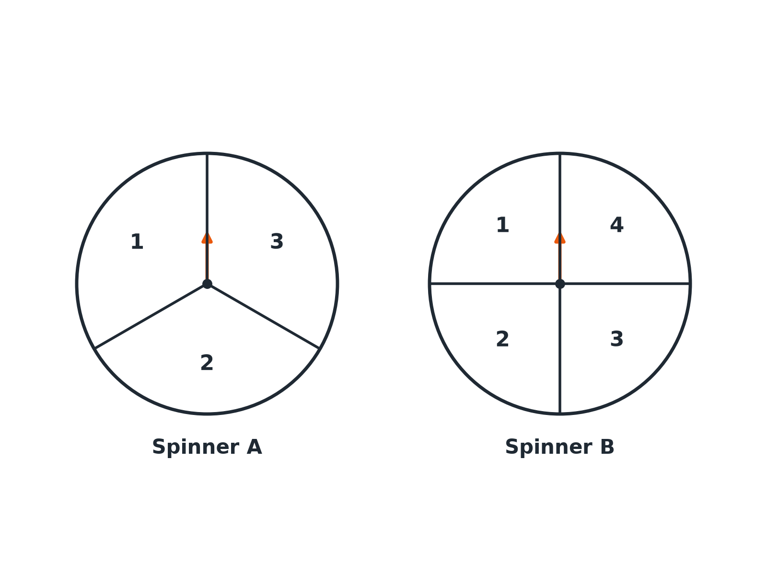

Question 3 · mark scheme
3 marks available. Award a mark for each point made.
▸ 12 outcomes. M1
▸ Three ways to make 5. M1
▸ ¼. A1
▸ Model answer. There are 3 × 4 = 12 outcomes. The totals of 5 are (1, 4), (2, 3) and (3, 2), so the probability is 3/12 = ¼.
Question 4 · 2 marks · Non-calculator
“For the same two spinners, work out the probability that the total is even.”
HOW TO ANSWER IT Command word: Non-calculator. Worth 2 marks, so plan before writing.
Question 4 · mark scheme
2 marks available. Award a mark for each point made.
▸ 6 successful outcomes. M1
▸ ½. A1
▸ Model answer. The even totals come from (1,1), (1,3), (3,1), (3,3), (2,2) and (2,4): 6 of 12. The probability is ½.
Question 5 · 3 marks · Non-calculator
“Two fair dice are rolled and the scores are added. Work out the probability that the total is at least 10.”
HOW TO ANSWER IT Command word: Non-calculator. Worth 3 marks, so plan before writing.
Question 5 · mark scheme
3 marks available. Award a mark for each point made.
▸ 6 successful outcomes. M1
▸ 6/36. M1
▸ 1/6. A1
▸ Model answer. Totals of 10, 11 and 12 occur 3 + 2 + 1 = 6 times out of 36. The probability is 6/36 = 1/6.
Question 6 · 2 marks · Non-calculator
“Two fair dice are rolled. Work out the probability of getting a double (the same number on both dice).”
HOW TO ANSWER IT Command word: Non-calculator. Worth 2 marks, so plan before writing.
Question 6 · mark scheme
2 marks available. Award a mark for each point made.
▸ 6 doubles. M1
▸ 1/6. A1
▸ Model answer. There are 6 doubles out of 36 outcomes, so the probability is 6/36 = 1/6.

