EDEXCEL GCSE MATHS · FOUNDATION & HIGHER
Venn diagrams and set notation
Probability · Lesson 6 of 6
Teacher copy - includes the notes for whoever is teaching from it.
Warm-up
Answer each one, then check.
1. List the even numbers from 1 to 10.
2, 4, 6, 8, 10
2. List the multiples of 3 from 1 to 10.
3, 6, 9
3. What number is in both lists above?
6
4. Work out 40 − 29.
11
5. Simplify 8/16.
½
Learning Objectives
1. Use set notation: ∈, ∪, ∩, A', xi and n(A).
2. Draw and complete a Venn diagram.
3. Shade the region for a set expression.
4. Find probabilities from a Venn diagram, including conditional ones (Higher).
Set Notation
Learn these symbols.
Symbol | Meaning | Example
xi | The universal set: everything being considered | xi= {1, 2, ..., 10}
A ∪ B | Union: in A or B or both | {2, 3, 4, 6, 8, 9, 10}
A ∩ B | Intersection: in both A and B | {6}
A' | Complement: not in A | {1, 3, 5, 7, 9}
n(A) | The number of elements in A | n(A) = 5
∈ | "is an element of" | 4 ∈A
Shading Set Regions
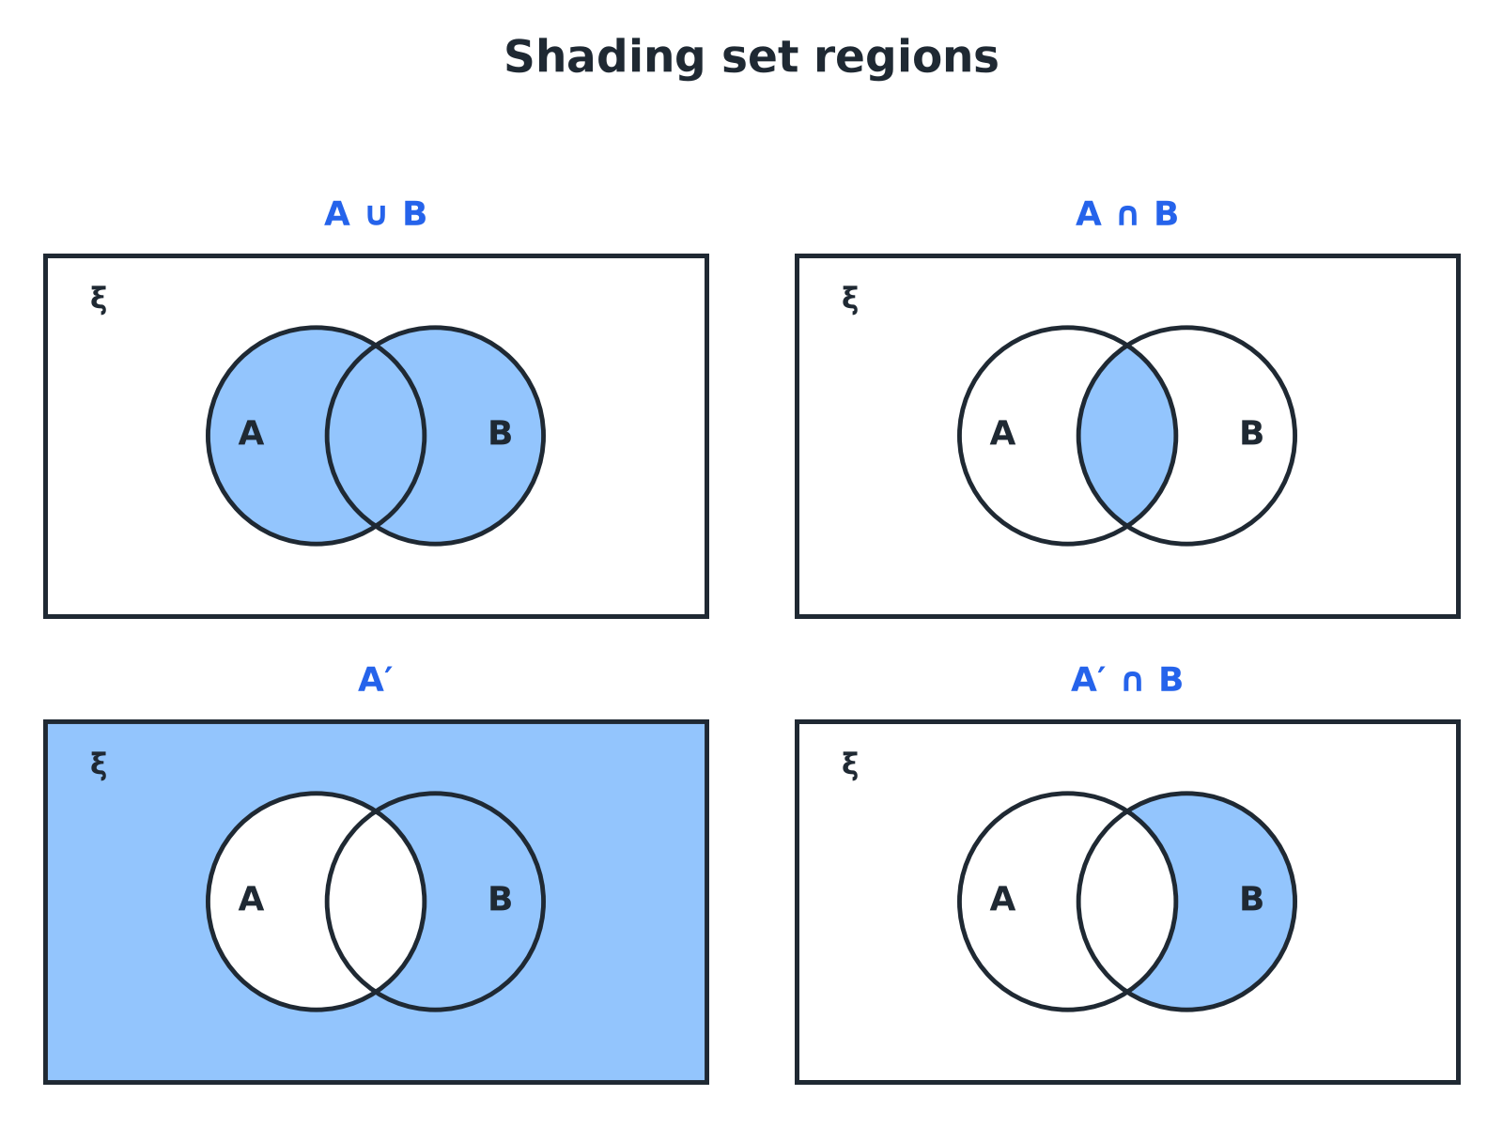
Shade the region that matches the notation.
Four Venn diagrams showing the shaded regions for A union B, A intersection B, the complement of A, and the complement of A intersected with B.
Sets of Numbers
xi= {1, 2, 3, ..., 10}, A = the even numbers and B = the multiples of 3. List A, B, A ∩ B, A ∪ B and A'.

1. A
{2, 4, 6, 8, 10}
2. B
{3, 6, 9}
3. In both
A ∩ B = {6}
4. In either
A ∪ B = {2, 3, 4, 6, 8, 9, 10}
5. Not in A
A' = {1, 3, 5, 7, 9}
Answer: See the lists above; n(A ∪ B) = 7.
Completing a Venn Diagram
Start in the middle and work outwards.
1  Fill in the overlap first  The number in both sets | 2  Work out the rest of each set  Subtract the overlap from each total | 3  Fill the outside  Universal total minus everything inside the circles | 4  Check  All the numbers add up to the universal total
A Survey
40 students were asked about music (M) and art (R). 22 take music, 15 take art and 8 take both. Complete the Venn diagram and find the number who take neither.

1. Both
8
2. Music only
22 − 8 = 14
3. Art only
15 − 8 = 7
4. Inside the circles
14 + 8 + 7 = 29
5. Neither
40 − 29 = 11
Answer: Music only 14, both 8, art only 7, neither 11.
Probabilities from a Venn Diagram
For the survey, a student is chosen at random. Find (a) P(neither), (b) P(M ∪ R).

1. (a) Neither
11/40
2. (b) Music or art (or both)
14 + 8 + 7 = 29, so 29/40
Answer: (a) 11/40 (b) 29/40
HIGHER TIER
Conditional Probability from a Venn Diagram
Restrict to the given set.
Given That HIGHER
For the survey, find P(M midR): the probability a student takes music, given that they take art.

1. "Given that they take art" restricts to the art circle
15 students
2. Of these, the number who also take music
8
3. Probability
8/15
Answer: 8/15
Key Terms
Set  A collection of items. | Element  One item in a set.
Universal set  The set of everything being considered, xi. | Union  Items in one set or the other or both, ∪.
Intersection  Items in both sets, ∩. | Complement  Items not in the set, A'.
Your Task: Class Survey
12 minutes
In a class of 30 students, 18 have a dog, 12 have a cat and 5 have both. Draw a Venn diagram, and find the probability that a randomly chosen student has (a) a dog only (b) neither (c) a cat given that they have a dog.
1. Fill in the overlap first.
2. Subtract for the other regions.
3. Use the right total.
A good answer shows: Dog only 18 − 5 = 13, cat only 12 − 5 = 7, both 5, neither 30 − 25 = 5. (a) 13/30 (b) 5/30 = 1/6 (c) 5/18.
Note: Point out that part (c) restricts the total to the 18 dog owners.
Can I...?
☐ Use the set notation symbols.
☐ List the elements of A ∩ B and A ∪ B.
☐ Find A'.
☐ Fill in a Venn diagram from totals.
☐ Shade the correct region.
☐ Find a probability from a Venn diagram.
☐ Find P(A midB) (Higher).
☐ Check the total.
Summary
✓ A ∪ B: in A or B. A ∩ B: in both. A': not in A.
✓ Fill the overlap first, then each circle, then the outside.
✓ The numbers must add up to the universal total.
✓ Higher: P(A midB) uses B as the new total.

EXAM FOCUS
40 students were asked about music and art. 22 take music, 15 take art and 8 take both. Draw a Venn diagram to show this information. (4 marks)
Start with the overlap (8), then subtract it from each circle total. Finish with the number outside.
Exam Practice: Venn Diagrams and Set Notation
Answer all questions. Show your working. · 30 minutes
▸ Question 1 · 2 marks · Non-calculator. xi= {1, 2, 3, 4, 5, 6, 7, 8, 9, 10}, A = {even numbers} and B = {multiples of 3}. List the members of A ∩ B.
▸ Question 2 · 2 marks · Non-calculator. Using the same sets, list the members of A'.
▸ Question 3 · 4 marks · Non-calculator. 40 students were asked whether they take music (M) and art (R). 22 take music, 15 take art and 8 take both. Complete the Venn diagram.
▸ Question 4 · 2 marks · Non-calculator. One of the 40 students is chosen at random. Use your Venn diagram to work out the probability that the student takes neither music nor art.
▸ Question 5 · 2 marks · Non-calculator. Write down the number of students in M ∪ R.
▸ Question 6 · 3 marks · Non-calculator. One of the 40 students is chosen at random. Given that the student takes art, work out the probability that they also take music.
Question 1 · 2 marks · Non-calculator
“xi= {1, 2, 3, 4, 5, 6, 7, 8, 9, 10}, A = {even numbers} and B = {multiples of 3}. List the members of A ∩ B.”
HOW TO ANSWER IT Command word: Non-calculator. Worth 2 marks, so plan before writing.
Question 1 · mark scheme
2 marks available. Award a mark for each point made.
▸ A = {2, 4, 6, 8, 10} and B = {3, 6, 9}. M1
▸ {6}. A1
▸ Model answer. A ∩ B = {6}.
Question 2 · 2 marks · Non-calculator
“Using the same sets, list the members of A'.”
HOW TO ANSWER IT Command word: Non-calculator. Worth 2 marks, so plan before writing.
Question 2 · mark scheme
2 marks available. Award a mark for each point made.
▸ Odd numbers seen. M1
▸ {1, 3, 5, 7, 9}. A1
▸ Model answer. A' = {1, 3, 5, 7, 9}.
Question 3 · 4 marks · Non-calculator
40 students were asked whether they take music (M) and art (R). 22 take music, 15 take art and 8 take both. Complete the Venn diagram. (4 marks) | 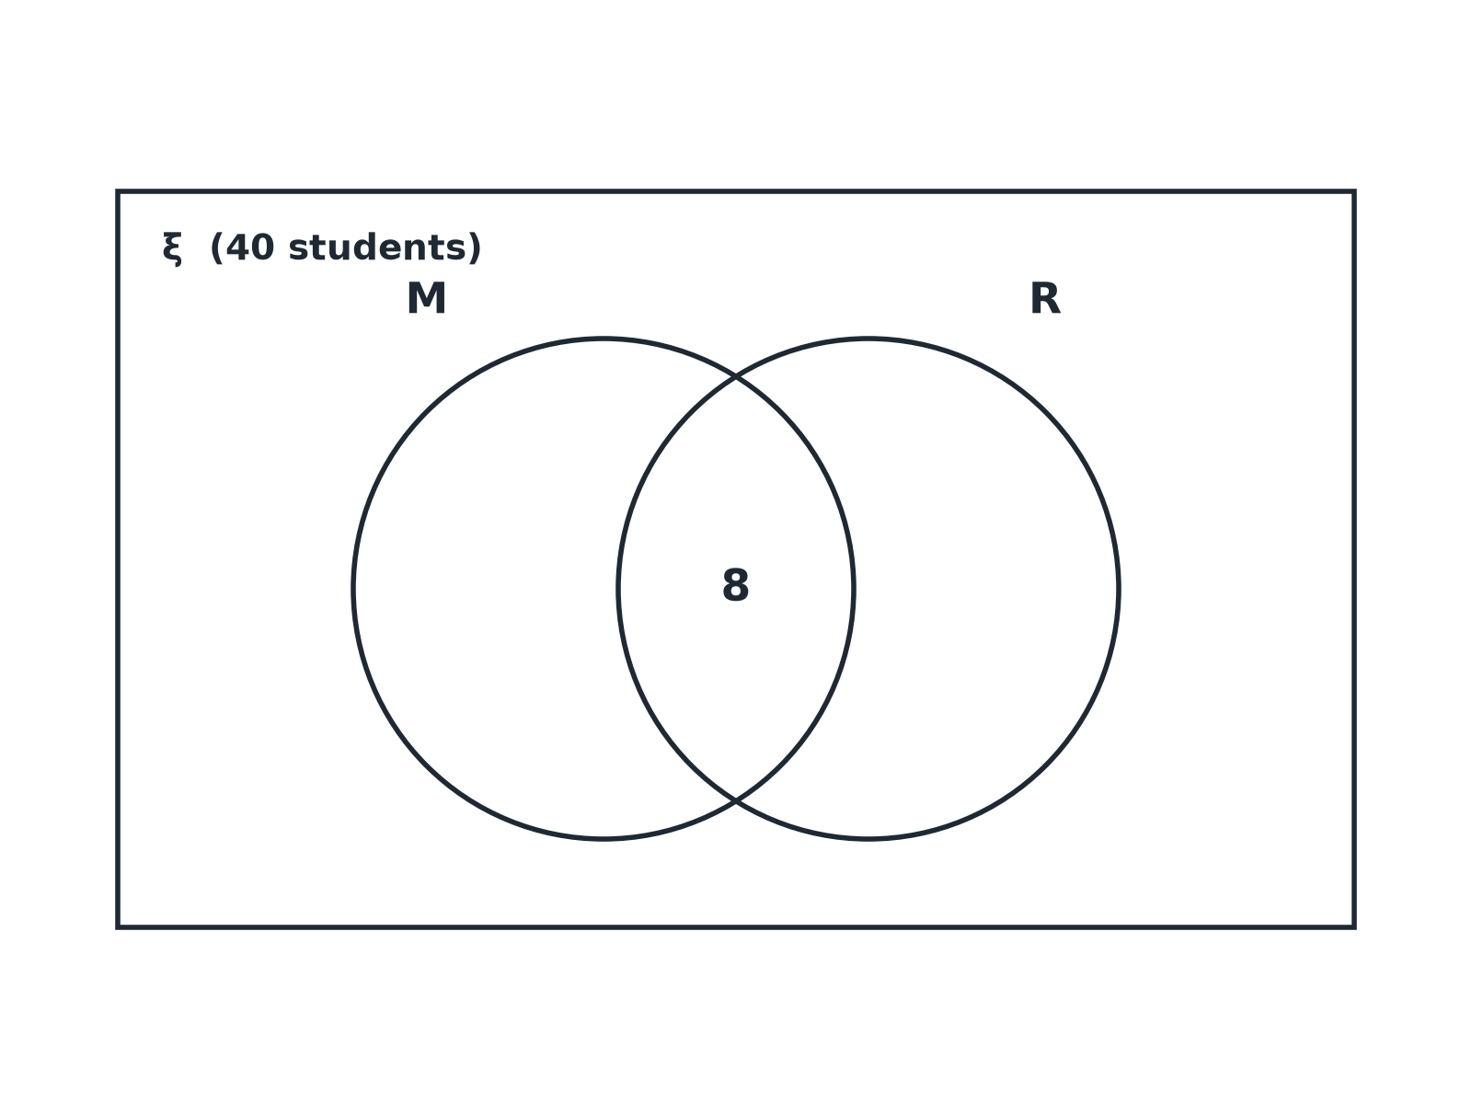

Question 3 · mark scheme
4 marks available. Award a mark for each point made.
▸ Overlap 8. B1
▸ M only 14. B1
▸ R only 7. B1
▸ Outside 11. B1
▸ Model answer. M only 14, overlap 8, R only 7, outside the circles 11.
Question 4 · 2 marks · Non-calculator
“One of the 40 students is chosen at random. Use your Venn diagram to work out the probability that the student takes neither music nor art.”
HOW TO ANSWER IT Command word: Non-calculator. Worth 2 marks, so plan before writing.
Question 4 · mark scheme
2 marks available. Award a mark for each point made.
▸ 11. M1
▸ 11/40. A1
▸ Model answer. 11/40.
Question 5 · 2 marks · Non-calculator
“Write down the number of students in M ∪ R.”
HOW TO ANSWER IT Command word: Non-calculator. Worth 2 marks, so plan before writing.
Question 5 · mark scheme
2 marks available. Award a mark for each point made.
▸ Adding the three regions. M1
▸ 29. A1
▸ Model answer. 14 + 8 + 7 = 29.
Question 6 · 3 marks · Non-calculator
“One of the 40 students is chosen at random. Given that the student takes art, work out the probability that they also take music.”
HOW TO ANSWER IT Command word: Non-calculator. Worth 3 marks, so plan before writing.
Question 6 · mark scheme
3 marks available. Award a mark for each point made.
▸ 15 as the total. M1
▸ 8/15. A1
▸ A correct conclusion. C1
▸ Model answer. 15 students take art, and 8 of these also take music. The probability is 8/15.

