EDEXCEL GCSE MATHS · FOUNDATION & HIGHER
More compound measures
Multiplicative reasoning · Lesson 3 of 4
Teacher copy - includes the notes for whoever is teaching from it.
Warm-up
Answer each one, then check.
1. Change 2.5 hours into hours and minutes.
2 h 30 min
2. What is density?
Mass divided by volume
3. Work out 60 ÷ 1.5.
40
4. Work out 60 ÷ 60.
1
5. How many litres in 1 m³?
1000
Learning Objectives
1. Use rates such as population density and flow rate.
2. Work out average speed for a journey in stages.
3. Convert compound units, including density.
4. Solve multi-step problems with compound measures.
Everyday Compound Measures
Population density  population/area, for example people per km². | Rate of flow  volume/time, for example litres per minute.
Unit price  cost/quantity, for example £ per kg. | Average speed  (total distance)/(total time).
Population Density
A town has 60 000 people and an area of 25 km². Find its population density.

1. Density = population/area
(60 000)/25
2. Work it out
2400
Answer: 2400 people per km²
Rate of Flow
A tank holds 1200 litres. Water runs into it at 15 litres per minute. How long does it take to fill, in hours and minutes?

1. Time = volume/rate
1200/15
2. Work it out
80 minutes
3. Convert
1 hour 20 minutes
Answer: 1 hour 20 minutes
A Two-Stage Journey
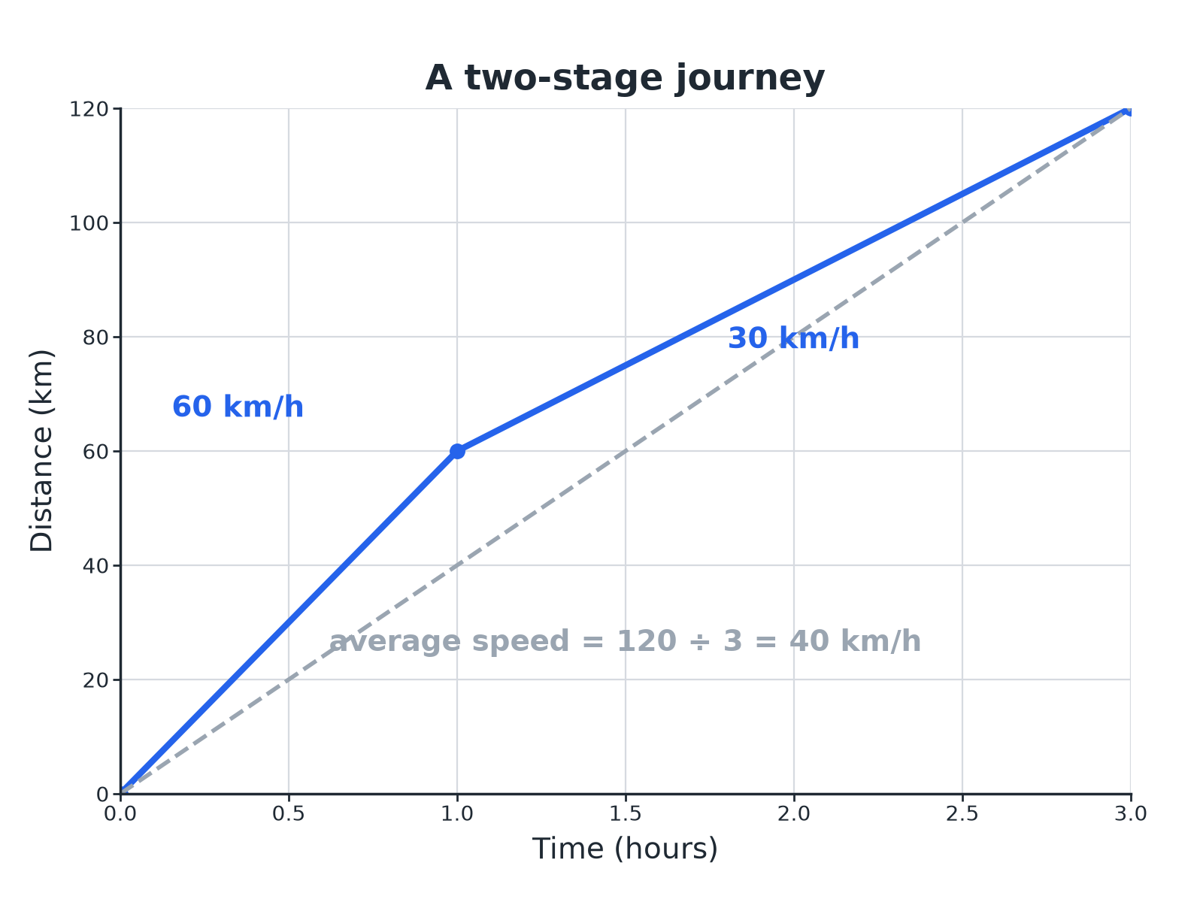
Average speed uses the whole distance and the whole time.
A distance-time graph of a two-stage journey with the average speed shown as a straight dashed line from start to finish.
Average Speed in Two Stages
A car travels 60 km at 40 km/h and then 60 km at 60 km/h. Find its average speed for the whole journey.

1. Time for stage 1
60 ÷ 40 = 1.5 hours
2. Time for stage 2
60 ÷ 60 = 1 hour
3. Total distance and time
120 km in 2.5 hours
4. Average speed
120 ÷ 2.5 = 48
Answer: 48 km/h (not 50 km/h)
Converting Density
Steel has density 7.8 g/cm³. Write this in kg/m³.

1. 1 g is 0.001 kg and 1 cm³ is 0.000 001 m³
1 g/cm³ = 0.001/(0.000 001) kg/m³
2. Simplify
1 g/cm³ = 1000 kg/m³
3. Multiply
7.8 × 1000
Answer: 7800 kg/m³
Converting Speed the Other Way
A cyclist rides at 15 m/s. Find her speed in km/h.

1. 15 m per second in 1 hour
15 × 3600 = 54 000 m
2. Change to km
54 000 ÷ 1000
Answer: 54 km/h
Handy Conversions
Learn or work these out.
From | To | Rule
m/s | km/h | Multiply by 3.6
km/h | m/s | Divide by 3.6
g/cm³ | kg/m³ | Multiply by 1000
cm² | m² | Divide by 10 000
litres | cm³ | Multiply by 1000
Key Terms
Rate  A quantity compared with another, such as litres per minute. | Population density  The number of people per unit of area.
Average speed  Total distance divided by total time. | Flow rate  The volume passing a point per unit of time.
Unit price  The cost of one unit of a product. | Conversion  Changing from one unit to another.
Your Task: Best Journey
12 minutes
Ali drives 90 km at 60 km/h and then 90 km at 90 km/h. Ben drives the whole 180 km at 72 km/h. Who has the higher average speed, and by how much?
1. Find each time.
2. Total distance over total time.
3. Compare.
A good answer shows: Ali: times 1.5 h and 1 h, so 2.5 h for 180 km: 72 km/h. Ben: 72 km/h. They have the same average speed, even though Ali's speeds average to 75 km/h.
Note: Use this to show why averaging the speeds gives the wrong answer.
Can I...?
☐ Work out population density.
☐ Work out a rate of flow.
☐ Find average speed for a whole journey.
☐ Avoid averaging the speeds.
☐ Convert m/s to km/h.
☐ Convert g/cm³ to kg/m³.
☐ Use unit prices.
☐ Show clear working.
Summary
✓ Average speed = total distance ÷ total time.
✓ Density, pressure and flow rate are all "one thing per another".
✓ Convert units before dividing.
✓ m/s to km/h: multiply by 3.6.

EXAM FOCUS
A car travels 60 km at 40 km/h and then 60 km at 60 km/h. Work out its average speed for the whole journey. (4 marks)
Find the time for each stage, then divide the total distance by the total time. The answer is not the average of the two speeds.
Exam Practice: More Compound Measures
Answer all questions. Show your working. · 30 minutes
▸ Question 1 · 3 marks · Calculator. A town has a population of 60 000 and an area of 25 km². Work out the population density of the town in people per km².
▸ Question 2 · 2 marks · Non-calculator. A cyclist travels at 15 metres per second. Work out her speed in kilometres per hour.
▸ Question 3 · 3 marks · Calculator. A tank holds 1200 litres of water. Water runs into the tank at 15 litres per minute. Work out how long the tank takes to fill. Give your…
▸ Question 4 · 4 marks · Calculator. A car travels 60 km at 40 km/h and then 60 km at 60 km/h. Work out the average speed of the car for the whole journey.
▸ Question 5 · 4 marks · Calculator. The distance-time graph shows a car journey. (a) Work out the speed of the car during the last part of the journey. (b) Work out the…
▸ Question 6 · 2 marks · Non-calculator. Steel has a density of 7.8 g/cm³. Write this density in kg/m³.
Question 1 · 3 marks · Calculator
“A town has a population of 60 000 and an area of 25 km². Work out the population density of the town in people per km².”
HOW TO ANSWER IT Command word: Calculator. Worth 3 marks, so plan before writing.
Question 1 · mark scheme
3 marks available. Award a mark for each point made.
▸ 60 000 ÷ 25. M1
▸ 2400. A1
▸ Units. B1
▸ Model answer. 60 000 ÷ 25 = 2400 people per km².
Question 2 · 2 marks · Non-calculator
“A cyclist travels at 15 metres per second. Work out her speed in kilometres per hour.”
HOW TO ANSWER IT Command word: Non-calculator. Worth 2 marks, so plan before writing.
Question 2 · mark scheme
2 marks available. Award a mark for each point made.
▸ 15 × 3600 or 15 × 3.6. M1
▸ 54. A1
▸ Model answer. 15 × 3600 ÷ 1000 = 54 km/h.
Question 3 · 3 marks · Calculator
“A tank holds 1200 litres of water. Water runs into the tank at 15 litres per minute. Work out how long the tank takes to fill. Give your answer in hours and minutes.”
HOW TO ANSWER IT Command word: Calculator. Worth 3 marks, so plan before writing.
Question 3 · mark scheme
3 marks available. Award a mark for each point made.
▸ 1200 ÷ 15. M1
▸ 80 minutes. A1
▸ 1 hour 20 minutes. A1
▸ Model answer. 1200 ÷ 15 = 80 minutes, which is 1 hour 20 minutes.
Question 4 · 4 marks · Calculator
“A car travels 60 km at 40 km/h and then 60 km at 60 km/h. Work out the average speed of the car for the whole journey.”
HOW TO ANSWER IT Command word: Calculator. Worth 4 marks, so plan before writing.
Question 4 · mark scheme
4 marks available. Award a mark for each point made.
▸ 60 ÷ 40. M1
▸ Total time 2.5 hours. M1
▸ 120 ÷ 2.5. M1
▸ 48. A1
▸ Model answer. The times are 60 ÷ 40 = 1.5 hours and 60 ÷ 60 = 1 hour. The total is 120 km in 2.5 hours, so the average speed is 120 ÷ 2.5 = 48 km/h.
Question 5 · 4 marks · Calculator
The distance-time graph shows a car journey. (a) Work out the speed of the car during the last part of the journey. (b) Work out the average speed for the whole journey. (4 marks) | 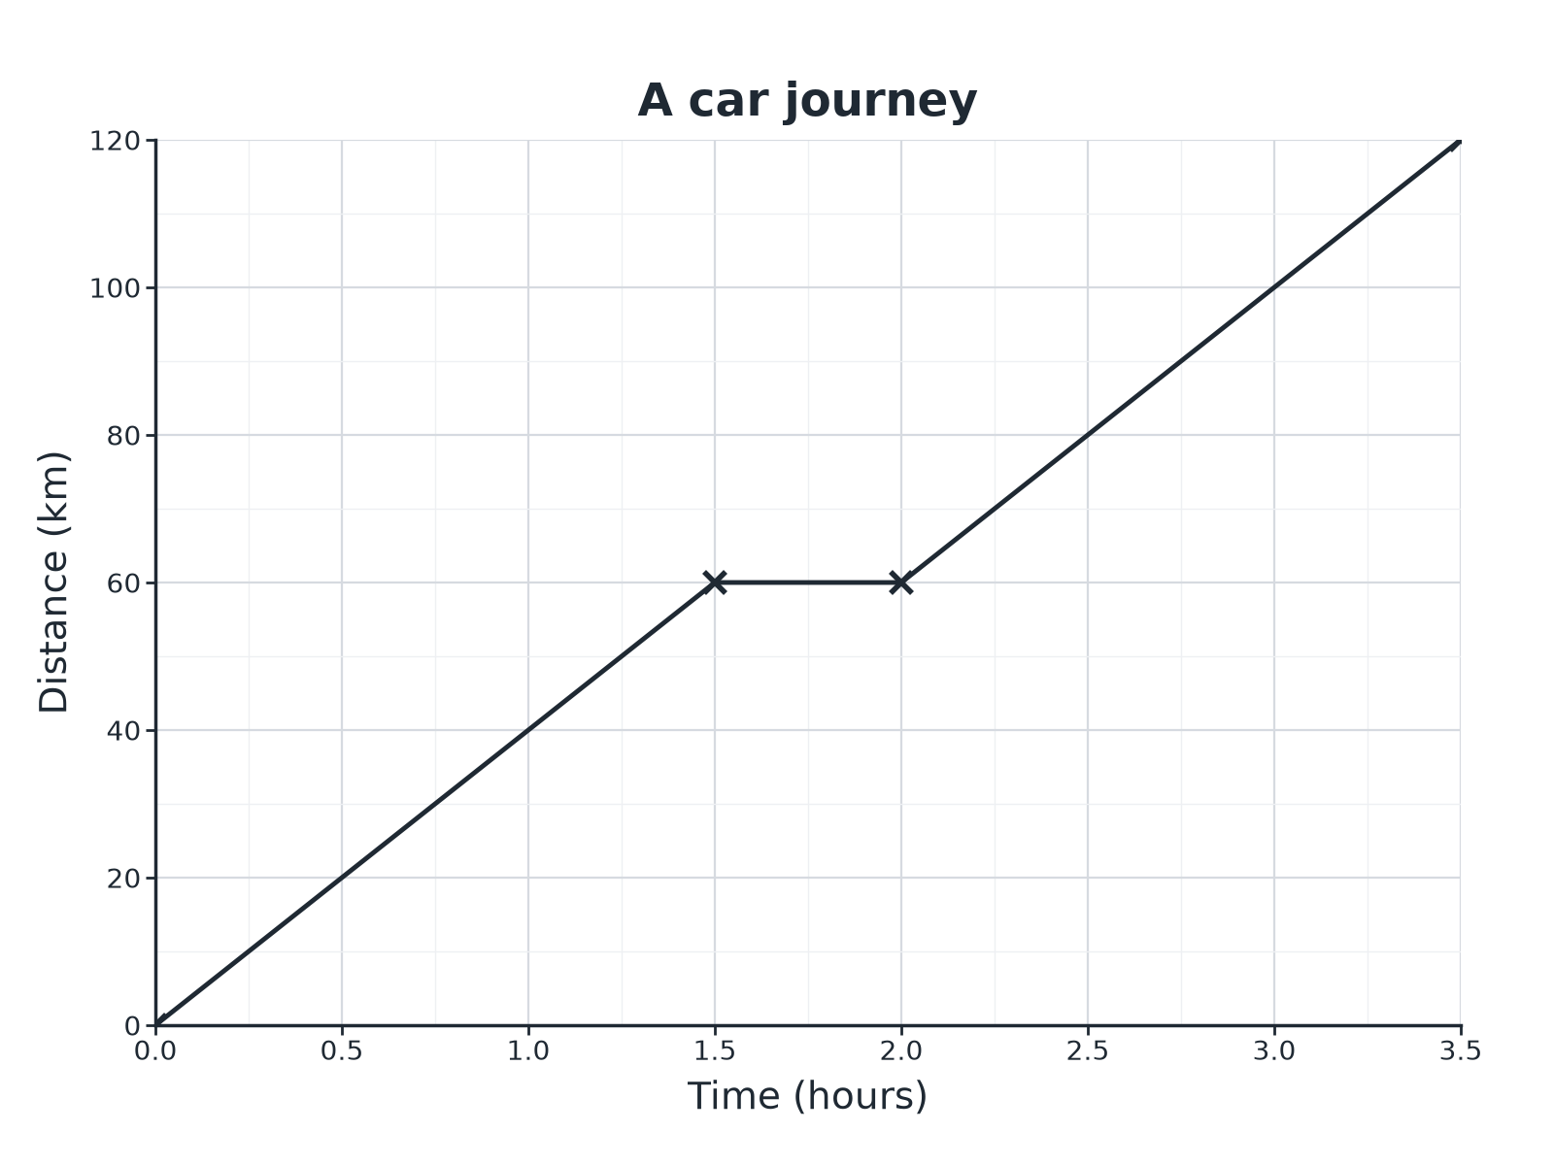

Question 5 · mark scheme
4 marks available. Award a mark for each point made.
▸ (a) 60 ÷ 1.5. M1
▸ (a) 40. A1
▸ (b) 120 ÷ 3.5. M1
▸ (b) 34.3. A1
▸ Model answer. (a) 60 ÷ 1.5 = 40 km/h. (b) The total is 120 km in 3.5 hours, so 120 ÷ 3.5 = 34.3 km/h.
Question 6 · 2 marks · Non-calculator
“Steel has a density of 7.8 g/cm³. Write this density in kg/m³.”
HOW TO ANSWER IT Command word: Non-calculator. Worth 2 marks, so plan before writing.
Question 6 · mark scheme
2 marks available. Award a mark for each point made.
▸ 7.8 × 1000. M1
▸ 7800. A1
▸ Model answer. 7.8 × 1000 = 7800 kg/m³.

