EDEXCEL GCSE MATHS · FOUNDATION & HIGHER
Ratio and proportion
Multiplicative reasoning · Lesson 4 of 4
Teacher copy - includes the notes for whoever is teaching from it.
Warm-up
Answer each one, then check.
1. 4 pens cost £3.20. How much does 1 pen cost?
£0.80
2. If y = 3x and x = 5, what is y?
15
3. Solve 12 = k/4.
k = 48
4. Work out 48 ÷ 6.
8
5. What does "directly proportional" mean?
Both increase in the same ratio
Learning Objectives
1. Solve direct proportion problems with y = kx.
2. Solve inverse proportion problems with y = k/x.
3. Recognise proportion from a table or graph.
4. Use y ∝ x², y ∝ x³ and y ∝ √x (Higher).
Proportion Graphs
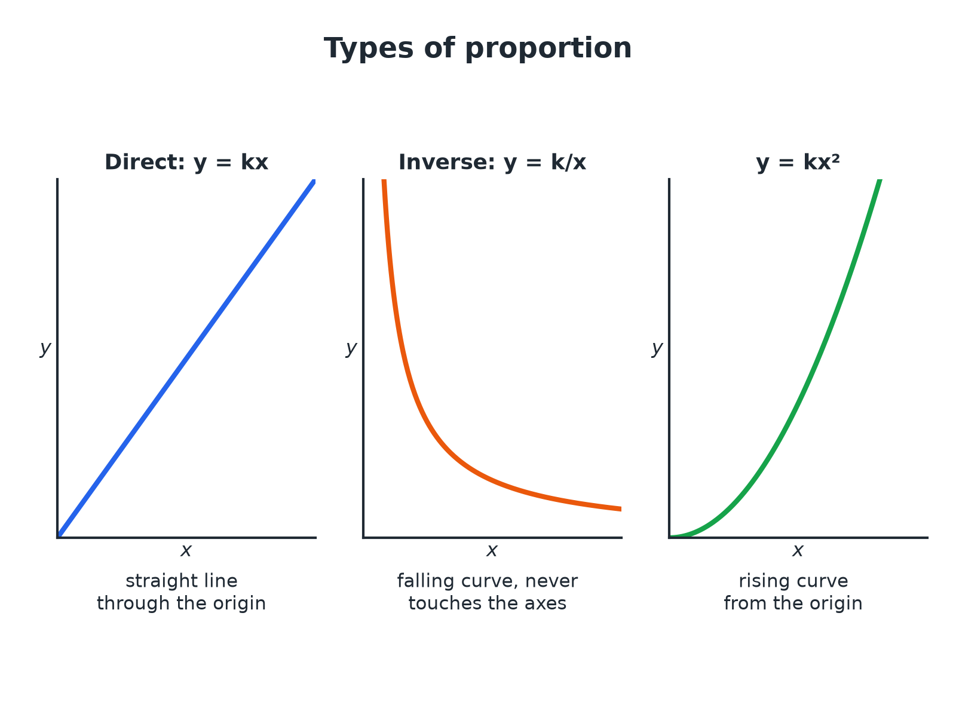
The shape of the graph tells you the type of proportion.
Three graphs: a straight line through the origin for direct proportion, a falling curve for inverse proportion and a rising curve for proportional to x squared.
Direct and Inverse Proportion
DIRECT PROPORTION | INVERSE PROPORTION
▸ As x increases, y increases in the same ratio.  ▸ y = kx, so y/x is constant.  ▸ The graph is a straight line through the origin. | ▸ As x increases, y decreases in the opposite ratio.  ▸ y = k/x, so xy is constant.  ▸ The graph is a curve that never touches the axes.
Direct Proportion
y is directly proportional to x. When x = 7, y = 21. Find y when x = 10.

1. Write y = kx
21 = k × 7
2. Find k
k = 3
3. Substitute x = 10
y = 3 × 10
Answer: y = 30
Inverse Proportion
y is inversely proportional to x. When x = 4, y = 12. Find y when x = 6.

1. Write y = k/x
12 = k/4
2. Find k
k = 48
3. Substitute x = 6
y = 48/6
Answer: y = 8
A Worker Problem
5 workers take 12 days to build a wall. How long would 8 workers take, working at the same rate?

1. More workers means fewer days: inverse proportion
Workers × days is constant
2. Constant
5 × 12 = 60
3. Days for 8 workers
60 ÷ 8
Answer: 7.5 days
HIGHER TIER
Other Proportions
Squares, cubes and square roots.
Proportional to a Square HIGHER
y is directly proportional to x². When x = 2, y = 20. Find y when x = 3.

1. Write y = kx²
20 = k × 4
2. Find k
k = 5
3. Substitute x = 3
y = 5 × 9
Answer: y = 45
Proportional to a Square Root HIGHER
y is directly proportional to √x. When x = 4, y = 6. Find y when x = 25.

1. Write y = k√x
6 = k × 2
2. Find k
k = 3
3. Substitute x = 25
y = 3 × 5
Answer: y = 15
Types of Proportion HIGHER
Learn the equation for each phrase.
Statement | Equation
y is proportional to x | y = kx
y is inversely proportional to x | y = k/x
y is proportional to x² | y = kx²
y is proportional to x³ | y = kx³
y is proportional to √x | y = k√x
y is inversely proportional to x² | y = k/x²
Key Terms
Direct proportion  Two quantities that increase together in the same ratio. | Inverse proportion  As one quantity increases the other decreases in the opposite ratio.
Constant of proportionality  The number k in a proportion equation. | Proportional to  Written y ∝ x.
Unitary method  Finding the value of one unit first. | Rate  How much of one quantity per unit of another.
Your Task: Which Type?
12 minutes
For each situation decide whether it is direct or inverse proportion, and write an equation with a constant k. (a) The cost of buying n identical books (b) the time t to fill a pool with p identical pumps (c) the area A of a circle with radius r.
1. Say what happens when one doubles.
2. Write the equation.
A good answer shows: (a) Direct: C = kn. (b) Inverse: t = k/p. (c) A = kr² (with k = π).
Note: Ask what happens to the time if the number of pumps doubles.
Can I...?
☐ Solve a direct proportion problem.
☐ Solve an inverse proportion problem.
☐ Find the constant k.
☐ Write y = kx and y = k/x.
☐ Recognise proportion from a graph.
☐ Use y = kx² (Higher).
☐ Use y = k√x (Higher).
☐ Explain the type of proportion.
Summary
✓ Direct: y = kx. Inverse: y = k/x.
✓ Find k from the first pair of values.
✓ Higher: y = kx², y = kx³, y = k√x.
✓ Check your answer makes sense.

EXAM FOCUS
y is directly proportional to x². When x = 2, y = 20. Find the value of y when x = 3. (3 marks)
Write the equation with k first, use the given pair to find k, then substitute the new value.
Exam Practice: Ratio and Proportion
Answer all questions. Show your working. · 30 minutes
▸ Question 1 · 3 marks · Non-calculator. 5 workers can build a wall in 12 days. All the workers work at the same rate. Work out how many days it would take 8 workers to build the…
▸ Question 2 · 3 marks · Non-calculator. y is directly proportional to x. When x = 7, y = 21. Find the value of y when x = 10.
▸ Question 3 · 3 marks · Non-calculator. y is inversely proportional to x. When x = 4, y = 12. Find the value of y when x = 6.
▸ Question 4 · 3 marks · Non-calculator. The graph shows the relationship between x and y. Write down an equation connecting x and y.
▸ Question 5 · 3 marks · Non-calculator. y is directly proportional to x². When x = 2, y = 20. Find the value of y when x = 3.
▸ Question 6 · 3 marks · Non-calculator. y is directly proportional to √x. When x = 4, y = 6. Find the value of y when x = 25.
Question 1 · 3 marks · Non-calculator
“5 workers can build a wall in 12 days. All the workers work at the same rate. Work out how many days it would take 8 workers to build the wall.”
HOW TO ANSWER IT Command word: Non-calculator. Worth 3 marks, so plan before writing.
Question 1 · mark scheme
3 marks available. Award a mark for each point made.
▸ 60 worker-days. M1
▸ 60 ÷ 8. M1
▸ 7.5. A1
▸ Model answer. 5 × 12 = 60 worker-days. 60 ÷ 8 = 7.5 days.
Question 2 · 3 marks · Non-calculator
“y is directly proportional to x. When x = 7, y = 21. Find the value of y when x = 10.”
HOW TO ANSWER IT Command word: Non-calculator. Worth 3 marks, so plan before writing.
Question 2 · mark scheme
3 marks available. Award a mark for each point made.
▸ y = kx. M1
▸ k = 3. A1
▸ 30. A1
▸ Model answer. y = kx, so 21 = 7k and k = 3. When x = 10, y = 30.
Question 3 · 3 marks · Non-calculator
“y is inversely proportional to x. When x = 4, y = 12. Find the value of y when x = 6.”
HOW TO ANSWER IT Command word: Non-calculator. Worth 3 marks, so plan before writing.
Question 3 · mark scheme
3 marks available. Award a mark for each point made.
▸ y = k/x. M1
▸ k = 48. A1
▸ 8. A1
▸ Model answer. y = k/x, so 12 = k/4 and k = 48. When x = 6, y = 8.
Question 4 · 3 marks · Non-calculator
The graph shows the relationship between x and y. Write down an equation connecting x and y. (3 marks) | 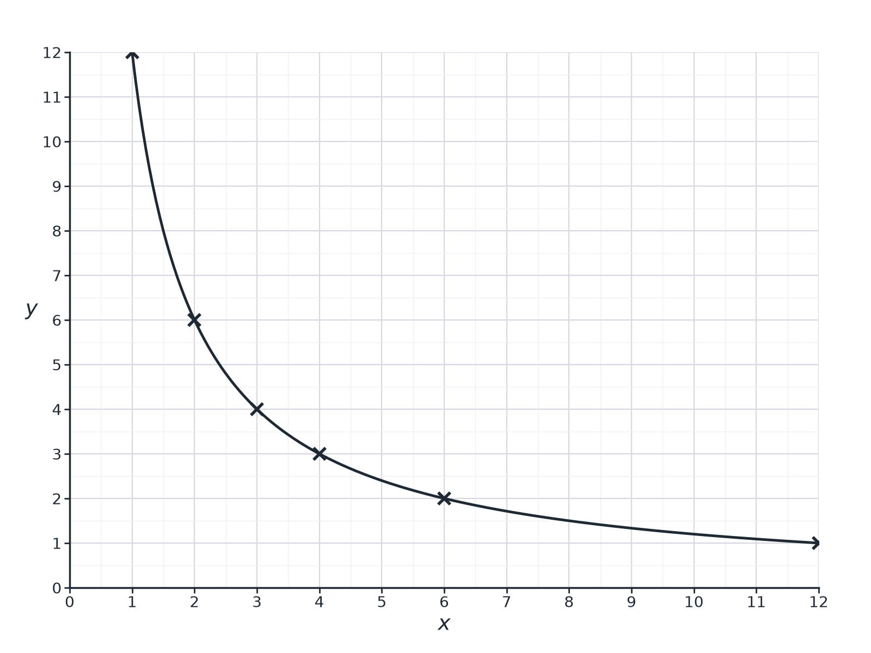

Question 4 · mark scheme
3 marks available. Award a mark for each point made.
▸ Recognising inverse proportion. M1
▸ k = 12. M1
▸ y = 12/x. A1
▸ Model answer. The points show that xy = 12 each time, so y = 12/x (inverse proportion).
Question 5 · 3 marks · Non-calculator
“y is directly proportional to x². When x = 2, y = 20. Find the value of y when x = 3.”
HOW TO ANSWER IT Command word: Non-calculator. Worth 3 marks, so plan before writing.
Question 5 · mark scheme
3 marks available. Award a mark for each point made.
▸ y = kx². M1
▸ k = 5. A1
▸ 45. A1
▸ Model answer. y = kx², so 20 = 4k and k = 5. When x = 3, y = 5 × 9 = 45.
Question 6 · 3 marks · Non-calculator
“y is directly proportional to √x. When x = 4, y = 6. Find the value of y when x = 25.”
HOW TO ANSWER IT Command word: Non-calculator. Worth 3 marks, so plan before writing.
Question 6 · mark scheme
3 marks available. Award a mark for each point made.
▸ y = k√x. M1
▸ k = 3. A1
▸ 15. A1
▸ Model answer. y = k√x, so 6 = 2k and k = 3. When x = 25, y = 3 × 5 = 15.

