EDEXCEL GCSE MATHS · HIGHER
Graph of the sine function
More trigonometry · Lesson 2 of 9
Teacher copy - includes the notes for whoever is teaching from it.
Warm-up
Answer each one, then check.
1. What is sin 30°?
0.5
2. What is sin 90°?
1
3. What is the largest value sin x can take?
1
4. What does SOH mean?
sin = opposite ÷ hypotenuse
5. Which mode must a calculator be in for degrees?
DEG
Learning Objectives
1. Sketch the graph of y = sin x for 0° ≤ x ≤ 360°.
2. Recall key values of sine.
3. Use symmetry to find a second solution of sin x = k.
4. Read solutions from the graph.
Sine Graph
The graph of y = sin x is a smooth wave that repeats every 360°.
It starts at 0, rises to 1 at 90°, returns to 0 at 180°, falls to −1 at 270° and returns to 0 at 360°.
The Sine Graph
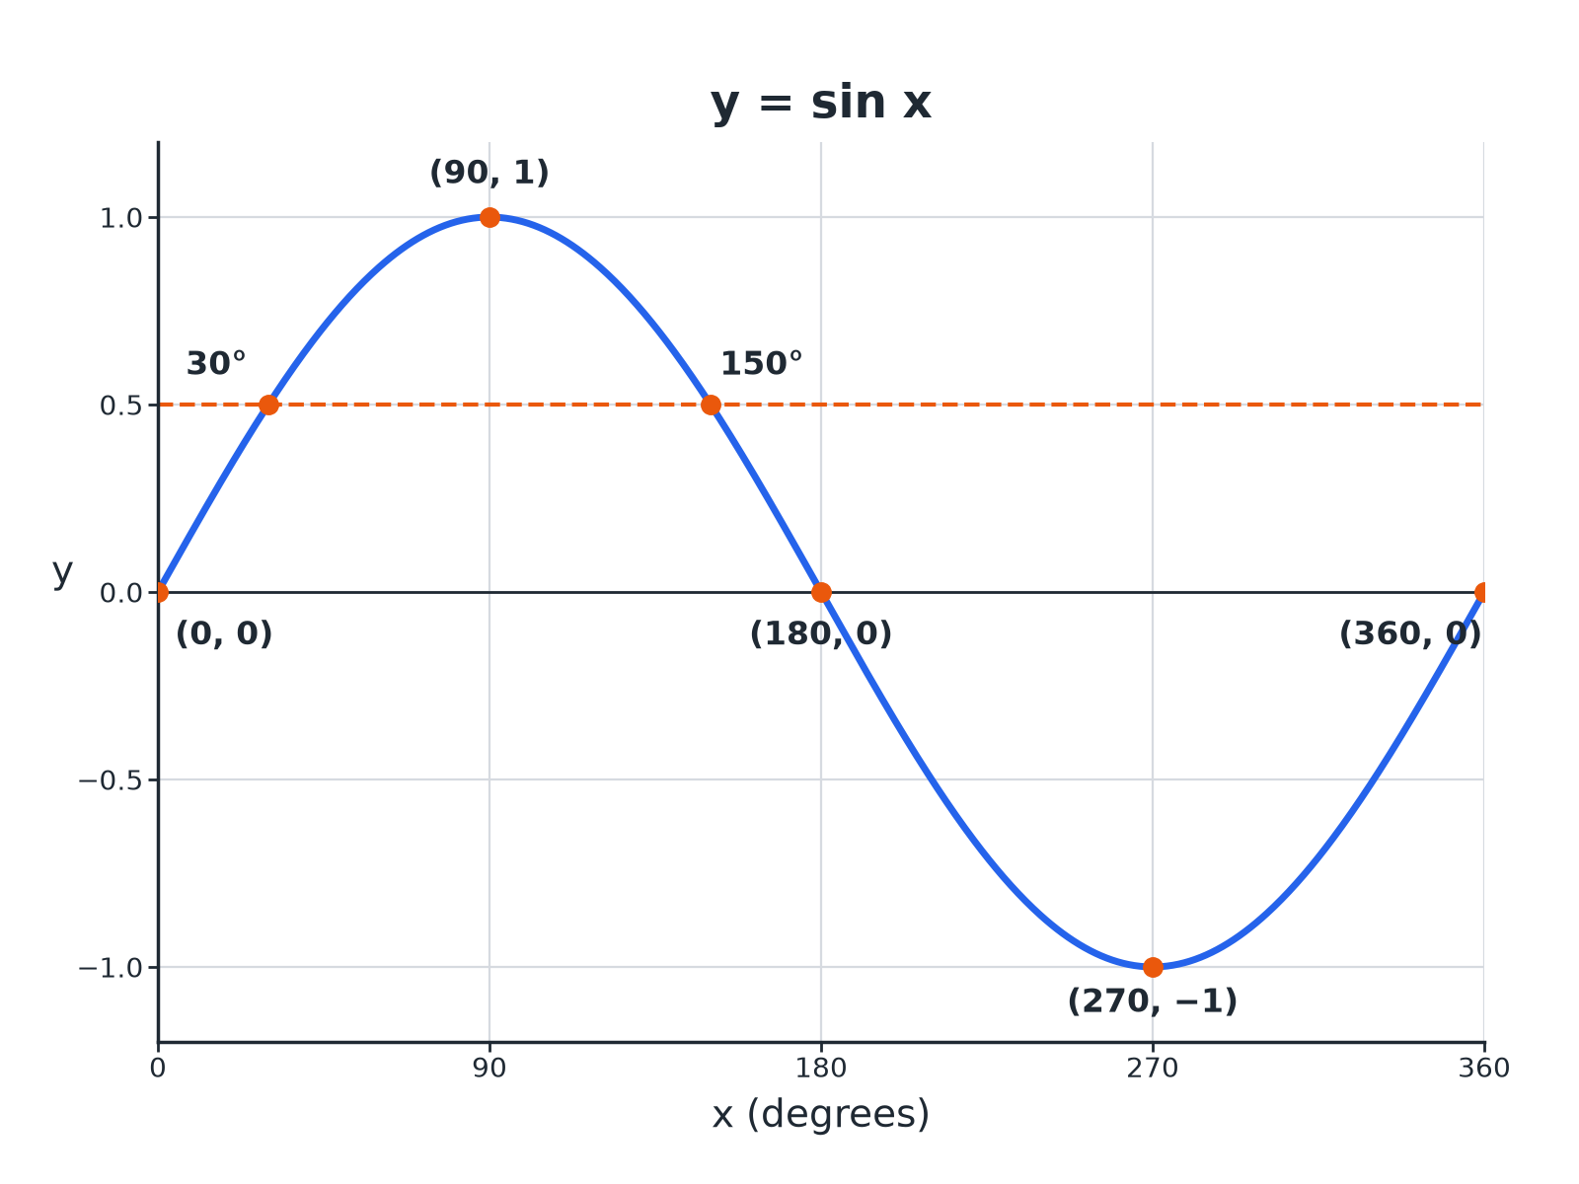
Sine x equals 0.5 has two solutions: 30 degrees and 150 degrees.
The graph of y equals sine x from 0 to 360 degrees, showing the maximum at 90, the minimum at 270 and the two solutions of sine x equals 0.5.
Key Values of Sine
These are worth learning.
x | 0° | 30° | 90° | 150°
sin x | 0 | 0.5 | 1 | 0.5 | 0 | −1 | 0
Features of the Graph
Period  Repeats every 360°. | Maximum  1 at x = 90°.
Minimum  −1 at x = 270°. | Roots  x = 0°, 180°, 360°.
Symmetry
Symmetrical about x = 90° and x = 270°.
Finding Two Solutions
Use symmetry about x = 90°.
1  Use the calculator  Find x = sin ⁻¹(k); this is the first solution | 2  Reflect about 90  Second solution = 180°− x | 3  Check the range  Both must be between 0° and 360° | 4  Negative values  If k < 0, the solutions are between 180° and 360°
Solving sin x = 0.5
Solve sin x = 0.5 for 0° ≤ x ≤ 360°.

1. Calculator
x = sin ⁻¹(0.5) = 30°
2. Reflect
x = 180°− 30°= 150°
Answer: x = 30° and x = 150°
Solving a Negative Value
Solve sin x = −0.5 for 0° ≤ x ≤ 360°.

1. Calculator gives
sin ⁻¹(−0.5) = −30°, so use the positive 30° as a reference
2. Below the axis
Solutions are 180°+ 30° and 360°− 30°
3. Values
210° and 330°
Answer: x = 210° and x = 330°
Key Terms
Period  The length after which the graph repeats. | Amplitude  The height from the middle line to the maximum.
Maximum  The highest value on the graph. | Minimum  The lowest value on the graph.
Inverse sine  sin ⁻¹, the calculator function that finds an angle. | Symmetry  The graph looks the same on both sides of a line.
Your Task: Sketch and Solve
12 minutes
(a) Sketch y = sin x for 0° to 360°. (b) Mark y = 0.8 and read the two solutions from your sketch. (c) Calculate them: sin ⁻¹(0.8) = 53.1°.
1. Draw the axes with 90° marks.
2. Use symmetry about 90°.
A good answer shows: (b) About 53° and 127°. (c) x = 53.1° and 180°− 53.1°= 126.9°.
Note: Check that the sketch solutions match the calculated ones.
Can I...?
☐ Sketch the sine graph.
☐ State its maximum and minimum.
☐ State its period.
☐ Recall sin 30 and sin 90.
☐ Use sin inverse.
☐ Find the second solution.
☐ Solve for negative values.
☐ Read solutions from a graph.
Summary
✓ Sine repeats every 360°, max 1, min −1.
✓ sin x = k has two solutions in 0° to 360° for −1 < k < 1.
✓ Positive k: x and 180°− x.
✓ Negative k: angles in the second half.

EXAM FOCUS
Solve sin x = 0.6 for 0° ≤ x ≤ 360°. Give answers correct to 1 decimal place. (3 marks)
Second solution is 180°− x. Check both are in range.
Exam Practice: Graph of the sine function
Answer all questions. Show your working. · 25 minutes
▸ Question 1 · 3 marks · Solve. Solve sin x = 0.6 for 0° ≤ x ≤ 360°. Give your answers correct to 1 decimal place.
▸ Question 2 · 2 marks · Write down. Write down the value of (a) sin 90° (b) sin 270°
▸ Question 3 · 3 marks · Use the graph. The graph shows y = sin x for 0° ≤ x ≤ 360°. Use the graph to solve sin x = 0.5 and to write down the maximum value of sin x.
▸ Question 4 · 3 marks · Solve. Solve sin x = −0.3 for 0° ≤ x ≤ 360°. Give your answers correct to 1 decimal place.
▸ Question 5 · 2 marks · Explain. Amir says that sin x = 1.4 has a solution. Explain why he is wrong.
▸ Question 6 · 2 marks · Write down. sin 40°= 0.64 (to 2 decimal places). Write down another angle between 0° and 360° with sine 0.64.
Question 1 · 3 marks · Solve
“Solve sin x = 0.6 for 0° ≤ x ≤ 360°. Give your answers correct to 1 decimal place.”
HOW TO ANSWER IT Command word: Solve. Worth 3 marks, so plan before writing.
Question 1 · mark scheme
3 marks available. Award a mark for each point made.
▸ sin ⁻¹(0.6) = 36.9°. B1
▸ 180 − 36.9. M1
▸ 143.1. A1
▸ Model answer. x = 36.9° and x = 143.1°
Question 2 · 2 marks · Write down
“Write down the value of (a) sin 90° (b) sin 270°”
HOW TO ANSWER IT Command word: Write down. Worth 2 marks, so plan before writing.
Question 2 · mark scheme
2 marks available. Award a mark for each point made.
▸ 1. B1
▸ −1. B1
▸ Model answer. (a) 1 (b) −1
Question 3 · 3 marks · Use the graph
The graph shows y = sin x for 0° ≤ x ≤ 360°. Use the graph to solve sin x = 0.5 and to write down the maximum value of sin x. (3 marks) | 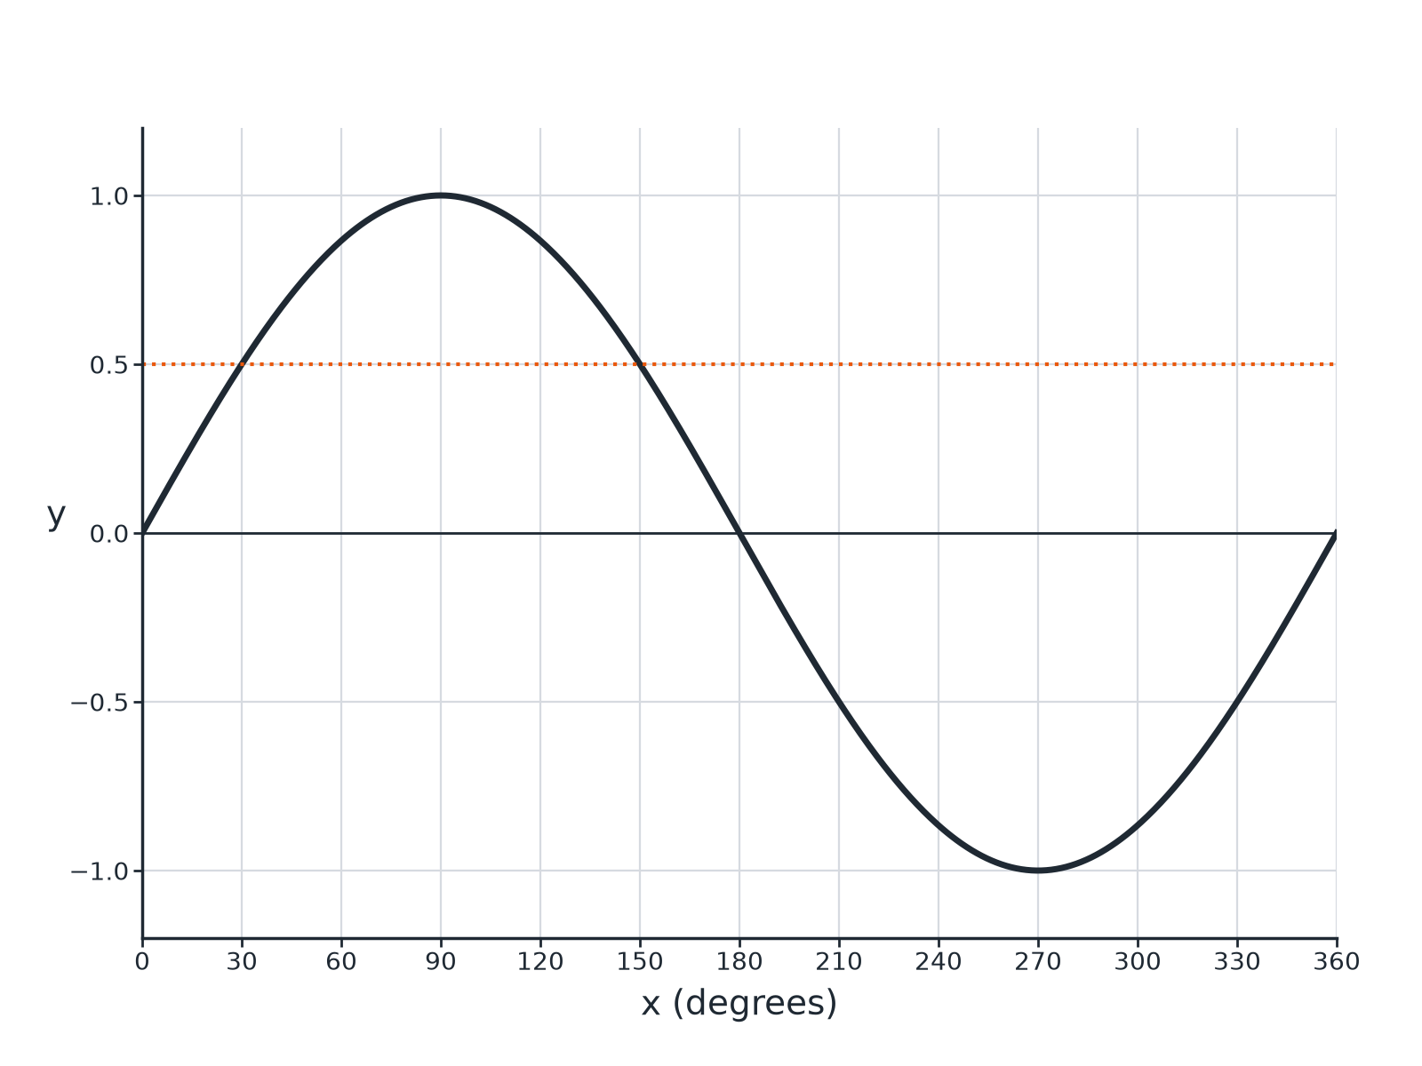

Question 3 · mark scheme
3 marks available. Award a mark for each point made.
▸ 30. B1
▸ 150. B1
▸ 1. B1
▸ Model answer. x = 30° and x = 150°; maximum value 1.
Question 4 · 3 marks · Solve
“Solve sin x = −0.3 for 0° ≤ x ≤ 360°. Give your answers correct to 1 decimal place.”
HOW TO ANSWER IT Command word: Solve. Worth 3 marks, so plan before writing.
Question 4 · mark scheme
3 marks available. Award a mark for each point made.
▸ Reference angle 17.5°. B1
▸ 180 + 17.5 or 360 − 17.5. M1
▸ Both answers. A1
▸ Model answer. x = 197.5° and x = 342.5°
Question 5 · 2 marks · Explain
“Amir says that sin x = 1.4 has a solution. Explain why he is wrong.”
HOW TO ANSWER IT Command word: Explain. Worth 2 marks, so plan before writing.
Question 5 · mark scheme
2 marks available. Award a mark for each point made.
▸ Maximum of sine is 1. M1
▸ Conclusion. C1
▸ Model answer. The sine graph never goes above 1 or below −1, so there is no angle with sine 1.4.
Question 6 · 2 marks · Write down
“sin 40°= 0.64 (to 2 decimal places). Write down another angle between 0° and 360° with sine 0.64.”
HOW TO ANSWER IT Command word: Write down. Worth 2 marks, so plan before writing.
Question 6 · mark scheme
2 marks available. Award a mark for each point made.
▸ 180 − 40. M1
▸ 140. A1
▸ Model answer. 140°

