EDEXCEL GCSE MATHS · HIGHER
Graph of the cosine function
More trigonometry · Lesson 3 of 9
Teacher copy - includes the notes for whoever is teaching from it.
Warm-up
Answer each one, then check.
1. What is cos 60°?
0.5
2. What is cos 0°?
1
3. What does CAH mean?
cos = adjacent ÷ hypotenuse
4. What is the period of the sine graph?
360°
5. What are the largest and smallest values of sine?
1 and −1
Learning Objectives
1. Sketch the graph of y = cos x for 0° ≤ x ≤ 360°.
2. Recall key values of cosine.
3. Use symmetry to find a second solution of cos x = k.
4. Describe how the cosine and sine graphs are related.
Cosine Graph
The graph of y = cos x is the sine wave shifted 90° to the left.
It starts at 1 when x = 0°, falls to 0 at 90°, reaches −1 at 180°, is 0 at 270° and back to 1 at 360°.
The Cosine Graph
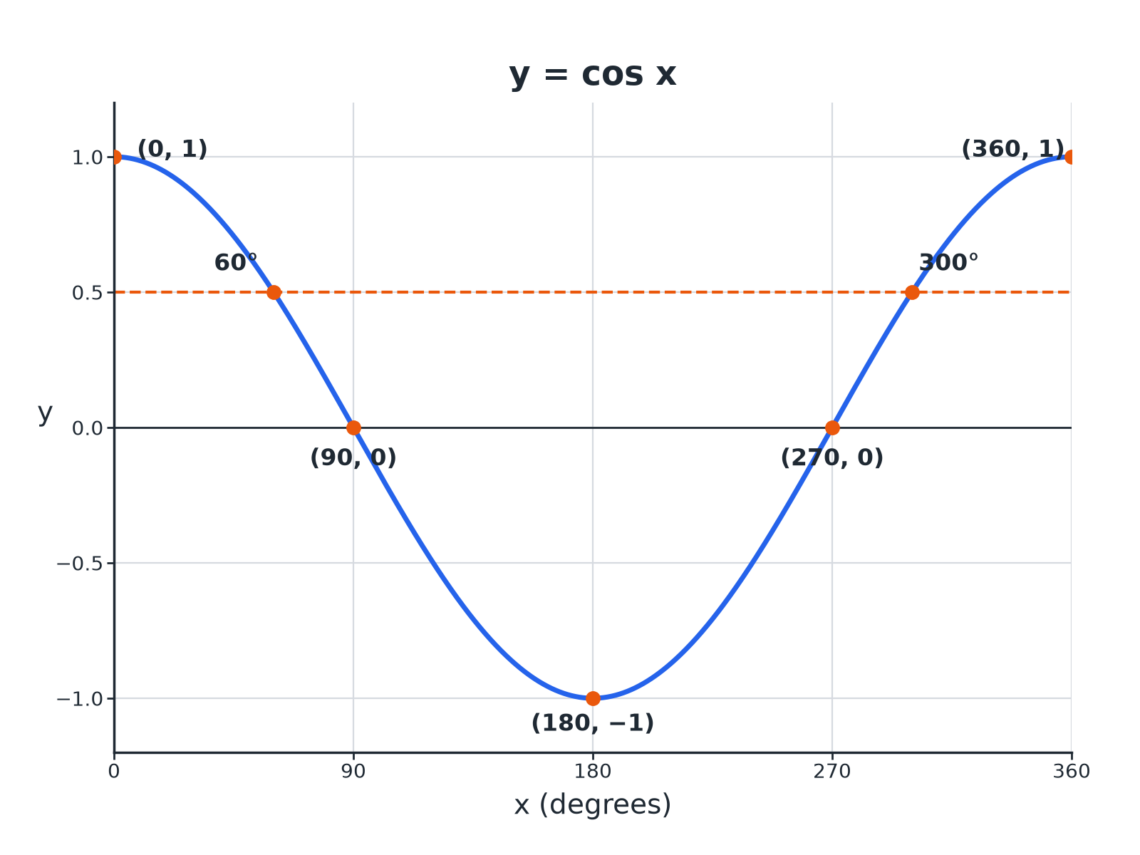
Cosine x equals 0.5 has two solutions: 60 degrees and 300 degrees.
The graph of y equals cosine x from 0 to 360 degrees, showing the maximum at 0 and 360, the minimum at 180 and the two solutions of cosine x equals 0.5.
Key Values of Cosine
These are worth learning.
x | 0° | 60° | 90° | 180°
cos x | 1 | 0.5 | 0 | −1 | 0 | 0.5 | 1
Features of the Graph
Period  Repeats every 360°. | Maximum  1 at x = 0° and 360°.
Minimum  −1 at x = 180°. | Roots  x = 90° and 270°.
Symmetry
Symmetrical about x = 180°.
Finding Two Solutions
Use symmetry about x = 180°.
1  Use the calculator  Find x = cos ⁻¹(k); this is the first solution | 2  Reflect about 180  Second solution = 360°− x | 3  Check the range  Both must be between 0° and 360° | 4  Negative values  cos ⁻¹ of a negative gives an angle between 90° and 180°
Solving cos x = 0.5
Solve cos x = 0.5 for 0° ≤ x ≤ 360°.

1. Calculator
x = cos ⁻¹(0.5) = 60°
2. Reflect
x = 360°− 60°= 300°
Answer: x = 60° and x = 300°
Solving a Negative Value
Solve cos x = −0.7 for 0° ≤ x ≤ 360°, correct to 1 decimal place.

1. Calculator
x = cos ⁻¹(−0.7) = 134.4°
2. Reflect
360°− 134.4°= 225.6°
Answer: x = 134.4° and x = 225.6°
Sine and Cosine Graphs
Y = SIN X | Y = COS X
▸ Starts at 0.  ▸ Maximum at 90°, minimum at 270°.  ▸ Second solution: 180°− x. | ▸ Starts at 1.  ▸ Maximum at 0° and 360°, minimum at 180°.  ▸ Second solution: 360°− x.
Key Terms
Cosine graph  The wave y = cos x. | Period  360° for both sine and cosine.
Inverse cosine  cos ⁻¹, the calculator function that finds an angle. | Translation  Sliding a graph without turning it.
Symmetry  The graph mirrors itself about a line. | Solution  A value of x that gives the required y.
Your Task: Sine Meets Cosine
12 minutes
Sketch y = sin x and y = cos x on the same axes for 0° to 360°. (a) Where do they cross? (b) What single translation maps sine onto cosine?
1. Draw both curves.
2. Read the crossing points.
A good answer shows: (a) At x = 45° and 225°. (b) A translation of 90° to the left.
Note: Check the crossings with a calculator: sin 45°= cos 45°.
Can I...?
☐ Sketch the cosine graph.
☐ State its maximum and minimum.
☐ Recall cos 0, cos 60 and cos 90.
☐ Use cos inverse.
☐ Find the second solution.
☐ Solve for negative values.
☐ Compare sine and cosine.
☐ Read solutions from a graph.
Summary
✓ Cosine starts at 1, falls to −1 at 180°, returns to 1 at 360°.
✓ cos x = k has two solutions in 0° to 360° for −1 < k < 1.
✓ Solutions are x and 360°− x.
✓ Cosine is sine shifted 90° left.

EXAM FOCUS
Solve cos x = 0.3 for 0° ≤ x ≤ 360°. Give answers correct to 1 decimal place. (3 marks)
Second solution is 360°− x.
Exam Practice: Graph of the cosine function
Answer all questions. Show your working. · 25 minutes
▸ Question 1 · 3 marks · Solve. Solve cos x = 0.3 for 0° ≤ x ≤ 360°. Give your answers correct to 1 decimal place.
▸ Question 2 · 2 marks · Write down. Write down the value of (a) cos 0° (b) cos 180°
▸ Question 3 · 3 marks · Use the graph. The graph shows y = cos x for 0° ≤ x ≤ 360°. Use the graph to solve cos x = −0.5 and to write down the minimum value of cos x.
▸ Question 4 · 3 marks · Solve. Solve cos x = −0.7 for 0° ≤ x ≤ 360°. Give your answers correct to 1 decimal place.
▸ Question 5 · 2 marks · Write down. cos 50°= 0.64 (to 2 decimal places). Write down another angle between 0° and 360° with cosine 0.64.
▸ Question 6 · 2 marks · Describe. Describe the single transformation that maps the graph of y = sin x onto the graph of y = cos x.
Question 1 · 3 marks · Solve
“Solve cos x = 0.3 for 0° ≤ x ≤ 360°. Give your answers correct to 1 decimal place.”
HOW TO ANSWER IT Command word: Solve. Worth 3 marks, so plan before writing.
Question 1 · mark scheme
3 marks available. Award a mark for each point made.
▸ cos ⁻¹(0.3) = 72.5°. B1
▸ 360 − 72.5. M1
▸ 287.5. A1
▸ Model answer. x = 72.5° and x = 287.5°
Question 2 · 2 marks · Write down
“Write down the value of (a) cos 0° (b) cos 180°”
HOW TO ANSWER IT Command word: Write down. Worth 2 marks, so plan before writing.
Question 2 · mark scheme
2 marks available. Award a mark for each point made.
▸ 1. B1
▸ −1. B1
▸ Model answer. (a) 1 (b) −1
Question 3 · 3 marks · Use the graph
The graph shows y = cos x for 0° ≤ x ≤ 360°. Use the graph to solve cos x = −0.5 and to write down the minimum value of cos x. (3 marks) | 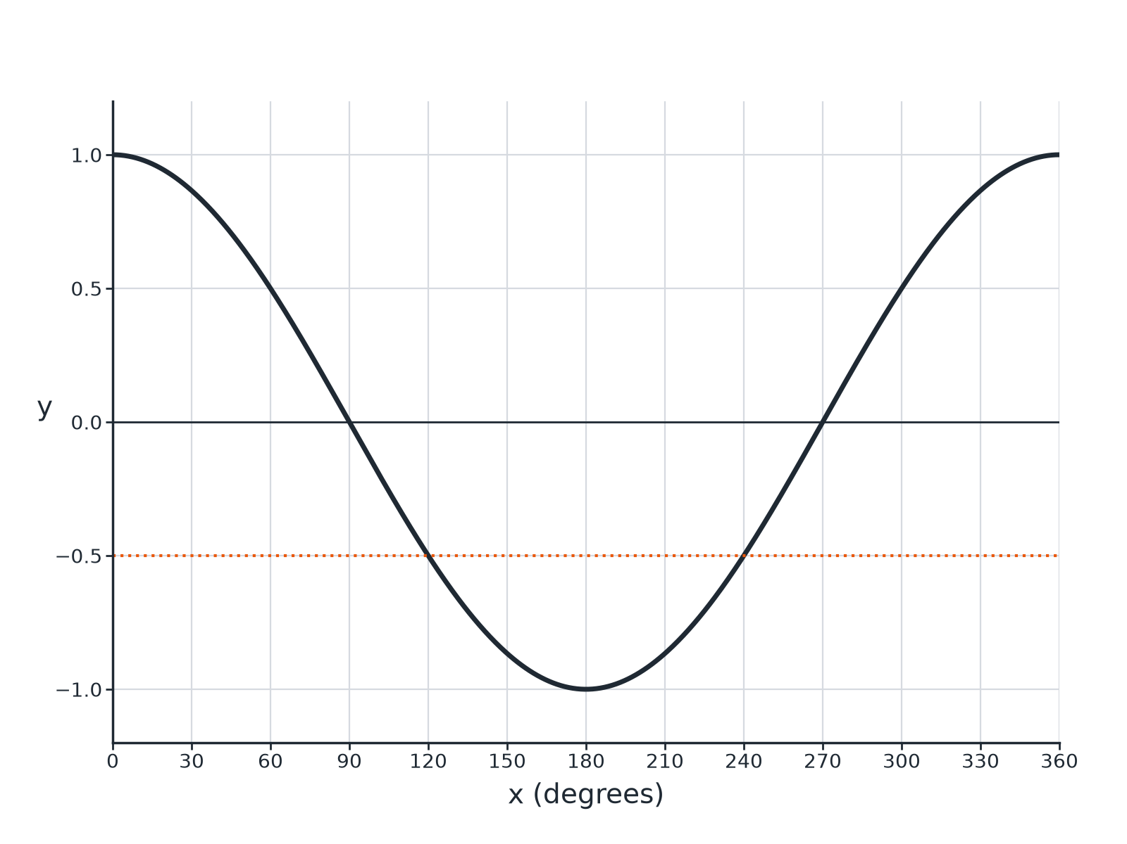

Question 3 · mark scheme
3 marks available. Award a mark for each point made.
▸ 120. B1
▸ 240. B1
▸ −1. B1
▸ Model answer. x = 120° and x = 240°; minimum value −1.
Question 4 · 3 marks · Solve
“Solve cos x = −0.7 for 0° ≤ x ≤ 360°. Give your answers correct to 1 decimal place.”
HOW TO ANSWER IT Command word: Solve. Worth 3 marks, so plan before writing.
Question 4 · mark scheme
3 marks available. Award a mark for each point made.
▸ cos ⁻¹(−0.7) = 134.4°. B1
▸ 360 − 134.4. M1
▸ 225.6. A1
▸ Model answer. x = 134.4° and x = 225.6°
Question 5 · 2 marks · Write down
“cos 50°= 0.64 (to 2 decimal places). Write down another angle between 0° and 360° with cosine 0.64.”
HOW TO ANSWER IT Command word: Write down. Worth 2 marks, so plan before writing.
Question 5 · mark scheme
2 marks available. Award a mark for each point made.
▸ 360 − 50. M1
▸ 310. A1
▸ Model answer. 310°
Question 6 · 2 marks · Describe
“Describe the single transformation that maps the graph of y = sin x onto the graph of y = cos x.”
HOW TO ANSWER IT Command word: Describe. Worth 2 marks, so plan before writing.
Question 6 · mark scheme
2 marks available. Award a mark for each point made.
▸ Translation. M1
▸ 90° to the left. A1
▸ Model answer. A translation of 90° to the left.

