EDEXCEL GCSE MATHS · HIGHER
Graph of the tangent function
More trigonometry · Lesson 4 of 9
Teacher copy - includes the notes for whoever is teaching from it.
Warm-up
Answer each one, then check.
1. What does TOA mean?
tan = opposite ÷ adjacent
2. What is tan 45°?
1
3. What is tan 0°?
0
4. What is the period of sine and cosine?
360°
5. Can you divide by zero?
No
Learning Objectives
1. Sketch the graph of y = tan x for 0° ≤ x ≤ 360°.
2. Recall key values and the position of the asymptotes.
3. Use the period of 180° to find a second solution.
4. Read solutions from the graph.
Tangent Graph
The graph of y = tan x repeats every 180° and has vertical asymptotes at x = 90° and x = 270°.
Unlike sine and cosine, tangent has no maximum or minimum: it goes up to infinity and down to minus infinity.
The Tangent Graph
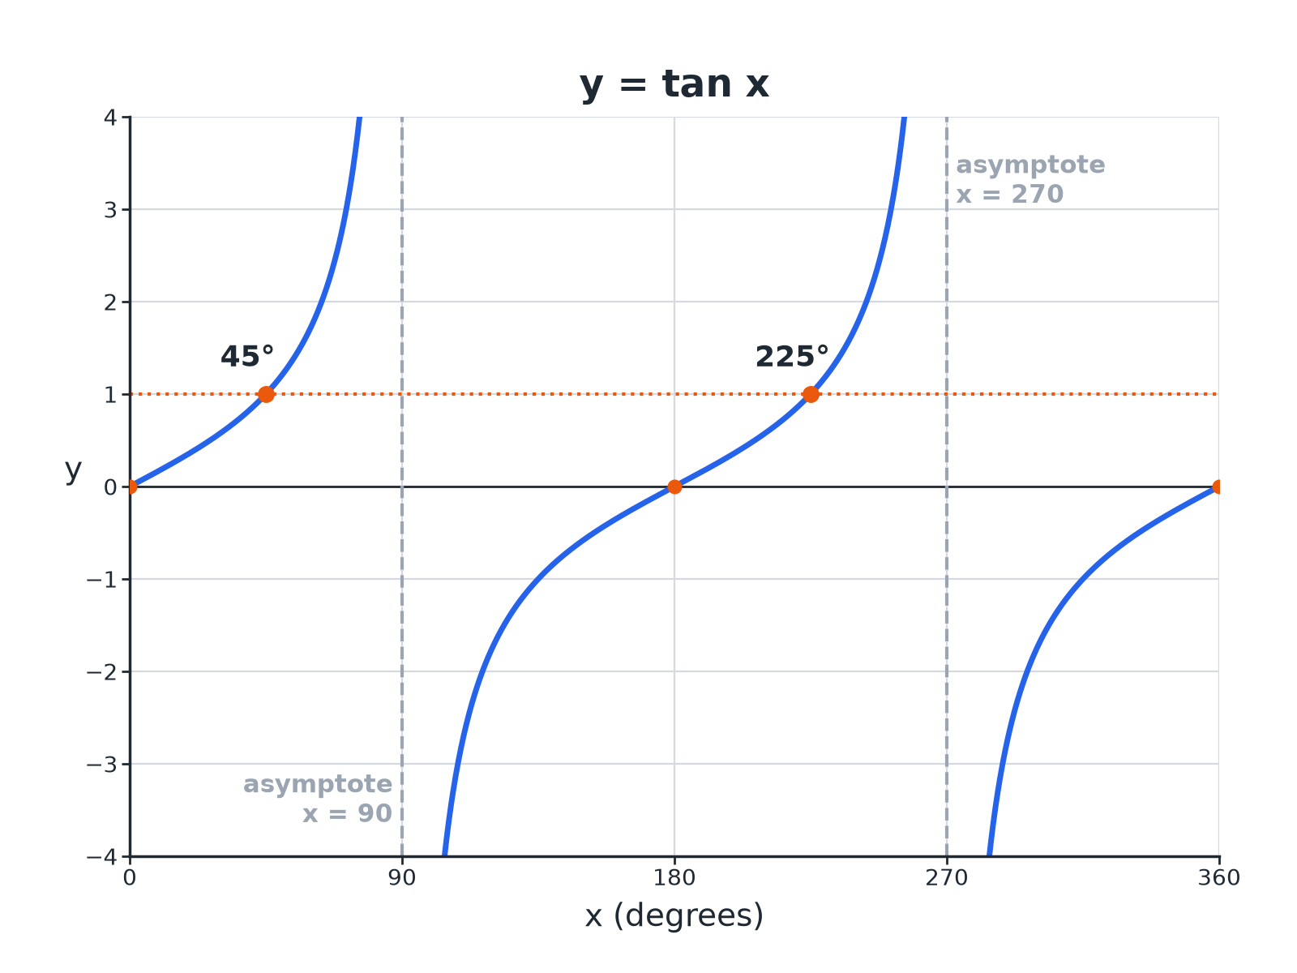
Tan x = 1 has solutions at 45 degrees and 225 degrees.
The graph of y equals tangent x from 0 to 360 degrees with vertical asymptotes at 90 and 270 and solutions of tangent x equals 1 at 45 and 225.
Key Values of Tangent
Learn these, and note the gaps.
x | 0° | 45° | 90° | 135°
tan x | 0 | 1 | undefined | −1 | 0 | 1 | undefined | −1 | 0
Features of the Graph
Period  Repeats every 180°. | Asymptotes  Vertical lines at x = 90° and 270°; the graph never touches them.
Roots  x = 0°, 180°, 360°. | Range  Every value of y; no maximum or minimum.
Shape
Rises steeply through each root.
Finding Two Solutions
The graph repeats every 180°.
1  Calculator  Find x = tan ⁻¹(k); this is the first solution | 2  Add the period  Second solution = x + 180° | 3  Negative values  If tan ⁻¹(k) is negative, add 180° and 360° | 4  Check the range  Only keep answers between 0° and 360°
Solving tan x = 2
Solve tan x = 2 for 0° ≤ x ≤ 360°, correct to 1 decimal place.

1. Calculator
x = tan ⁻¹(2) = 63.4°
2. Add 180°
63.4°+ 180°= 243.4°
Answer: x = 63.4° and x = 243.4°
Solving a Negative Value
Solve tan x = −1 for 0° ≤ x ≤ 360°.

1. Calculator gives
tan ⁻¹(−1) = −45°
2. Add 180°
−45°+ 180°= 135°
3. Add 360°
−45°+ 360°= 315°
Answer: x = 135° and x = 315°
Comparing the Three Graphs
SIN X AND COS X | TAN X
▸ Period 360°.  ▸ Smooth waves between −1 and 1.  ▸ No asymptotes.  ▸ Solutions: x and 180°− x (sin), x and 360°− x (cos). | ▸ Period 180°.  ▸ Takes every value.  ▸ Asymptotes at 90° and 270°.  ▸ Solutions: x and x + 180°.
Key Terms
Asymptote  A line that a graph gets closer to but never touches. | Period  The length after which the graph repeats.
Undefined  Has no value, e.g. tan 90°. | Inverse tangent  tan ⁻¹, the calculator function that finds an angle.
Root  A value of x where y = 0. | Range  The set of values y can take.
Your Task: Tangent Table
12 minutes
Use a calculator to fill in tan x for x = 60°, 80°, 85°, 89° (1 d.p.). Then describe what happens as x gets close to 90°.
1. Type each value into the calculator.
2. Describe the pattern.
A good answer shows: 1.7, 5.7, 11.4, 57.3. The values get bigger and bigger, which is why there is an asymptote at 90°.
Note: Try 91°, 95° to see the values become large and negative.
Can I...?
☐ Sketch the tangent graph.
☐ State the period.
☐ Mark the asymptotes.
☐ Recall tan 45.
☐ Use tan inverse.
☐ Find the second solution.
☐ Solve for negative values.
☐ Read solutions from a graph.
Summary
✓ Tangent repeats every 180°.
✓ Vertical asymptotes at 90° and 270°.
✓ Solutions are x and x + 180°.
✓ Tangent takes every value, so tan x = k always has solutions.

EXAM FOCUS
Solve tan x = 0.5 for 0° ≤ x ≤ 360°. Give answers correct to 1 decimal place. (3 marks)
The period is 180°, so the second solution is x + 180°.
Exam Practice: Graph of the tangent function
Answer all questions. Show your working. · 25 minutes
▸ Question 1 · 3 marks · Solve. Solve tan x = 0.5 for 0° ≤ x ≤ 360°. Give your answers correct to 1 decimal place.
▸ Question 2 · 2 marks · Write down. Write down the value of (a) tan 45° (b) tan 0°
▸ Question 3 · 3 marks · Use the graph. The graph shows y = tan x for 0° ≤ x ≤ 180°. Use the graph to solve tan x = 1, and write down the equation of the asymptote.
▸ Question 4 · 3 marks · Solve. Solve tan x = −2 for 0° ≤ x ≤ 360°. Give your answers correct to 1 decimal place.
▸ Question 5 · 2 marks · Explain. Explain why tan 90° has no value.
▸ Question 6 · 2 marks · Write down. tan 30°= 0.58 (to 2 decimal places). Write down another angle between 0° and 360° with tangent 0.58.
Question 1 · 3 marks · Solve
“Solve tan x = 0.5 for 0° ≤ x ≤ 360°. Give your answers correct to 1 decimal place.”
HOW TO ANSWER IT Command word: Solve. Worth 3 marks, so plan before writing.
Question 1 · mark scheme
3 marks available. Award a mark for each point made.
▸ tan ⁻¹(0.5) = 26.6°. B1
▸ Adds 180. M1
▸ 206.6. A1
▸ Model answer. x = 26.6° and x = 206.6°
Question 2 · 2 marks · Write down
“Write down the value of (a) tan 45° (b) tan 0°”
HOW TO ANSWER IT Command word: Write down. Worth 2 marks, so plan before writing.
Question 2 · mark scheme
2 marks available. Award a mark for each point made.
▸ 1. B1
▸ 0. B1
▸ Model answer. (a) 1 (b) 0
Question 3 · 3 marks · Use the graph
The graph shows y = tan x for 0° ≤ x ≤ 180°. Use the graph to solve tan x = 1, and write down the equation of the asymptote. (3 marks) | 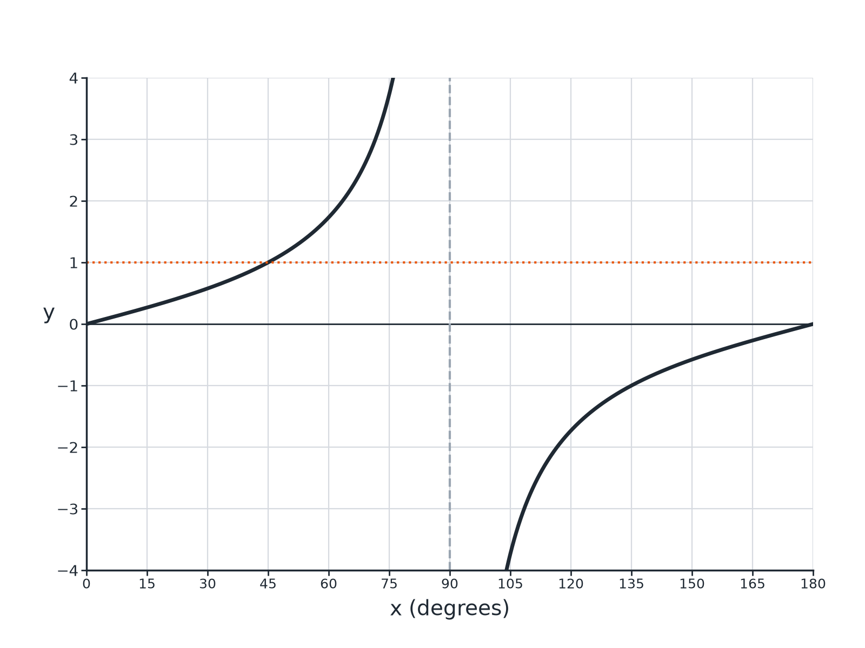

Question 3 · mark scheme
3 marks available. Award a mark for each point made.
▸ 45. B1
▸ x = 90. B1
▸ Equation written in the form x = 90. B1
▸ Model answer. x = 45°; the asymptote is x = 90°.
Question 4 · 3 marks · Solve
“Solve tan x = −2 for 0° ≤ x ≤ 360°. Give your answers correct to 1 decimal place.”
HOW TO ANSWER IT Command word: Solve. Worth 3 marks, so plan before writing.
Question 4 · mark scheme
3 marks available. Award a mark for each point made.
▸ tan ⁻¹(−2) = −63.4°. B1
▸ −63.4 + 180 or −63.4 + 360. M1
▸ Both answers. A1
▸ Model answer. x = 116.6° and x = 296.6°
Question 5 · 2 marks · Explain
“Explain why tan 90° has no value.”
HOW TO ANSWER IT Command word: Explain. Worth 2 marks, so plan before writing.
Question 5 · mark scheme
2 marks available. Award a mark for each point made.
▸ Refers to the asymptote or the graph. M1
▸ Values grow without limit. C1
▸ Model answer. The tangent graph has an asymptote at 90°: the values get larger and larger and never reach a value.
Question 6 · 2 marks · Write down
“tan 30°= 0.58 (to 2 decimal places). Write down another angle between 0° and 360° with tangent 0.58.”
HOW TO ANSWER IT Command word: Write down. Worth 2 marks, so plan before writing.
Question 6 · mark scheme
2 marks available. Award a mark for each point made.
▸ 30 + 180. M1
▸ 210. A1
▸ Model answer. 210°

