EDEXCEL GCSE MATHS · HIGHER
Calculating areas and the sine rule
More trigonometry · Lesson 5 of 9
Teacher copy - includes the notes for whoever is teaching from it.
Warm-up
Answer each one, then check.
1. What is the area of a triangle?
½ × base × height
2. What do the angles in a triangle add up to?
180°
3. What is sin ⁻¹(0.5)?
30°
4. Which side is opposite the right angle?
The hypotenuse
5. What does SOH CAH TOA help with?
Right-angled triangles only
Learning Objectives
1. Label a triangle with lower-case sides opposite capital angles.
2. Find the area of any triangle using ½absin C.
3. Use the sine rule to find a missing side.
4. Use the sine rule to find a missing angle.
Sine Rule
In any triangle, the sides and the sines of their opposite angles are in proportion.
a/(sin A) = b/(sin B) = c/(sin C). Flip it to find an angle: (sin A)/a = (sin B)/b.
Labelling a Triangle
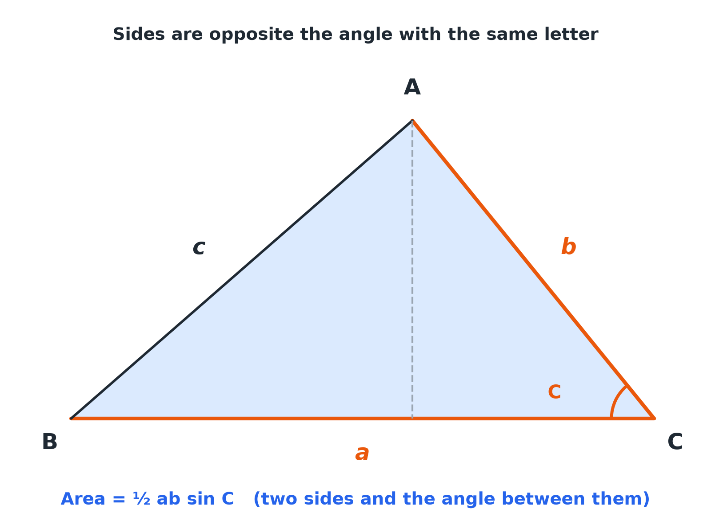
Side a is opposite angle A, and so on. Area uses two sides and the angle between them.
A triangle with vertices A, B, C and opposite sides a, b, c, with the angle C between sides a and b highlighted.
Which Formula?
Area  ½absin C: two sides and the angle between them. | Sine rule (side)  Two angles and a side, need another side.
Sine rule (angle)  Two sides and a non-included angle, need an angle. | Neither  Three sides, or two sides and the included angle: use the cosine rule (next lesson).
Area of a Triangle
Find the area of a triangle with sides a = 8 cm and b = 11 cm and angle C = 50° between them. Give your answer to 3 significant figures.

1. Write the formula
Area = ½absin C
2. Substitute
½ × 8 × 11 × sin 50°
3. Work out
44 × 0.7660 = 33.7
Answer: Area = 33.7 cm²
Sine Rule: Finding a Side
In triangle ABC, A = 40°, B = 65° and a = 8 cm. Find b.

1. Set up
b/(sin 65°) = 8/(sin 40°)
2. Rearrange
b = (8 × sin 65°)/(sin 40°)
3. Work out
b = 11.28
Answer: b = 11.3 cm (3 s.f.)
Sine Rule: Finding an Angle
In triangle ABC, a = 7 cm, b = 9 cm and angle A = 35°. Find angle B.

1. Set up
(sin B)/9 = (sin 35°)/7
2. Rearrange
sin B = (9 × sin 35°)/7 = 0.7375
3. Inverse sine
B = sin ⁻¹(0.7375) = 47.5°
Answer: B = 47.5° (1 d.p.)
Setting Out
Put the unknown on top.
▸ Missing side. Write the rule with sides on top: a/(sin A) = b/(sin B).
▸ Missing angle. Write the rule with sines on top: (sin A)/a = (sin B)/b.
▸ Diagram. Mark which side is opposite which angle before you start.
▸ Check. The biggest angle is opposite the longest side.
Key Terms
Sine rule  a/(sin A) = b/(sin B) = c/(sin C). | Opposite  Across the triangle from an angle, not touching it.
Included angle  The angle between two given sides. | Scalene  A triangle with no equal sides.
Vertex  A corner of a shape. | Non-right-angled  A triangle with no 90° angle.
Your Task: Choose the Method
12 minutes
For each, say whether you would use the area formula, the sine rule, or neither yet, and why. (a) Two angles and one side, find another side. (b) Two sides and the angle between them, find the area. (c) Three sides, find an angle. (d) Two sides and an angle not between them, find another angle.
1. List what is given.
2. Choose the formula.
A good answer shows: (a) Sine rule. (b) Area = ½absin C. (c) Neither yet: cosine rule. (d) Sine rule.
Note: Encourage learners to write the known and unknown parts of the triangle first.
Can I...?
☐ Label sides and angles.
☐ Write the area formula.
☐ Find the area of a triangle.
☐ Write the sine rule.
☐ Find a missing side.
☐ Find a missing angle.
☐ Put the unknown on top.
☐ Check the answer is sensible.
Summary
✓ Area = ½absin C.
✓ Sine rule: a/(sin A) = b/(sin B).
✓ Use the sine rule with two angles and a side, or two sides and a non-included angle.
✓ Check side lengths against angles.

EXAM FOCUS
In triangle ABC, AB = 7 cm, angle B = 40° and angle C = 75°. Work out the length of AC. Give your answer correct to 3 significant figures. (3 marks)
Write the sine rule with the unknown side on top. Keep your calculator in degrees.
Exam Practice: Areas and the sine rule
Answer all questions. Show your working. · 30 minutes
▸ Question 1 · 3 marks · Work out. In triangle ABC, AB = 7 cm, angle ABC = 40° and angle ACB = 75°. Work out the length of AC. Give your answer correct to 3 significant…
▸ Question 2 · 3 marks · Work out. In triangle ABC, angle A = 52°, angle B = 71° and BC = 9.4 cm. Work out the length of AC. Give your answer correct to 3 significant figures.
▸ Question 3 · 3 marks · Work out. In triangle ABC, BC = 7 cm, AC = 9 cm and angle BAC = 35°. Work out the size of angle ABC. Give your answer correct to 1 decimal place…
▸ Question 4 · 2 marks · Work out. A triangle has two sides of length 9.5 cm and 6.2 cm with an angle of 112° between them. Work out the area of the triangle. Give your…
▸ Question 5 · 4 marks · Work out. The area of a triangle is 25 cm². Two of its sides are 5 cm and 10 cm and the angle between them is acute. Work out the size of the angle…
▸ Question 6 · 3 marks · Explain. In a triangle, angle A = 30°, a = 6 cm and b = 10 cm. Show that sin B = 5/6.
Question 1 · 3 marks · Work out
In triangle ABC, AB = 7 cm, angle ABC = 40° and angle ACB = 75°. Work out the length of AC. Give your answer correct to 3 significant figures. (3 marks) | 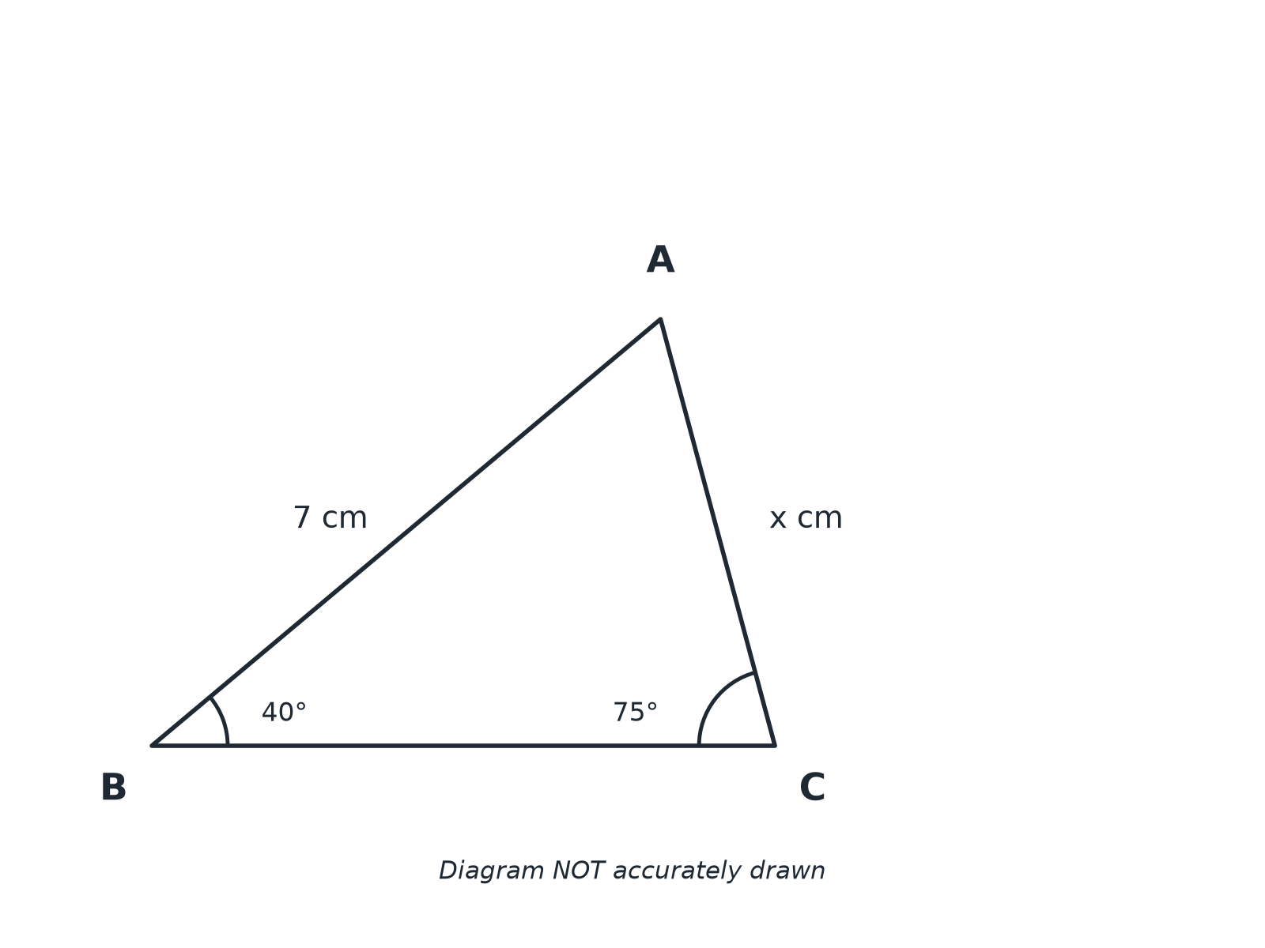

Question 1 · mark scheme
3 marks available. Award a mark for each point made.
▸ AC/(sin 40°) = 7/(sin 75°). M1
▸ (7 × sin 40°)/(sin 75°). M1
▸ 4.66. A1
▸ Model answer. AC = (7 sin 40°)/(sin 75°) = 4.66 cm
Question 2 · 3 marks · Work out
“In triangle ABC, angle A = 52°, angle B = 71° and BC = 9.4 cm. Work out the length of AC. Give your answer correct to 3 significant figures.”
HOW TO ANSWER IT Command word: Work out. Worth 3 marks, so plan before writing.
Question 2 · mark scheme
3 marks available. Award a mark for each point made.
▸ AC/(sin 71°) = 9.4/(sin 52°). M1
▸ (9.4 × sin 71°)/(sin 52°). M1
▸ 11.3. A1
▸ Model answer. AC = (9.4 sin 71°)/(sin 52°) = 11.3 cm
Question 3 · 3 marks · Work out
“In triangle ABC, BC = 7 cm, AC = 9 cm and angle BAC = 35°. Work out the size of angle ABC. Give your answer correct to 1 decimal place. (Angle ABC is acute.)”
HOW TO ANSWER IT Command word: Work out. Worth 3 marks, so plan before writing.
Question 3 · mark scheme
3 marks available. Award a mark for each point made.
▸ (sin B)/9 = (sin 35°)/7. M1
▸ sin B = 0.7375.... M1
▸ 47.5. A1
▸ Model answer. sin B = (9 sin 35°)/7 = 0.7375, so B = 47.5°
Question 4 · 2 marks · Work out
“A triangle has two sides of length 9.5 cm and 6.2 cm with an angle of 112° between them. Work out the area of the triangle. Give your answer correct to 3 significant figures.”
HOW TO ANSWER IT Command word: Work out. Worth 2 marks, so plan before writing.
Question 4 · mark scheme
2 marks available. Award a mark for each point made.
▸ ½ × 9.5 × 6.2 × sin 112°. M1
▸ 27.3. A1
▸ Model answer. ½ × 9.5 × 6.2 × sin 112°= 27.3 cm²
Question 5 · 4 marks · Work out
“The area of a triangle is 25 cm². Two of its sides are 5 cm and 10 cm and the angle between them is acute. Work out the size of the angle between these two sides. Give your answer correct to 1 decimal place.”
HOW TO ANSWER IT Command word: Work out. Worth 4 marks, so plan before writing.
Question 5 · mark scheme
4 marks available. Award a mark for each point made.
▸ ½ × 5 × 10 × sin C = 25. M1
▸ 25 sin C = 25. M1
▸ sin C = 1. A1
▸ 90.0. A1
▸ Model answer. ½ × 5 × 10 × sin C = 25, so sin C = 1, giving C = 90°.
Question 6 · 3 marks · Explain
“In a triangle, angle A = 30°, a = 6 cm and b = 10 cm. Show that sin B = 5/6.”
HOW TO ANSWER IT Command word: Explain. Worth 3 marks, so plan before writing.
Question 6 · mark scheme
3 marks available. Award a mark for each point made.
▸ Sine rule set up. M1
▸ sin 30°= 0.5. M1
▸ Completes the proof. A1
▸ Model answer. (sin B)/10 = (sin 30°)/6, so sin B = (10 × 0.5)/6 = 5/6.

