EDEXCEL GCSE MATHS · HIGHER
The cosine rule and 2D trigonometric problems
More trigonometry · Lesson 6 of 9
Teacher copy - includes the notes for whoever is teaching from it.
Warm-up
Answer each one, then check.
1. What is cos 60°?
0.5
2. What is Pythagoras' theorem?
a² + b² = c²
3. What is the sine rule?
a/(sin A) = b/(sin B)
4. What is a bearing?
An angle measured clockwise from north, with three figures
5. What is cos ⁻¹(0.5)?
60°
Learning Objectives
1. Use the cosine rule to find a missing side.
2. Rearrange the cosine rule to find a missing angle.
3. Decide between the sine rule, cosine rule and right-angled trigonometry.
4. Solve 2D problems, including bearings.
Cosine Rule
The cosine rule links three sides and one angle: it is Pythagoras with a correction.
a² = b² + c² − 2bccos A. To find an angle: cos A = (b² + c² − a²)/2bc.
The Cosine Rule
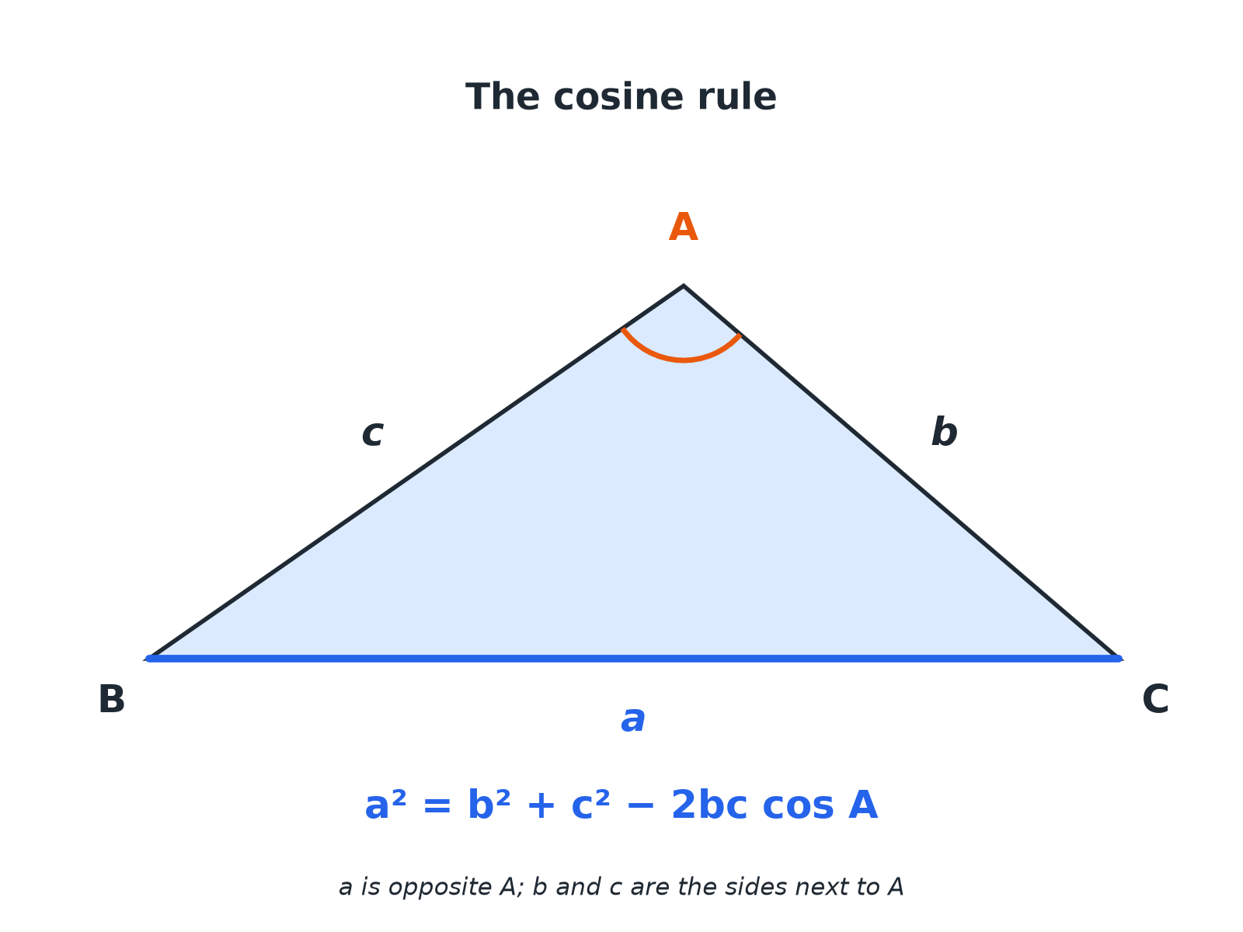
The angle in the formula is opposite the side you are finding.
A triangle with sides a, b, c and angle A opposite side a, with the cosine rule written underneath.
Which Rule?
USE THE SINE RULE WHEN... | USE THE COSINE RULE WHEN...
▸ You have two angles and a side.  ▸ You have two sides and an angle not between them.  ▸ You have a matching pair (a side and its opposite angle). | ▸ You have two sides and the angle between them.  ▸ You have all three sides.  ▸ You do not have a matching pair.
Cosine Rule: Finding a Side
In triangle ABC, b = 7 cm, c = 9 cm and angle A = 60°. Find a.

1. Write the rule
a² = b² + c² − 2bccos A
2. Substitute
a² = 7² + 9² − 2 × 7 × 9 × cos 60°
3. Work out
a² = 49 + 81 − 63 = 67
4. Square root
a = 8.19
Answer: a = 8.19 cm (3 s.f.)
Cosine Rule: Finding an Angle
A triangle has sides 5 cm, 7 cm and 9 cm. Find the largest angle.

1. Largest angle is opposite 9
a = 9, b = 5, c = 7
2. Rearranged rule
cos A = (5² + 7² − 9²)/(2 × 5 × 7)
3. Work out
cos A = (−7)/70 = −0.1
4. Inverse cosine
A = 95.7°
Answer: Largest angle = 95.7° (1 d.p.)
A Bearings Problem
A ship sails 12 km on a bearing of 040° and then 9 km on a bearing of 130°. How far is it from its starting point?

1. Angle between the two legs
130°− 40°= 90°
2. Right-angled triangle
Use Pythagoras
3. Work out
12² + 9² = 144 + 81 = 225
4. Square root
√225 = 15
Answer: The ship is 15 km from its start.
Common Slips
Avoid these.
▸ Subtracting before multiplying. Work out 2bccos A as a whole first, then subtract.
▸ Wrong angle. The angle in the formula is opposite the side on the left-hand side.
▸ Rounding early. Keep the full value until the final step.
▸ Angle over 90. A negative cosine means the angle is obtuse; this is fine.
Key Terms
Cosine rule  a² = b² + c² − 2bccos A. | Bearing  A direction measured clockwise from north as three figures.
Included angle  The angle between two given sides. | Obtuse  An angle between 90° and 180°.
Largest angle  The angle opposite the longest side. | Rearrange  Change the subject of a formula.
Your Task: Which Rule and Why?
12 minutes
For each triangle, state which rule you would use first. (a) a = 6, b = 8, C = 50°, find c. (b) a = 5, b = 7, c = 9, find A. (c) A = 40°, B = 70°, a = 8, find b. (d) a = 9, b = 12, A = 30°, find B.
1. Check for a side with its opposite angle.
2. If there is none, use the cosine rule.
A good answer shows: (a) Cosine rule (two sides and the included angle). (b) Cosine rule (three sides). (c) Sine rule. (d) Sine rule.
Note: Discuss what makes a matching pair.
Can I...?
☐ Write the cosine rule.
☐ Find a missing side.
☐ Rearrange to find an angle.
☐ Identify the largest angle.
☐ Choose sine or cosine rule.
☐ Solve a bearings problem.
☐ Avoid rounding too early.
☐ Check with a sketch.
Summary
✓ a² = b² + c² − 2bccos A.
✓ cos A = (b² + c² − a²)/2bc.
✓ Use cosine rule for SAS and SSS, sine rule when you have a matching pair.
✓ Bearings: measure clockwise from north.

EXAM FOCUS
In triangle PQR, PQ = 8.4 cm, PR = 6.1 cm and angle QPR = 57°. Work out the length of QR. Give your answer correct to 3 significant figures. (3 marks)
Write the rule first, substitute, then use your calculator in one go.
Exam Practice: The cosine rule
Answer all questions. Show your working. · 30 minutes
▸ Question 1 · 3 marks · Work out. In triangle PQR, PQ = 8.4 cm, PR = 6.1 cm and angle QPR = 57°. Work out the length of QR. Give your answer correct to 3 significant figures.
▸ Question 2 · 3 marks · Work out. In triangle ABC, AB = 8 cm, AC = 6 cm and angle BAC = 40°. Work out the length of BC. Give your answer correct to 3 significant figures.
▸ Question 3 · 3 marks · Work out. A triangle has sides of length 6 cm, 8 cm and 11 cm. Work out the size of the largest angle. Give your answer correct to 1 decimal place.
▸ Question 4 · 3 marks · Work out. A ship sails 12 km on a bearing of 040°. It then sails 9 km on a bearing of 130°. Work out the distance of the ship from its starting point.
▸ Question 5 · 3 marks · Work out. A triangle has sides of length 7 cm, 8 cm and 9 cm. Work out the size of the smallest angle. Give your answer correct to 1 decimal place.
▸ Question 6 · 2 marks · Explain. In triangle ABC, you are given a, c and angle B. Which rule would you use to find b, the sine rule or the cosine rule? Give a reason.
Question 1 · 3 marks · Work out
In triangle PQR, PQ = 8.4 cm, PR = 6.1 cm and angle QPR = 57°. Work out the length of QR. Give your answer correct to 3 significant figures. (3 marks) | 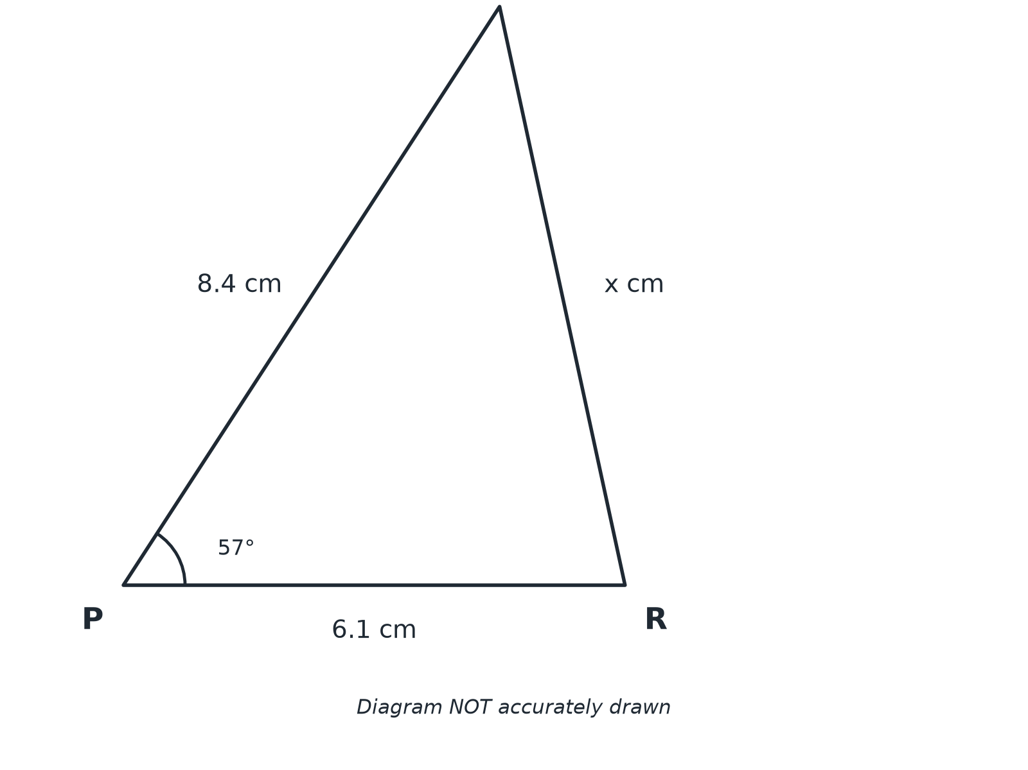

Question 1 · mark scheme
3 marks available. Award a mark for each point made.
▸ 8.4² + 6.1² − 2 × 8.4 × 6.1 × cos 57°. M1
▸ 51.9.... A1
▸ 7.21. A1
▸ Model answer. QR² = 8.4² + 6.1² − 2 × 8.4 × 6.1 × cos 57°= 51.95, so QR = 7.21 cm
Question 2 · 3 marks · Work out
“In triangle ABC, AB = 8 cm, AC = 6 cm and angle BAC = 40°. Work out the length of BC. Give your answer correct to 3 significant figures.”
HOW TO ANSWER IT Command word: Work out. Worth 3 marks, so plan before writing.
Question 2 · mark scheme
3 marks available. Award a mark for each point made.
▸ 6² + 8² − 2 × 6 × 8 × cos 40°. M1
▸ 26.4.... A1
▸ 5.14. A1
▸ Model answer. BC² = 6² + 8² − 2 × 6 × 8 × cos 40°= 26.46, so BC = 5.14 cm
Question 3 · 3 marks · Work out
“A triangle has sides of length 6 cm, 8 cm and 11 cm. Work out the size of the largest angle. Give your answer correct to 1 decimal place.”
HOW TO ANSWER IT Command word: Work out. Worth 3 marks, so plan before writing.
Question 3 · mark scheme
3 marks available. Award a mark for each point made.
▸ (6² + 8² − 11²)/(2 × 6 × 8). M1
▸ −0.21875. A1
▸ 102.6. A1
▸ Model answer. cos A = (6² + 8² − 11²)/(2 × 6 × 8) = −0.21875, so A = 102.6°
Question 4 · 3 marks · Work out
“A ship sails 12 km on a bearing of 040°. It then sails 9 km on a bearing of 130°. Work out the distance of the ship from its starting point.”
HOW TO ANSWER IT Command word: Work out. Worth 3 marks, so plan before writing.
Question 4 · mark scheme
3 marks available. Award a mark for each point made.
▸ Right angle identified. M1
▸ 12² + 9² = 225. M1
▸ 15. A1
▸ Model answer. The angle between the two legs is 130°− 40°= 90°, so the distance is √(12² + 9²) = √225 = 15 km.
Question 5 · 3 marks · Work out
“A triangle has sides of length 7 cm, 8 cm and 9 cm. Work out the size of the smallest angle. Give your answer correct to 1 decimal place.”
HOW TO ANSWER IT Command word: Work out. Worth 3 marks, so plan before writing.
Question 5 · mark scheme
3 marks available. Award a mark for each point made.
▸ (8² + 9² − 7²)/(2 × 8 × 9). M1
▸ 0.666.... A1
▸ 48.2. A1
▸ Model answer. cos A = (8² + 9² − 7²)/(2 × 8 × 9) = 0.6667, so A = 48.2°
Question 6 · 2 marks · Explain
“In triangle ABC, you are given a, c and angle B. Which rule would you use to find b, the sine rule or the cosine rule? Give a reason.”
HOW TO ANSWER IT Command word: Explain. Worth 2 marks, so plan before writing.
Question 6 · mark scheme
2 marks available. Award a mark for each point made.
▸ Cosine rule. B1
▸ Two sides and the included angle. B1
▸ Model answer. The cosine rule, because two sides and the angle between them are known and there is no matching side and angle pair.

