EDEXCEL GCSE MATHS · HIGHER
Transforming trigonometric graphs 2
More trigonometry · Lesson 9 of 9
Teacher copy - includes the notes for whoever is teaching from it.
Warm-up
Answer each one, then check.
1. What is the period of y = sin x?
360°
2. Where is the first maximum of y = sin x?
x = 90°
3. What does y = sin x + 2 do to the graph?
Moves it up 2
4. What is the period of y = tan x?
180°
5. What does y = 3sin x do to the graph?
Stretches it vertically by 3
Learning Objectives
1. Describe and sketch y = sin (x + a) and y = cos (x − a).
2. Describe and sketch y = sin ax and y = cos ax.
3. Find the period of y = sin ax.
4. Solve equations such as sin 2x = 0.5.
Horizontal Transformations
Changes inside the brackets move or stretch the graph left and right, and often do the opposite of what you expect.
y = f(x + a) translates left by a. y = f(x − a) translates right by a. y = f(ax) stretches horizontally with scale factor 1/a.
Four Horizontal Transformations
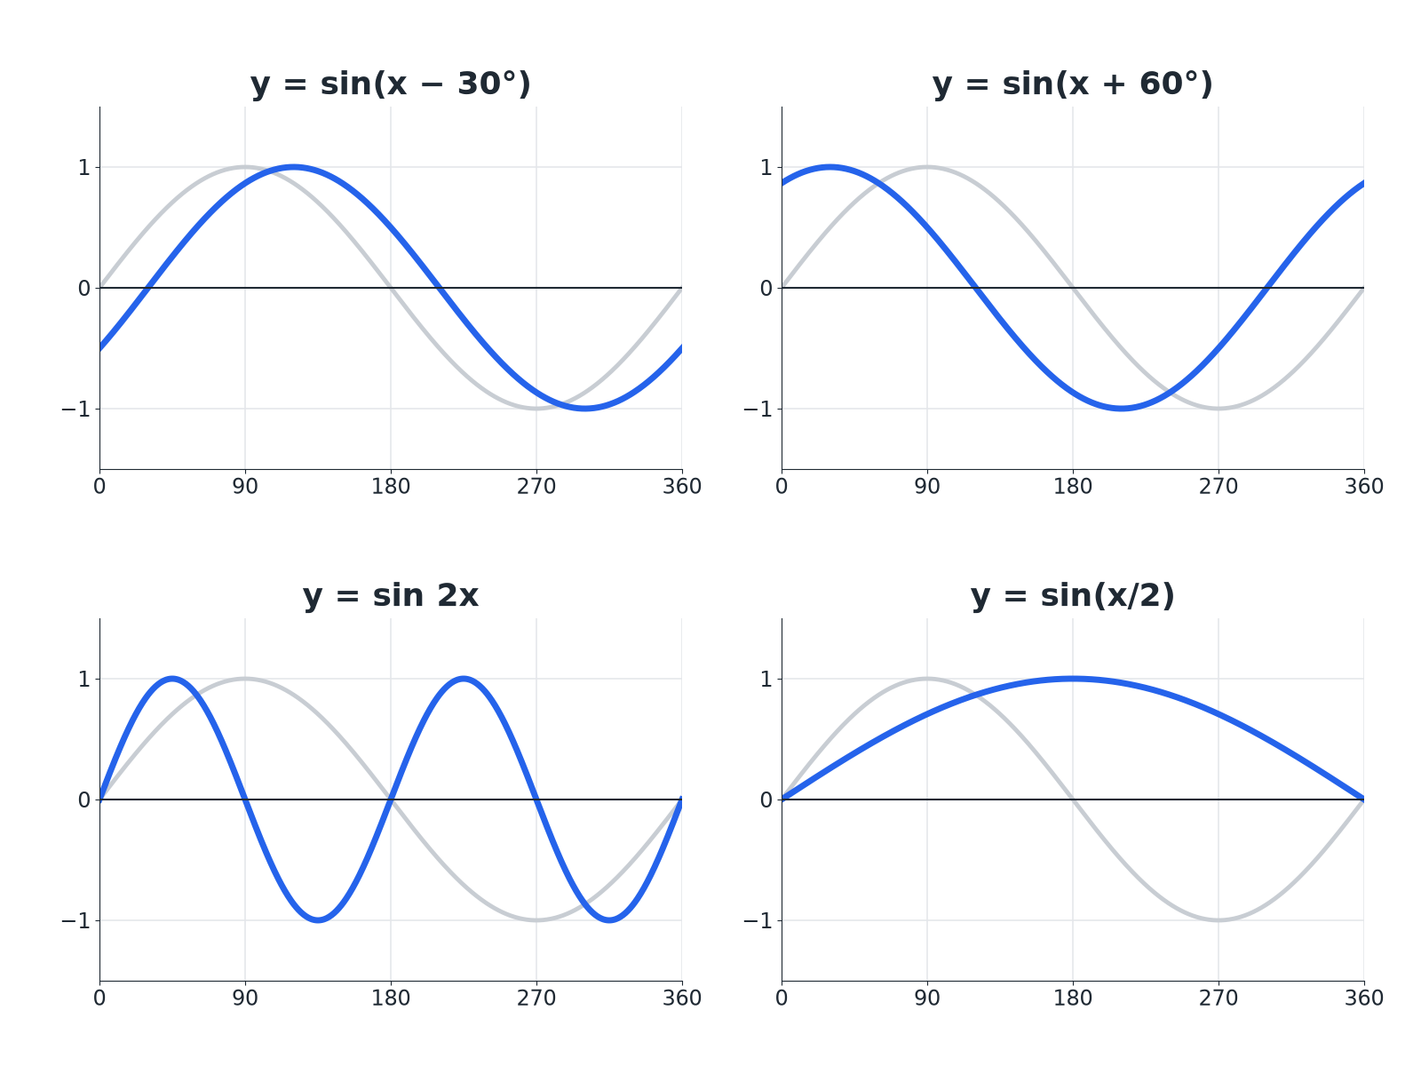
The faint curve is y equals sine x.
Four graphs showing sine of x minus 30, sine of x plus 60, sine of 2x and sine of x over 2 compared with sine x.
Effects on the Graph
Read the change inside the brackets.
Equation | Transformation | Period
y = sin (x − 30°) | Translate right 30 | 360°
y = sin (x + 60°) | Translate left 60 | 360°
y = sin 2x | Horizontal stretch, scale factor ½ | 180°
y = cos 3x | Horizontal stretch, scale factor ⅓ | 120°
y = sin x/2 | Horizontal stretch, scale factor 2 | 720°
A Horizontal Translation
The graph of y = sin x is translated to give y = sin (x + 30°). Describe the translation and find the first maximum.

1. Plus inside the bracket
Moves left by 30°
2. Maximum was at
90°
3. Now at
90°− 30°= 60°
Answer: A translation of 30° to the left; the first maximum is at x = 60°.
A Horizontal Stretch
State the period of y = cos 3x and how many full waves there are between 0° and 360°.

1. Period
360°/3 = 120°
2. Number of waves
360/120 = 3
Answer: The period is 120°, giving 3 full waves.
Solving sin 2x = 0.5
Solve sin 2x = 0.5 for 0° ≤ x ≤ 360°.

1. Range for 2x
0° ≤ 2x ≤ 720°
2. Solve for 2x
2x = 30°, 150°, 390°, 510°
3. Halve
x = 15°, 75°, 195°, 255°
Answer: x = 15°, 75°, 195°, 255°
Inside and Outside the Brackets
OUTSIDE THE BRACKETS: VERTICAL | INSIDE THE BRACKETS: HORIZONTAL
▸ y = asin x: stretch in y.  ▸ y = sin x + a: translate up.  ▸ Does what it looks like. | ▸ y = sin (x + a): translate left.  ▸ y = sin ax: stretch in x by 1/a.  ▸ Does the opposite of what it looks like.
Key Terms
Period  The length after which the graph repeats. | Horizontal stretch  A stretch that changes the x-values.
Translation  A slide left, right, up or down. | Scale factor  The number the x-values are multiplied by.
Full wave  One complete cycle of the graph. | Phase shift  A horizontal translation of a trig graph.
Your Task: Period Detective
12 minutes
State the period of each graph. (a) y = sin 4x (b) y = cos x/3 (c) y = tan 2x. Then say where the first maximum of (a) is.
1. Divide the normal period by the number.
2. Divide the first maximum position in the same way.
A good answer shows: (a) 90°. (b) 1080°. (c) 90° (tangent's normal period is 180°, so divide by 2). First maximum of (a) at x = 22.5°.
Note: The period is always the normal period divided by the number multiplying x.
Can I...?
☐ Describe y = sin(x + a).
☐ Describe y = sin(x - a).
☐ Describe y = sin ax.
☐ Find the period.
☐ Find a first maximum.
☐ Sketch a transformed graph.
☐ Solve sin 2x = k.
☐ Find a from a graph.
Summary
✓ y = f(x + a): translate left by a. y = f(x − a): translate right.
✓ y = f(ax): stretch in x by scale factor 1/a.
✓ Period of sin ax or cos ax: 360°/a.
✓ Solving sin ax = k: extend the range to 360a.

EXAM FOCUS
Solve sin 2x = 0.5 for 0° ≤ x ≤ 360°. (4 marks)
Find the range for the whole bracket first. Then solve, then divide.
Exam Practice: Transforming trigonometric graphs 2
Answer all questions. Show your working. · 30 minutes
▸ Question 1 · 2 marks · Find. The graph shows y = cos ax for 0° ≤ x ≤ 360°, where a is a positive whole number. Find the value of a.
▸ Question 2 · 2 marks · Describe. Describe the single transformation that maps the graph of y = sin x onto the graph of y = sin (x − 40°).
▸ Question 3 · 1 mark · Write down. Write down the period of y = sin 4x.
▸ Question 4 · 2 marks · Write down. Write down the coordinates of the first maximum point of y = sin (x − 30°) for x > 0.
▸ Question 5 · 3 marks · Sketch. On a grid, sketch the graph of y = sin 2x for 0° ≤ x ≤ 360°.
▸ Question 6 · 4 marks · Solve. Solve sin 2x = 0.5 for 0° ≤ x ≤ 360°.
Question 1 · 2 marks · Find
The graph shows y = cos ax for 0° ≤ x ≤ 360°, where a is a positive whole number. Find the value of a. (2 marks) | 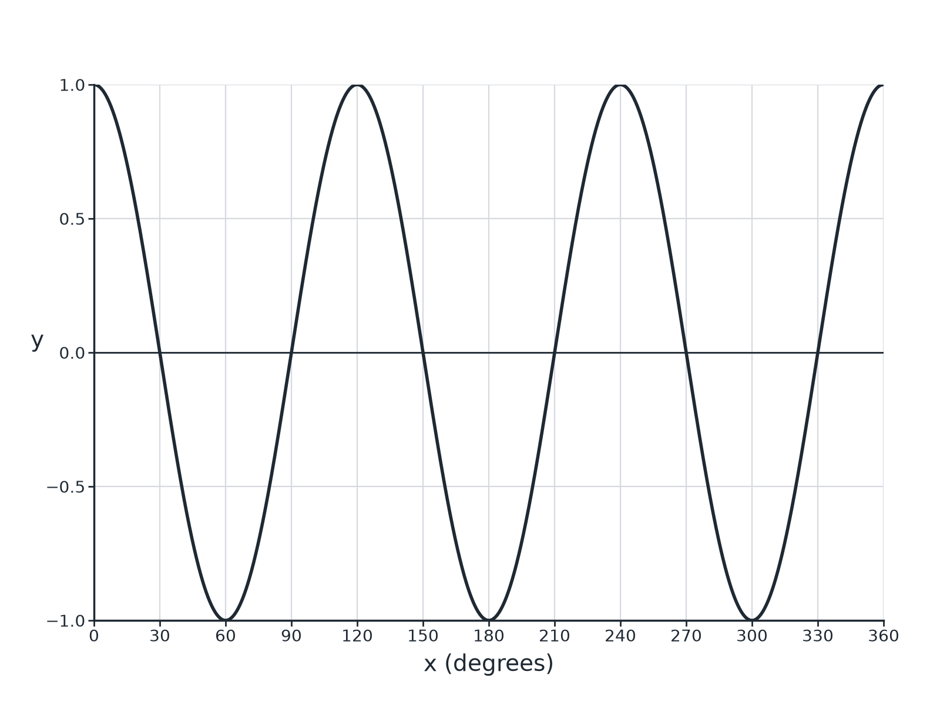

Question 1 · mark scheme
2 marks available. Award a mark for each point made.
▸ Three waves or period 120°. M1
▸ 3. A1
▸ Model answer. a = 3
Question 2 · 2 marks · Describe
“Describe the single transformation that maps the graph of y = sin x onto the graph of y = sin (x − 40°).”
HOW TO ANSWER IT Command word: Describe. Worth 2 marks, so plan before writing.
Question 2 · mark scheme
2 marks available. Award a mark for each point made.
▸ Translation. M1
▸ 40° to the right. A1
▸ Model answer. A translation of 40° to the right, that is by the vector beginpmatrix40 \ 0endpmatrix.
Question 3 · 1 mark · Write down
“Write down the period of y = sin 4x.”
HOW TO ANSWER IT Command word: Write down. Worth 1 mark, so plan before writing.
Question 3 · mark scheme
1 mark available. Award a mark for each point made.
▸ 90. B1
▸ Model answer. 90°
Question 4 · 2 marks · Write down
“Write down the coordinates of the first maximum point of y = sin (x − 30°) for x > 0.”
HOW TO ANSWER IT Command word: Write down. Worth 2 marks, so plan before writing.
Question 4 · mark scheme
2 marks available. Award a mark for each point made.
▸ x = 120. B1
▸ y = 1. B1
▸ Model answer. (120°, 1)
Question 5 · 3 marks · Sketch
“On a grid, sketch the graph of y = sin 2x for 0° ≤ x ≤ 360°.”
HOW TO ANSWER IT Command word: Sketch. Worth 3 marks, so plan before writing.
Question 5 · mark scheme
3 marks available. Award a mark for each point made.
▸ Two full waves. B1
▸ Maximum 1 and minimum −1. B1
▸ Correct roots or turning points. B1
▸ Model answer. Two full sine waves: maxima of 1 at 45° and 225°, minima of −1 at 135° and 315°, crossing the x-axis at 0°, 90°, 180°, 270°, 360°.
Question 6 · 4 marks · Solve
“Solve sin 2x = 0.5 for 0° ≤ x ≤ 360°.”
HOW TO ANSWER IT Command word: Solve. Worth 4 marks, so plan before writing.
Question 6 · mark scheme
4 marks available. Award a mark for each point made.
▸ 2x = 30. M1
▸ 2x = 150. M1
▸ Extends to 390 and 510. M1
▸ All four answers. A1
▸ Model answer. x = 15°, 75°, 195°, 255°

