EDEXCEL GCSE MATHS · FOUNDATION & HIGHER
Cumulative frequency
Further statistics · Lesson 2 of 6
Teacher copy - includes the notes for whoever is teaching from it.
Warm-up
Answer each one, then check.
1. What is the median?
The middle value when the data are in order
2. What is the range?
Largest minus smallest
3. Running total of 4, 11, 20?
4, 15, 35
4. What is a grouped frequency table?
A table showing how many values fall in each class
5. Write the class 20 < t ≤ 30 in words.
More than 20 and up to and including 30
Learning Objectives
1. Work out cumulative frequencies from a grouped table.
2. Plot a cumulative frequency graph.
3. Estimate the median, lower quartile and upper quartile.
4. Find the interquartile range and answer questions from the graph.
Cumulative Frequency
Cumulative frequency is a running total of the frequencies. Plot each total against the upper class boundary.
Points are joined with a smooth curve that always rises.
Building the Table
Time taken (t minutes) to complete a puzzle, 60 students.
Time | Frequency | Cumulative frequency
0 < t ≤ 10 | 4 | 4
10 < t ≤ 20 | 11 | 15
20 < t ≤ 30 | 20 | 35
30 < t ≤ 40 | 16 | 51
40 < t ≤ 50 | 7 | 58
50 < t ≤ 60 | 2 | 60
Reading the Curve
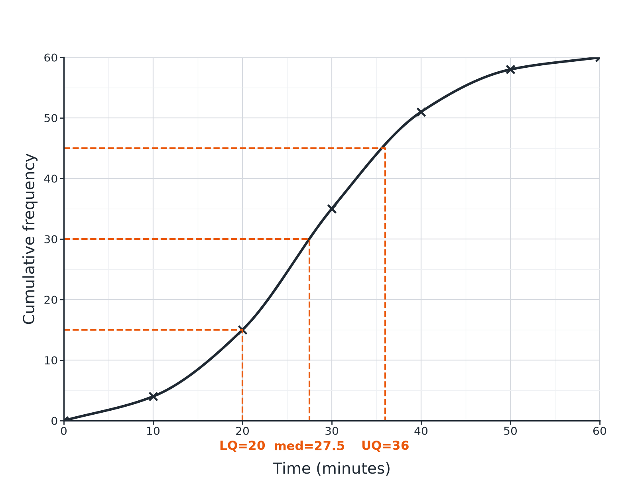
Read the quartiles at one quarter, one half and three quarters of the total.
A cumulative frequency curve with the lower quartile, median and upper quartile marked by dashed lines.
Reading Quartiles
Use the total frequency n.
1  Median  Go across at n/2, then down to the x-axis | 2  Lower quartile  Go across at n/4, then down | 3  Upper quartile  Go across at 3n/4, then down | 4  Interquartile range  IQR = UQ − LQ
Median and Quartiles
For the 60 students, estimate the median, the quartiles and the interquartile range.

1. Total
n = 60
2. Median
At 30: about 27.5 minutes
3. Lower quartile
At 15: 20 minutes
4. Upper quartile
At 45: about 36 minutes
5. Interquartile range
36 − 20 = 16 minutes
Answer: Median ≈ 27.5 minutes, IQR ≈ 16 minutes.
How Many More Than...?
Use the graph to estimate how many of the 60 students took more than 40 minutes.

1. Cumulative frequency at 40
51 students took 40 minutes or less
2. Subtract from the total
60 − 51 = 9
Answer: About 9 students took more than 40 minutes.
Common Mistakes
Watch for these.
▸ Wrong boundary. Plot at the upper class boundary, not the middle of the class.
▸ Straight lines. The graph is a smooth curve, not a polygon (unless the question says so).
▸ Reading frequency, not value. Go across from the cumulative frequency, then down to the data value.
▸ Forgetting the start. The curve starts at the lowest boundary with a cumulative frequency of 0.
Key Terms
Cumulative frequency  A running total of frequencies. | Upper class boundary  The largest value in a class.
Median  The middle value; the value at n/2. | Lower quartile  The value one quarter of the way through the data.
Upper quartile  The value three quarters of the way through the data. | Interquartile range  Upper quartile minus lower quartile.
Your Task: Build a Cumulative Frequency Table
12 minutes
Heights (h cm) of 40 plants: 0 < h ≤ 10: 3, 10 < h ≤ 20: 9, 20 < h ≤ 30: 16, 30 < h ≤ 40: 8, 40 < h ≤ 50: 4. (a) Complete the cumulative frequency column. (b) At what value of n do you read the median?
1. Add each frequency to the running total.
2. The last total equals the total frequency.
A good answer shows: (a) 3, 12, 28, 36, 40. (b) 40/2 = 20, which lies in the class 20 < h ≤ 30.
Note: Ask learners to say which upper class boundaries they would plot against.
Can I...?
☐ Find cumulative frequencies.
☐ Plot at upper class boundaries.
☐ Draw a smooth curve.
☐ Read the median.
☐ Read the quartiles.
☐ Find the IQR.
☐ Find how many are above or below a value.
☐ Avoid common mistakes.
Summary
✓ Plot cumulative frequency against upper class boundaries.
✓ Median at n/2, LQ at n/4, UQ at 3n/4.
✓ IQR = UQ − LQ.
✓ Values read from a graph are estimates.

EXAM FOCUS
The cumulative frequency graph shows the times taken by 80 students. Use it to estimate the median and the interquartile range. (4 marks)
Show your dashed lines on the graph and write the values down.
Exam Practice: Cumulative frequency
Answer all questions. Show your working. · 30 minutes
▸ Question 1 · 4 marks · Use the graph. The cumulative frequency graph shows the times, in minutes, taken by 80 students to complete a puzzle. Use the graph to find an estimate…
▸ Question 2 · 2 marks · Use the graph. Use the same graph of the times taken by 80 students to estimate how many students took more than 45 minutes.
▸ Question 3 · 2 marks · Complete. The table shows the times taken by 60 students. Frequencies: 0 < t ≤ 10: 4, 10 < t ≤ 20: 11, 20 < t ≤ 30: 20, 30 < t ≤ 40: 16, 40 < t ≤ 50…
▸ Question 4 · 2 marks · Explain. Explain why the points on a cumulative frequency graph are plotted at the upper class boundaries.
▸ Question 5 · 3 marks · Draw. Describe how to draw a cumulative frequency graph from a table of grouped data.
▸ Question 6 · 2 marks · Work out. A cumulative frequency graph shows the lower quartile is 20 and the upper quartile is 36. Work out the interquartile range and explain what…
Question 1 · 4 marks · Use the graph
The cumulative frequency graph shows the times, in minutes, taken by 80 students to complete a puzzle. Use the graph to find an estimate for (a) the median (b) the interquartile range. (4 marks) | 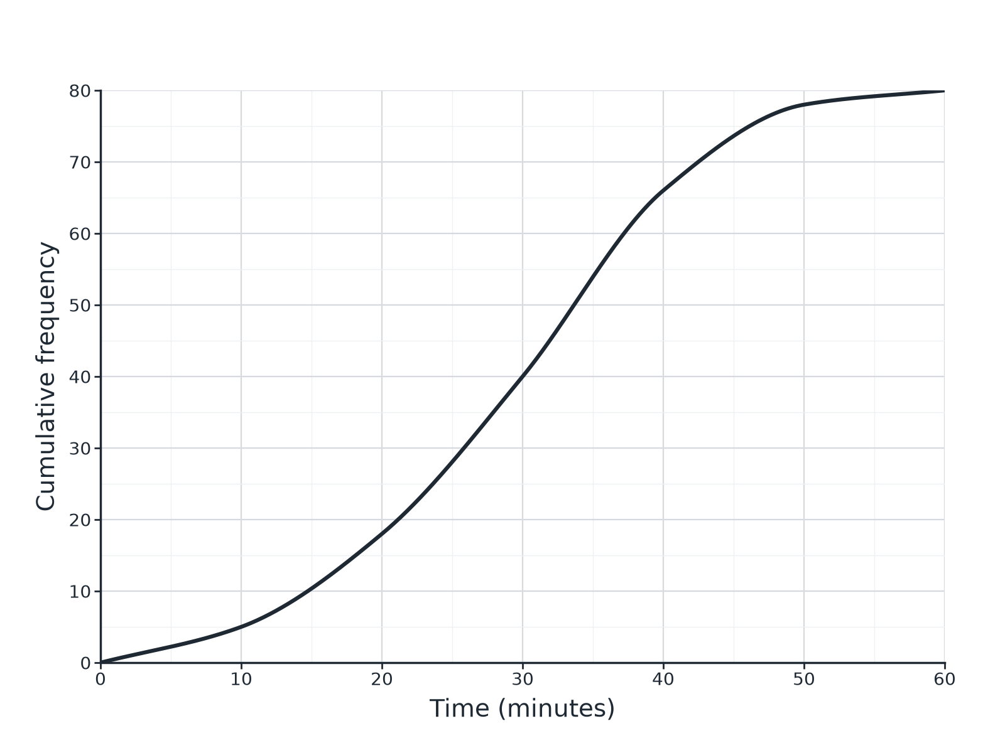

Question 1 · mark scheme
4 marks available. Award a mark for each point made.
▸ Median: reads across at 40. M1
▸ 30 (accept 29 to 31). A1
▸ LQ and UQ read at 20 and 60. M1
▸ IQR about 17. A1
▸ Model answer. (a) Median at 40: about 30 minutes. (b) LQ at 20: about 21; UQ at 60: about 38; IQR about 17. Accept readings within 1 minute.
Question 2 · 2 marks · Use the graph
“Use the same graph of the times taken by 80 students to estimate how many students took more than 45 minutes.”
HOW TO ANSWER IT Command word: Use the graph. Worth 2 marks, so plan before writing.
Question 2 · mark scheme
2 marks available. Award a mark for each point made.
▸ Reads about 72 at 45. M1
▸ 80 − 72 = 8. A1
▸ Model answer. About 72 students took 45 minutes or less, so 80 − 72 = 8 took more. Accept 7 to 9.
Question 3 · 2 marks · Complete
“The table shows the times taken by 60 students. Frequencies: 0 < t ≤ 10: 4, 10 < t ≤ 20: 11, 20 < t ≤ 30: 20, 30 < t ≤ 40: 16, 40 < t ≤ 50: 7, 50 < t ≤ 60: 2. Work out the cumulative frequencies.”
HOW TO ANSWER IT Command word: Complete. Worth 2 marks, so plan before writing.
Question 3 · mark scheme
2 marks available. Award a mark for each point made.
▸ At least 3 correct. M1
▸ All correct. A1
▸ Model answer. 4, 15, 35, 51, 58, 60
Question 4 · 2 marks · Explain
“Explain why the points on a cumulative frequency graph are plotted at the upper class boundaries.”
HOW TO ANSWER IT Command word: Explain. Worth 2 marks, so plan before writing.
Question 4 · mark scheme
2 marks available. Award a mark for each point made.
▸ Cumulative frequency includes the whole class. M1
▸ Only true at the upper boundary. C1
▸ Model answer. The cumulative frequency counts everyone up to the end of each class, so the running total is only known at the upper boundary.
Question 5 · 3 marks · Draw
“Describe how to draw a cumulative frequency graph from a table of grouped data.”
HOW TO ANSWER IT Command word: Draw. Worth 3 marks, so plan before writing.
Question 5 · mark scheme
3 marks available. Award a mark for each point made.
▸ Running totals. B1
▸ Plot at upper boundaries. B1
▸ Smooth curve. B1
▸ Model answer. Work out the running totals. Plot each total against the upper class boundary, plus a point at 0 for the lowest boundary. Join the points with a smooth curve.
Question 6 · 2 marks · Work out
“A cumulative frequency graph shows the lower quartile is 20 and the upper quartile is 36. Work out the interquartile range and explain what it tells you.”
HOW TO ANSWER IT Command word: Work out. Worth 2 marks, so plan before writing.
Question 6 · mark scheme
2 marks available. Award a mark for each point made.
▸ 16. B1
▸ The spread of the middle 50%. C1
▸ Model answer. 36 − 20 = 16. The middle half of the data lie within a range of 16.

