EDEXCEL GCSE MATHS · HIGHER
Drawing histograms
Further statistics · Lesson 4 of 6
Teacher copy - includes the notes for whoever is teaching from it.
Warm-up
Answer each one, then check.
1. What is the width of the class 10 < t ≤ 30?
20
2. Work out 30 ÷ 20.
1.5
3. What is a frequency table?
A table of how often values occur
4. How does a bar chart differ from a histogram?
A histogram's bar area shows frequency; classes are continuous
5. Write 12 ÷ 10 as a decimal.
1.2
Learning Objectives
1. Explain why a histogram uses frequency density.
2. Work out the frequency density for each class.
3. Draw a histogram with unequal class widths.
4. Label the axes correctly.
Histogram
In a histogram the area of each bar shows the frequency. The height is the frequency density.
frequency density = frequency/(class width). The bars touch and there are no gaps.
A Histogram
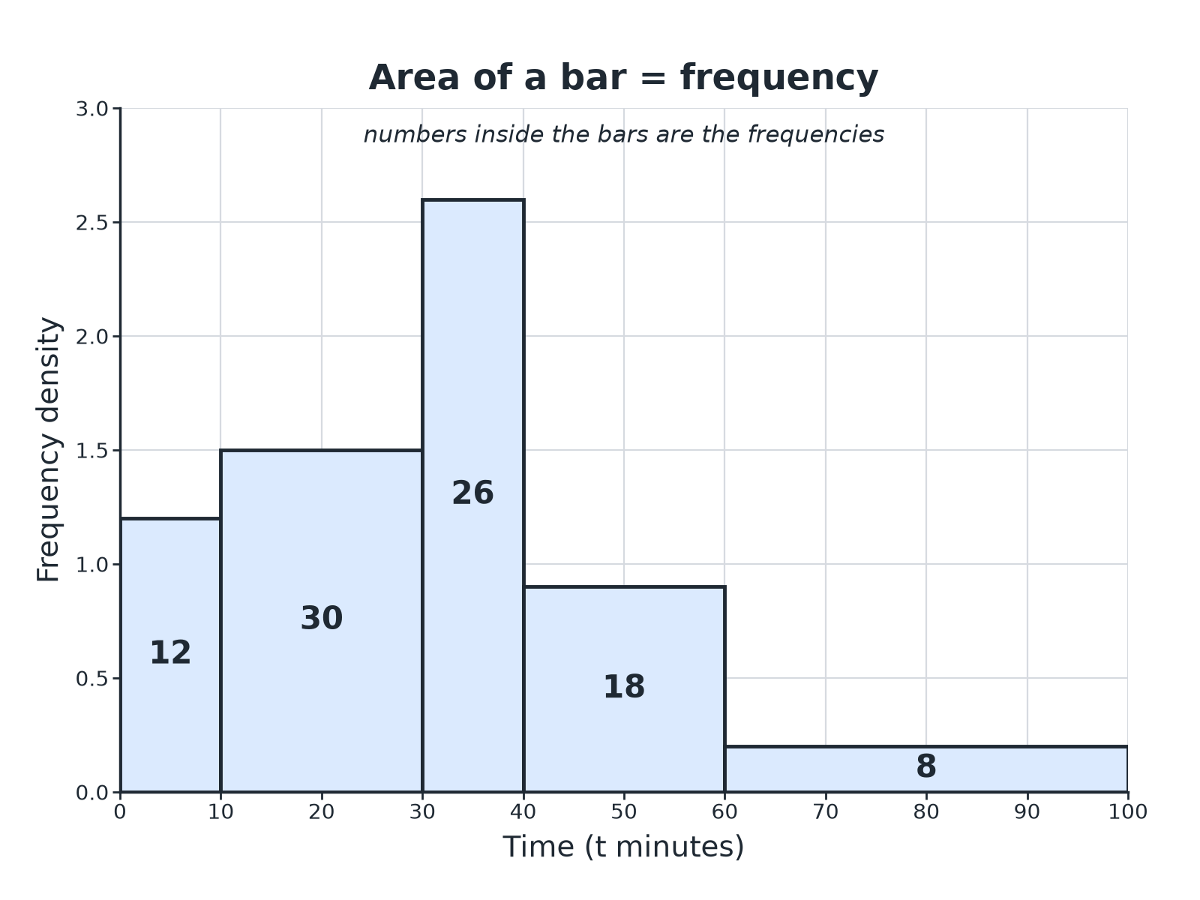
Wider bars are shorter for the same frequency.
A histogram of times with unequal class widths, with bar heights of frequency density and frequencies written inside the bars.
Working Out Frequency Density
Times taken (t minutes) by 94 customers.
Time | Frequency | Class width | Frequency density
0 < t ≤ 10 | 12 | 10 | 1.2
10 < t ≤ 30 | 30 | 20 | 1.5
30 < t ≤ 40 | 26 | 10 | 2.6
40 < t ≤ 60 | 18 | 20 | 0.9
60 < t ≤ 100 | 8 | 40 | 0.2
Drawing a Histogram
Follow the steps.
1  Work out the class widths  Upper boundary minus lower boundary | 2  Work out the frequency density  Frequency divided by class width | 3  Draw the axes  Data on the horizontal axis, frequency density on the vertical axis | 4  Draw the bars  Bars touch; the height is the frequency density | 5  Label  Add a scale and a label for each axis
Frequency Density
A class 20 < x ≤ 50 has frequency 60. Work out the frequency density.

1. Class width
50 − 20 = 30
2. Divide
60/30 = 2
Answer: The frequency density is 2, so the bar has height 2.
Completing a Histogram
Age (a years): 0 < a ≤ 10: 8, 10 < a ≤ 20: 20, 20 < a ≤ 40: 36, 40 < a ≤ 60: 30. The first three bars are drawn. Work out the height of the last bar.

1. Class width
60 − 40 = 20
2. Frequency density
30/20 = 1.5
Answer: Draw a bar from 40 to 60 with height 1.5.
Common Mistakes
Watch for these.
▸ Frequency as the height. Use frequency density.
▸ Gaps between bars. The bars must touch.
▸ Widths. Use the actual class width, not the number of classes.
▸ Labels. The vertical axis is "Frequency density", not "Frequency".
Key Terms
Histogram  A chart where bar area shows frequency. | Frequency density  Frequency divided by class width.
Class width  The upper boundary minus the lower boundary. | Continuous data  Data measured, not counted.
Unequal class widths  Classes of different sizes. | Area  Height multiplied by width.
Your Task: Find the Density
10 minutes
Work out the frequency density for each class. (a) 0 < w ≤ 5, frequency 15 (b) 5 < w ≤ 15, frequency 40 (c) 15 < w ≤ 35, frequency 30 (d) 35 < w ≤ 60, frequency 10.
1. Class width first.
2. Then divide.
A good answer shows: (a) 3 (b) 4 (c) 1.5 (d) 0.4
Note: Ask which bar will be tallest and why.
Can I...?
☐ Find the class widths.
☐ Work out frequency density.
☐ Draw and label axes.
☐ Draw bars that touch.
☐ Use unequal class widths.
☐ Complete a partly drawn histogram.
☐ Explain why frequency density is used.
☐ Avoid common mistakes.
Summary
✓ Frequency density = frequency/(class width).
✓ Area of bar = frequency.
✓ Bars touch; classes may have different widths.
✓ The vertical axis is frequency density.

EXAM FOCUS
A table shows the ages of 94 people in classes with different widths. Work out the frequency density for each class and draw the histogram. (4 marks)
Add a frequency density column to the table first.
Exam Practice: Drawing histograms
Answer all questions. Show your working. · 30 minutes
▸ Question 1 · 3 marks · Complete. The table shows the times, t minutes, taken by 94 customers. Frequencies: 0 < t ≤ 10: 12, 10 < t ≤ 30: 30, 30 < t ≤ 40: 26, 40 < t ≤ 60…
▸ Question 2 · 3 marks · Complete the histogram. The table shows information about the ages, a years, of 94 people: 0 < a ≤ 10: 8, 10 < a ≤ 20: 20, 20 < a ≤ 40: 36, 40 < a ≤ 60: 30…
▸ Question 3 · 2 marks · Work out. A class 5 < x ≤ 25 has frequency 40. Work out the frequency density.
▸ Question 4 · 2 marks · Work out. A histogram bar for the class 10 < x ≤ 14 has a frequency density of 3. Work out the frequency of the class.
▸ Question 5 · 2 marks · Explain. Explain why the height of a bar in a histogram is not the frequency when the class widths are unequal.
▸ Question 6 · 3 marks · Draw. Describe how to draw a histogram from a grouped frequency table with unequal class widths.
Question 1 · 3 marks · Complete
“The table shows the times, t minutes, taken by 94 customers. Frequencies: 0 < t ≤ 10: 12, 10 < t ≤ 30: 30, 30 < t ≤ 40: 26, 40 < t ≤ 60: 18, 60 < t ≤ 100: 8. Work out the frequency density for each class.”
HOW TO ANSWER IT Command word: Complete. Worth 3 marks, so plan before writing.
Question 1 · mark scheme
3 marks available. Award a mark for each point made.
▸ Class widths. M1
▸ At least three correct. M1
▸ All correct. A1
▸ Model answer. 1.2, 1.5, 2.6, 0.9, 0.2
Question 2 · 3 marks · Complete the histogram
The table shows information about the ages, a years, of 94 people: 0 < a ≤ 10: 8, 10 < a ≤ 20: 20, 20 < a ≤ 40: 36, 40 < a ≤ 60: 30. Complete the histogram. (3 marks) | 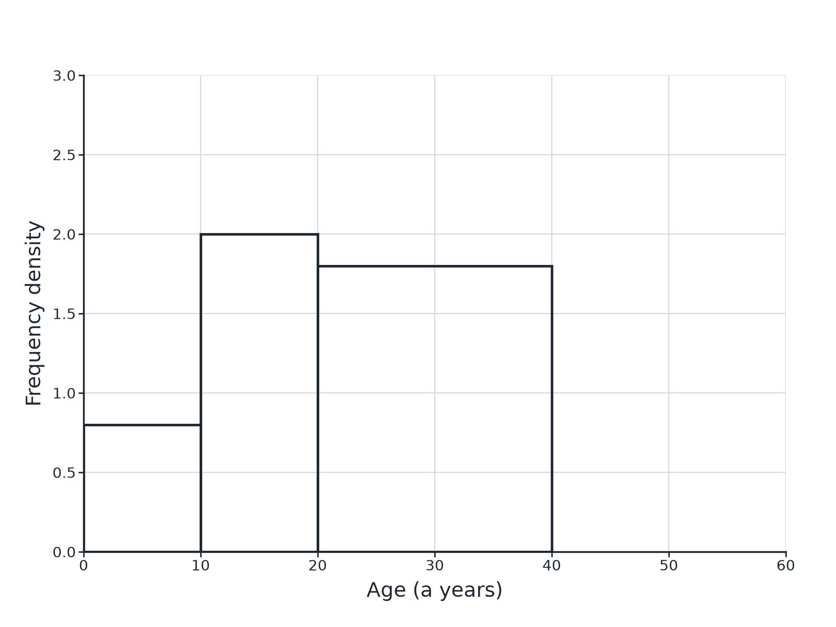

Question 2 · mark scheme
3 marks available. Award a mark for each point made.
▸ Frequency density 1.5. M1
▸ Bar from 40 to 60. A1
▸ Height 1.5. A1
▸ Model answer. Frequency density = 30 ÷ 20 = 1.5; a bar drawn from 40 to 60 of height 1.5.
Question 3 · 2 marks · Work out
“A class 5 < x ≤ 25 has frequency 40. Work out the frequency density.”
HOW TO ANSWER IT Command word: Work out. Worth 2 marks, so plan before writing.
Question 3 · mark scheme
2 marks available. Award a mark for each point made.
▸ Class width 20. M1
▸ 2. A1
▸ Model answer. 40 ÷ 20 = 2
Question 4 · 2 marks · Work out
“A histogram bar for the class 10 < x ≤ 14 has a frequency density of 3. Work out the frequency of the class.”
HOW TO ANSWER IT Command word: Work out. Worth 2 marks, so plan before writing.
Question 4 · mark scheme
2 marks available. Award a mark for each point made.
▸ Uses 4 × 3. M1
▸ 12. A1
▸ Model answer. Width 4; frequency = 4 × 3 = 12
Question 5 · 2 marks · Explain
“Explain why the height of a bar in a histogram is not the frequency when the class widths are unequal.”
HOW TO ANSWER IT Command word: Explain. Worth 2 marks, so plan before writing.
Question 5 · mark scheme
2 marks available. Award a mark for each point made.
▸ Area shows frequency. M1
▸ Frequency density used for the height. C1
▸ Model answer. The area of a bar shows the frequency, so a wider class needs a lower bar for the same frequency. The height is the frequency density.
Question 6 · 3 marks · Draw
“Describe how to draw a histogram from a grouped frequency table with unequal class widths.”
HOW TO ANSWER IT Command word: Draw. Worth 3 marks, so plan before writing.
Question 6 · mark scheme
3 marks available. Award a mark for each point made.
▸ Frequency density. B1
▸ Axes correctly labelled. B1
▸ Touching bars with correct heights. B1
▸ Model answer. Work out the class width and then the frequency density for each class. Draw a frequency density scale on the vertical axis and the data on the horizontal axis. Draw touching bars with heights equal to the frequency densities.

