EDEXCEL GCSE MATHS · HIGHER
Interpreting histograms
Further statistics · Lesson 5 of 6
Teacher copy - includes the notes for whoever is teaching from it.
Warm-up
Answer each one, then check.
1. What is frequency density?
Frequency divided by class width
2. Work out 20 × 1.5.
30
3. What is the midpoint of the class 20 < x ≤ 40?
30
4. How do you estimate a mean from grouped data?
Add up midpoint times frequency, divide by total frequency
5. What is the median position for 124 values?
The 62nd value
Learning Objectives
1. Find frequencies from a histogram using area.
2. Estimate the number in part of a class.
3. Estimate the median from a histogram.
4. Estimate the mean from a histogram.
Reading A Histogram
Frequency = frequency density × class width. That is the area of the bar.
To estimate a frequency for part of a class, use the width of just that part.
Area Shows Frequency
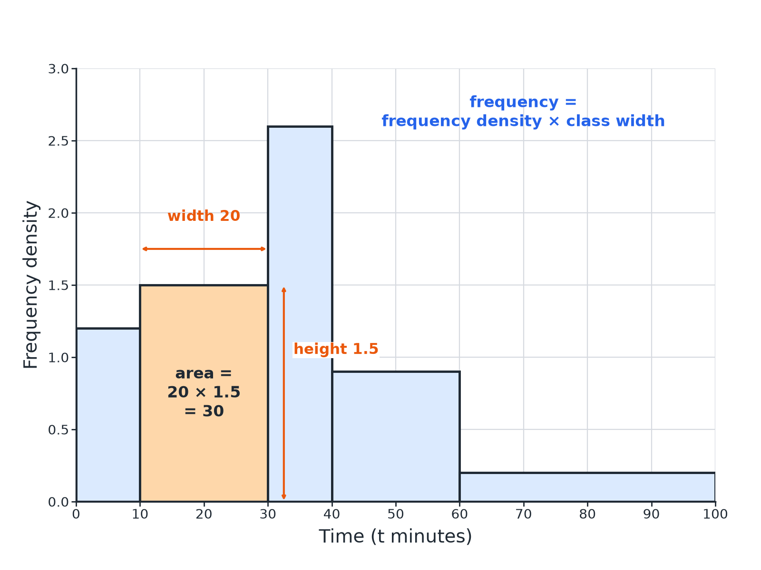
Area of the bar = frequency.
A histogram with one bar shaded to show that its area, width 20 times height 1.5, equals a frequency of 30.
Frequency from a Bar
A histogram bar for the class 10 < t ≤ 30 has height 1.5. Find the frequency.

1. Class width
30 − 10 = 20
2. Multiply
20 × 1.5 = 30
Answer: The frequency is 30.
Part of a Class
In the class 20 < x ≤ 40 the frequency density is 2.2. Estimate the number of values between 25 and 40.

1. Width of the part
40 − 25 = 15
2. Multiply
15 × 2.2 = 33
Answer: About 33 values.
Estimating the Median
Frequencies of 16, 30, 44, 24 and 10 are in classes 0−10, 10−20, 20−40, 40−70, 70−90 (total 124). The frequency density of 20−40 is 2.2. Estimate the median.

1. Position
124 ÷ 2 = 62
2. Running total
16 + 30 = 46, so the median is in 20−40
3. Values needed in this class
62 − 46 = 16
4. Width needed
16 ÷ 2.2 = 7.27
5. Median
20 + 7.27 = 27.3
Answer: The median is about 27.3.
Estimating the Mean
Use the same data to estimate the mean.

1. Midpoints
5, 15, 30, 55, 80
2. Multiply
80 + 450 + 1320 + 1320 + 800 = 3970
3. Divide by 124
3970 ÷ 124 = 32.0
Answer: The mean is about 32.0.
Reading Tips
Keep the method tidy.
▸ Add a frequency column. Work out each bar's frequency first.
▸ Running totals. Use them to find the median class.
▸ Median. Interpolate inside the median class.
▸ Estimates. Values from grouped data are only estimates.
Key Terms
Frequency density  Height of a histogram bar. | Estimate  An approximate answer from grouped data.
Midpoint  The middle of a class. | Median class  The class that contains the median.
Interpolate  Find a value part of the way through a class. | Area  Width times height.
Your Task: Read the Bars
12 minutes
A histogram has bars: 0−10 height 1.6, 10−20 height 3, 20−40 height 2.2, 40−70 height 0.8, 70−90 height 0.5. (a) Find each frequency. (b) Find the total. (c) Estimate the number aged 30 to 40.
1. Width times height.
2. Add them up.
A good answer shows: (a) 16, 30, 44, 24, 10. (b) 124. (c) 10 × 2.2 = 22.
Note: Encourage learners to write the frequency above each bar.
Can I...?
☐ Find frequency from area.
☐ Find the total frequency.
☐ Estimate part of a class.
☐ Find the median class.
☐ Interpolate the median.
☐ Work out midpoints.
☐ Estimate the mean.
☐ Explain why answers are estimates.
Summary
✓ Frequency = frequency density × class width.
✓ Median: find the class, then interpolate.
✓ Mean: Σ(midpoint × frequency)/(total frequency).
✓ Grouped answers are estimates.

EXAM FOCUS
The histogram shows the ages of visitors to a museum. Work out an estimate for the number of visitors aged 25 to 40. (3 marks)
Use the class width of only the part you need.
Exam Practice: Interpreting histograms
Answer all questions. Show your working. · 30 minutes
▸ Question 1 · 4 marks · Use the histogram. The histogram gives information about the ages of visitors to a museum. (a) Work out the number of visitors aged 10 to 20. (b) Work out an…
▸ Question 2 · 2 marks · Work out. Use the same histogram to work out the total number of visitors.
▸ Question 3 · 3 marks · Estimate. Use the same histogram to find an estimate for the median age.
▸ Question 4 · 3 marks · Estimate. Use the same histogram to find an estimate for the mean age of the visitors.
▸ Question 5 · 2 marks · Work out. A histogram bar for a class of width 20 has height 1.4. Work out the frequency of the class.
▸ Question 6 · 2 marks · Explain. Explain why the answer to part (b) of the first question is only an estimate.
Question 1 · 4 marks · Use the histogram
The histogram gives information about the ages of visitors to a museum. (a) Work out the number of visitors aged 10 to 20. (b) Work out an estimate for the number of visitors aged 25 to 40. (4 marks) | 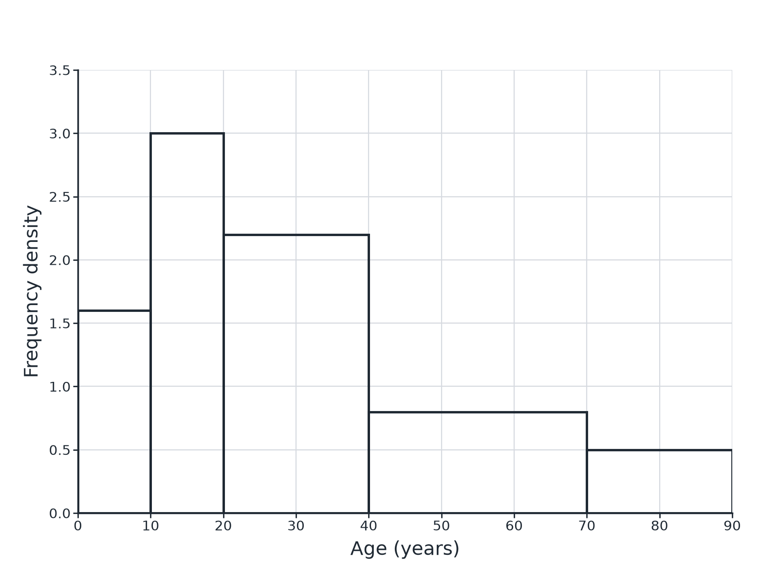

Question 1 · mark scheme
4 marks available. Award a mark for each point made.
▸ 10 × 3. M1
▸ 30. A1
▸ 15 × 2.2. M1
▸ 33. A1
▸ Model answer. (a) 10 × 3 = 30. (b) 15 × 2.2 = 33.
Question 2 · 2 marks · Work out
“Use the same histogram to work out the total number of visitors.”
HOW TO ANSWER IT Command word: Work out. Worth 2 marks, so plan before writing.
Question 2 · mark scheme
2 marks available. Award a mark for each point made.
▸ All five frequencies. M1
▸ 124. A1
▸ Model answer. 16 + 30 + 44 + 24 + 10 = 124
Question 3 · 3 marks · Estimate
“Use the same histogram to find an estimate for the median age.”
HOW TO ANSWER IT Command word: Estimate. Worth 3 marks, so plan before writing.
Question 3 · mark scheme
3 marks available. Award a mark for each point made.
▸ Median position 62. B1
▸ Interpolates in the class 20 to 40. M1
▸ 27.3 (accept 27 to 27.5). A1
▸ Model answer. Median position 62; running total 46 after age 20; 62 − 46 = 16; 16 ÷ 2.2 = 7.27; median ≈ 27.3.
Question 4 · 3 marks · Estimate
“Use the same histogram to find an estimate for the mean age of the visitors.”
HOW TO ANSWER IT Command word: Estimate. Worth 3 marks, so plan before writing.
Question 4 · mark scheme
3 marks available. Award a mark for each point made.
▸ Midpoints times frequencies. M1
▸ 3970. A1
▸ 32.0. A1
▸ Model answer. (16 × 5 + 30 × 15 + 44 × 30 + 24 × 55 + 10 × 80)/124 = 3970/124 = 32.0
Question 5 · 2 marks · Work out
“A histogram bar for a class of width 20 has height 1.4. Work out the frequency of the class.”
HOW TO ANSWER IT Command word: Work out. Worth 2 marks, so plan before writing.
Question 5 · mark scheme
2 marks available. Award a mark for each point made.
▸ Uses 20 × 1.4. M1
▸ 28. A1
▸ Model answer. 20 × 1.4 = 28
Question 6 · 2 marks · Explain
“Explain why the answer to part (b) of the first question is only an estimate.”
HOW TO ANSWER IT Command word: Explain. Worth 2 marks, so plan before writing.
Question 6 · mark scheme
2 marks available. Award a mark for each point made.
▸ Data grouped. M1
▸ Assumes even spread. C1
▸ Model answer. The data are grouped, so we do not know how the values are spread inside the class. We assumed they are evenly spread.

