EDEXCEL GCSE MATHS · FOUNDATION & HIGHER
Comparing and describing distributions
Further statistics · Lesson 6 of 6
Teacher copy - includes the notes for whoever is teaching from it.
Warm-up
Answer each one, then check.
1. Name a measure of average.
Mean, median or mode
2. Name a measure of spread.
Range or interquartile range
3. What is an outlier?
A value far from the others
4. Does an outlier affect the median much?
No
5. Does an outlier affect the mean much?
Yes
Learning Objectives
1. Compare two distributions using an average and a measure of spread.
2. Choose the best average and spread.
3. Describe skew.
4. Write comparisons in context.
Comparing
To compare distributions, compare one average and one measure of spread, using numbers and context.
A higher average means the values are generally bigger. A larger spread means the values are less consistent.
The Shape of a Distribution
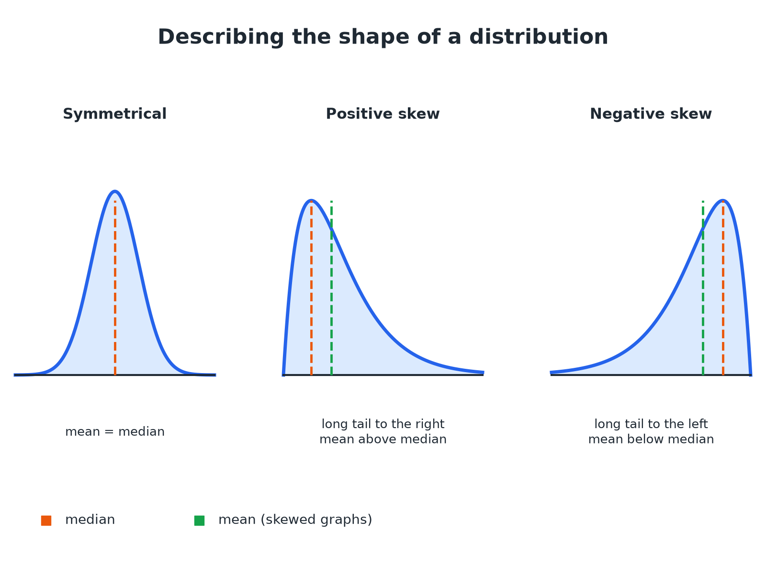
The tail shows the direction of the skew.
Three distribution curves showing symmetrical, positive skew and negative skew shapes.
Choosing Averages and Spreads
AVERAGES | SPREADS
▸ Mean uses every value, but is affected by outliers.  ▸ Median is not affected by outliers.  ▸ Mode is the most common value. | ▸ Range uses the largest and smallest values only.  ▸ IQR is the spread of the middle 50%.  ▸ IQR is not affected by outliers.
Comparing Two Data Sets
Boys: median 12.4 s, IQR 1.2 s. Girls: median 13.1 s, IQR 2.0 s. Compare the times for the 100 m sprint.

1. Average
Boys' median 12.4 is lower than girls' 13.1
2. Meaning
On average the boys were faster
3. Spread
Boys' IQR 1.2 is smaller than girls' 2.0
4. Meaning
The boys' times were more consistent
Answer: On average the boys were faster (median 12.4 s against 13.1 s) and their times were more consistent (IQR 1.2 s against 2.0 s).
Comparing Cumulative Frequency Curves
Two cumulative frequency curves show the times of Group A and Group B (60 people each). Group A: median 28, IQR 16. Group B: median 22, IQR 17. Compare the groups.

1. Median
B's median is lower
2. Spread
The IQRs are very close
3. Conclusion
Group B were quicker on average, with a similar spread
Answer: Group B were quicker on average (median 22 against 28) and both groups had a similar spread (IQR 17 against 16).
Describing Skew
The mean is 30 and the median is 25. Describe the skew.

1. Compare
The mean is greater than the median
2. Shape
The tail is to the right
Answer: The distribution has positive skew.
Writing Good Comparisons
A full-mark answer has four parts.
▸ An average. Compare medians or means, quoting numbers.
▸ A spread. Compare IQRs or ranges, quoting numbers.
▸ Context. Write in terms of the situation.
▸ A conclusion. For example "so Group B were faster and more consistent".
Key Terms
Distribution  How values are spread across a data set. | Skew  A lack of symmetry; the tail shows the direction.
Symmetrical  The same on both sides of the middle. | Outlier  A value much larger or smaller than the rest.
Consistent  Little variation. | In context  Written using the real situation.
Your Task: Write the Comparison
12 minutes
Set A: mean 24, range 10. Set B: mean 21, range 25. Write a comparison of the two sets.
1. Compare averages.
2. Compare spreads.
A good answer shows: On average Set A has higher values (mean 24 against 21) and Set A is more consistent (range 10 against 25).
Note: Ask learners to check that they used a number for each statement.
Can I...?
☐ Compare two medians.
☐ Compare two IQRs.
☐ Compare means and ranges.
☐ Read a cumulative frequency graph.
☐ Describe skew.
☐ Write in context.
☐ Use numbers.
☐ Explain the choice of average.
Summary
✓ Compare one average and one spread.
✓ Median and IQR are best if there are outliers.
✓ Positive skew: long tail to the right, mean above median.
✓ Give numbers and a conclusion.

EXAM FOCUS
The cumulative frequency graph shows the times taken by two groups. Compare the times. (4 marks)
Compare an average and a spread, and use the words of the question.
Exam Practice: Comparing and describing distributions
Answer all questions. Show your working. · 30 minutes
▸ Question 1 · 4 marks · Compare. The cumulative frequency graphs show the times taken by 60 people in Group A and 60 people in Group B to complete a puzzle. Compare the…
▸ Question 2 · 2 marks · Compare. Boys: median 12.4 s, interquartile range 1.2 s. Girls: median 13.1 s, interquartile range 2.0 s. Write down two comparisons.
▸ Question 3 · 2 marks · Compare. Set A has mean 24 and range 10. Set B has mean 21 and range 25. Compare the two sets.
▸ Question 4 · 2 marks · Describe. A distribution has a mean of 30 and a median of 25. Describe the skew of the distribution.
▸ Question 5 · 2 marks · Explain. A data set has one very large outlier. Explain why the median is a better average than the mean.
▸ Question 6 · 2 marks · Explain. The mean time for pupils in a London school is lower than in a school in Leeds. Ben says every pupil in the London school must be faster…
Question 1 · 4 marks · Compare
The cumulative frequency graphs show the times taken by 60 people in Group A and 60 people in Group B to complete a puzzle. Compare the times taken by the two groups. (4 marks) | 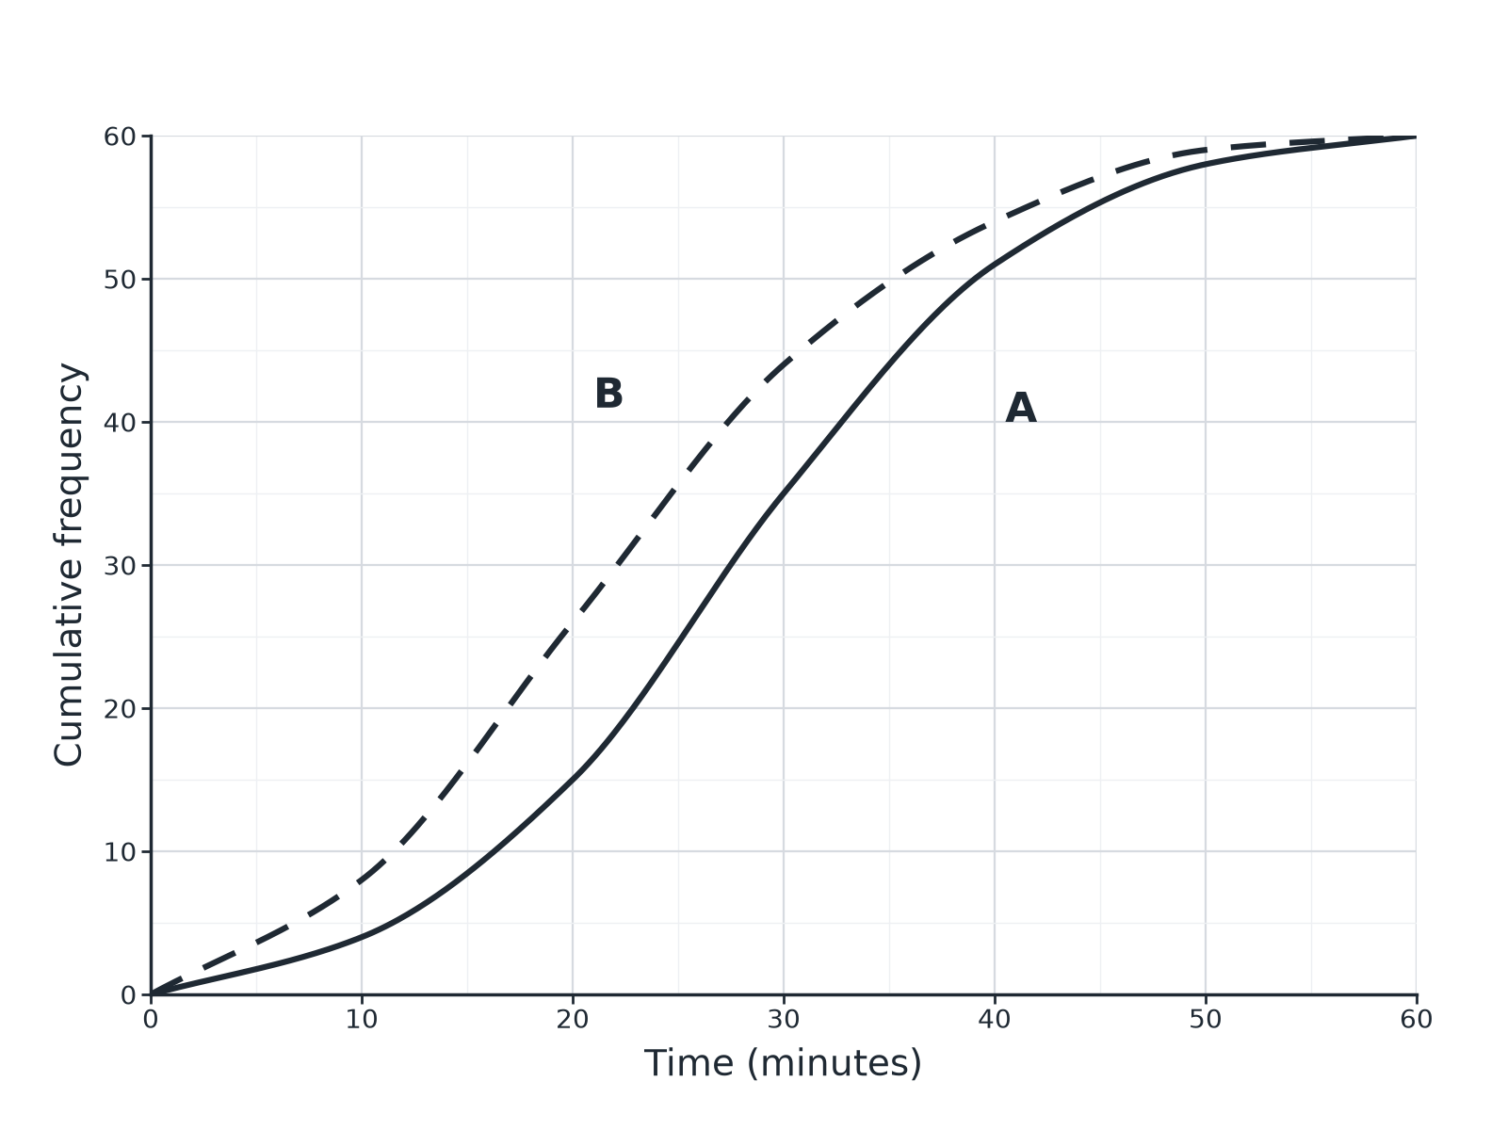

Question 1 · mark scheme
4 marks available. Award a mark for each point made.
▸ Median for each read from the graph. M1
▸ Comment on average in context. A1
▸ IQR for each read from the graph. M1
▸ Comment on spread in context. A1
▸ Model answer. The median for B (about 22) is lower than for A (about 28), so B were quicker on average. The IQRs are similar (B about 17, A about 16), so the spread is similar.
Question 2 · 2 marks · Compare
“Boys: median 12.4 s, interquartile range 1.2 s. Girls: median 13.1 s, interquartile range 2.0 s. Write down two comparisons.”
HOW TO ANSWER IT Command word: Compare. Worth 2 marks, so plan before writing.
Question 2 · mark scheme
2 marks available. Award a mark for each point made.
▸ Average compared in context. B1
▸ Spread compared in context. B1
▸ Model answer. On average the boys were faster (12.4 s against 13.1 s). The boys' times were more consistent (IQR 1.2 s against 2.0 s).
Question 3 · 2 marks · Compare
“Set A has mean 24 and range 10. Set B has mean 21 and range 25. Compare the two sets.”
HOW TO ANSWER IT Command word: Compare. Worth 2 marks, so plan before writing.
Question 3 · mark scheme
2 marks available. Award a mark for each point made.
▸ Compares means. B1
▸ Compares ranges. B1
▸ Model answer. Set A has a higher mean (24 against 21). Set A has a smaller range (10 against 25), so it is more consistent.
Question 4 · 2 marks · Describe
“A distribution has a mean of 30 and a median of 25. Describe the skew of the distribution.”
HOW TO ANSWER IT Command word: Describe. Worth 2 marks, so plan before writing.
Question 4 · mark scheme
2 marks available. Award a mark for each point made.
▸ Mean above median. M1
▸ Positive skew. A1
▸ Model answer. The mean is greater than the median, so the distribution has positive skew (a long tail to the right).
Question 5 · 2 marks · Explain
“A data set has one very large outlier. Explain why the median is a better average than the mean.”
HOW TO ANSWER IT Command word: Explain. Worth 2 marks, so plan before writing.
Question 5 · mark scheme
2 marks available. Award a mark for each point made.
▸ Mean affected by outlier. M1
▸ Median not affected. C1
▸ Model answer. The outlier pulls the mean up but has almost no effect on the median, so the median better represents the typical value.
Question 6 · 2 marks · Explain
“The mean time for pupils in a London school is lower than in a school in Leeds. Ben says every pupil in the London school must be faster than every pupil in Leeds. Explain why Ben is wrong.”
HOW TO ANSWER IT Command word: Explain. Worth 2 marks, so plan before writing.
Question 6 · mark scheme
2 marks available. Award a mark for each point made.
▸ Mean is an average only. M1
▸ Individual values may overlap. C1
▸ Model answer. The mean is only an average. Some pupils in the London school could be slower than some in Leeds; the data may be spread widely.

