EDEXCEL GCSE MATHS · FOUNDATION & HIGHER
Representing inequalities graphically
Equations and graphs · Lesson 2 of 6
Teacher copy - includes the notes for whoever is teaching from it.
Warm-up
Answer each one, then check.
1. What does x > 3 mean?
x is greater than 3
2. What does y ≤ 2 mean?
y is less than or equal to 2
3. What is the line x = 4?
A vertical line through 4 on the x-axis
4. What is the line y = 2?
A horizontal line through 2 on the y-axis
5. Draw the line y = x: what is its gradient?
1
Learning Objectives
1. Draw a boundary line for an inequality.
2. Choose a solid or dashed line.
3. Shade the correct region.
4. Write inequalities for a region and list integer points.
Inequality Regions
An inequality describes a region. Draw the boundary line, then shade the side where the inequality is true.
Solid line for ≤ or ≥. Dashed line for < or >.
A Region from Three Inequalities
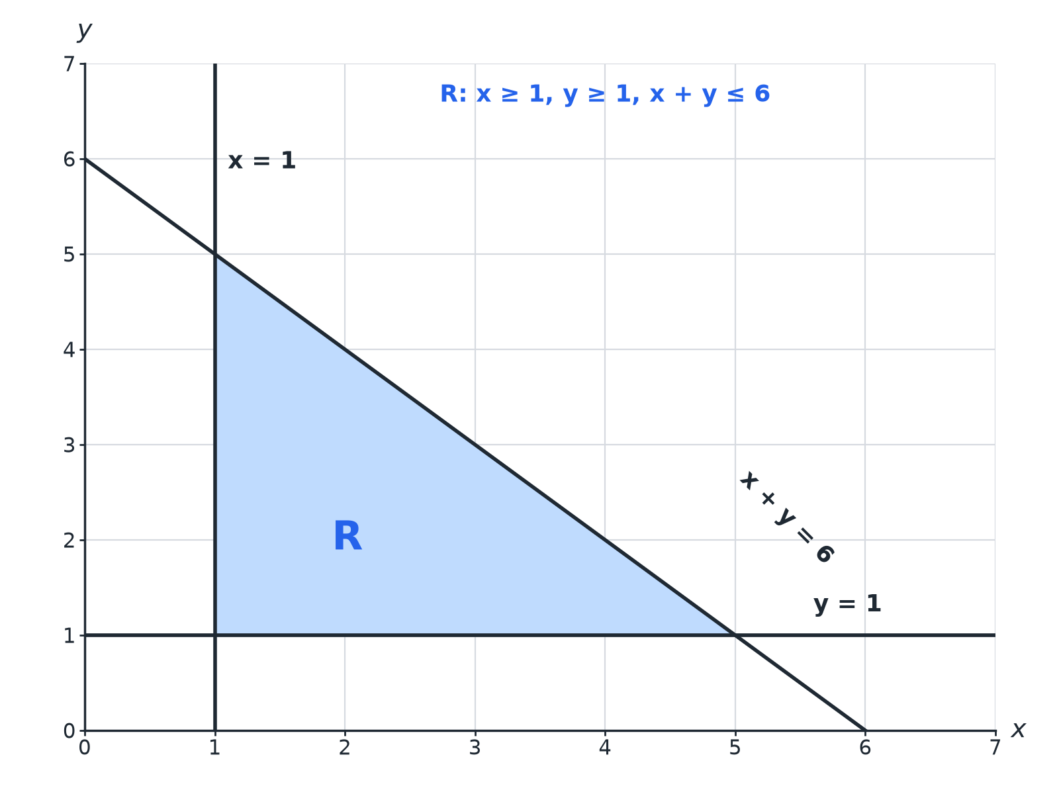
The region R satisfies all three inequalities.
A shaded triangular region R bounded by the lines x equals 1, y equals 1 and x plus y equals 6.
Solid or Dashed?
The boundary is part of the region only for ≤ and ≥.
Inequality | Boundary line | Points on the line
y ≥ 2 | Solid | Included
y > 2 | Dashed | Not included
x + y ≤ 6 | Solid | Included
y < x | Dashed | Not included
Test a Point
Show which side of the line x + y = 6 satisfies x + y ≤ 6.

1. Test the origin
0 + 0 = 0
2. Compare
0 ≤ 6 is true
3. So shade
The side of the line containing the origin
Answer: Shade the region below the line x + y = 6, including the line.
Integer Points in a Region
List the integer points in x ≥ 1, y ≥ 1, x + y ≤ 4.

1. Try x = 1
y = 1, 2, 3
2. Try x = 2
y = 1, 2
3. Try x = 3
y = 1
Answer: (1,1), (1,2), (1,3), (2,1), (2,2), (3,1)
Writing Inequalities
A region is bounded by y = 1, x = 4 and y = x, and lies above y = 1, to the left of x = 4 and below y = x. Write the inequalities.

1. Above y = 1
y ≥ 1
2. Left of x = 4
x ≤ 4
3. Below y = x
y ≤ x
Answer: y ≥ 1, x ≤ 4, y ≤ x
Tips
Keep it clear.
▸ Label R. Mark the required region clearly.
▸ Check with a point. Test one point in the region in every inequality.
▸ Boundary lines. Draw all lines even if only part of them bounds the region.
▸ Read the instruction. Some questions ask you to shade the region that is NOT wanted.
Key Terms
Inequality  A statement using <, >, ≤ or ≥. | Boundary  The line separating the region from the rest.
Region  The set of points that satisfy the inequalities. | Integer  A whole number.
Test point  A point used to decide which side to shade. | Solid line  Boundary included.
Your Task: Sketch the Region
12 minutes
Draw the region satisfying x ≥ 2, y ≥ 1 and x + y ≤ 6. List the integer points that lie in it.
1. Draw each boundary line.
2. Count integer points column by column.
A good answer shows: The region is a triangle with corners (2, 1), (5, 1) and (2, 4). Integer points: (2,1),(2,2),(2,3),(2,4),(3,1),(3,2),(3,3),(4,1),(4,2),(5,1).
Note: Ask learners to check points on the boundary.
Can I...?
☐ Draw x = a and y = b lines.
☐ Draw sloping boundary lines.
☐ Use solid and dashed lines.
☐ Test a point.
☐ Shade the correct region.
☐ Write inequalities for a region.
☐ List integer points.
☐ Label R clearly.
Summary
✓ ≤ and ≥: solid line. < and >: dashed.
✓ Test a point to decide which side to shade.
✓ The region satisfies all inequalities at once.
✓ Integer points on a solid boundary are included.

EXAM FOCUS
The diagram shows a region R. Write down the three inequalities that define R. (3 marks)
Name each boundary line first, then decide which side is R.
Exam Practice: Representing inequalities graphically
Answer all questions. Show your working. · 25 minutes
▸ Question 1 · 3 marks · Write down. The region R is shown shaded on the grid. Write down the three inequalities that define R.
▸ Question 2 · 3 marks · Write down. x and y are integers with x ≥ 1, y ≥ 1 and x + y ≤ 4. Write down all the possible pairs (x, y).
▸ Question 3 · 3 marks · Write down. A region on a grid is bounded by the lines x = 1, y = 1 and x + y = 6, and lies above y = 1, to the right of x = 1 and below x + y = 6…
▸ Question 4 · 2 marks · Explain. Explain when you would draw a dashed line rather than a solid line for the boundary of an inequality.
▸ Question 5 · 2 marks · Decide. Is the point (2, 3) in the region y > 2x − 1? Give a reason.
▸ Question 6 · 3 marks · Shade. On a grid, show by shading the region defined by x ≥ 2, y < 3 and y ≥ 0. Describe the shape you have shaded.
Question 1 · 3 marks · Write down
The region R is shown shaded on the grid. Write down the three inequalities that define R. (3 marks) | 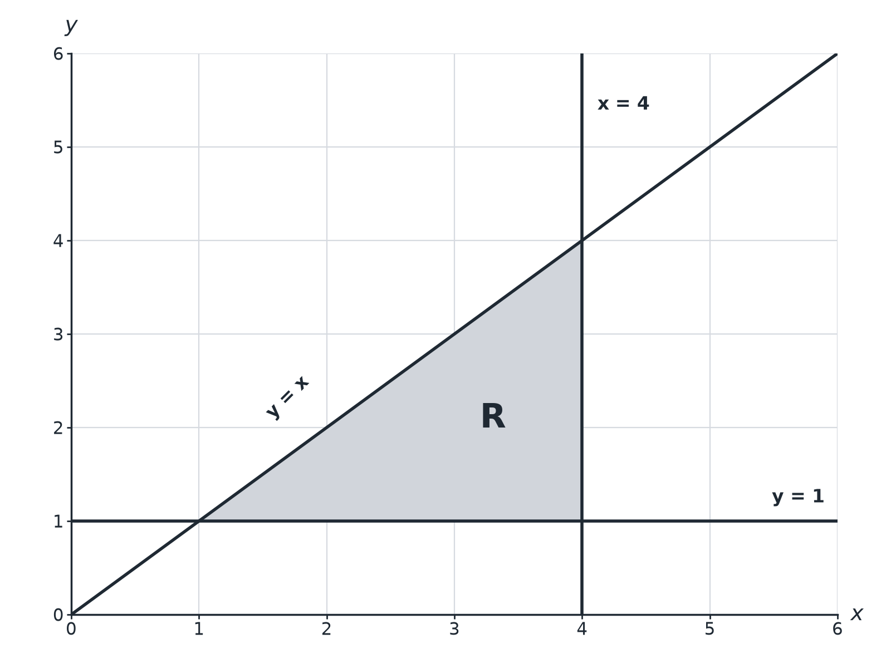

Question 1 · mark scheme
3 marks available. Award a mark for each point made.
▸ One correct inequality. B1
▸ Two correct. B1
▸ All three correct. B1
▸ Model answer. y ≥ 1, x ≤ 4, y ≤ x
Question 2 · 3 marks · Write down
“x and y are integers with x ≥ 1, y ≥ 1 and x + y ≤ 4. Write down all the possible pairs (x, y).”
HOW TO ANSWER IT Command word: Write down. Worth 3 marks, so plan before writing.
Question 2 · mark scheme
3 marks available. Award a mark for each point made.
▸ At least 3 correct pairs and none wrong. M1
▸ 5 correct. A1
▸ All 6 correct. A1
▸ Model answer. (1,1), (1,2), (1,3), (2,1), (2,2), (3,1)
Question 3 · 3 marks · Write down
“A region on a grid is bounded by the lines x = 1, y = 1 and x + y = 6, and lies above y = 1, to the right of x = 1 and below x + y = 6. Write down the three inequalities that define the region.”
HOW TO ANSWER IT Command word: Write down. Worth 3 marks, so plan before writing.
Question 3 · mark scheme
3 marks available. Award a mark for each point made.
▸ One correct. B1
▸ Two correct. B1
▸ All three. B1
▸ Model answer. x ≥ 1, y ≥ 1, x + y ≤ 6
Question 4 · 2 marks · Explain
“Explain when you would draw a dashed line rather than a solid line for the boundary of an inequality.”
HOW TO ANSWER IT Command word: Explain. Worth 2 marks, so plan before writing.
Question 4 · mark scheme
2 marks available. Award a mark for each point made.
▸ Dashed for < or >. M1
▸ Points on the line not included. C1
▸ Model answer. Use a dashed line for < or >, because points on the line are not included in the region. Use a solid line for ≤ or ≥.
Question 5 · 2 marks · Decide
“Is the point (2, 3) in the region y > 2x − 1? Give a reason.”
HOW TO ANSWER IT Command word: Decide. Worth 2 marks, so plan before writing.
Question 5 · mark scheme
2 marks available. Award a mark for each point made.
▸ Substitutes. M1
▸ No, with reason. A1
▸ Model answer. No. When x = 2, 2x − 1 = 3, and 3 > 3 is false, so the point is on the boundary, which is not included.
Question 6 · 3 marks · Shade
“On a grid, show by shading the region defined by x ≥ 2, y < 3 and y ≥ 0. Describe the shape you have shaded.”
HOW TO ANSWER IT Command word: Shade. Worth 3 marks, so plan before writing.
Question 6 · mark scheme
3 marks available. Award a mark for each point made.
▸ x = 2 solid. B1
▸ y = 3 dashed. B1
▸ Correct region. B1
▸ Model answer. A rectangular strip: the region to the right of the line x = 2 (solid), below the dashed line y = 3 and above the x-axis (solid line y = 0).

