EDEXCEL GCSE MATHS · FOUNDATION & HIGHER
Quadratic equations
Equations and graphs · Lesson 3 of 6
Teacher copy - includes the notes for whoever is teaching from it.
Warm-up
Answer each one, then check.
1. Factorise x² + 5x + 6.
(x + 2)(x + 3)
2. Expand (x + 3)(x − 1).
x² + 2x − 3
3. What is √49?
7
4. If ab = 0, what do you know?
a = 0 or b = 0
5. What is the value of 3²?
9
Learning Objectives
1. Solve a quadratic by factorising.
2. Solve a quadratic with the quadratic formula.
3. Complete the square and use it to solve.
4. Choose the most efficient method.
Quadratic Equations
A quadratic equation can be written ax² + bx + c = 0 and usually has two solutions.
Rearrange so that one side is 0 before you use any method.
Two Solutions
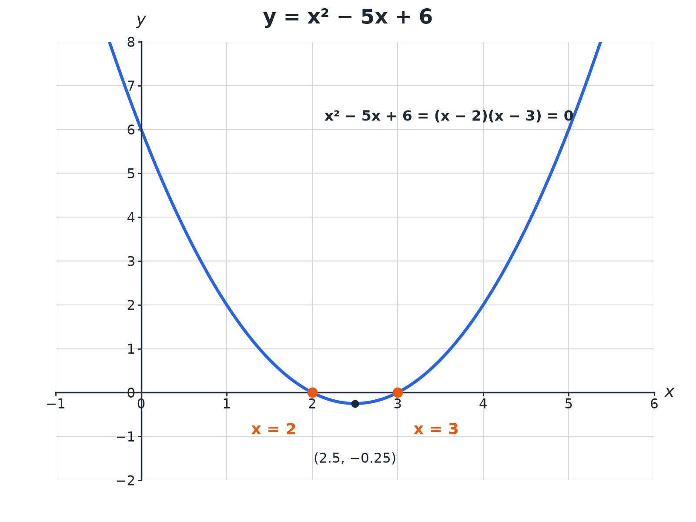
The solutions are where the graph crosses the x-axis.
A parabola crossing the x-axis at 2 and 3, showing the two solutions of x squared minus 5x plus 6 equals 0.
Choosing a Method
Use the quickest one that works.
Method | Use it when | Example
Factorising | The quadratic factorises easily | x² − 5x + 6 = 0
Formula | It does not factorise, or the answer is needed as a decimal | x² + 4x − 7 = 0
Completing the square | You need exact surds or the turning point | x² + 6x − 2 = 0
Factorising
Solve 2x² + 5x − 3 = 0.

1. Factorise
(2x − 1)(x + 3) = 0
2. Each bracket is 0
2x − 1 = 0 or x + 3 = 0
3. Solve
x = ½ or x = −3
Answer: x = ½ or x = −3
The Quadratic Formula
Solve x² + 4x − 7 = 0. Give your answers to 2 decimal places.

1. Formula
x = (−b ± √(b² − 4ac))/2a
2. Substitute a = 1, b = 4, c = −7
x = (−4 ± √(16 + 28))/2
3. Simplify
x = (−4 ± √44)/2
4. Evaluate
x = 1.32 or x = −5.32
Answer: x = 1.32 or x = −5.32
Completing the Square
Solve x² + 6x − 2 = 0 by completing the square. Give your answers to 2 decimal places.

1. Complete the square
(x + 3)² − 9 − 2 = 0
2. Simplify
(x + 3)² = 11
3. Square root
x + 3 = ± √11
4. Solve
x = −3 ± √11 = 0.32 or −6.32
Answer: x = 0.32 or x = −6.32
Common Mistakes
Avoid these.
▸ Not rearranging to 0. Move everything to one side first.
▸ Dividing by x. Solving x² = 7x by dividing loses the solution x = 0; factorise instead.
▸ Signs in the formula. Take care with −b and b² − 4ac when b or c is negative.
▸ Only one solution. Give both solutions.
Key Terms
Quadratic  An equation with a highest power of x². | Factorise  Write as a product of brackets.
Root  A solution of an equation. | Discriminant  b² − 4ac.
Completing the square  Writing x² + bx + c as (x + p)² + q. | Surd  A root that cannot be simplified to a whole number, e.g. √11.
Your Task: Choose Your Method
12 minutes
Solve each and say which method you used. (a) x² − 7x + 10 = 0 (b) x² + 2x − 5 = 0 (2 d.p.) (c) x² = 9x.
1. Look for factors first.
2. Otherwise use the formula.
A good answer shows: (a) x = 2 or 5 (factorising). (b) x = −1 ± √6 = 1.45 or −3.45 (formula or completing the square). (c) x(x − 9) = 0, so x = 0 or 9.
Note: Point out that (c) must not be divided by x.
Can I...?
☐ Rearrange to equal zero.
☐ Factorise and solve.
☐ Use the quadratic formula.
☐ Complete the square.
☐ Give answers to a given accuracy.
☐ Give both solutions.
☐ Avoid dividing by x.
☐ Choose a method.
Summary
✓ Factorise if you can.
✓ Formula: x = (−b ± √(b² − 4ac))/2a.
✓ Complete the square: (x + p)² + q.
✓ Every quadratic has up to two solutions.

EXAM FOCUS
Solve x² + 4x − 7 = 0. Give your solutions correct to 2 decimal places. (3 marks)
Write the formula first, then substitute carefully, using brackets for negatives.
Exam Practice: Quadratic equations
Answer all questions. Show your working. · 30 minutes
▸ Question 1 · 2 marks · Solve. Solve x² − 5x + 6 = 0.
▸ Question 2 · 3 marks · Solve. Solve 2x² + 5x − 3 = 0.
▸ Question 3 · 3 marks · Solve. Solve x² + 4x − 7 = 0. Give your solutions correct to 2 decimal places.
▸ Question 4 · 4 marks · Solve. (a) Write x² + 6x − 2 in the form (x + a)² + b. (b) Hence solve x² + 6x − 2 = 0. Give your answers correct to 2 decimal places.
▸ Question 5 · 2 marks · Use the graph. The graph of y = x² − 4x + 1 is shown. Use the graph to find estimates for the solutions of x² − 4x + 1 = 0.
▸ Question 6 · 2 marks · Solve. Solve x² = 7x.
Question 1 · 2 marks · Solve
“Solve x² − 5x + 6 = 0.”
HOW TO ANSWER IT Command word: Solve. Worth 2 marks, so plan before writing.
Question 1 · mark scheme
2 marks available. Award a mark for each point made.
▸ (x − 2)(x − 3). M1
▸ 2 and 3. A1
▸ Model answer. (x − 2)(x − 3) = 0, so x = 2 or x = 3.
Question 2 · 3 marks · Solve
“Solve 2x² + 5x − 3 = 0.”
HOW TO ANSWER IT Command word: Solve. Worth 3 marks, so plan before writing.
Question 2 · mark scheme
3 marks available. Award a mark for each point made.
▸ Factorises. M1
▸ One correct solution. A1
▸ Both correct. A1
▸ Model answer. (2x − 1)(x + 3) = 0, so x = ½ or x = −3.
Question 3 · 3 marks · Solve
“Solve x² + 4x − 7 = 0. Give your solutions correct to 2 decimal places.”
HOW TO ANSWER IT Command word: Solve. Worth 3 marks, so plan before writing.
Question 3 · mark scheme
3 marks available. Award a mark for each point made.
▸ Substitutes into the formula. M1
▸ (−4 ± √44)/2. A1
▸ 1.32 and −5.32. A1
▸ Model answer. x = (−4 ± √44)/2; x = 1.32 or x = −5.32.
Question 4 · 4 marks · Solve
“(a) Write x² + 6x − 2 in the form (x + a)² + b. (b) Hence solve x² + 6x − 2 = 0. Give your answers correct to 2 decimal places.”
HOW TO ANSWER IT Command word: Solve. Worth 4 marks, so plan before writing.
Question 4 · mark scheme
4 marks available. Award a mark for each point made.
▸ a = 3. B1
▸ b = −11. B1
▸ x = −3 ± √11. M1
▸ 0.32 and −6.32. A1
▸ Model answer. (a) (x + 3)² − 11. (b) x + 3 = ± √11, so x = 0.32 or x = −6.32.
Question 5 · 2 marks · Use the graph
The graph of y = x² − 4x + 1 is shown. Use the graph to find estimates for the solutions of x² − 4x + 1 = 0. (2 marks) | 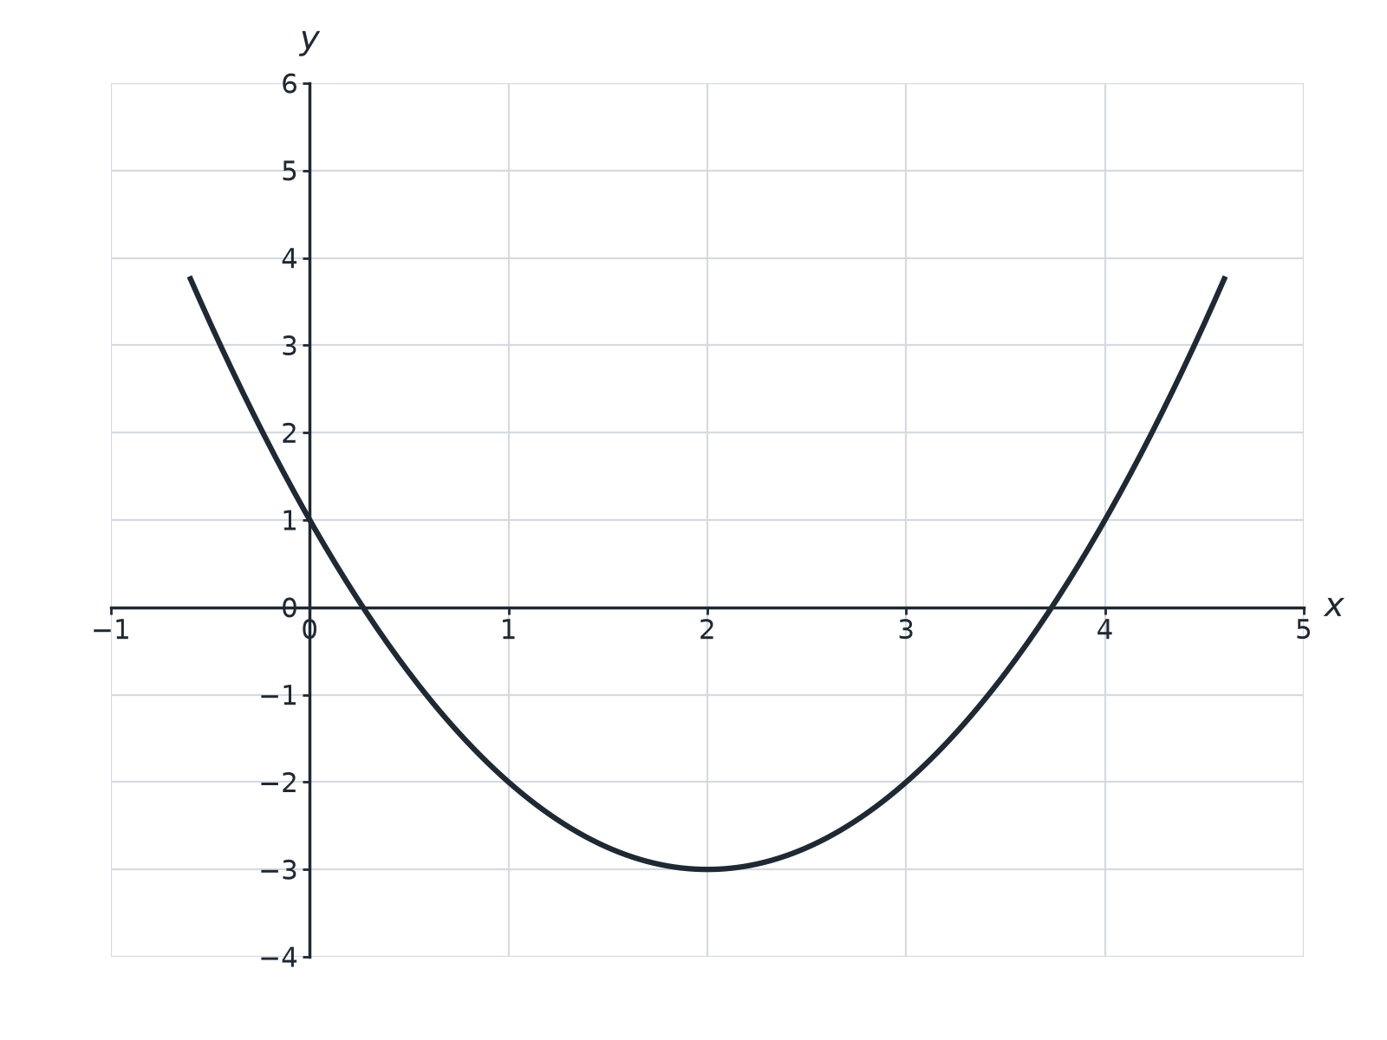

Question 5 · mark scheme
2 marks available. Award a mark for each point made.
▸ One correct estimate. B1
▸ Both correct. B1
▸ Model answer. x ≈ 0.3 and x ≈ 3.7. Accept 0.2 to 0.4 and 3.6 to 3.8.
Question 6 · 2 marks · Solve
“Solve x² = 7x.”
HOW TO ANSWER IT Command word: Solve. Worth 2 marks, so plan before writing.
Question 6 · mark scheme
2 marks available. Award a mark for each point made.
▸ x(x − 7) = 0. M1
▸ 0 and 7. A1
▸ Model answer. x² − 7x = 0, x(x − 7) = 0, so x = 0 or x = 7.

