EDEXCEL GCSE MATHS · HIGHER
Cubic equations
Equations and graphs · Lesson 5 of 6
Teacher copy - includes the notes for whoever is teaching from it.
Warm-up
Answer each one, then check.
1. Work out (−2)³.
−8
2. Factorise x² − 4.
(x − 2)(x + 2)
3. Work out 2³ − 4 × 2.
0
4. What is a root of a graph?
Where y = 0
5. What shape is y = x²?
A parabola
Learning Objectives
1. Recognise the shape of a cubic graph.
2. Complete a table and draw a cubic graph.
3. Find roots by factorising or from the graph.
4. Solve f(x) = k by drawing a horizontal line.
Cubic Graph
A cubic graph has an x³ term and a smooth S-shaped curve. It can cross the x-axis up to three times.
With a positive x³ term the curve rises from bottom left to top right.
A Cubic Graph
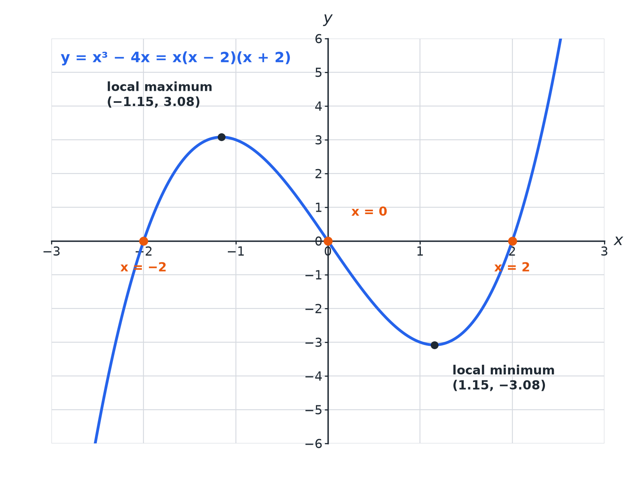
Three roots, one maximum and one minimum.
The graph of y equals x cubed minus 4x showing three roots and two turning points.
Table of Values
y = x³ − 4x.
x | −3 | −2 | −1 | 1
y | −15 | 0 | 3 | 0 | −3 | 0 | 15
Roots of a Cubic
Find the roots of y = x³ − 4x.

1. Set y = 0
x³ − 4x = 0
2. Factorise
x(x² − 4) = x(x − 2)(x + 2)
3. Solve
x = 0, 2, −2
Answer: The roots are x = −2, 0 and 2.
Solving a Cubic from the Graph
Use the graph of y = x³ − 4x to solve x³ − 4x = 1.

1. Draw
The line y = 1
2. Read the three intersections
x ≈ −1.9, −0.3 and 2.1
3. Check
2.1³ − 4 × 2.1 = 0.861, close to 1
Answer: x ≈ −1.9, x ≈ −0.3 and x ≈ 2.1
How Many Solutions?
How many solutions does x³ − 4x = 5 have?

1. Local maximum
About 3.1, below 5
2. The line y = 5
Meets the curve once, on the right
Answer: One solution.
Common Mistakes
Draw carefully.
▸ Sharp corners. The curve is smooth: no straight segments or points.
▸ Negative values. Cube negatives carefully: (−2)³ = −8.
▸ Missing solutions. A cubic can have up to three solutions.
▸ Turning point values. Read them from the graph or a fine table.
Key Terms
Cubic  An expression or equation with a highest power of x³. | Root  A solution of f(x) = 0.
Local maximum  A turning point at the top of a hill. | Local minimum  A turning point at the bottom of a valley.
Intersection  Where two graphs meet. | Estimate  An approximate value from a graph.
Your Task: Cubic Table
12 minutes
Complete a table for y = x³ − 3x for x = −2 to 2. Sketch the graph. How many roots does it have?
1. Cube each x carefully.
2. Join with a smooth curve.
A good answer shows: y = −2, 2, 0, −2, 2. The curve crosses the x-axis at x = −√3, 0, √3: three roots.
Note: Ask learners to describe where the turning points are.
Can I...?
☐ Recognise a cubic graph.
☐ Complete a table.
☐ Draw a smooth curve.
☐ Find roots.
☐ Identify turning points.
☐ Draw a line to solve an equation.
☐ Count the solutions.
☐ Avoid common mistakes.
Summary
✓ A cubic has an x³ term.
✓ It can have up to three roots and two turning points.
✓ Solve f(x) = k with the line y = k.
✓ Factorise to find exact roots.

EXAM FOCUS
Use the graph of y = x³ − 4x to find estimates for the solutions of x³ − 4x = 1. (3 marks)
Draw the horizontal line y = 1 and read all three intersections.
Exam Practice: Cubic equations
Answer all questions. Show your working. · 30 minutes
▸ Question 1 · 2 marks · Complete the table. Complete the table of values for y = x³ − 4x for x = −3, −2, −1, 0, 1, 2, 3.
▸ Question 2 · 3 marks · Use the graph. The graph of y = x³ − 4x is drawn on the grid. Use the graph to find estimates for the solutions of x³ − 4x = 1.
▸ Question 3 · 3 marks · Solve. Factorise x³ − 4x and hence solve x³ − 4x = 0.
▸ Question 4 · 2 marks · Explain. Use the graph to explain why x³ − 4x = 5 has only one solution.
▸ Question 5 · 2 marks · Work out. Work out the value of x³ − 4x when x = 1.2.
▸ Question 6 · 2 marks · Describe. Describe the shape of the graph of y = x³ and write down its root.
Question 1 · 2 marks · Complete the table
“Complete the table of values for y = x³ − 4x for x = −3, −2, −1, 0, 1, 2, 3.”
HOW TO ANSWER IT Command word: Complete the table. Worth 2 marks, so plan before writing.
Question 1 · mark scheme
2 marks available. Award a mark for each point made.
▸ At least 4 correct. M1
▸ All correct. A1
▸ Model answer. y = −15, 0, 3, 0, −3, 0, 15
Question 2 · 3 marks · Use the graph
The graph of y = x³ − 4x is drawn on the grid. Use the graph to find estimates for the solutions of x³ − 4x = 1. (3 marks) | 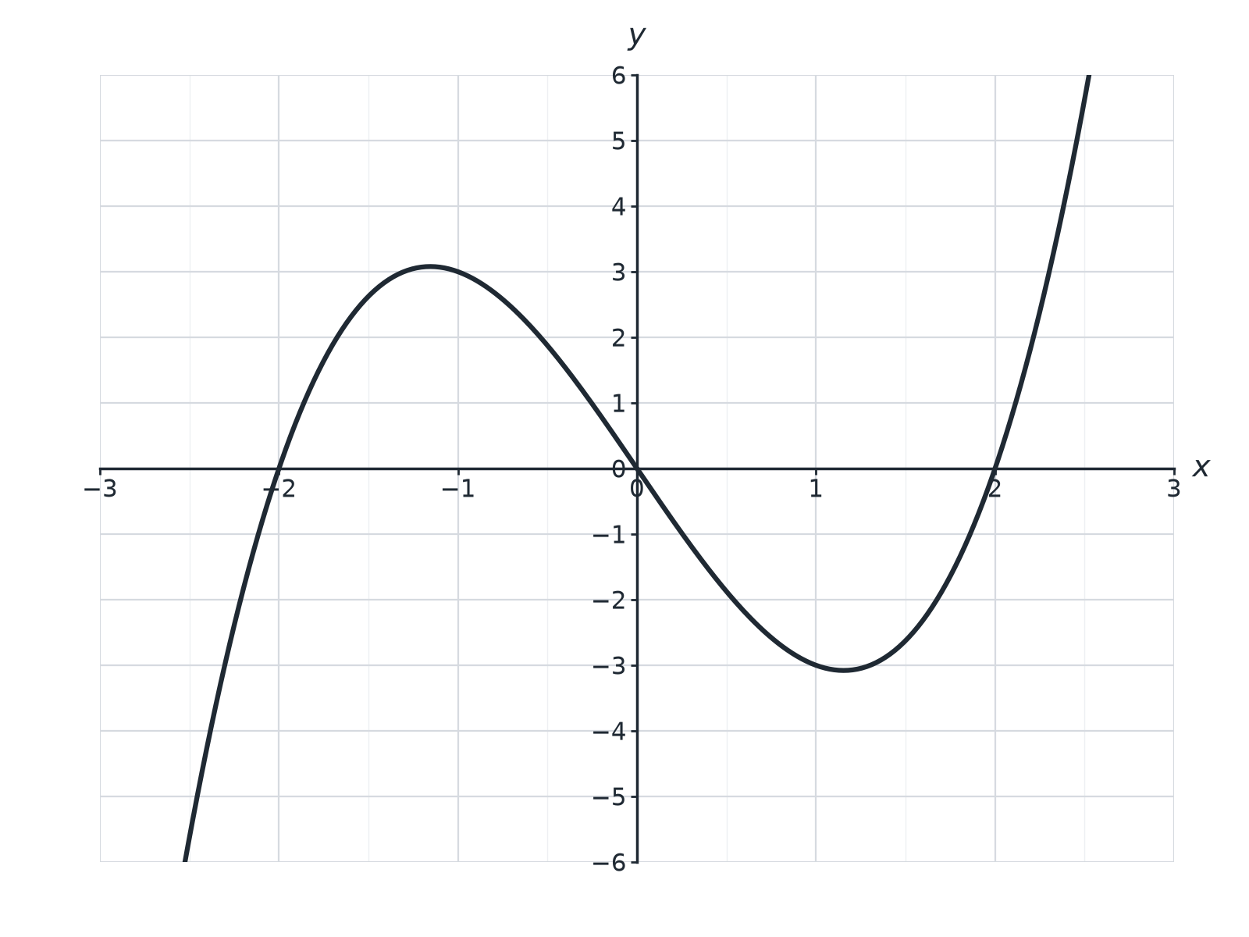

Question 2 · mark scheme
3 marks available. Award a mark for each point made.
▸ Draws y = 1. M1
▸ Two correct estimates. A1
▸ All three. A1
▸ Model answer. Draw y = 1. Solutions x ≈ −1.9, −0.3 and 2.1. Accept −2.0 to −1.8, −0.4 to −0.2 and 2.0 to 2.2.
Question 3 · 3 marks · Solve
“Factorise x³ − 4x and hence solve x³ − 4x = 0.”
HOW TO ANSWER IT Command word: Solve. Worth 3 marks, so plan before writing.
Question 3 · mark scheme
3 marks available. Award a mark for each point made.
▸ x(x² − 4). M1
▸ x(x − 2)(x + 2). A1
▸ Three solutions. A1
▸ Model answer. x(x − 2)(x + 2) = 0, so x = 0, x = 2 or x = −2.
Question 4 · 2 marks · Explain
“Use the graph to explain why x³ − 4x = 5 has only one solution.”
HOW TO ANSWER IT Command word: Explain. Worth 2 marks, so plan before writing.
Question 4 · mark scheme
2 marks available. Award a mark for each point made.
▸ Line y = 5 is above the maximum. M1
▸ Only one intersection. C1
▸ Model answer. The line y = 5 is above the local maximum of the curve (about 3.1), so it meets the curve only once, on the right.
Question 5 · 2 marks · Work out
“Work out the value of x³ − 4x when x = 1.2.”
HOW TO ANSWER IT Command word: Work out. Worth 2 marks, so plan before writing.
Question 5 · mark scheme
2 marks available. Award a mark for each point made.
▸ 1.2³ = 1.728. M1
▸ −3.072. A1
▸ Model answer. 1.728 − 4.8 = −3.072
Question 6 · 2 marks · Describe
“Describe the shape of the graph of y = x³ and write down its root.”
HOW TO ANSWER IT Command word: Describe. Worth 2 marks, so plan before writing.
Question 6 · mark scheme
2 marks available. Award a mark for each point made.
▸ S-shaped curve. B1
▸ x = 0. B1
▸ Model answer. A smooth S-shaped curve rising from bottom left to top right through the origin; the root is x = 0.

