EDEXCEL GCSE MATHS · HIGHER
Using iteration to solve equations
Equations and graphs · Lesson 6 of 6
Teacher copy - includes the notes for whoever is teaching from it.
Warm-up
Answer each one, then check.
1. Work out 1³ − 1 − 1.
−1
2. Work out 2³ − 2 − 1.
5
3. What is ∛8?
2
4. What does ANS do on a calculator?
Uses the previous answer
5. What does "to 2 decimal places" mean?
Rounded to two digits after the point
Learning Objectives
1. Show that a root lies between two values.
2. Use decimal search to narrow down a root.
3. Use an iteration formula x_(n+1) = f(x_n).
4. Rearrange an equation into an iteration formula.
Change Of Sign
If f(a) and f(b) have opposite signs, the graph crosses the x-axis between a and b, so there is a root in that interval.
This works when f is continuous, with no breaks in the curve.
Iteration Staircase
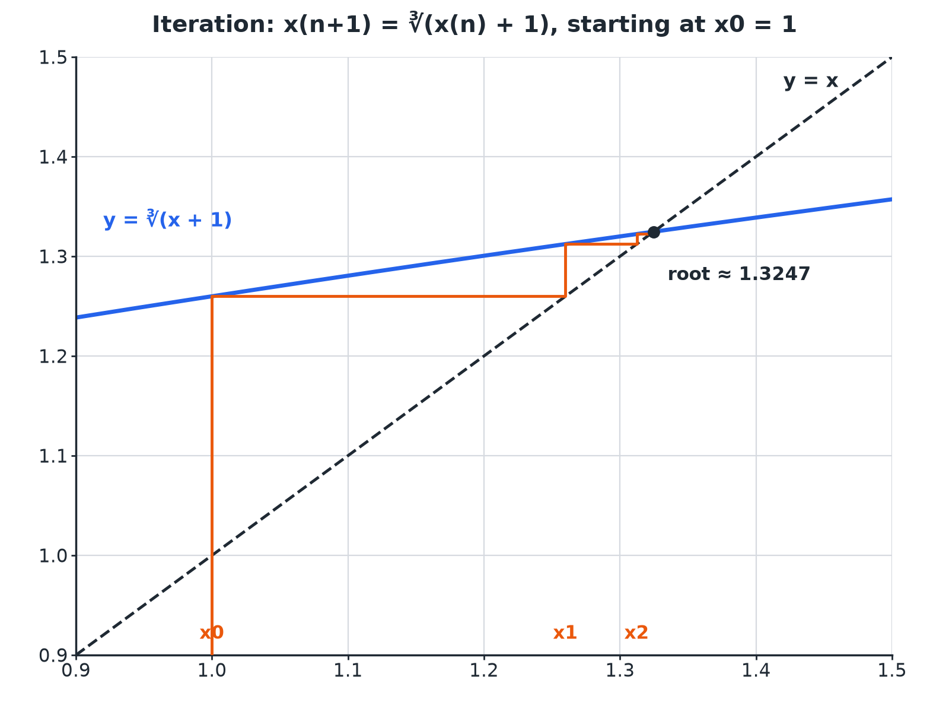
Each step feeds the last answer back in, moving towards the root.
A staircase diagram showing iteration converging to the intersection of y equals x and y equals the cube root of x plus 1.
Change of Sign
Show that x³ − x − 1 = 0 has a root between 1 and 2.

1. Write the function
f(x) = x³ − x − 1
2. f(1)
1 − 1 − 1 = −1
3. f(2)
8 − 2 − 1 = 5
4. Sign change
Negative to positive
Answer: f(1) < 0 and f(2) > 0, so there is a root between 1 and 2.
Decimal Search
Find the root of x³ − x − 1 = 0 to 2 decimal places.

1. f(1.3)
−0.103 (negative)
2. f(1.4)
0.344 (positive)
3. f(1.32)
−0.020 (negative)
4. f(1.33)
0.023 (positive)
5. Midpoint f(1.325)
0.001 (positive), so the root is below 1.325
Answer: The root is 1.32 to 2 decimal places.
Iteration
x_(n+1) = ∛(x_n + 1) with x₀ = 1. Work out x₁, x₂ and x₃.

1. x₁
∛2 = 1.2599
2. x₂
∛(1.2599 + 1) = 1.3123
3. x₃
∛(1.3123 + 1) = 1.3224
Answer: x₁ = 1.2599, x₂ = 1.3123, x₃ = 1.3224; the values are approaching the root 1.3247.
Rearranging to an Iteration Formula
Show that x³ − x − 1 = 0 can be rearranged to x = ∛(x + 1).

1. Add x + 1
x³ = x + 1
2. Cube root
x = ∛(x + 1)
Answer: x³ − x − 1 = 0 gives x³ = x + 1, so x = ∛(x + 1).
Calculator Tips
Use your calculator efficiently.
▸ Type the starting value. Press =, then type the formula using ANS.
▸ Keep pressing =. Each press gives the next term.
▸ Do not round in between. Use the full value from ANS.
▸ Compare. When two terms agree to the accuracy needed, stop.
Key Terms
Iteration  Repeating a calculation using the previous answer. | Iteration formula  A rule x_(n+1) = f(x_n).
Starting value  The first value, x₀. | Change of sign  f(a) and f(b) have opposite signs.
Root  A value of x where f(x) = 0. | Convergence  The values getting closer to a limit.
Your Task: Close In on a Root
12 minutes
(a) Show that x³ + 2x − 7 = 0 has a root between 1 and 2. (b) Use decimal search to find the root to 1 decimal place.
1. Test the midpoint of the last interval.
2. Decide which way to round.
A good answer shows: (a) f(1) = −4, f(2) = 5. (b) f(1.5) = −0.625, f(1.6) = 0.296, f(1.55) = −0.176; the root is between 1.55 and 1.6, so it is 1.6 to 1 d.p.
Note: Discuss why testing the midpoint 1.55 settles the rounding.
Can I...?
☐ Evaluate f(a) and f(b).
☐ Explain a change of sign.
☐ Use decimal search.
☐ Use a starting value.
☐ Use ANS on a calculator.
☐ Use an iteration formula.
☐ Rearrange to an iteration formula.
☐ Stop at the required accuracy.
Summary
✓ Change of sign shows a root in an interval.
✓ Decimal search narrows the interval.
✓ Iteration: feed each answer back into the formula.
✓ Stop when values agree to the required accuracy.

EXAM FOCUS
Show that x³ − x − 1 = 0 has a root between 1 and 2. (2 marks)
Show both values of f and state that the sign changes.
Exam Practice: Using iteration to solve equations
Answer all questions. Show your working. · 30 minutes
▸ Question 1 · 2 marks · Show that. Show that the equation x³ − x − 1 = 0 has a root between 1 and 2.
▸ Question 2 · 3 marks · Work out. x_(n+1) = ∛(x_n + 1) and x₀ = 1. Work out the values of x₁, x₂ and x₃.
▸ Question 3 · 2 marks · Show that. Show that x³ − x − 1 = 0 can be rearranged to give x = ∛(x + 1).
▸ Question 4 · 4 marks · Find. The graph of y = x³ − x − 1 is shown. It crosses the x-axis between x = 1 and x = 2. Use a trial and improvement method to find this root…
▸ Question 5 · 4 marks · Find. (a) Show that x³ + 2x − 7 = 0 has a root between 1 and 2. (b) Find this root correct to 1 decimal place.
▸ Question 6 · 2 marks · Explain. Using x_(n+1) = ∛(x_n + 1) with x₀ = 1, the values are x₅ = 1.32463 and x₆ = 1.32470. Write down the root of x³ − x − 1 = 0 to 3 decimal…
Question 1 · 2 marks · Show that
“Show that the equation x³ − x − 1 = 0 has a root between 1 and 2.”
HOW TO ANSWER IT Command word: Show that. Worth 2 marks, so plan before writing.
Question 1 · mark scheme
2 marks available. Award a mark for each point made.
▸ f(1) = −1 and f(2) = 5. M1
▸ Change of sign conclusion. C1
▸ Model answer. f(1) = −1 and f(2) = 5. There is a change of sign, so a root lies between 1 and 2.
Question 2 · 3 marks · Work out
“x_(n+1) = ∛(x_n + 1) and x₀ = 1. Work out the values of x₁, x₂ and x₃.”
HOW TO ANSWER IT Command word: Work out. Worth 3 marks, so plan before writing.
Question 2 · mark scheme
3 marks available. Award a mark for each point made.
▸ x₁ = 1.26. B1
▸ x₂ = 1.31. B1
▸ x₃ = 1.32. B1
▸ Model answer. x₁ = 1.2599, x₂ = 1.3123, x₃ = 1.3224
Question 3 · 2 marks · Show that
“Show that x³ − x − 1 = 0 can be rearranged to give x = ∛(x + 1).”
HOW TO ANSWER IT Command word: Show that. Worth 2 marks, so plan before writing.
Question 3 · mark scheme
2 marks available. Award a mark for each point made.
▸ x³ = x + 1. M1
▸ Cube root both sides. A1
▸ Model answer. x³ = x + 1, so x = ∛(x + 1).
Question 4 · 4 marks · Find
The graph of y = x³ − x − 1 is shown. It crosses the x-axis between x = 1 and x = 2. Use a trial and improvement method to find this root correct to 1 decimal place. You must show all your working. (4 marks) | 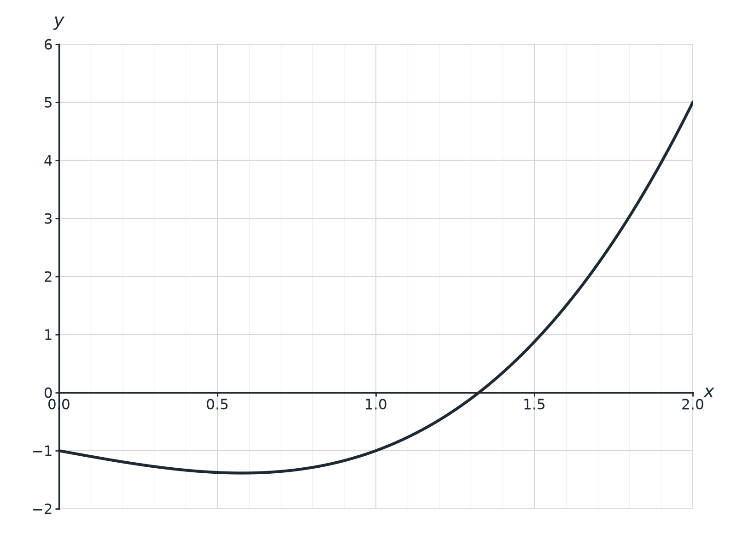

Question 4 · mark scheme
4 marks available. Award a mark for each point made.
▸ Tests values in the interval. M1
▸ f(1.3) < 0 and f(1.4) > 0. A1
▸ Tests 1.35. M1
▸ 1.3. A1
▸ Model answer. f(1.3) = −0.103; f(1.4) = 0.344; the root is between 1.3 and 1.4. f(1.35) = 0.1104 (positive), so the root is below 1.35 and the answer is 1.3.
Question 5 · 4 marks · Find
“(a) Show that x³ + 2x − 7 = 0 has a root between 1 and 2. (b) Find this root correct to 1 decimal place.”
HOW TO ANSWER IT Command word: Find. Worth 4 marks, so plan before writing.
Question 5 · mark scheme
4 marks available. Award a mark for each point made.
▸ f(1) = −4 and f(2) = 5. B1
▸ Tests 1.5 or 1.6. M1
▸ Tests 1.55. M1
▸ 1.6. A1
▸ Model answer. (a) f(1) = −4, f(2) = 5: change of sign. (b) f(1.5) = −0.625, f(1.6) = 0.296, f(1.55) = −0.176, so the root is between 1.55 and 1.6: 1.6.
Question 6 · 2 marks · Explain
“Using x_(n+1) = ∛(x_n + 1) with x₀ = 1, the values are x₅ = 1.32463 and x₆ = 1.32470. Write down the root of x³ − x − 1 = 0 to 3 decimal places and explain how you know.”
HOW TO ANSWER IT Command word: Explain. Worth 2 marks, so plan before writing.
Question 6 · mark scheme
2 marks available. Award a mark for each point made.
▸ 1.325. B1
▸ Successive values agree to 3 d.p.. C1
▸ Model answer. 1.325, because both x₅ and x₆ round to 1.325 to 3 decimal places.

