AQA GCSE PHYSICS · PAPER 1 · FOUNDATION & HIGHER
Energy stores and systems
Energy · Lesson 1 of 7
Teacher copy - includes the notes for whoever is teaching from it.
Warm-up
Answer each one, then check.
1. What is the unit of energy?
The joule (J)
2. What is a system?
An object or group of objects
3. Name the energy store in a stretched spring.
Elastic potential
4. Name the energy store in food and fuels.
Chemical
5. Can energy be created or destroyed?
No, it can only be transferred, stored or dissipated
Learning Objectives
1. Define a system and describe changes in the way energy is stored when a system changes.
2. Name the main energy stores and the four transfer pathways.
3. Describe the energy changes in common situations, such as an object projected upwards or a kettle boiling water.
4. Write clear statements using the phrase 'energy is transferred from ... to ...'.
Conservation Of Energy
Energy cannot be created or destroyed. It can be transferred usefully, stored or dissipated.
A system is an object or group of objects. When a system changes, there are changes in the way energy is stored.
Energy Changes in Two Systems
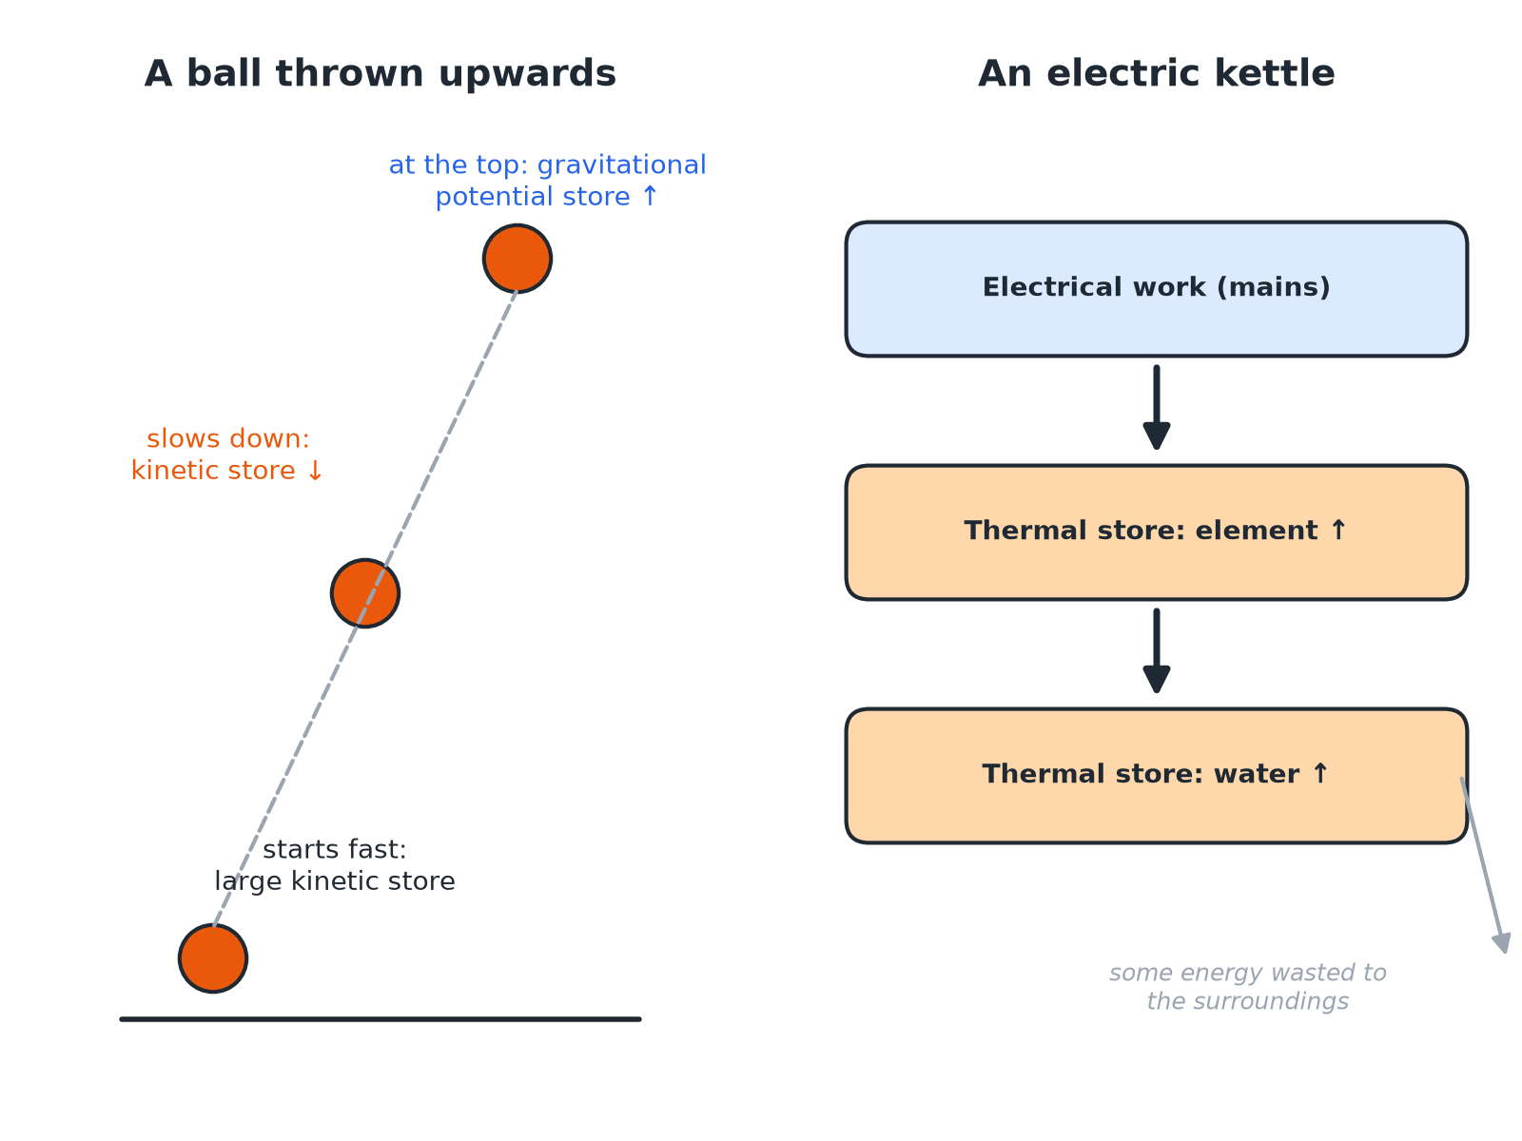
Ask 'which store goes down and which goes up?' for every change.
A ball thrown up changing kinetic energy into gravitational potential energy, and a kettle transferring electrical energy to the thermal store of water.
The Energy Stores
Learn the main stores and an example of each.
Energy store | Examples
Kinetic | Any moving object
Gravitational potential | An object above the ground
Elastic potential | A stretched or compressed spring, an elastic band
Thermal | A hot object; the particles have more energy
Chemical | Fuels, food, batteries
Nuclear | The nucleus of an atom
Magnetic | Magnets and electromagnets
Electrostatic | Charged objects, such as a charged balloon
Ways Energy Is Transferred
Mechanically  A force moves an object through a distance (work done). | Electrically  Charge flows in a circuit (work done by the current).
By heating  Energy flows from a hotter object to a cooler one. | By radiation  Energy is carried by waves, such as light and sound.
A Ball Thrown Upwards
Describe the changes in the way energy is stored when a ball is thrown upwards, until it reaches its highest point.

1. Just after leaving the hand
The ball has a large kinetic energy store
2. As it rises
It slows down, so the kinetic energy store decreases
3. At the same time
Its height increases, so the gravitational potential energy store increases
4. Small effect
Some energy is transferred to the thermal store of the air by friction
Answer: Energy is transferred mechanically from the kinetic store to the gravitational potential store, with a little dissipated to the thermal store of the air.
Boiling Water in a Kettle
Describe the changes in the way energy is stored when a kettle boils water.

1. Electrical work
Charge flowing through the heating element transfers energy from the mains
2. Heating element
The thermal energy store of the element increases
3. By heating
Energy is transferred to the thermal energy store of the water, which increases
4. Wasted
Some energy heats the kettle and the surroundings
Answer: Energy is transferred electrically and then by heating to the thermal store of the water; some is dissipated to the surroundings.
Writing Good Answers
Use the language of stores and transfers.
▸ Name the stores. Say 'the kinetic energy store decreases', not 'kinetic energy is lost'.
▸ Say how. Give the pathway: mechanically, electrically, by heating or by radiation.
▸ Say where the rest goes. Mention dissipation to the surroundings if the system is not perfectly efficient.
▸ Total energy. The total energy after the change is the same as before.
Key Terms
System  An object or group of objects. | Energy store  A way energy is held, such as kinetic or thermal.
Transfer  Energy moving from one store to another. | Dissipated  Spread out to the surroundings in less useful stores.
Closed system  A system where no energy enters or leaves. | Work done  Energy transferred by a force or a current.
Your Task: Store to Store
10 minutes
For each situation, name the store that decreases and the store that increases. (a) A car braking. (b) A book falling off a shelf. (c) A battery powering a motor lifting a weight. (d) A bow being drawn and released.
1. Name the store before.
2. Name the store after.
A good answer shows: (a) Kinetic decreases; thermal (brakes) increases. (b) Gravitational potential decreases; kinetic increases. (c) Chemical decreases; gravitational potential increases (plus some thermal). (d) Chemical (archer) to elastic potential, then elastic decreases; kinetic of the arrow increases.
Note: Ask learners to name the pathway for each change.
Can I...?
☐ Name the main energy stores.
☐ Name the four transfer pathways.
☐ Define a system.
☐ Describe energy changes for an object projected upwards.
☐ Describe energy changes when a vehicle slows down.
☐ Describe how a kettle heats water.
☐ Use 'increases' and 'decreases' correctly.
☐ State that total energy is conserved.
Summary
✓ Energy can be transferred, stored or dissipated but not created or destroyed.
✓ Describe changes with 'store decreases' and 'store increases'.
✓ Pathways: mechanically, electrically, by heating, by radiation.
✓ In a closed system the total energy does not change.

EXAM FOCUS
A car slows down to a stop using its brakes. Describe the changes in the way energy is stored. (2 marks)
Say which store decreases and which increases.
Exam Practice: Energy stores and systems
Answer all questions. Use the mark allocation as a guide to how much to write. · 13 minutes
▸ Question 1 · 1 mark · Which. A ball is thrown upwards. Which energy store increases as the ball rises? Tick one box. kinetic / gravitational potential / thermal /…
▸ Question 2 · 2 marks · Describe. A car slows down to a stop using its brakes. Describe the changes in the way energy is stored.
▸ Question 3 · 3 marks · Describe. An electric kettle is used to bring water to the boil. Describe the changes in the way energy is stored.
▸ Question 4 · 2 marks · Describe. A box slides across a rough floor and comes to rest. Describe the changes in the way energy is stored.
▸ Question 5 · 4 marks · Describe. A bungee jumper steps off a platform, falls, and comes to rest momentarily at the lowest point when the cord is stretched. Describe the…
Question 1 · 1 mark · Which
“A ball is thrown upwards. Which energy store increases as the ball rises? Tick one box. kinetic / gravitational potential / thermal / chemical”
HOW TO ANSWER IT Command word: Which. Worth 1 mark, so plan before writing.
Question 1 · mark scheme
1 mark available. Award a mark for each point made.
▸ Gravitational potential. 1 mark
▸ Model answer. Gravitational potential.
Question 2 · 2 marks · Describe
“A car slows down to a stop using its brakes. Describe the changes in the way energy is stored.”
HOW TO ANSWER IT Command word: Describe. Worth 2 marks, so plan before writing.
Question 2 · mark scheme
2 marks available. Award a mark for each point made.
▸ Kinetic energy store decreases. 1 mark
▸ Thermal energy store of the brakes or surroundings increases. 1 mark
▸ Model answer. The kinetic energy store of the car decreases. The thermal energy store of the brakes (and surroundings) increases.
Question 3 · 3 marks · Describe
“An electric kettle is used to bring water to the boil. Describe the changes in the way energy is stored.”
HOW TO ANSWER IT Command word: Describe. Worth 3 marks, so plan before writing.
Question 3 · mark scheme
3 marks available. Award a mark for each point made.
▸ Electrical transfer from the mains. 1 mark
▸ Thermal store of the water increases. 1 mark
▸ Some energy dissipated to the surroundings. 1 mark
▸ Model answer. Energy is transferred electrically to the thermal energy store of the heating element and then by heating to the thermal energy store of the water, which increases. Some energy is transferred to the thermal energy store of the surroundings.
Question 4 · 2 marks · Describe
“A box slides across a rough floor and comes to rest. Describe the changes in the way energy is stored.”
HOW TO ANSWER IT Command word: Describe. Worth 2 marks, so plan before writing.
Question 4 · mark scheme
2 marks available. Award a mark for each point made.
▸ Kinetic store decreases. 1 mark
▸ Thermal stores of box, floor or surroundings increase. 1 mark
▸ Model answer. The kinetic energy store of the box decreases. The thermal energy stores of the box and floor increase because of friction.
Question 5 · 4 marks · Describe
“A bungee jumper steps off a platform, falls, and comes to rest momentarily at the lowest point when the cord is stretched. Describe the changes in the way energy is stored during the fall.”
HOW TO ANSWER IT Command word: Describe. Worth 4 marks, so plan before writing.
Question 5 · mark scheme
4 marks available. Award a mark for each point made.
▸ Gravitational potential store decreases. 1 mark
▸ Kinetic store increases then decreases to zero. 1 mark
▸ Elastic potential energy store of the cord increases. 1 mark
▸ Some energy dissipated to the surroundings. 1 mark
▸ Model answer. The gravitational potential energy store decreases as the jumper falls. The kinetic energy store increases. As the cord stretches, the elastic potential energy store of the cord increases while the kinetic store decreases to zero at the lowest point. A small amount of energy is dissipated to the thermal energy store of the air.

