AQA GCSE PHYSICS · PAPER 1 · FOUNDATION & HIGHER
Kinetic, elastic and gravitational potential energy
Energy · Lesson 2 of 7
Teacher copy - includes the notes for whoever is teaching from it.
Warm-up
Answer each one, then check.
1. Write the unit for mass.
Kilograms (kg)
2. Convert 6.0 cm to metres.
0.060 m
3. Work out 4².
16
4. What does g stand for in E_p = mgh?
Gravitational field strength
5. What is the unit of speed?
Metres per second (m/s)
Learning Objectives
1. Recall and apply the equation for kinetic energy.
2. Recall and apply the equation for elastic potential energy.
3. Apply the equation for gravitational potential energy.
4. Use energy conservation to find speeds and heights.
5. Convert units and give answers to an appropriate number of significant figures.
Three Energy Equations
E_k = ½mv² E_e = ½ke² E_p = mgh
Learn the first two. E_p = mgh is on the equation sheet, and the value of g (9.8 N/kg) is always given in the question.
Three Stores, Three Equations
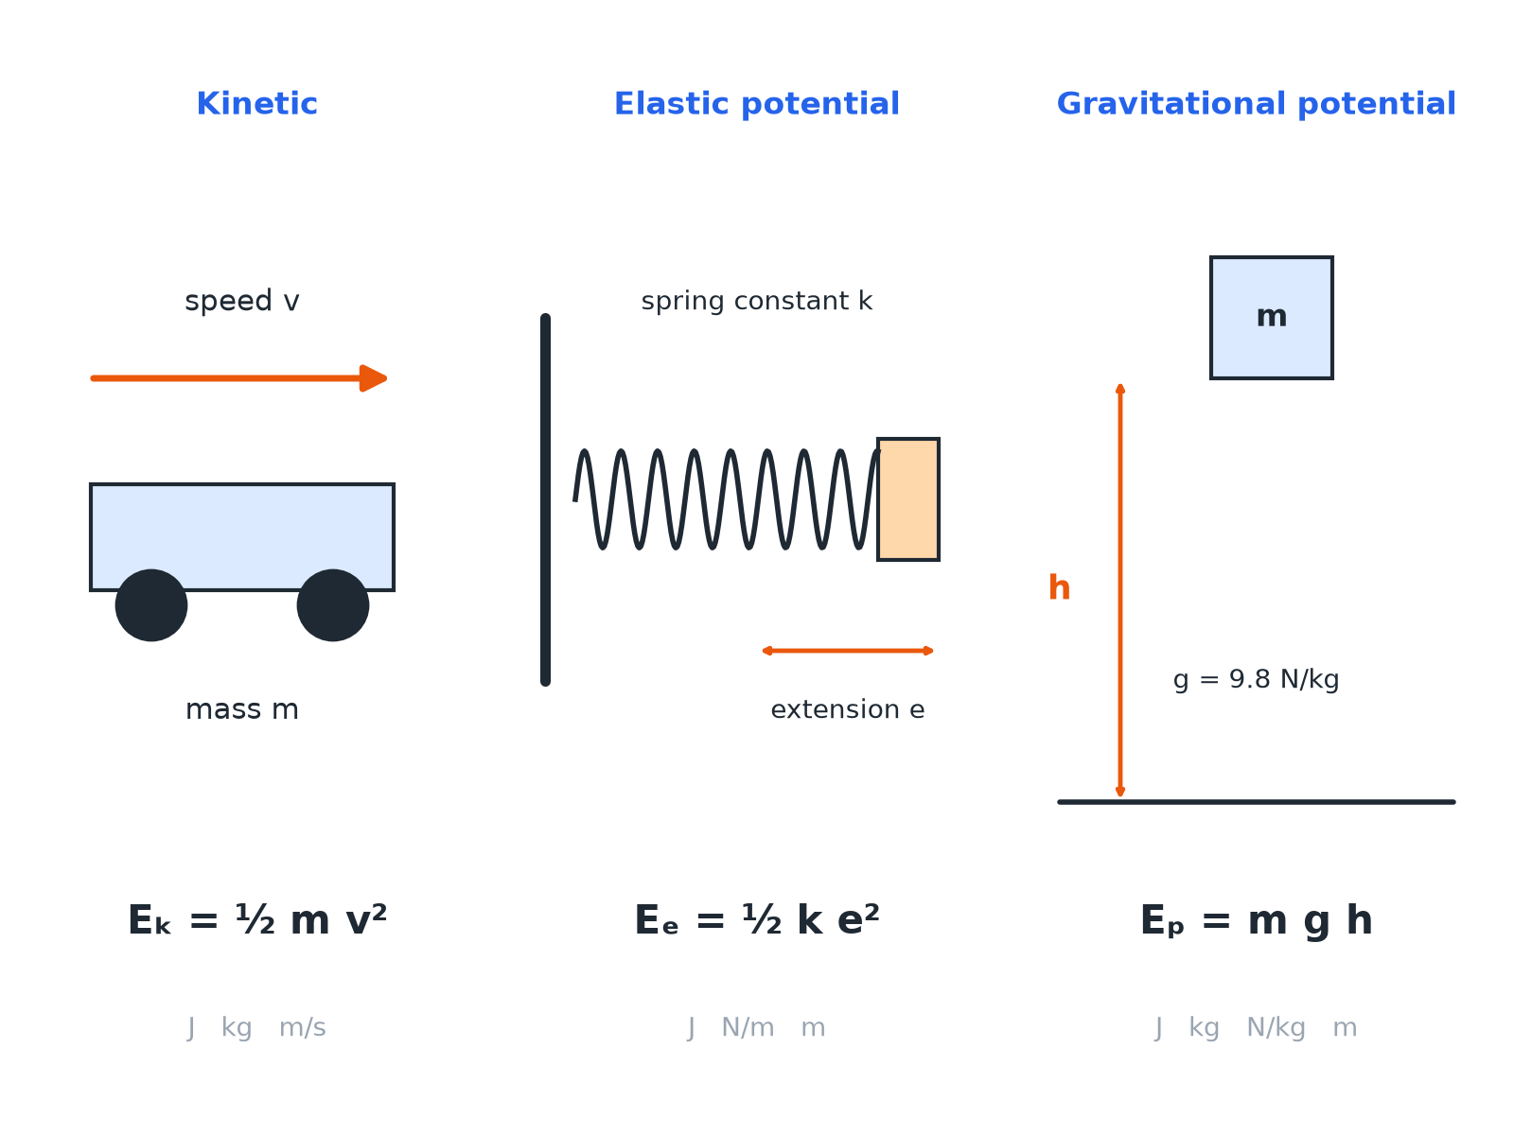
Check the units before you substitute.
Diagrams of a moving car, a stretched spring and a raised object with their energy equations.
Quantities and Units
Always use these units.
Quantity | Symbol | Unit
Kinetic energy | E_k | joules (J)
Elastic potential energy | E_e | joules (J)
Gravitational potential energy | E_p | joules (J)
Mass | m | kilograms (kg)
Speed | v | metres per second (m/s)
Spring constant | k | newtons per metre (N/m)
Extension | e | metres (m)
Gravitational field strength | g | newtons per kilogram (N/kg)
Height | h | metres (m)
Kinetic Energy
A car of mass 1200 kg travels at 15 m/s. Calculate its kinetic energy.

1. Write the equation
E_k = ½mv²
2. Substitute
E_k = 0.5 × 1200 × 15²
3. Square first
15² = 225
4. Answer
E_k = 135 000 J
Answer: Kinetic energy = 135 000 J (or 135 kJ).
Elastic Potential Energy
A spring has a spring constant of 40 N/m. It is stretched by 25 cm. Calculate the elastic potential energy stored.

1. Convert the extension
25 cm = 0.25 m
2. Substitute
E_e = 0.5 × 40 × 0.25²
3. Answer
E_e = 1.25 J
Answer: 1.25 J
Gravitational Potential Energy
A 2.0 kg book is lifted 3.0 m onto a shelf. g = 9.8 N/kg. Calculate the gain in gravitational potential energy.

1. Write the equation
E_p = mgh
2. Substitute
E_p = 2.0 × 9.8 × 3.0
3. Answer
E_p = 58.8 J
Answer: 58.8 J (about 59 J)
Using Energy Conservation
A roller coaster car starts from rest at a height of 20 m. Ignoring friction, find its speed at the bottom. g = 9.8 N/kg.

1. Gravitational potential lost equals kinetic gained
mgh = ½mv²
2. The mass cancels
v² = 2gh = 2 × 9.8 × 20 = 392
3. Square root
v = 19.8 m/s
Answer: 19.8 m/s
Common Mistakes
Marks are often lost here.
▸ Squaring. Square only the speed or extension, not the whole of ½mv.
▸ Units. Convert cm to m and g to kg before substituting.
▸ Halving. Do not forget the 0.5 in the kinetic and elastic equations.
▸ Significant figures. Give the answer to the same number of s.f. as the least accurate data, usually 2 or 3.
Key Terms
Kinetic energy  Energy stored in the movement of an object. | Elastic potential energy  Energy stored in a stretched or compressed object.
Gravitational potential energy  Energy stored in an object raised above the ground. | Spring constant  How stiff a spring is; force needed per metre of extension.
Extension  The increase in length of a spring. | Gravitational field strength  The force on each kilogram; 9.8 N/kg on Earth.
Your Task: Energy Race
12 minutes
Calculate each. (a) A 0.50 kg ball moving at 8.0 m/s. (b) A spring with k = 100 N/m stretched by 0.10 m. (c) A 60 kg climber 15 m up a cliff (g = 9.8 N/kg).
1. Write the equation.
2. Substitute and calculate.
3. Add the unit.
A good answer shows: (a) 16 J (b) 0.50 J (c) 8820 J (about 8800 J).
Note: Ask learners which store each answer is in.
Can I...?
☐ Recall the kinetic energy equation.
☐ Recall the elastic potential energy equation.
☐ Use the gravitational potential energy equation.
☐ Convert cm to m.
☐ Square the correct quantity.
☐ Use conservation of energy to find a speed.
☐ Give units and sensible significant figures.
☐ Rearrange an equation.
Summary
✓ E_k = ½mv².
✓ E_e = ½ke², with e in metres.
✓ E_p = mgh, with g given.
✓ Energy lost from one store is gained by another if no energy is dissipated.

EXAM FOCUS
A 0.40 kg ball moves at 12 m/s. Calculate its kinetic energy. (2 marks)
Write the equation, substitute, then give the unit.
Exam Practice: Kinetic, elastic and gravitational potential energy
Answer all questions. Use the mark allocation as a guide to how much to write. · 17 minutes
▸ Question 1 · 2 marks · Calculate. A ball of mass 0.40 kg moves at 12 m/s. Calculate the kinetic energy of the ball. Use the equation: kinetic energy = 0.5 × mass × (speed)²
▸ Question 2 · 3 marks · Calculate. A person of mass 55 kg climbs a ladder to a height of 4.0 m. Calculate the increase in gravitational potential energy. Gravitational field…
▸ Question 3 · 3 marks · Calculate. A spring has a spring constant of 25 N/m. It is stretched by 6.0 cm. Calculate the elastic potential energy stored in the spring. Assume…
▸ Question 4 · 4 marks · Calculate. The diagram shows a roller coaster car of mass 400 kg. It is released from rest at A. Gravitational field strength = 9.8 N/kg. (a)…
▸ Question 5 · 4 marks · Calculate. A ball of mass 0.050 kg is thrown vertically upwards at 20 m/s. Assume there is no air resistance. Calculate the maximum height reached by…
Question 1 · 2 marks · Calculate
“A ball of mass 0.40 kg moves at 12 m/s. Calculate the kinetic energy of the ball. Use the equation: kinetic energy = 0.5 × mass × (speed)²”
HOW TO ANSWER IT Command word: Calculate. Worth 2 marks, so plan before writing.
Question 1 · mark scheme
2 marks available. Award a mark for each point made.
▸ Correct substitution. 1 mark
▸ 28.8 J. 1 mark
▸ Model answer. E_k = 0.5 × 0.40 × 12² = 28.8 J
Question 2 · 3 marks · Calculate
“A person of mass 55 kg climbs a ladder to a height of 4.0 m. Calculate the increase in gravitational potential energy. Gravitational field strength = 9.8 N/kg. Give your answer to 2 significant figures.”
HOW TO ANSWER IT Command word: Calculate. Worth 3 marks, so plan before writing.
Question 2 · mark scheme
3 marks available. Award a mark for each point made.
▸ Correct substitution. 1 mark
▸ 2156 J. 1 mark
▸ 2200 J. 1 mark
▸ Model answer. E_p = 55 × 9.8 × 4.0 = 2156 J, which is 2200 J (2 s.f.)
Question 3 · 3 marks · Calculate
“A spring has a spring constant of 25 N/m. It is stretched by 6.0 cm. Calculate the elastic potential energy stored in the spring. Assume the limit of proportionality has not been exceeded.”
HOW TO ANSWER IT Command word: Calculate. Worth 3 marks, so plan before writing.
Question 3 · mark scheme
3 marks available. Award a mark for each point made.
▸ Converts 6.0 cm to 0.060 m. 1 mark
▸ Correct substitution. 1 mark
▸ 0.045 J. 1 mark
▸ Model answer. e = 0.060 m; E_e = 0.5 × 25 × 0.060² = 0.045 J
Question 4 · 4 marks · Calculate
The diagram shows a roller coaster car of mass 400 kg. It is released from rest at A. Gravitational field strength = 9.8 N/kg. (a) Calculate the gravitational potential energy stored when the car is at A. (b) Assume no energy is dissipated. Calculate the speed of the car at B. (4 marks) | 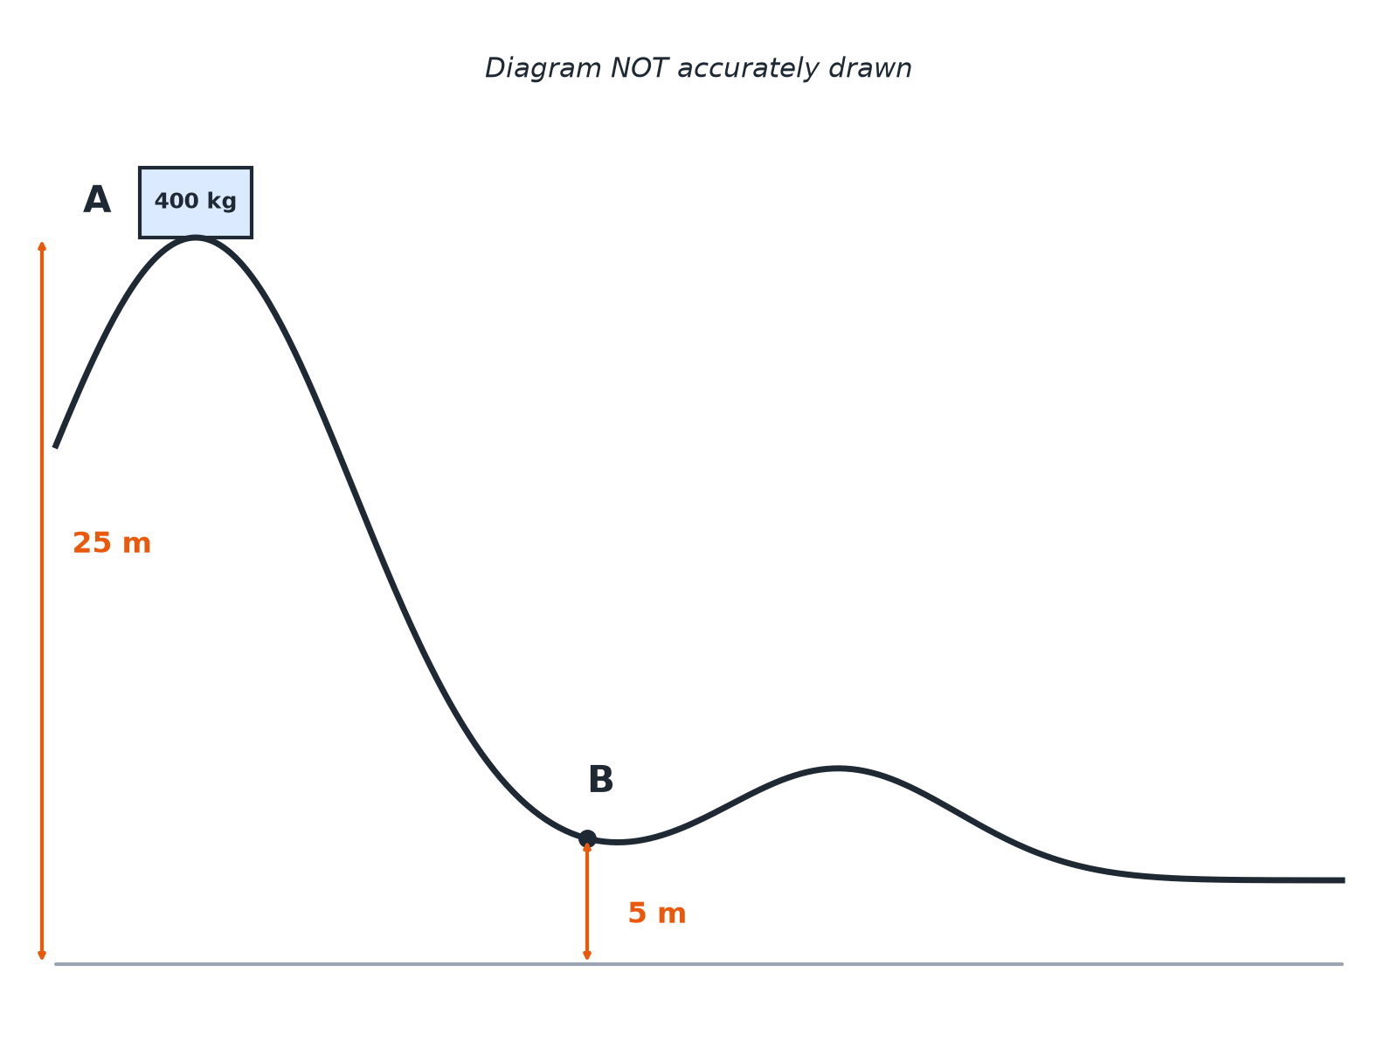

Question 4 · mark scheme
4 marks available. Award a mark for each point made.
▸ 98 000 J. 1 mark
▸ Kinetic energy gained = 78 400 J. 1 mark
▸ v² = 2E_k ÷ m. 1 mark
▸ 19.8 m/s (accept 20 m/s). 1 mark
▸ Model answer. (a) E_p = 400 × 9.8 × 25 = 98 000 J. (b) At B, E_p = 400 × 9.8 × 5 = 19 600 J. Kinetic energy = 98 000 − 19 600 = 78 400 J. v = √(2 × 78 400 ÷ 400) = 19.8 m/s
Question 5 · 4 marks · Calculate
“A ball of mass 0.050 kg is thrown vertically upwards at 20 m/s. Assume there is no air resistance. Calculate the maximum height reached by the ball. Gravitational field strength = 9.8 N/kg.”
HOW TO ANSWER IT Command word: Calculate. Worth 4 marks, so plan before writing.
Question 5 · mark scheme
4 marks available. Award a mark for each point made.
▸ Kinetic energy = 10 J. 1 mark
▸ Kinetic energy equals gravitational potential energy at the top. 1 mark
▸ h = E_p ÷ (mg). 1 mark
▸ 20 m (accept 20.4 m). 1 mark
▸ Model answer. E_k = 0.5 × 0.050 × 20² = 10 J. This becomes gravitational potential energy: h = 10 ÷ (0.050 × 9.8) = 20.4 m

