AQA GCSE PHYSICS · PAPER 1 · FOUNDATION & HIGHER
Specific heat capacity
Energy · Lesson 3 of 7
Teacher copy - includes the notes for whoever is teaching from it.
Warm-up
Answer each one, then check.
1. What is the unit of temperature change used in this equation?
Degrees Celsius (°C)
2. What is the equation for power?
P = E ÷ t
3. What unit is energy measured in?
Joules
4. Convert 500 g to kilograms.
0.50 kg
5. Which store increases when a substance is heated?
Thermal
Learning Objectives
1. Define specific heat capacity.
2. Apply ΔE = mcΔθ to calculate energy, mass, temperature change or c.
3. Describe the method for Required Practical 1.
4. Explain why measured values are often too high.
5. Interpret energy against temperature graphs.
Specific Heat Capacity
The specific heat capacity of a substance is the energy needed to raise the temperature of 1 kg of the substance by 1 °C.
ΔE = mcΔθ is given on the equation sheet. The unit of c is J/kg °C. For water, c = 4200 J/kg °C.
Required Practical 1: Apparatus
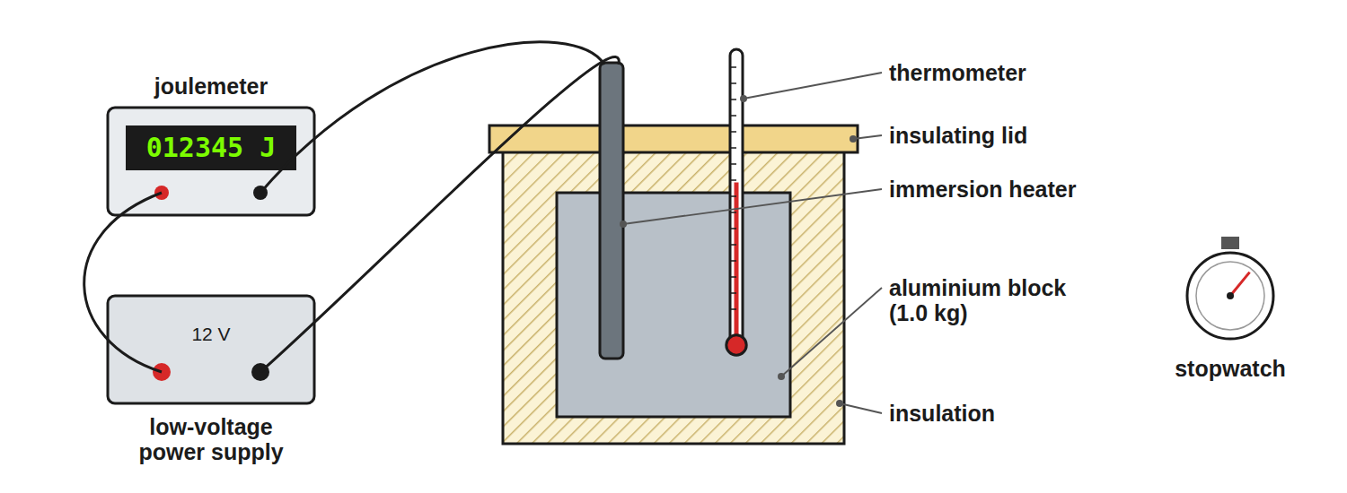
Insulation reduces energy lost to the surroundings.
Apparatus to measure specific heat capacity: an insulated metal block with an electric heater, thermometer and power supply.
Method for Required Practical 1
Find the specific heat capacity of a metal block.
1  Measure the mass  Use a balance; record m in kg. | 2  Set up  Put the heater and thermometer in the block and wrap it in insulation. | 3  Start  Record the starting temperature and switch on the heater. | 4  Record  At regular intervals record the temperature and the energy transferred (from the joulemeter, or power times time). | 5  Plot  Draw a graph of temperature against energy supplied. | 6  Calculate  The gradient is 1/mc, so c = 1/(m × gradient).
Calculating Energy
Calculate the energy needed to heat 2.0 kg of water from 20 °C to 35 °C. c = 4200 J/kg °C.

1. Temperature change
35 − 20 = 15 °C
2. Substitute
ΔE = 2.0 × 4200 × 15
3. Answer
ΔE = 126 000 J
Answer: 126 000 J (126 kJ)
Finding c
A 0.50 kg metal block needs 9000 J to raise its temperature by 20 °C. Find the specific heat capacity of the metal.

1. Rearrange
c = ΔE/mΔθ
2. Substitute
c = 9000/(0.50 × 20)
3. Answer
c = 900 J/kg °C
Answer: 900 J/kg °C
Finding the Temperature Change
3.0 kg of oil (c = 2000 J/kg °C) is given 240 kJ of energy. What is the temperature rise?

1. Convert energy
240 kJ = 240 000 J
2. Rearrange
Δθ= ΔE/mc
3. Substitute
(240 000)/(3.0 × 2000)
4. Answer
40 °C
Answer: 40 °C
Why the Result Is Too High
A very common exam question.
▸ Energy is lost. Some of the energy from the heater warms the surroundings instead of the block.
▸ So. The energy supplied is more than the energy that actually heats the block.
▸ Effect. c = ΔE/mΔθ uses the energy supplied, so the calculated value is too big.
▸ Fix. Use more insulation, add a lid, or use a lagged block.
Specific Heat Capacity or Latent Heat?
SPECIFIC HEAT CAPACITY | SPECIFIC LATENT HEAT
▸ Temperature changes.  ▸ ΔE = mcΔθ.  ▸ Unit: J/kg °C. | ▸ Temperature stays constant (a change of state).  ▸ E = mL.  ▸ Unit: J/kg.
Key Terms
Specific heat capacity  Energy needed to raise 1 kg of a substance by 1 °C. | Thermal energy  Energy stored in the moving particles of a substance.
Temperature change  Final temperature minus starting temperature, Δθ. | Insulation  A material that reduces energy transfer by heating.
Joulemeter  A meter that shows the energy transferred in joules. | Gradient  How steep a graph line is.
Your Task: Which Is Hotter?
12 minutes
1.0 kg of water and 1.0 kg of aluminium (c = 900 J/kg °C) each receive 45 000 J. Calculate the temperature rise of each and say which changes more.
1. Rearrange for temperature change.
2. Compare the two answers.
A good answer shows: Water: 45 000 ÷ (1.0 × 4200) = 10.7 °C. Aluminium: 45 000 ÷ (1.0 × 900) = 50 °C. Aluminium heats up much more.
Note: Discuss why water is good for hot water bottles and central heating.
Can I...?
☐ Recall the meaning of specific heat capacity.
☐ Use ΔE = mcΔθ.
☐ Rearrange for c.
☐ Convert kJ to J and g to kg.
☐ Describe Required Practical 1.
☐ Explain why the measured c is too high.
☐ Use a graph gradient to find c.
☐ Choose sensible units.
Summary
✓ ΔE = mcΔθ.
✓ The unit of c is J/kg °C.
✓ Measured values of c are too high if energy is lost.
✓ Insulate the block to reduce losses.

EXAM FOCUS
Calculate the energy needed to raise the temperature of 1.5 kg of water by 40 °C. c = 4200 J/kg °C. (2 marks)
Substitute all three values then multiply.
Exam Practice: Specific heat capacity
Answer all questions. Use the mark allocation as a guide to how much to write. · 19 minutes
▸ Question 1 · 2 marks · Calculate. Calculate the energy needed to raise the temperature of 1.5 kg of water by 40 °C. Specific heat capacity of water = 4200 J/kg °C. Use the…
▸ Question 2 · 4 marks · Calculate. A student heats a block of aluminium of mass 0.80 kg using a heater of power 60 W. The graph shows how the temperature of the block changes…
▸ Question 3 · 2 marks · Explain. The value of specific heat capacity found in the experiment is higher than the true value. Explain why.
▸ Question 4 · 6 marks · Describe. Describe an investigation to determine the specific heat capacity of an aluminium block. Your answer should include the apparatus…
▸ Question 5 · 2 marks · Explain. Water is used in central heating systems. Suggest why.
▸ Question 6 · 2 marks · Calculate. 250 g of water cools from 80 °C to 30 °C. Calculate the energy transferred from the water. Specific heat capacity of water = 4200 J/kg °C.
Question 1 · 2 marks · Calculate
“Calculate the energy needed to raise the temperature of 1.5 kg of water by 40 °C. Specific heat capacity of water = 4200 J/kg °C. Use the equation: change in thermal energy = mass × specific heat capacity × temperature change”
HOW TO ANSWER IT Command word: Calculate. Worth 2 marks, so plan before writing.
Question 1 · mark scheme
2 marks available. Award a mark for each point made.
▸ Correct substitution. 1 mark
▸ 252 000 J. 1 mark
▸ Model answer. 1.5 × 4200 × 40 = 252 000 J
Question 2 · 4 marks · Calculate
A student heats a block of aluminium of mass 0.80 kg using a heater of power 60 W. The graph shows how the temperature of the block changes with time. (a) Calculate the energy transferred by the heater in 300 s. (b) Use the graph and your answer to (a) to calculate the specific heat capacity of… (4 marks) | 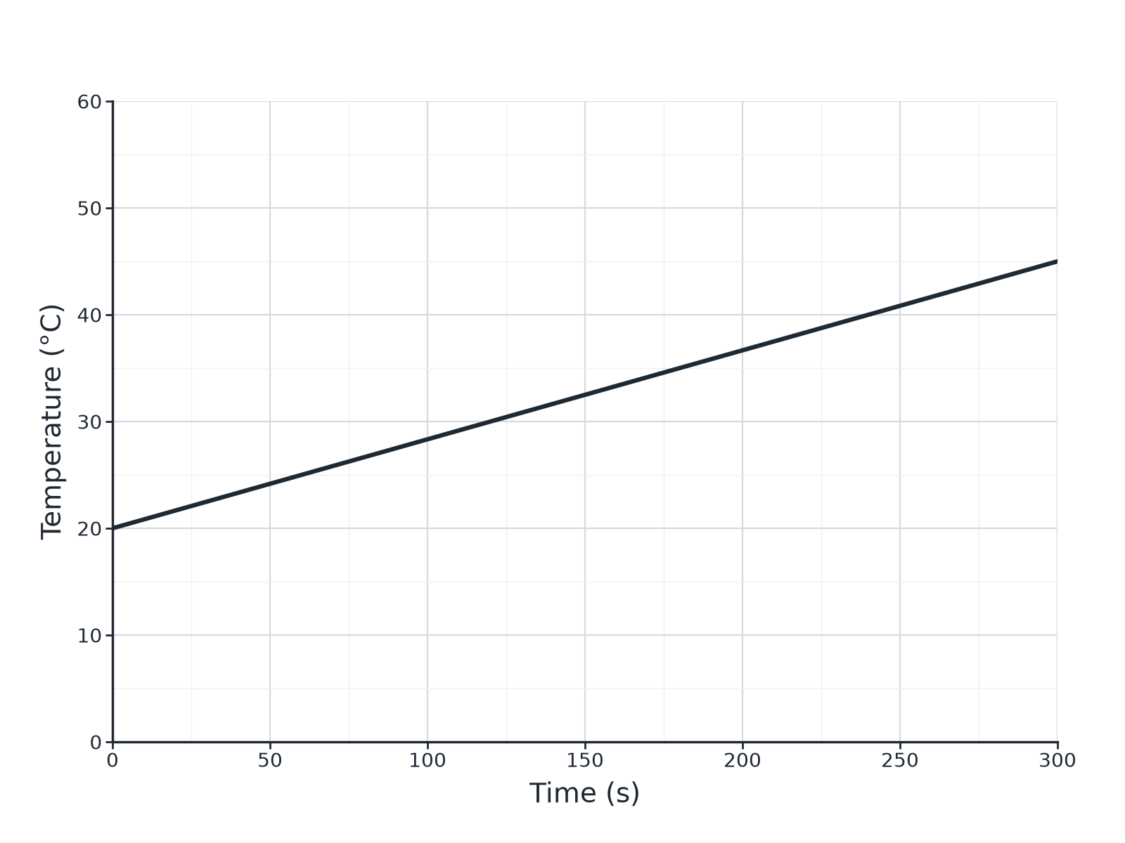

Question 2 · mark scheme
4 marks available. Award a mark for each point made.
▸ 18 000 J. 1 mark
▸ Temperature rise 25 °C read from graph. 1 mark
▸ c = ΔE ÷ (mΔθ). 1 mark
▸ 900 J/kg °C. 1 mark
▸ Model answer. (a) E = Pt = 60 × 300 = 18 000 J. (b) Temperature rise from the graph = 45 − 20 = 25 °C. c = 18 000 ÷ (0.80 × 25) = 900 J/kg °C
Question 3 · 2 marks · Explain
“The value of specific heat capacity found in the experiment is higher than the true value. Explain why.”
HOW TO ANSWER IT Command word: Explain. Worth 2 marks, so plan before writing.
Question 3 · mark scheme
2 marks available. Award a mark for each point made.
▸ Some energy is transferred to the surroundings. 1 mark
▸ Energy supplied is more than the energy stored in the block so c appears too high. 1 mark
▸ Model answer. Some energy was transferred to the surroundings, so the energy supplied is greater than the energy that heated the block. The equation then gives a larger value of c.
Question 4 · 6 marks · Describe
“Describe an investigation to determine the specific heat capacity of an aluminium block. Your answer should include the apparatus, measurements, and how you would use them to obtain the result.”
HOW TO ANSWER IT Command word: Describe. Worth 6 marks, so plan before writing.
Question 4 · mark scheme
6 marks available. Award a mark for each point made.
▸ Level 3 (5 to 6 marks): a clear, ordered method with apparatus (block, heater, thermometer, insulation, power supply or joulemeter), the measurements (mass, temperature, energy or power and time) and the calculation of c with a precaution. 5 to 6 marks
▸ Level 2 (3 to 4 marks): a method with most apparatus and measurements, and some reference to the calculation. 3 to 4 marks
▸ Level 1 (1 to 2 marks): simple statements about heating a block. 1 to 2 marks
▸ Model answer. See levels-of-response scheme.
Question 5 · 2 marks · Explain
“Water is used in central heating systems. Suggest why.”
HOW TO ANSWER IT Command word: Explain. Worth 2 marks, so plan before writing.
Question 5 · mark scheme
2 marks available. Award a mark for each point made.
▸ High specific heat capacity. 1 mark
▸ Can carry or store a lot of energy per kg per degree. 1 mark
▸ Model answer. Water has a high specific heat capacity, so it can store or carry a large amount of energy for each kilogram and each degree of temperature change.
Question 6 · 2 marks · Calculate
“250 g of water cools from 80 °C to 30 °C. Calculate the energy transferred from the water. Specific heat capacity of water = 4200 J/kg °C.”
HOW TO ANSWER IT Command word: Calculate. Worth 2 marks, so plan before writing.
Question 6 · mark scheme
2 marks available. Award a mark for each point made.
▸ Converts to 0.25 kg and uses 50 °C. 1 mark
▸ 52 500 J. 1 mark
▸ Model answer. 0.25 × 4200 × 50 = 52 500 J

