AQA GCSE PHYSICS · PAPER 1 · FOUNDATION & HIGHER
Efficiency
Energy · Lesson 6 of 7
Teacher copy - includes the notes for whoever is teaching from it.
Warm-up
Answer each one, then check.
1. What is dissipated energy?
Energy spread to the surroundings in less useful stores
2. What is 0.35 as a percentage?
35%
3. Write 60% as a decimal.
0.60
4. Give the unit of power.
Watt
5. What does 'useful' energy mean?
Energy transferred in the way we want
Learning Objectives
1. Recall and apply the efficiency equations.
2. Give efficiency as a decimal or a percentage.
3. Interpret Sankey diagrams.
4. Describe ways to increase the efficiency of an energy transfer (Higher tier).
Efficiency
efficiency = (useful output energy transfer)/(total input energy transfer)
Also: efficiency = (useful power output)/(total power input). Efficiency has no units and is never more than 1 (100%).
A Sankey Diagram
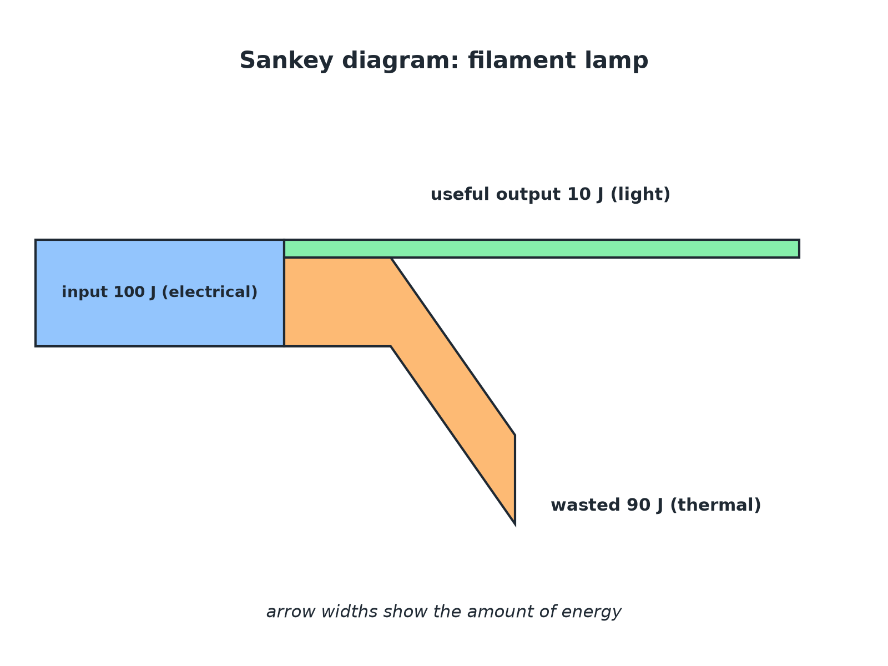
The width of each arrow shows the amount of energy.
A Sankey diagram of a lamp: 100 J in, 10 J light out and 90 J wasted as thermal energy.
Efficiency of a Lamp
A lamp transfers 100 J of electrical energy and 8 J of it is transferred as light. Calculate its efficiency.

1. Write the equation
efficiency = (useful output)/(total input)
2. Substitute
8/100
3. Decimal
0.08
4. Percentage
0.08 × 100 = 8%
Answer: Efficiency = 0.08 or 8%.
Using Power
A motor has a total power input of 500 W and a useful power output of 350 W. Calculate its efficiency as a percentage.

1. Substitute
350/500
2. Decimal
0.70
3. Percentage
70%
Answer: 70%
Finding the Useful Output
A machine is 85% efficient. How much useful energy does it transfer from a 400 J input?

1. Efficiency as a decimal
0.85
2. Multiply
0.85 × 400 = 340 J
Answer: 340 J
Ways to Increase Efficiency (Higher Tier)
Reduce the energy that is dissipated.
▸ Lubrication. Reduces friction between moving parts.
▸ Thermal insulation. Reduces energy lost by heating, for example around a boiler or a house.
▸ Streamlining. Reduces air resistance so less energy is wasted.
▸ Better design. For example LED lamps transfer more input energy as light.
▸ Higher tier. The question may ask you to suggest a way suitable for a described machine.
Common Mistakes
Check your answer.
▸ Efficiency above 1. It cannot be greater than 1 (100%): useful output cannot be more than the input.
▸ Wrong way up. Useful output goes on top.
▸ Units. Do not write J or W after an efficiency.
▸ Percent or decimal. Read the question for the form required.
Key Terms
Efficiency  The fraction of the input energy that is transferred usefully. | Useful output  Energy transferred in the way that is wanted.
Wasted energy  Energy transferred to stores that are not useful. | Sankey diagram  A diagram with arrow widths that show energy amounts.
Streamlining  Shaping an object to reduce air resistance. | Input  The energy or power supplied to a device.
Your Task: Compare the Lamps
12 minutes
LED lamp: efficiency 0.85, input power 8 W. Filament lamp: efficiency 0.10, input power 60 W. Calculate the useful power output of each and say which lamp is better.
1. Rearrange the equation for useful power.
2. Compare the two answers.
A good answer shows: LED: 0.85 × 8 = 6.8 W. Filament: 0.10 × 60 = 6.0 W. The LED gives more useful output from far less input, so it is better.
Note: Ask learners about cost.
Can I...?
☐ Recall both efficiency equations.
☐ Calculate efficiency.
☐ Convert decimal and percentage.
☐ Interpret a Sankey diagram.
☐ Explain efficiency cannot exceed 1.
☐ Find useful output from an efficiency.
☐ Describe ways to increase efficiency.
☐ Compare devices.
Summary
✓ Efficiency = useful output ÷ total input.
✓ Also useful power ÷ total power.
✓ Multiply by 100 for a percentage.
✓ Efficiency is never more than 1.

EXAM FOCUS
A device has an input of 400 J and a useful output of 100 J. Calculate the efficiency. (2 marks)
Put useful over total.
Exam Practice: Efficiency
Answer all questions. Use the mark allocation as a guide to how much to write. · 17 minutes
▸ Question 1 · 2 marks · Calculate. A device transfers 400 J of energy as input and 100 J of useful energy. Calculate the efficiency of the device. Use the equation…
▸ Question 2 · 3 marks · Use the diagram. The Sankey diagram shows the energy transfers in an electric motor. (a) Calculate the energy wasted every second. (b) Calculate the…
▸ Question 3 · 3 marks · Calculate. A lamp has an efficiency of 0.20 and a total power input of 60 W. Calculate the useful power output of the lamp.
▸ Question 4 · 2 marks · Suggest. A car engine wastes a lot of energy. Suggest two ways to increase the efficiency of the car.
▸ Question 5 · 4 marks · Compare. An LED lamp has an efficiency of 0.85 and an input power of 8 W. A filament lamp has an efficiency of 0.10 and an input power of 60 W…
▸ Question 6 · 2 marks · Explain. A student says that a machine has an efficiency of 120%. Explain why this cannot be correct.
Question 1 · 2 marks · Calculate
“A device transfers 400 J of energy as input and 100 J of useful energy. Calculate the efficiency of the device. Use the equation: efficiency = useful output energy transfer ÷ total input energy transfer”
HOW TO ANSWER IT Command word: Calculate. Worth 2 marks, so plan before writing.
Question 1 · mark scheme
2 marks available. Award a mark for each point made.
▸ Correct substitution. 1 mark
▸ 0.25 or 25%. 1 mark
▸ Model answer. 100 ÷ 400 = 0.25 (25%)
Question 2 · 3 marks · Use the diagram
The Sankey diagram shows the energy transfers in an electric motor. (a) Calculate the energy wasted every second. (b) Calculate the efficiency of the motor. (3 marks) | 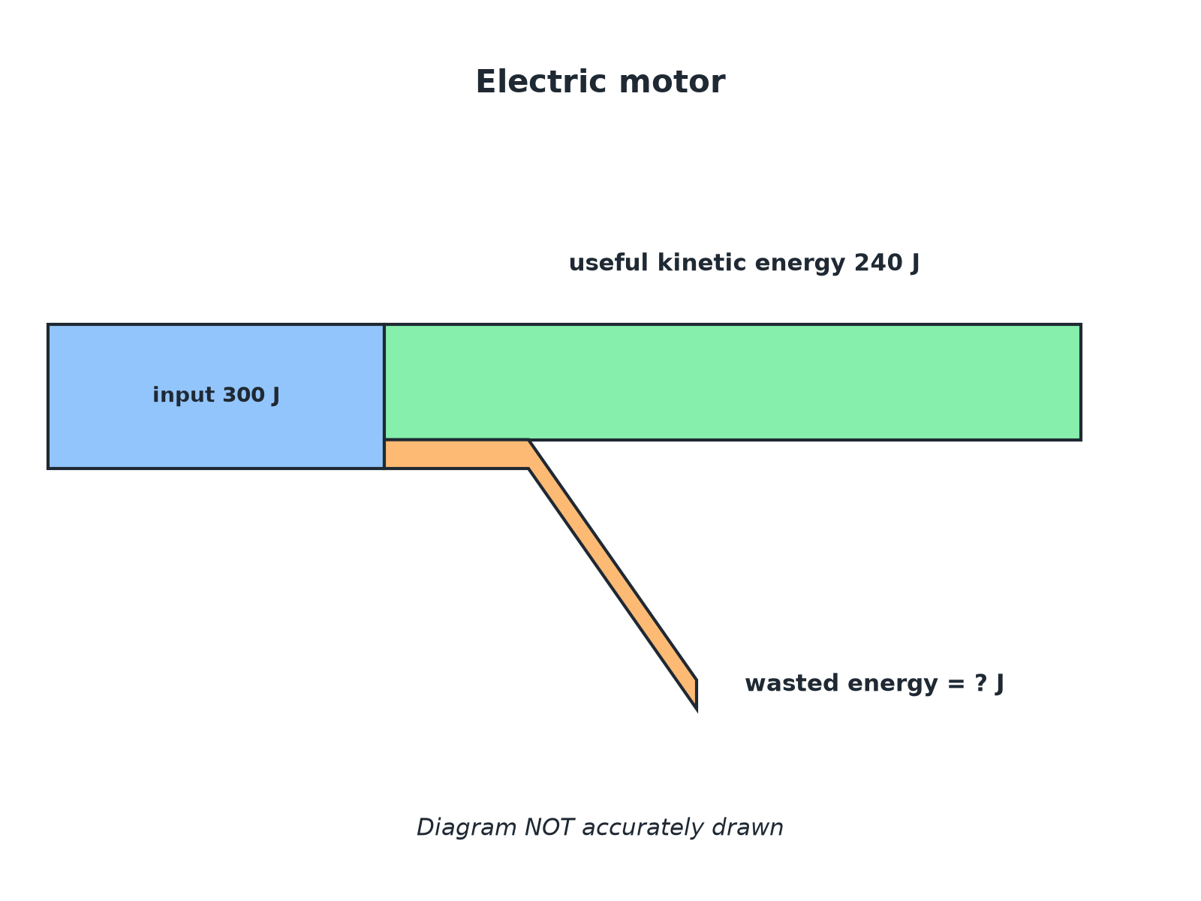

Question 2 · mark scheme
3 marks available. Award a mark for each point made.
▸ 60 J. 1 mark
▸ Correct substitution. 1 mark
▸ 0.80 or 80%. 1 mark
▸ Model answer. (a) 300 − 240 = 60 J. (b) 240 ÷ 300 = 0.80 (80%).
Question 3 · 3 marks · Calculate
“A lamp has an efficiency of 0.20 and a total power input of 60 W. Calculate the useful power output of the lamp.”
HOW TO ANSWER IT Command word: Calculate. Worth 3 marks, so plan before writing.
Question 3 · mark scheme
3 marks available. Award a mark for each point made.
▸ Rearranges to power output = efficiency × input. 1 mark
▸ Correct substitution. 1 mark
▸ 12 W. 1 mark
▸ Model answer. 0.20 × 60 = 12 W
Question 4 · 2 marks · Suggest
“A car engine wastes a lot of energy. Suggest two ways to increase the efficiency of the car.”
HOW TO ANSWER IT Command word: Suggest. Worth 2 marks, so plan before writing.
Question 4 · mark scheme
2 marks available. Award a mark for each point made.
▸ First way. 1 mark
▸ Second way. 1 mark
▸ Model answer. Any two from: lubricate moving parts to reduce friction; streamline the shape to reduce air resistance; improve insulation or design of the engine to reduce thermal losses.
Question 5 · 4 marks · Compare
“An LED lamp has an efficiency of 0.85 and an input power of 8 W. A filament lamp has an efficiency of 0.10 and an input power of 60 W. Compare the useful power output of the two lamps. Which is the better lamp? Show your calculations.”
HOW TO ANSWER IT Command word: Compare. Worth 4 marks, so plan before writing.
Question 5 · mark scheme
4 marks available. Award a mark for each point made.
▸ 6.8 W. 1 mark
▸ 6.0 W. 1 mark
▸ LED gives more useful power. 1 mark
▸ With much less input power. 1 mark
▸ Model answer. LED: 0.85 × 8 = 6.8 W. Filament: 0.10 × 60 = 6.0 W. The LED lamp transfers more useful power while using far less input power, so it is the better lamp.
Question 6 · 2 marks · Explain
“A student says that a machine has an efficiency of 120%. Explain why this cannot be correct.”
HOW TO ANSWER IT Command word: Explain. Worth 2 marks, so plan before writing.
Question 6 · mark scheme
2 marks available. Award a mark for each point made.
▸ Energy cannot be created. 1 mark
▸ Useful output cannot exceed the total input. 1 mark
▸ Model answer. Useful output cannot be greater than the input because energy cannot be created.

