AQA GCSE PHYSICS · PAPER 1 · FOUNDATION & HIGHER
National and global energy resources
Energy · Lesson 7 of 7
Teacher copy - includes the notes for whoever is teaching from it.
Warm-up
Answer each one, then check.
1. Name a fossil fuel.
Coal, oil or natural gas
2. What does renewable mean?
Can be replenished as it is used
3. What gas do fossil fuels release when burned?
Carbon dioxide
4. What is generated in a power station?
Electricity
5. Name a use of energy resources other than electricity.
Transport or heating
Learning Objectives
1. Name the main energy resources.
2. Distinguish renewable and non-renewable resources.
3. Compare their uses: transport, electricity generation, heating.
4. Explain why some resources are more reliable than others.
5. Describe environmental impacts and explain trends in resource use.
Renewable
A renewable energy resource is one that is being, or can be, replenished as it is used.
Non-renewable resources will run out: fossil fuels (coal, oil, gas) and nuclear fuel. Renewable: bio-fuel, wind, hydro-electricity, geothermal, tides, the Sun and water waves.
Renewable and Non-renewable Resources
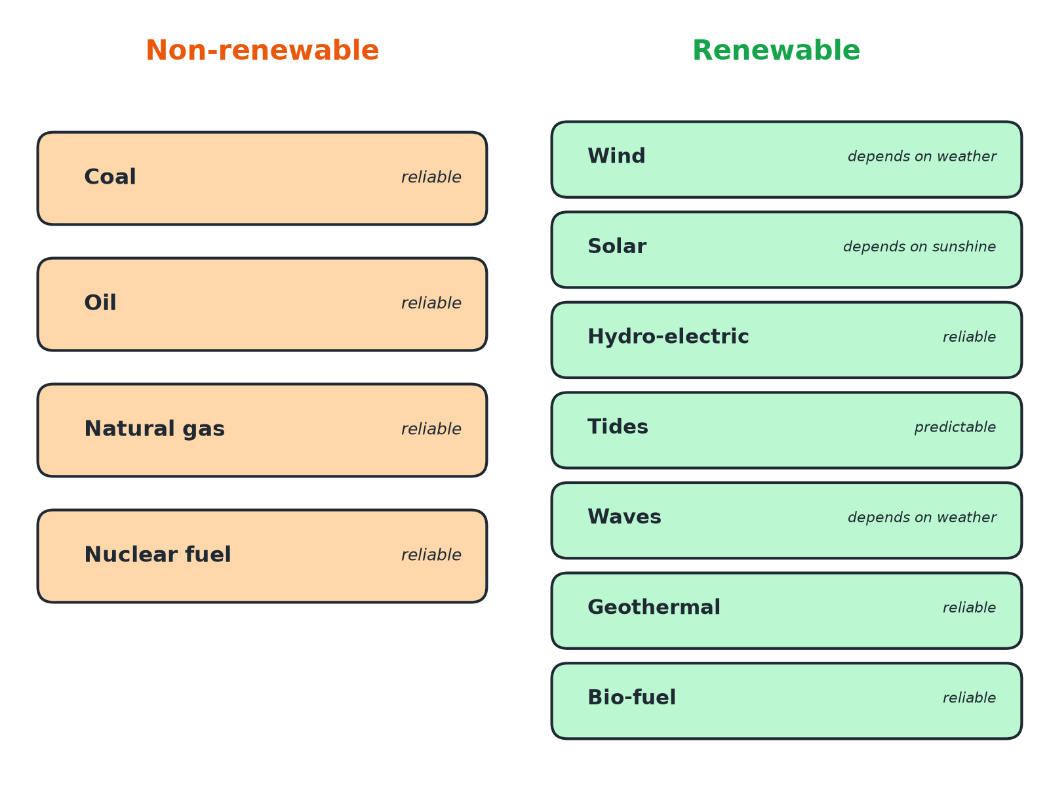
Reliable means it can produce power when needed.
Two columns showing non-renewable and renewable energy resources with their reliability.
Comparing Energy Resources
Use this to compare for evaluation questions.
Resource | Renewable? | Reliable? | Main environmental issue
Coal, oil, gas | No | Yes | Release carbon dioxide (global warming); coal and oil also cause acid rain or pollution
Nuclear fuel | No | Yes | Radioactive waste; risk of accidents; very low carbon dioxide
Wind | Yes | No: depends on wind speed | Visual and noise impact; can affect birds
Solar | Yes | No: only in daylight and sunshine | Land use for large solar farms
Hydro-electric | Yes | Mostly, if water is stored | Flooding valleys destroys habitats
Tides and waves | Yes | Tides are predictable; waves vary | Can affect marine life and sea views
Bio-fuel | Yes | Yes, can be stored | Land used for crops; carbon dioxide released when burned
Geothermal | Yes | Yes | Only possible in some places
Uses of Energy Resources
Transport  Petrol, diesel and bio-fuels power vehicles. | Electricity generation  Fossil fuels, nuclear fuel, wind, solar, hydro, tides, waves and geothermal turn generators or solar cells.
Heating  Gas and bio-fuels heat homes; geothermal and solar can heat water directly. | Descriptions of the power station process  are not required for this specification.
Why Are Some More Reliable?
Reliability means the resource can supply energy on demand.
▸ Fuels. Coal, oil, gas, nuclear fuel and bio-fuel can be stored and used when needed.
▸ Weather. Wind and solar depend on weather and time of day.
▸ Predictable. Tides are predictable because they depend on the Moon and Sun.
Patterns and Trends
Use of renewables has grown.
▸ Reasons for growth. To reduce carbon dioxide emissions, government targets, falling costs of wind and solar.
▸ Slow change. Building new power stations is expensive and takes time.
▸ Science and society. Science can identify environmental problems but political, social, ethical and economic factors decide how they are tackled.
Key Terms
Renewable  A resource that is replenished as it is used. | Non-renewable  A resource that will run out.
Fossil fuel  Coal, oil or natural gas formed from ancient organisms. | Reliable  Able to supply energy whenever it is needed.
Bio-fuel  A fuel made from plant or animal matter. | Global warming  Rise in the Earth's average temperature linked to greenhouse gases.
Your Task: Evaluate the Options
15 minutes
A town needs a new power source. In groups, choose between a wind farm, a gas power station and a nuclear power station, giving two advantages and two disadvantages of each.
1. List advantages.
2. List disadvantages.
3. Decide and justify.
A good answer shows: Wind: no fuel or CO2 in use but not reliable, visual impact. Gas: reliable but produces CO2 and uses a finite fuel. Nuclear: reliable and low CO2 but produces radioactive waste and is costly to build and decommission.
Note: Ask which factors carry most weight and why.
Can I...?
☐ Name the main energy resources.
☐ Say which are renewable.
☐ Compare uses of resources.
☐ Explain reliability.
☐ Describe environmental impacts.
☐ Describe trends in use.
☐ Evaluate two resources.
☐ Use data to justify a conclusion.
Summary
✓ Renewable resources are replenished as they are used.
✓ Fossil fuels and nuclear fuel are non-renewable.
✓ Wind and solar are not reliable; fuels are reliable.
✓ Each resource has environmental impacts.

EXAM FOCUS
State two renewable energy resources. (2 marks)
Give complete, specific resources such as wind or hydro-electricity.
Exam Practice: National and global energy resources
Answer all questions. Use the mark allocation as a guide to how much to write. · 20 minutes
▸ Question 1 · 2 marks · State. Give two examples of non-renewable energy resources.
▸ Question 2 · 2 marks · State. What is meant by a renewable energy resource?
▸ Question 3 · 4 marks · Use the data. The bar chart shows the percentage of a country's electricity generated by different resources in 2000 and in 2020. (a) Describe two…
▸ Question 4 · 3 marks · Explain. Wind turbines and gas power stations can both generate electricity. Compare the reliability of the two and explain the difference.
▸ Question 5 · 6 marks · Evaluate. Evaluate the use of nuclear fuel and wind to generate electricity. Include environmental effects and reliability in your answer.
▸ Question 6 · 2 marks · Suggest. Some countries still use fossil fuels even though they know about the environmental problems. Suggest two reasons for this.
Question 1 · 2 marks · State
“Give two examples of non-renewable energy resources.”
HOW TO ANSWER IT Command word: State. Worth 2 marks, so plan before writing.
Question 1 · mark scheme
2 marks available. Award a mark for each point made.
▸ First example. 1 mark
▸ Second example. 1 mark
▸ Model answer. Any two from: coal, oil, natural gas, nuclear fuel.
Question 2 · 2 marks · State
“What is meant by a renewable energy resource?”
HOW TO ANSWER IT Command word: State. Worth 2 marks, so plan before writing.
Question 2 · mark scheme
2 marks available. Award a mark for each point made.
▸ Replenished. 1 mark
▸ As it is used. 1 mark
▸ Model answer. A resource that is being or can be replenished as it is used.
Question 3 · 4 marks · Use the data
The bar chart shows the percentage of a country's electricity generated by different resources in 2000 and in 2020. (a) Describe two changes between 2000 and 2020. (b) Suggest one reason for one of these changes. (4 marks) | 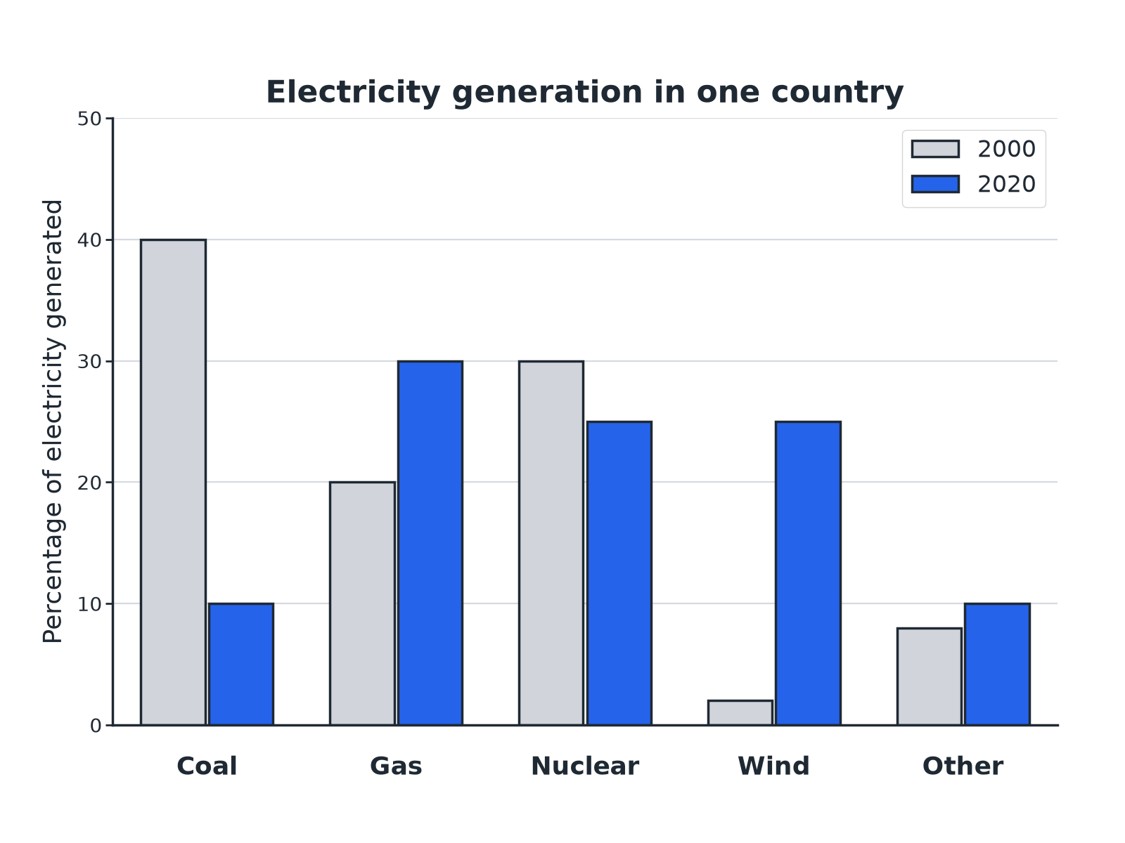

Question 3 · mark scheme
4 marks available. Award a mark for each point made.
▸ First change with data. 1 mark
▸ Second change with data. 1 mark
▸ Reason. 1 mark
▸ Linked to the change chosen. 1 mark
▸ Model answer. (a) Any two: coal fell from 40% to 10%; gas rose from 20% to 30%; wind rose from 2% to 25%; nuclear fell slightly. (b) To reduce carbon dioxide emissions and global warming; government targets or falling cost of wind turbines.
Question 4 · 3 marks · Explain
“Wind turbines and gas power stations can both generate electricity. Compare the reliability of the two and explain the difference.”
HOW TO ANSWER IT Command word: Explain. Worth 3 marks, so plan before writing.
Question 4 · mark scheme
3 marks available. Award a mark for each point made.
▸ Gas is more reliable. 1 mark
▸ Gas can be stored or supplied on demand. 1 mark
▸ Wind depends on the weather. 1 mark
▸ Model answer. Gas power stations are reliable because gas can be stored and burned when needed. Wind turbines are less reliable because the wind speed changes and they only produce electricity when it is windy.
Question 5 · 6 marks · Evaluate
“Evaluate the use of nuclear fuel and wind to generate electricity. Include environmental effects and reliability in your answer.”
HOW TO ANSWER IT Command word: Evaluate. Worth 6 marks, so plan before writing.
Question 5 · mark scheme
6 marks available. Award a mark for each point made.
▸ Level 3 (5 to 6 marks): a balanced comparison covering reliability, environmental impact and at least one of cost, carbon dioxide or waste, and a justified conclusion. 5 to 6 marks
▸ Level 2 (3 to 4 marks): several valid points for both, with some comparison. 3 to 4 marks
▸ Level 1 (1 to 2 marks): simple statements about one or both. 1 to 2 marks
▸ Model answer. See levels-of-response scheme.
Question 6 · 2 marks · Suggest
“Some countries still use fossil fuels even though they know about the environmental problems. Suggest two reasons for this.”
HOW TO ANSWER IT Command word: Suggest. Worth 2 marks, so plan before writing.
Question 6 · mark scheme
2 marks available. Award a mark for each point made.
▸ First reason. 1 mark
▸ Second reason. 1 mark
▸ Model answer. Any two from: renewable resources can be expensive to set up; renewables are not always reliable; countries have economic, political or social reasons or depend on fossil fuel industries.

