AQA GCSE PHYSICS · PAPER 1 · FOUNDATION & HIGHER
Energy transfers, conservation and dissipation
Energy · Lesson 5 of 7
Teacher copy - includes the notes for whoever is teaching from it.
Warm-up
Answer each one, then check.
1. Can energy be destroyed?
No
2. What is friction?
A force opposing motion between surfaces
3. Name a good thermal insulator.
Wool, foam or fibreglass
4. What is wasted energy?
Energy transferred to stores that are not useful
5. Which store increases when friction acts?
Thermal
Learning Objectives
1. Describe energy transfers in a closed system.
2. Explain how energy is dissipated.
3. Explain ways of reducing unwanted energy transfers: lubrication and thermal insulation.
4. Describe how thickness and thermal conductivity affect the rate of cooling of a building.
5. Describe an investigation into insulating materials.
Dissipation
Energy is never lost: it is transferred usefully, stored or dissipated. In every change some energy is dissipated into less useful stores.
The higher the thermal conductivity of a material, the higher the rate of energy transfer by conduction through it.
Investigating Insulation (Required Practical 2)
Different insulating materials are compared by how slowly hot water cools inside them.  What to notice  ▸ Insulated beaker. The material surrounds the beaker of hot water.  ▸ Control. An identical beaker with no insulation to compare against.  ▸ Thermometer and stopwatch. Record the temperature at regular times.  ▸ Fair test. Same volume, starting temperature, lid and beaker size. | 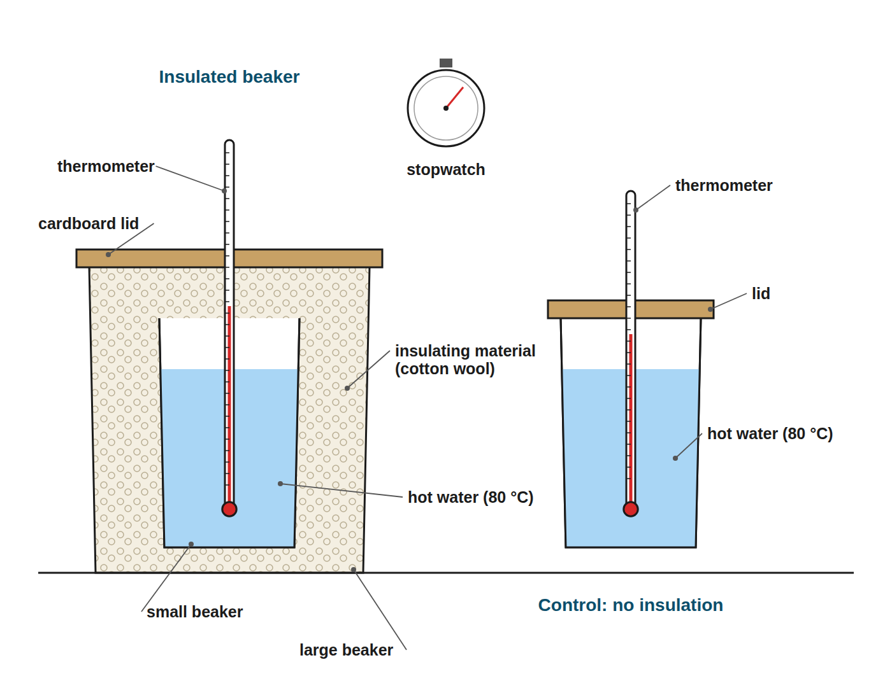  Only the insulating material should change.

Reducing Unwanted Energy Transfers
Lubrication  Oil between moving parts reduces friction, so less energy is dissipated to the thermal store. | Thermal insulation  Materials with low thermal conductivity, like foam and wool, reduce the rate of heat transfer.
Thicker walls  A thicker layer means a lower rate of energy transfer through it. | Lower conductivity  Walls made of material with lower thermal conductivity cool more slowly.
A House Cooling
Explain how the thickness and thermal conductivity of a house's walls affect its rate of cooling.

1. Thickness
Thicker walls slow the transfer of energy from inside to outside, so the house cools more slowly
2. Conductivity
Walls of lower thermal conductivity give a lower rate of energy transfer
3. Together
Thick walls made of a low-conductivity material give the lowest rate of cooling
Answer: The rate of cooling decreases with thicker walls and with lower thermal conductivity.
Required Practical 2: Method
Compare insulating materials.
1  Set up  Put a beaker of hot water inside a larger beaker with the insulating material packed around it. | 2  Same start  Use the same volume of water at the same starting temperature (about 80 °C) for each material. | 3  Measure  Record the temperature every minute for 15 to 20 minutes. | 4  Repeat  Repeat with other materials and a control with no insulation. | 5  Compare  Plot cooling curves. The smallest temperature fall shows the best insulator.
Control Variables
Make it a fair test.
▸ Independent variable. The type of insulating material (or its thickness).
▸ Dependent variable. The temperature drop, or the time to cool by a set amount.
▸ Control. Volume of water, starting temperature, beaker size, lid, room temperature.
Key Terms
Dissipated  Transferred to the surroundings and stored in less useful ways. | Thermal conductivity  How well a material conducts thermal energy.
Insulator  A material with low thermal conductivity. | Lubrication  Using oil or grease to reduce friction.
Closed system  A system where no energy enters or leaves. | Control variable  A variable kept the same in a fair test.
Your Task: Insulate the Cup
15 minutes
You have four cups, cotton wool, foam, newspaper and bubble wrap. Plan a fair test to find the best insulator, listing what you keep the same.
1. State what you change.
2. State what you measure and keep the same.
A good answer shows: Independent: material. Dependent: temperature fall in 10 minutes. Control: volume and starting temperature of water, cup and lid, thickness of material, room conditions. Repeat and find a mean.
Note: Ask how learners would show reliability.
Can I...?
☐ Explain energy conservation.
☐ Explain dissipation.
☐ Give ways to reduce unwanted energy transfers.
☐ Explain lubrication.
☐ Link thermal conductivity to rate of transfer.
☐ Describe Required Practical 2.
☐ Name control variables.
☐ Read cooling curves.
Summary
✓ Total energy is conserved.
✓ Energy is always dissipated to the surroundings.
✓ Lubrication reduces friction; insulation reduces heat loss.
✓ Low thermal conductivity means slower heat transfer.

EXAM FOCUS
A student compares three insulating materials by measuring how quickly hot water cools. Describe how to make the test fair. (3 marks)
Name what you change, measure and keep the same.
Exam Practice: Energy transfers, conservation and dissipation
Answer all questions. Use the mark allocation as a guide to how much to write. · 18 minutes
▸ Question 1 · 2 marks · Explain. A bicycle chain is lubricated with oil. Explain how this reduces the amount of energy wasted.
▸ Question 2 · 2 marks · Explain. A ball bounces, and each bounce is lower than the one before. Explain why, using the idea of conservation of energy.
▸ Question 3 · 4 marks · Use the graph. A student investigates how quickly hot water cools in three beakers, A, B and C. Each beaker is surrounded by a different insulating…
▸ Question 4 · 3 marks · Explain. A house has walls of thickness 20 cm. The walls are replaced with walls of the same material but thickness 30 cm. Explain what happens to…
▸ Question 5 · 6 marks · Describe. Describe an investigation to compare the effectiveness of different materials as thermal insulators. Your answer should include the…
Question 1 · 2 marks · Explain
“A bicycle chain is lubricated with oil. Explain how this reduces the amount of energy wasted.”
HOW TO ANSWER IT Command word: Explain. Worth 2 marks, so plan before writing.
Question 1 · mark scheme
2 marks available. Award a mark for each point made.
▸ Reduces friction. 1 mark
▸ Less energy transferred to thermal stores. 1 mark
▸ Model answer. The oil reduces friction between the moving parts, so less energy is transferred to the thermal energy stores of the chain and surroundings.
Question 2 · 2 marks · Explain
“A ball bounces, and each bounce is lower than the one before. Explain why, using the idea of conservation of energy.”
HOW TO ANSWER IT Command word: Explain. Worth 2 marks, so plan before writing.
Question 2 · mark scheme
2 marks available. Award a mark for each point made.
▸ Total energy is conserved or not destroyed. 1 mark
▸ Some energy dissipated to thermal stores or surroundings. 1 mark
▸ Model answer. Energy is not destroyed. Some energy is dissipated to the thermal energy store of the ball, floor and surroundings each time, so less is available as gravitational potential energy.
Question 3 · 4 marks · Use the graph
A student investigates how quickly hot water cools in three beakers, A, B and C. Each beaker is surrounded by a different insulating material. The graph shows the results. (a) Which beaker was surrounded by the best insulator? Give a reason. (b) Give two variables that should be controlled. (4 marks) | 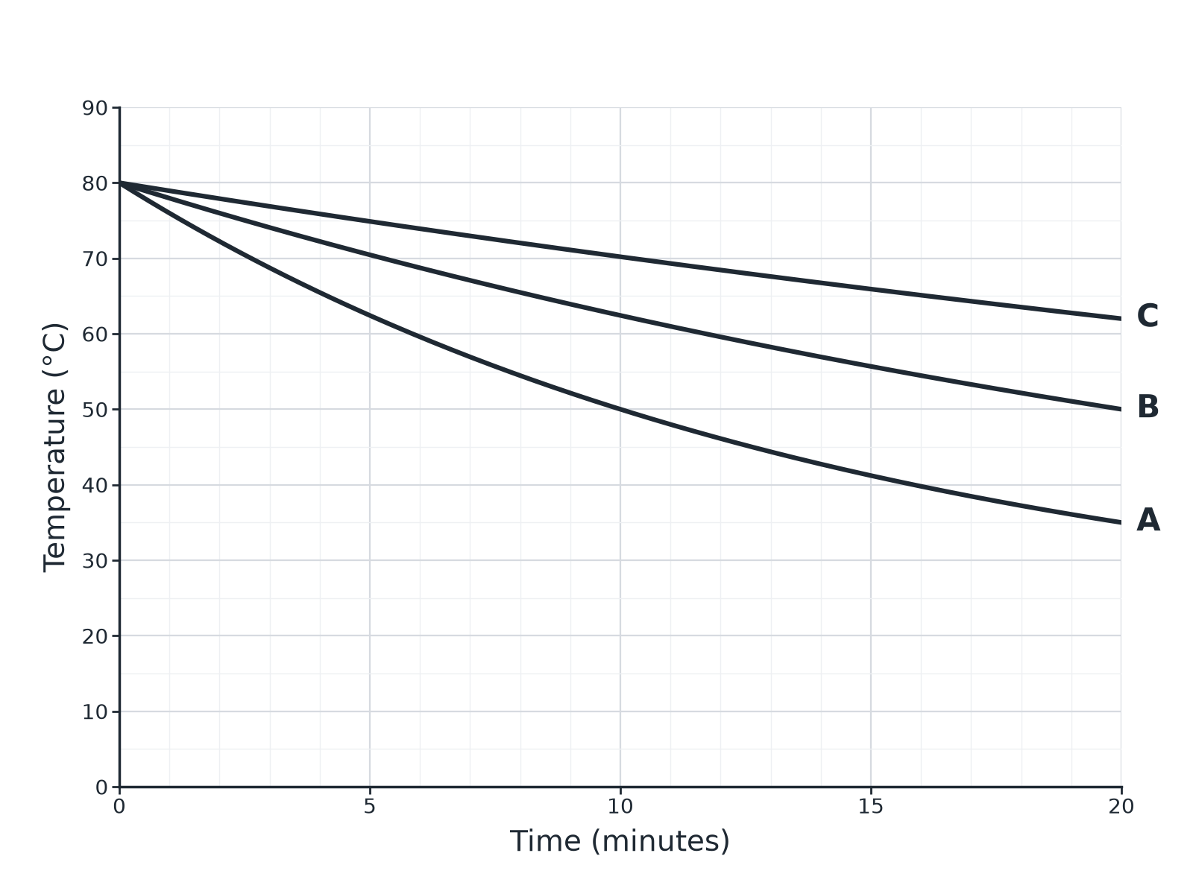

Question 3 · mark scheme
4 marks available. Award a mark for each point made.
▸ C. 1 mark
▸ Smallest fall in temperature or slowest cooling. 1 mark
▸ Any two controls, 1 mark each. 2 marks
▸ Model answer. (a) Beaker C, because the temperature fell the least. (b) Any two from: volume of water, starting temperature, size of beaker, thickness of insulation, lid.
Question 4 · 3 marks · Explain
“A house has walls of thickness 20 cm. The walls are replaced with walls of the same material but thickness 30 cm. Explain what happens to the rate at which the house cools.”
HOW TO ANSWER IT Command word: Explain. Worth 3 marks, so plan before writing.
Question 4 · mark scheme
3 marks available. Award a mark for each point made.
▸ Rate of cooling decreases. 1 mark
▸ Thicker walls. 1 mark
▸ Lower rate of energy transfer by conduction. 1 mark
▸ Model answer. The rate of cooling decreases. Thicker walls reduce the rate of energy transfer by conduction through the wall, so the house loses energy more slowly.
Question 5 · 6 marks · Describe
“Describe an investigation to compare the effectiveness of different materials as thermal insulators. Your answer should include the apparatus, how you would make it a fair test, and how you would use the results.”
HOW TO ANSWER IT Command word: Describe. Worth 6 marks, so plan before writing.
Question 5 · mark scheme
6 marks available. Award a mark for each point made.
▸ Level 3 (5 to 6 marks): a clear method using beakers, hot water, thermometer and timer with each material; several controls named; temperature change compared to identify the best insulator; repeats. 5 to 6 marks
▸ Level 2 (3 to 4 marks): a method with some controls and a way to compare. 3 to 4 marks
▸ Level 1 (1 to 2 marks): simple statements about insulating a beaker. 1 to 2 marks
▸ Model answer. See levels-of-response scheme.

