AQA GCSE PHYSICS · PAPER 1 · FOUNDATION & HIGHER
Series and parallel circuits
Electricity · Lesson 4 of 10
Teacher copy - includes the notes for whoever is teaching from it.
Warm-up
Answer each one, then check.
1. What is the same everywhere in a series loop?
The current
2. What does an ammeter measure?
Current
3. How is a voltmeter connected?
In parallel
4. What is the equation linking V, I and R?
V = IR
5. Add 4 + 8.
12
Learning Objectives
1. Describe the differences between series and parallel circuits.
2. Use R_(total) = R₁ + R₂ for resistors in series.
3. Calculate currents, pds and resistances in series circuits.
4. Explain why adding resistors in series increases and in parallel decreases the total resistance.
Series And Parallel
Series: same current, pd shared, R_(total) = R₁ + R₂. Parallel: same pd, currents add, R_(total) is less than the smallest resistor.
You are not required to calculate the total resistance of two resistors in parallel.
Series and Parallel
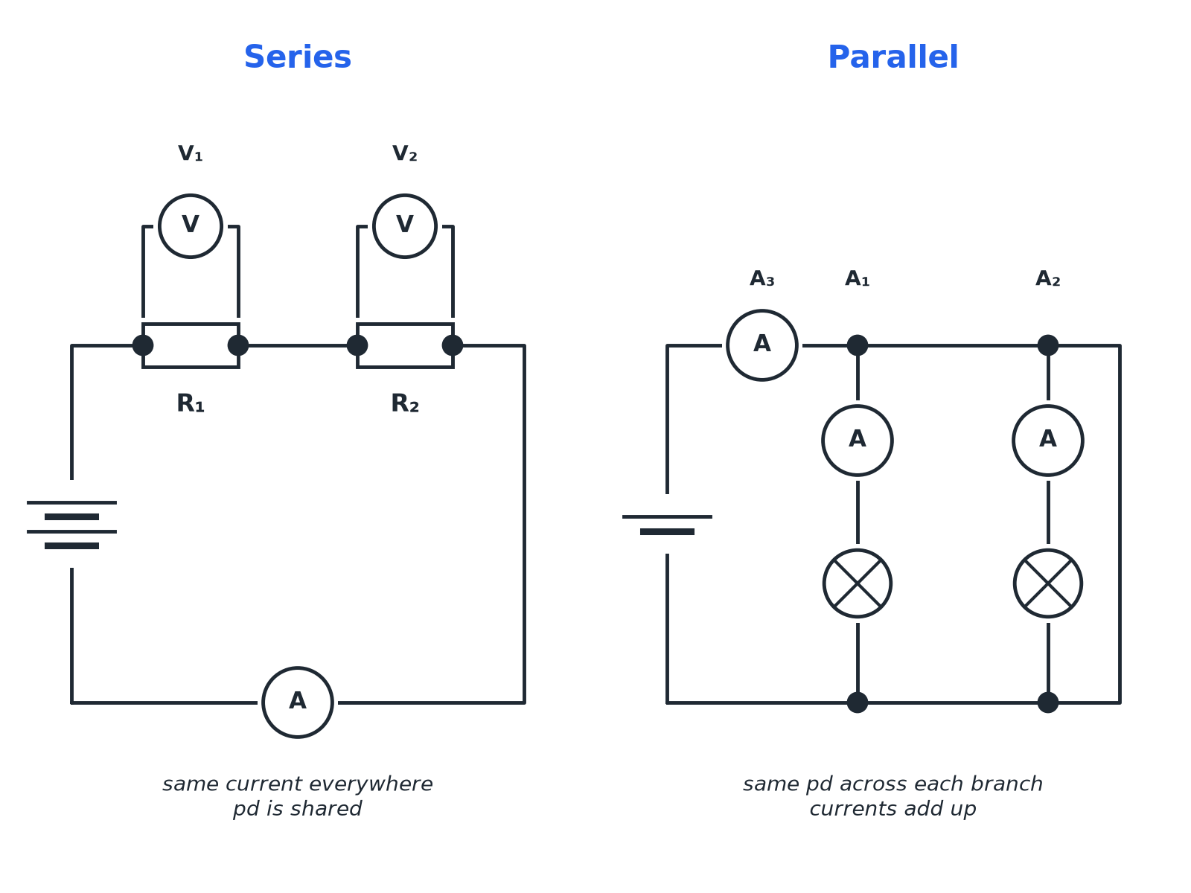
One path or several paths for the current.
A series circuit with two resistors and a parallel circuit with two lamps and three ammeters.
Series or Parallel?
SERIES | PARALLEL
▸ One loop for the current.  ▸ The same current through each component.  ▸ The supply pd is shared between components.  ▸ Total resistance = R1 + R2. | ▸ More than one loop.  ▸ The same pd across each branch.  ▸ The currents in the branches add to the total current.  ▸ Total resistance is less than the smallest resistor.
Series Circuit
A 12 V battery is connected in series with resistors of 4.0 Ω and 8.0 Ω. Calculate the current and the pd across each resistor.

1. Total resistance
R = 4.0 + 8.0 = 12 Ω
2. Current
I = V ÷ R = 12 ÷ 12 = 1.0 A
3. Pd across 4.0 Ω
V = IR = 1.0 × 4.0 = 4.0 V
4. Pd across 8.0 Ω
V = 1.0 × 8.0 = 8.0 V
5. Check
4.0 + 8.0 = 12 V
Answer: Current 1.0 A; pds 4.0 V and 8.0 V.
Parallel Circuit
Two lamps are connected in parallel to a 6.0 V supply. A1 reads 1.2 A and A2 reads 0.80 A. What does A3 in the main wire read?

1. Currents in the branches add
I_(total) = 1.2 + 0.80
2. Answer
I_(total) = 2.0 A
Answer: 2.0 A; each lamp has 6.0 V across it.
Why Resistance Changes
Explain it in words.
▸ In series. The current has to pass through each resistor one after another, so the total opposition is greater.
▸ In parallel. There are more paths for the current, so more charge can flow: the total resistance is less than any single resistor.
▸ Uses of series circuits. Measurement and testing, for example a circuit with a thermistor and an ammeter.
▸ Uses of parallel circuits. House lighting: each lamp has the full supply pd and can be switched on separately.
Key Terms
Series  Components connected one after another in a single loop. | Parallel  Components connected on separate branches.
Equivalent resistance  The single resistance that could replace the combination. | Branch  One of the paths in a parallel circuit.
Total resistance  The resistance of the whole circuit. | Shared pd  The supply pd divides between series components.
Your Task: Circuit Puzzle
12 minutes
A 9.0 V cell is connected to two resistors in series, 6.0 Ω and 12 Ω. (a) Find the total resistance. (b) Find the current. (c) Find the pd across the 12 Ω resistor.
1. Add the resistances.
2. Find I, then V across each.
A good answer shows: (a) 18 Ω (b) 9.0 ÷ 18 = 0.50 A (c) 0.50 × 12 = 6.0 V
Note: Check that the pds add up to 9.0 V.
Can I...?
☐ Describe series and parallel circuits.
☐ Add resistors in series.
☐ Find the current in a series circuit.
☐ Find the pd across each resistor.
☐ Add branch currents in parallel.
☐ State that pd is the same across parallel branches.
☐ Explain why total resistance changes.
☐ Draw a circuit diagram.
Summary
✓ Series: R_(total) = R₁ + R₂, same current, shared pd.
✓ Parallel: same pd, currents add, total resistance less than the smallest.
✓ Ammeters in series, voltmeters in parallel.
✓ Household circuits use parallel wiring.

EXAM FOCUS
A 12 V battery is connected in series to resistors of 4.0 Ω and 8.0 Ω. Calculate the current. (3 marks)
Add the resistances first, then use V = IR.
Exam Practice: Series and parallel circuits
Answer all questions. Use the mark allocation as a guide to how much to write. · 19 minutes
▸ Question 1 · 3 marks · Calculate. The diagram shows a 12 V battery connected to two resistors in series. Calculate (a) the total resistance and (b) the current in the…
▸ Question 2 · 3 marks · Calculate. Use your answer to the previous question to calculate the potential difference across the 8.0 Ω resistor. The current is 1.0 A.
▸ Question 3 · 3 marks · Use the diagram. The diagram shows two lamps connected in parallel to a 6.0 V supply. Ammeter A1 reads 1.2 A and A2 reads 0.80 A. (a) Calculate the reading…
▸ Question 4 · 2 marks · Explain. Explain why the lights in a house are connected in parallel rather than in series.
▸ Question 5 · 3 marks · Explain. Explain, in terms of the flow of current, why adding a second resistor in series increases the total resistance but adding a second…
▸ Question 6 · 4 marks · Calculate. A 9.0 V cell is connected to a 6.0 Ω resistor and a 12 Ω resistor in series. Calculate the potential difference across the 12 Ω resistor.
Question 1 · 3 marks · Calculate
The diagram shows a 12 V battery connected to two resistors in series. Calculate (a) the total resistance and (b) the current in the circuit. (3 marks) | 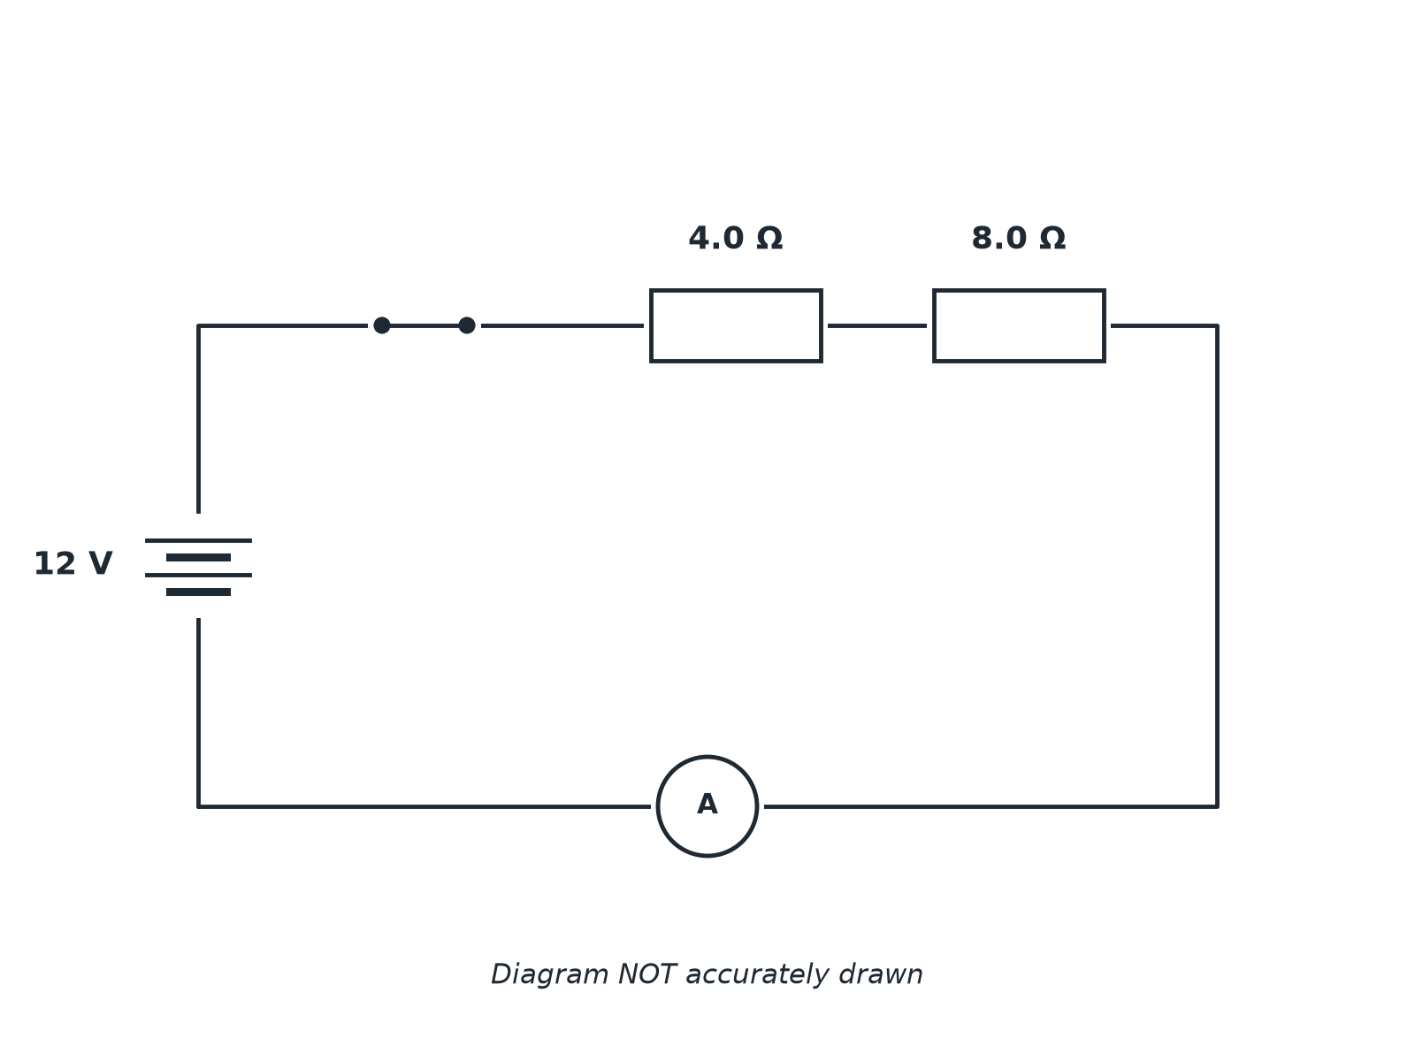

Question 1 · mark scheme
3 marks available. Award a mark for each point made.
▸ Adds resistances. 1 mark
▸ 12 Ω. 1 mark
▸ 1.0 A. 1 mark
▸ Model answer. (a) R = 4.0 + 8.0 = 12 Ω. (b) I = 12 ÷ 12 = 1.0 A
Question 2 · 3 marks · Calculate
“Use your answer to the previous question to calculate the potential difference across the 8.0 Ω resistor. The current is 1.0 A.”
HOW TO ANSWER IT Command word: Calculate. Worth 3 marks, so plan before writing.
Question 2 · mark scheme
3 marks available. Award a mark for each point made.
▸ Correct equation. 1 mark
▸ Correct substitution. 1 mark
▸ 8.0 V. 1 mark
▸ Model answer. V = IR = 1.0 × 8.0 = 8.0 V
Question 3 · 3 marks · Use the diagram
The diagram shows two lamps connected in parallel to a 6.0 V supply. Ammeter A1 reads 1.2 A and A2 reads 0.80 A. (a) Calculate the reading on A3. (b) State the pd across each lamp. (3 marks) | 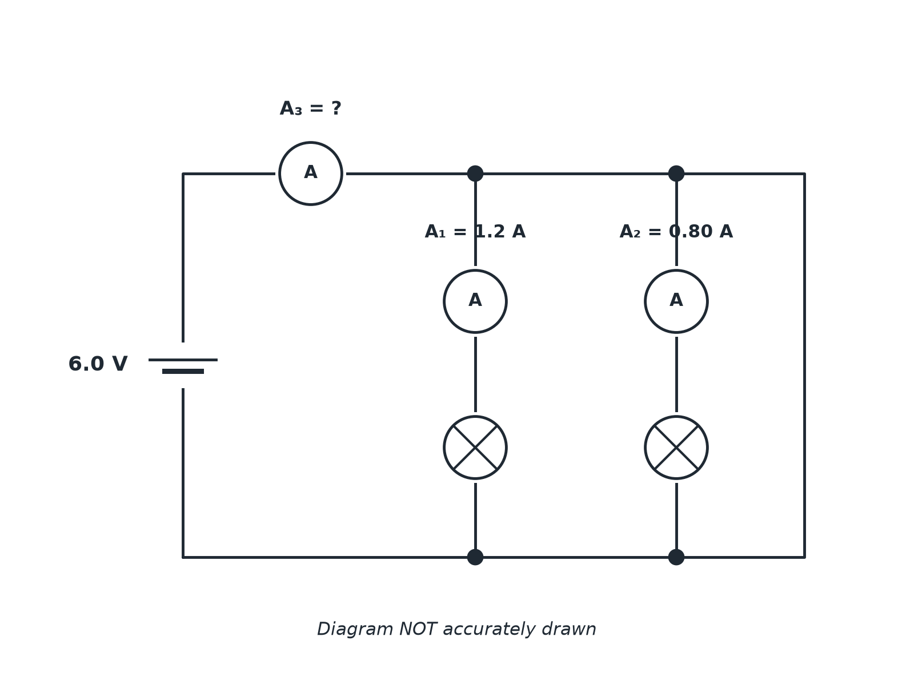

Question 3 · mark scheme
3 marks available. Award a mark for each point made.
▸ Adds the branch currents. 1 mark
▸ 2.0 A. 1 mark
▸ 6.0 V. 1 mark
▸ Model answer. (a) 1.2 + 0.80 = 2.0 A. (b) 6.0 V across each lamp.
Question 4 · 2 marks · Explain
“Explain why the lights in a house are connected in parallel rather than in series.”
HOW TO ANSWER IT Command word: Explain. Worth 2 marks, so plan before writing.
Question 4 · mark scheme
2 marks available. Award a mark for each point made.
▸ Each lamp gets the full supply pd. 1 mark
▸ Lamps can be switched independently or one failing does not stop the others. 1 mark
▸ Model answer. In parallel each lamp has the full supply potential difference across it, and each lamp can be switched on and off independently of the others.
Question 5 · 3 marks · Explain
“Explain, in terms of the flow of current, why adding a second resistor in series increases the total resistance but adding a second resistor in parallel decreases the total resistance.”
HOW TO ANSWER IT Command word: Explain. Worth 3 marks, so plan before writing.
Question 5 · mark scheme
3 marks available. Award a mark for each point made.
▸ Series: current passes through both, so resistance is greater. 1 mark
▸ Parallel: two paths. 1 mark
▸ More current for the same pd, so total resistance is less. 1 mark
▸ Model answer. In series the current must pass through both resistors so the opposition is greater. In parallel there are two paths, so more current can flow for the same potential difference, so the total resistance is less.
Question 6 · 4 marks · Calculate
“A 9.0 V cell is connected to a 6.0 Ω resistor and a 12 Ω resistor in series. Calculate the potential difference across the 12 Ω resistor.”
HOW TO ANSWER IT Command word: Calculate. Worth 4 marks, so plan before writing.
Question 6 · mark scheme
4 marks available. Award a mark for each point made.
▸ Total resistance 18 Ω. 1 mark
▸ Current 0.50 A. 1 mark
▸ Correct substitution. 1 mark
▸ 6.0 V. 1 mark
▸ Model answer. R = 18 Ω; I = 9.0 ÷ 18 = 0.50 A; V = 0.50 × 12 = 6.0 V

