AQA GCSE PHYSICS · PAPER 1 · FOUNDATION & HIGHER
Mains electricity and safety
Electricity · Lesson 5 of 10
Teacher copy - includes the notes for whoever is teaching from it.
Warm-up
Answer each one, then check.
1. What is the unit of frequency?
Hertz (Hz)
2. What colour is the earth wire?
Green and yellow stripes
3. What does a fuse do?
Melts and breaks the circuit if the current is too large
4. What does AC stand for?
Alternating current
5. What is the potential difference of the mains?
About 230 V
Learning Objectives
1. State the frequency and potential difference of UK mains.
2. Explain the difference between dc and ac.
3. Identify the live, neutral and earth wires by colour and function.
4. Explain why a live wire can be dangerous even when a switch is open, and the dangers of connecting live to earth.
Mains Electricity
Mains electricity in the UK is an alternating supply of about 230 V with a frequency of 50 Hz.
Direct pd (dc) always pushes charge in the same direction. Alternating pd (ac) repeatedly changes direction.
Direct and Alternating pd
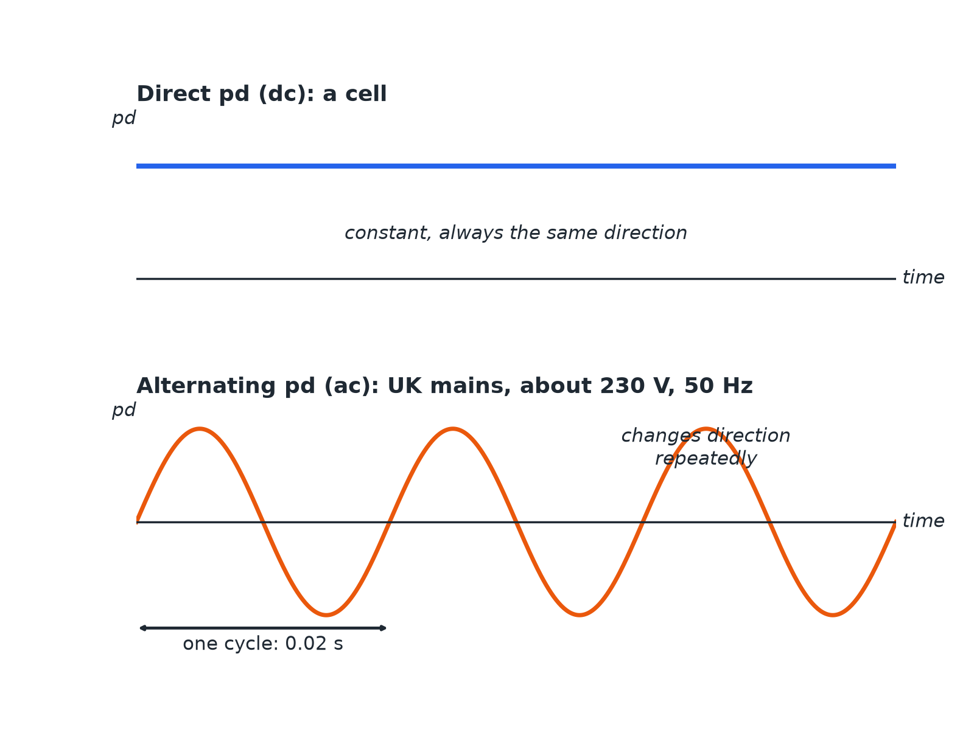
Alternating pd changes direction 50 times each second.
Graphs of direct pd as a flat line and alternating pd as a wave crossing the axis.
A Three-pin Plug
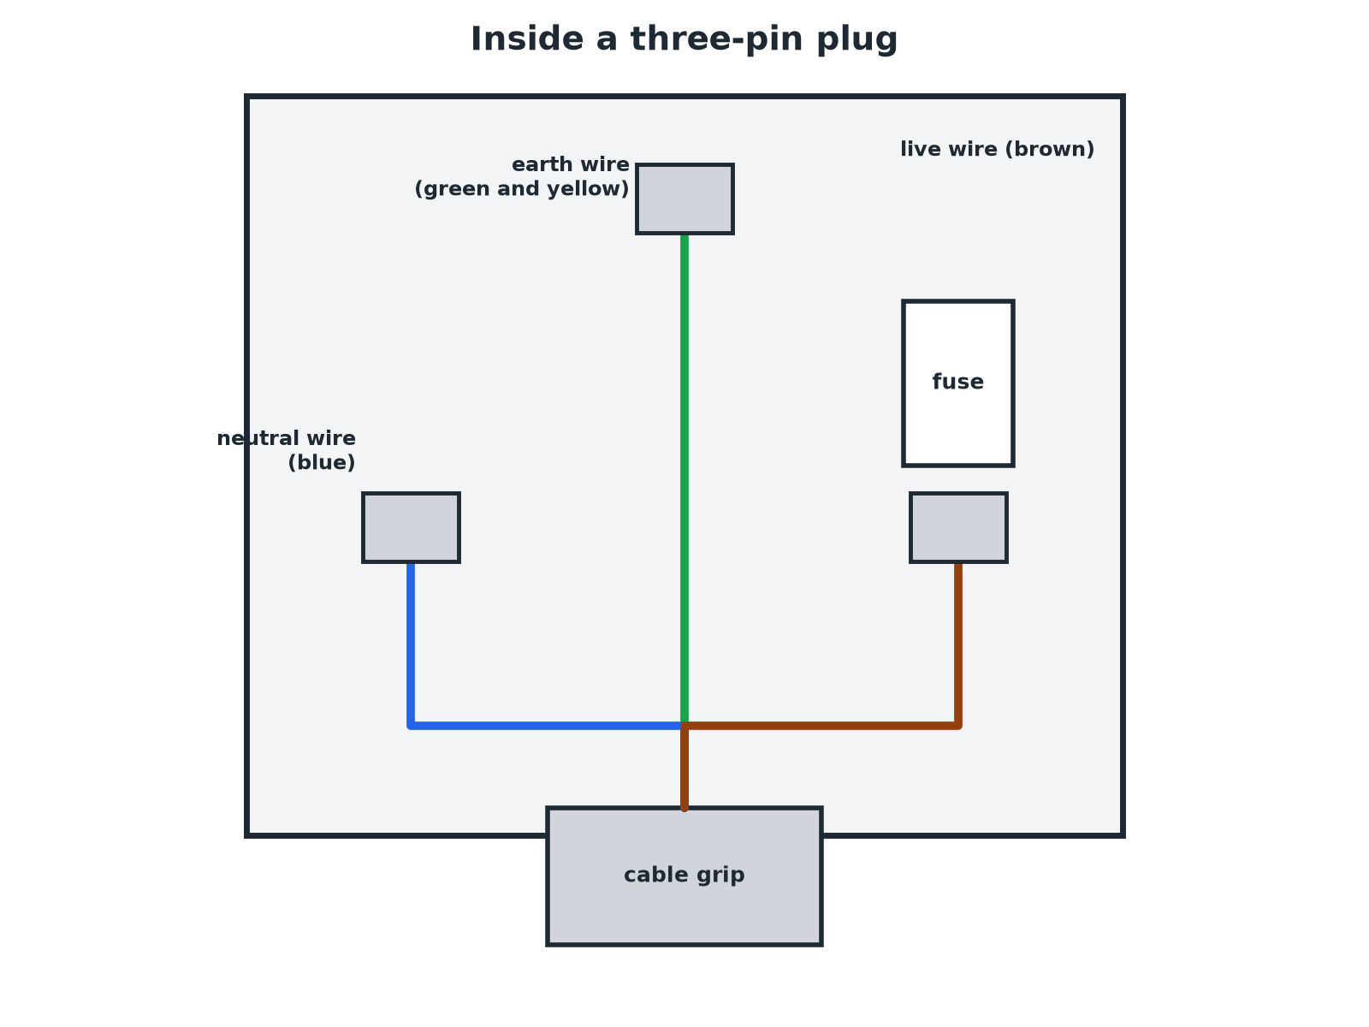
Colour coding makes the wires easy to identify.
A three-pin plug with brown live, blue neutral and green and yellow earth wires labelled.
The Three-Core Cable
Learn the colour, name and job of each wire.
Wire | Colour | Job | Potential difference
Live | Brown | Carries the alternating pd from the supply | About 230 V
Neutral | Blue | Completes the circuit | At or close to 0 V
Earth | Green and yellow stripes | Safety wire: stops the appliance becoming live | 0 V; only carries a current if there is a fault
Why the Live Wire Is Dangerous
Explain why touching a live wire can be dangerous even when the switch in the appliance is open.

1. Switch position
If the switch is in the neutral wire, the live wire stays connected to the appliance
2. Potential difference
The live wire is at about 230 V compared with earth
3. Danger
A person touching it can provide a path to earth, and a current flows through the person
Answer: The live wire is at 230 V even when the switch is open (if the switch is in the neutral); touching it can give a dangerous current.
Live and Earth
Explain the dangers of a connection between the live wire and earth.

1. Low resistance path
A very large current can flow to earth
2. Effects
The wires heat up, which can cause a fire; a person may be electrocuted
3. Earth wire
It gives a safe path so a fuse blows or the trip operates
Answer: A connection between live and earth can cause a large current, overheating, fires or electric shock.
Safety Tips
Exam-ready reasons.
▸ Fuse and switch. They go in the live wire so the appliance is disconnected from 230 V.
▸ Earth wire. Connected to the metal case so that if the live wire touches it, a large current flows and the fuse melts.
▸ Double-insulated appliances. Have no earth wire because they have a plastic case.
Key Terms
Direct pd (dc)  A pd that always pushes charge in the same direction. | Alternating pd (ac)  A pd that repeatedly changes direction.
Frequency  The number of cycles per second, in hertz. | Live wire  The wire carrying the alternating pd, at about 230 V.
Neutral wire  The wire that completes the circuit, at about 0 V. | Earth wire  The safety wire, at 0 V, connected to the metal case.
Your Task: Plug Detective
10 minutes
A plug's wires are brown, blue and green and yellow. State the name of each wire and its job. Then say why a switch should go in the live wire.
1. Name each wire.
2. Say what it does.
A good answer shows: Brown: live, carries 230 V. Blue: neutral, completes the circuit. Green and yellow: earth, safety wire. A switch in the live wire disconnects the appliance from the 230 V supply.
Note: Ask what could happen if a switch were in the neutral wire.
Can I...?
☐ State the frequency and pd of UK mains.
☐ Explain dc and ac.
☐ Name the three wires and their colours.
☐ State the job of each wire.
☐ Say the live wire is at 230 V.
☐ Explain why a live wire is dangerous with the switch open.
☐ Explain the dangers of live-to-earth connections.
☐ Explain the purpose of the earth wire.
Summary
✓ UK mains: 230 V, 50 Hz, ac.
✓ Live: brown; neutral: blue; earth: green and yellow.
✓ Earth wire only carries current if there is a fault.
✓ Switches go in the live wire.

EXAM FOCUS
Give the colour of the live wire and state its potential difference compared with earth. (2 marks)
Brown, and about 230 V.
Exam Practice: Mains electricity and safety
Answer all questions. Use the mark allocation as a guide to how much to write. · 15 minutes
▸ Question 1 · 2 marks · State. State the frequency and the approximate potential difference of the UK mains supply.
▸ Question 2 · 3 marks · Complete. The diagram shows the wires in a three-pin plug labelled A, B and C. Give the name of each wire.
▸ Question 3 · 2 marks · Explain. Explain the difference between direct potential difference and alternating potential difference.
▸ Question 4 · 3 marks · Explain. The earth wire in a kettle is connected to its metal case. Explain the purpose of the earth wire.
▸ Question 5 · 4 marks · Explain. A person touches the live wire in a broken appliance, but the switch in the appliance was off. Explain why the person could still receive…
Question 1 · 2 marks · State
“State the frequency and the approximate potential difference of the UK mains supply.”
HOW TO ANSWER IT Command word: State. Worth 2 marks, so plan before writing.
Question 1 · mark scheme
2 marks available. Award a mark for each point made.
▸ 50 Hz. 1 mark
▸ 230 V. 1 mark
▸ Model answer. 50 Hz and about 230 V.
Question 2 · 3 marks · Complete
The diagram shows the wires in a three-pin plug labelled A, B and C. Give the name of each wire. (3 marks) | 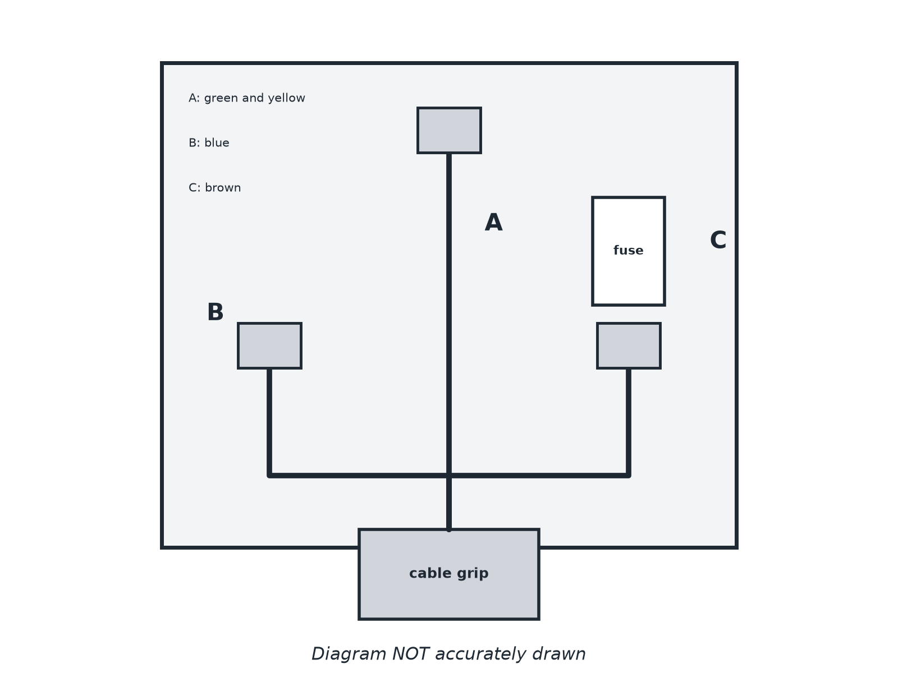

Question 2 · mark scheme
3 marks available. Award a mark for each point made.
▸ Earth. 1 mark
▸ Neutral. 1 mark
▸ Live. 1 mark
▸ Model answer. A: earth (green and yellow), B: neutral (blue), C: live (brown).
Question 3 · 2 marks · Explain
“Explain the difference between direct potential difference and alternating potential difference.”
HOW TO ANSWER IT Command word: Explain. Worth 2 marks, so plan before writing.
Question 3 · mark scheme
2 marks available. Award a mark for each point made.
▸ Direct: one direction. 1 mark
▸ Alternating: changes direction repeatedly. 1 mark
▸ Model answer. A direct pd always causes charge to flow in the same direction. An alternating pd repeatedly changes direction.
Question 4 · 3 marks · Explain
“The earth wire in a kettle is connected to its metal case. Explain the purpose of the earth wire.”
HOW TO ANSWER IT Command word: Explain. Worth 3 marks, so plan before writing.
Question 4 · mark scheme
3 marks available. Award a mark for each point made.
▸ Safety wire. 1 mark
▸ Stops the case becoming live. 1 mark
▸ Only carries current if there is a fault, so the fuse melts. 1 mark
▸ Model answer. It is a safety wire. If the live wire touches the case, a large current flows through the earth wire, which stops the case from becoming live, and the fuse melts.
Question 5 · 4 marks · Explain
“A person touches the live wire in a broken appliance, but the switch in the appliance was off. Explain why the person could still receive an electric shock, and why connecting the live wire to earth is dangerous.”
HOW TO ANSWER IT Command word: Explain. Worth 4 marks, so plan before writing.
Question 5 · mark scheme
4 marks available. Award a mark for each point made.
▸ Live wire is at about 230 V. 1 mark
▸ Switch may be in the neutral wire, so live remains connected. 1 mark
▸ Current flows through the person to earth. 1 mark
▸ Live to earth: very large current causing heating, fire or shock. 1 mark
▸ Model answer. The live wire is at about 230 V, and if the switch is in the neutral wire the live wire is still connected to the supply, so the person provides a path to earth and a current flows through them. A connection between live and earth gives a very large current which can cause a fire or shock.

