AQA GCSE PHYSICS · PAPER 1 · FOUNDATION & HIGHER
The National Grid
Electricity · Lesson 8 of 10
Teacher copy - includes the notes for whoever is teaching from it.
Warm-up
Answer each one, then check.
1. What does a power station generate?
Electricity
2. What happens to a wire when a current flows?
It heats up
3. Write the equation for power using current and resistance.
P = I²R
4. What does step-up mean?
Increases the potential difference
5. What is a cable?
A wire used to carry current
Learning Objectives
1. Describe the National Grid as a system of cables and transformers.
2. State the roles of step-up and step-down transformers.
3. Explain why the National Grid is an efficient way to transfer energy.
The National Grid
Step-up transformers increase the potential difference for transmission, which reduces the current and so the energy wasted as heat in the cables.
The National Grid is a system of cables and transformers linking power stations to consumers.
From Power Station to Home
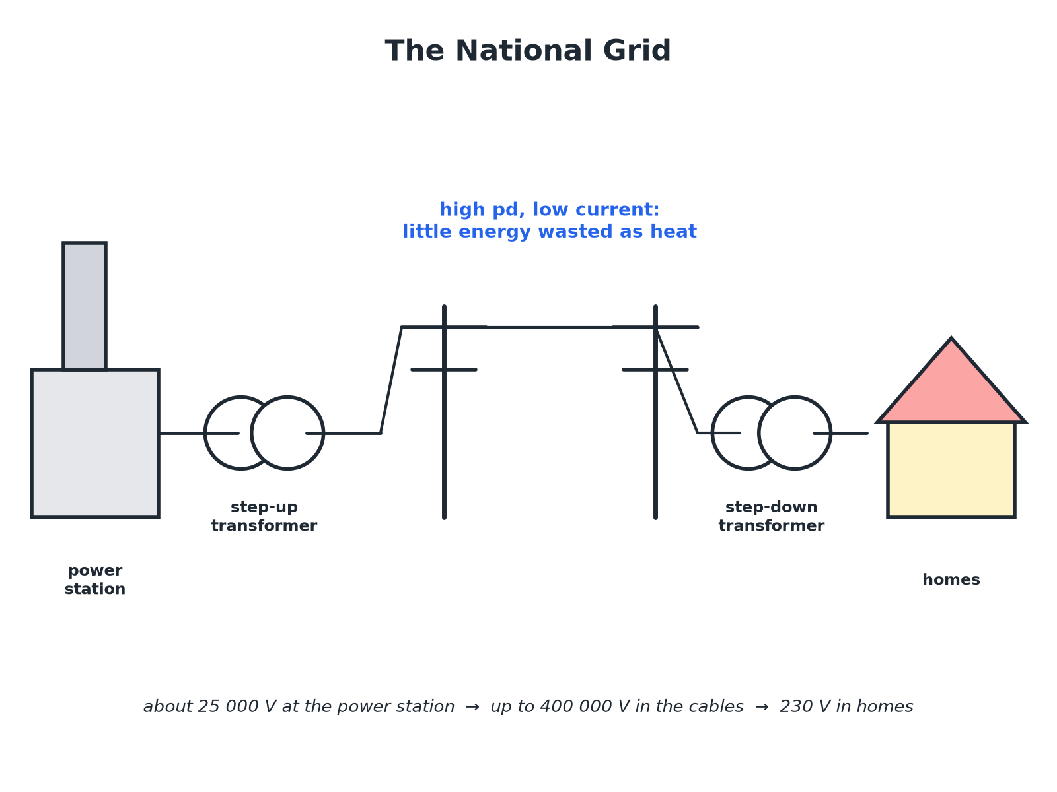
High pd means low current.
The National Grid: power station, step-up transformer, transmission cables, step-down transformer and homes.
Why High pd Means Efficient
Follow the logic.
1  Power = pd × current  For the same power, a higher pd means a smaller current. | 2  Less current  A smaller current means less heating in the cables. | 3  Energy wasted  Power loss in the cable is P = I²R, so halving the current cuts the loss to a quarter. | 4  Step-up transformers  Increase the pd before the cables. | 5  Step-down transformers  Decrease the pd to a safe value for homes (230 V).
Comparing Losses
100 kW is transmitted through cables of total resistance 2.0 Ω. Compare the power lost at 1000 V with the power lost at 10 000 V.

1. Current at 1000 V
I = P ÷ V = 100 000 ÷ 1000 = 100 A
2. Power lost
P = I²R = 100² × 2.0 = 20 000 W
3. Current at 10 000 V
I = 100 000 ÷ 10 000 = 10 A
4. Power lost
10² × 2.0 = 200 W
Answer: 20 kW lost at 1000 V but only 200 W lost at 10 000 V: high pd wastes far less energy.
Key Points
For an exam answer.
▸ Efficient. High pd, low current means little energy wasted as heat in the cables.
▸ Step-up. Used at the power station end.
▸ Step-down. Used near homes and factories.
▸ Safety. The high pd is reduced to 230 V before homes.
Key Terms
National Grid  A system of cables and transformers linking power stations to consumers. | Transformer  A device that changes the size of an alternating pd.
Step-up transformer  Increases the pd. | Step-down transformer  Decreases the pd.
Transmission cables  Cables that carry electricity over long distances. | Efficient  Wasting little energy.
Your Task: Follow the Grid
10 minutes
Put these in the correct order: homes, step-up transformer, power station, step-down transformer, transmission cables.
1. Start at the power station.
2. End at homes.
A good answer shows: Power station, step-up transformer, transmission cables, step-down transformer, homes.
Note: Ask why the pd is increased before the cables.
Can I...?
☐ Describe the National Grid.
☐ State what a step-up transformer does.
☐ State what a step-down transformer does.
☐ Explain why high pd is used.
☐ Link current to energy wasted.
☐ Compare power losses.
☐ Draw or complete a grid diagram.
☐ Explain why 230 V is needed in homes.
Summary
✓ Step-up transformers increase pd, step-down decrease it.
✓ High pd means low current for the same power.
✓ Low current means less energy wasted as heat in the cables.
✓ The National Grid is efficient.

EXAM FOCUS
Explain why the National Grid transmits electricity at a high potential difference. (3 marks)
Say higher pd means lower current, so less heating.
Exam Practice: The National Grid
Answer all questions. Use the mark allocation as a guide to how much to write. · 15 minutes
▸ Question 1 · 2 marks · Complete. Name the two types of transformer used in the National Grid and state what each does.
▸ Question 2 · 3 marks · Use the diagram. The diagram shows part of the National Grid. (a) Name the parts labelled A and B. (b) State why B is needed near homes.
▸ Question 3 · 3 marks · Explain. Explain why using a high potential difference to transmit electricity is efficient.
▸ Question 4 · 4 marks · Calculate. A power of 100 kW is transmitted at 10 000 V through cables of total resistance 2.0 Ω. Calculate the power wasted as heat in the cables.
▸ Question 5 · 2 marks · Explain. The potential difference in the transmission cables is much higher than in homes. Explain why the potential difference in homes is reduced.
Question 1 · 2 marks · Complete
“Name the two types of transformer used in the National Grid and state what each does.”
HOW TO ANSWER IT Command word: Complete. Worth 2 marks, so plan before writing.
Question 1 · mark scheme
2 marks available. Award a mark for each point made.
▸ Step-up increases pd. 1 mark
▸ Step-down decreases pd. 1 mark
▸ Model answer. Step-up transformers increase the potential difference; step-down transformers decrease the potential difference.
Question 2 · 3 marks · Use the diagram
The diagram shows part of the National Grid. (a) Name the parts labelled A and B. (b) State why B is needed near homes. (3 marks) | 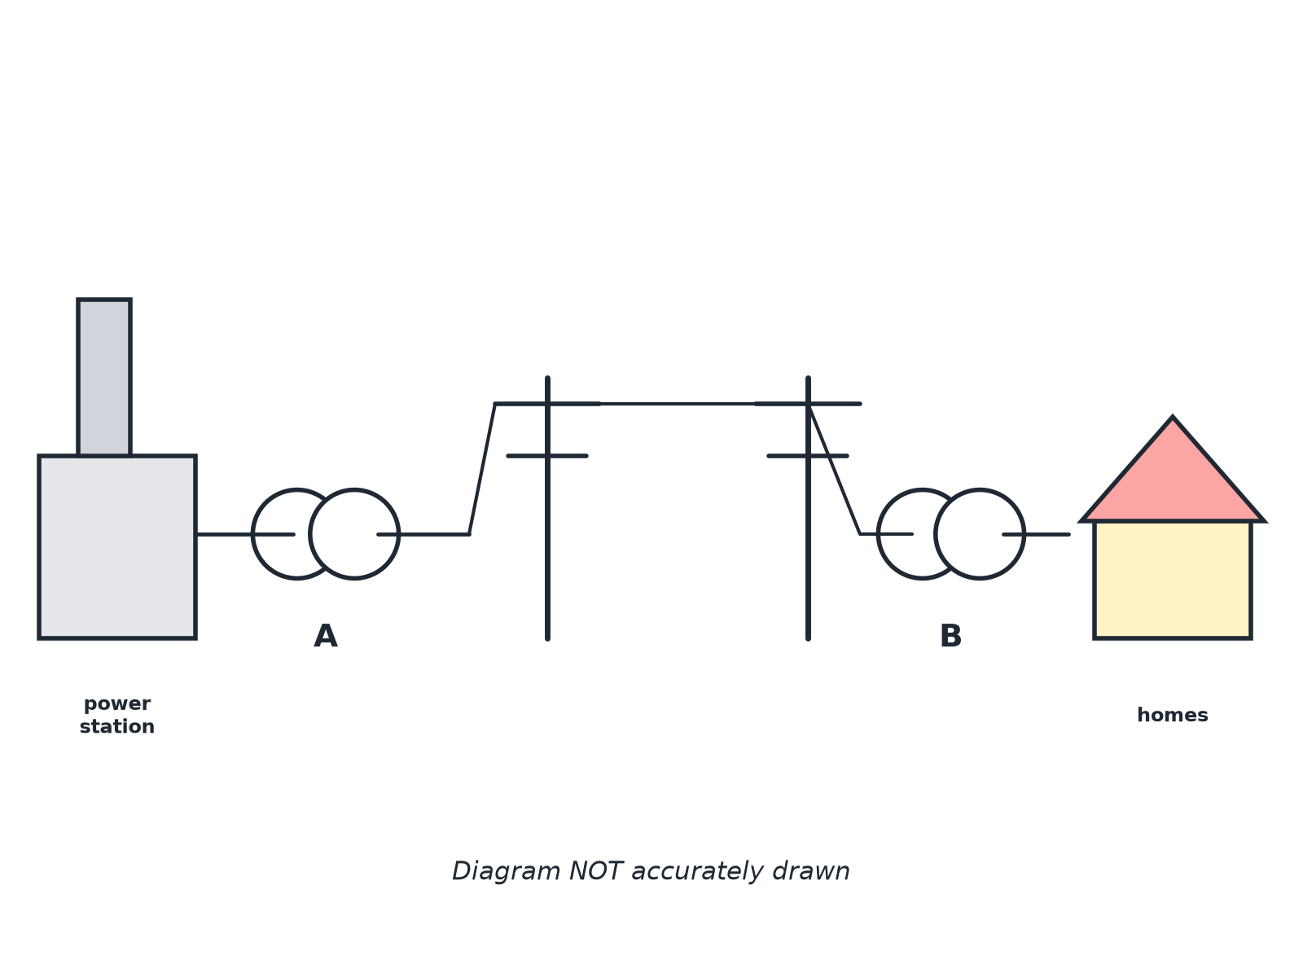

Question 2 · mark scheme
3 marks available. Award a mark for each point made.
▸ A: step-up transformer. 1 mark
▸ B: step-down transformer. 1 mark
▸ Reduces the pd to a safe value for homes. 1 mark
▸ Model answer. (a) A is a step-up transformer; B is a step-down transformer. (b) To decrease the pd to a safe value for homes (230 V).
Question 3 · 3 marks · Explain
“Explain why using a high potential difference to transmit electricity is efficient.”
HOW TO ANSWER IT Command word: Explain. Worth 3 marks, so plan before writing.
Question 3 · mark scheme
3 marks available. Award a mark for each point made.
▸ High pd means lower current for the same power. 1 mark
▸ Lower current means less heating of the cables. 1 mark
▸ So less energy wasted. 1 mark
▸ Model answer. For the same power, a high potential difference means a smaller current. A smaller current causes less heating in the cables, so less energy is wasted.
Question 4 · 4 marks · Calculate
“A power of 100 kW is transmitted at 10 000 V through cables of total resistance 2.0 Ω. Calculate the power wasted as heat in the cables.”
HOW TO ANSWER IT Command word: Calculate. Worth 4 marks, so plan before writing.
Question 4 · mark scheme
4 marks available. Award a mark for each point made.
▸ Rearranges to I = P ÷ V. 1 mark
▸ 10 A. 1 mark
▸ Correct substitution into I²R. 1 mark
▸ 200 W. 1 mark
▸ Model answer. I = 100 000 ÷ 10 000 = 10 A; P = I²R = 10² × 2.0 = 200 W
Question 5 · 2 marks · Explain
“The potential difference in the transmission cables is much higher than in homes. Explain why the potential difference in homes is reduced.”
HOW TO ANSWER IT Command word: Explain. Worth 2 marks, so plan before writing.
Question 5 · mark scheme
2 marks available. Award a mark for each point made.
▸ Safe for homes or appliances designed for 230 V. 1 mark
▸ Step-down transformer decreases the pd. 1 mark
▸ Model answer. 230 V is safer for use in homes and works with appliances designed for it; a step-down transformer is used to decrease the pd.

