AQA GCSE PHYSICS · PAPER 1 · FOUNDATION & HIGHER
Electric fields
Electricity · Lesson 10 of 10
Teacher copy - includes the notes for whoever is teaching from it.
Warm-up
Answer each one, then check.
1. What is a field?
A region where a force acts on certain objects
2. Which charges attract?
Unlike charges
3. What is a non-contact force?
A force between objects that are not touching
4. What charge does an electron have?
Negative
5. What is a spark?
A sudden flow of charge through air
Learning Objectives
1. Explain the concept of an electric field.
2. Draw the electric field pattern for an isolated charged sphere.
3. Describe how the strength of the field changes with distance.
4. Explain non-contact forces and sparking using the idea of a field.
Electric Fields
A charged object creates an electric field around itself. A second charged object placed in the field experiences a force.
The field is strongest close to the charged object and gets weaker with distance. The force gets stronger as the distance between the objects decreases.
Field Around a Charged Sphere
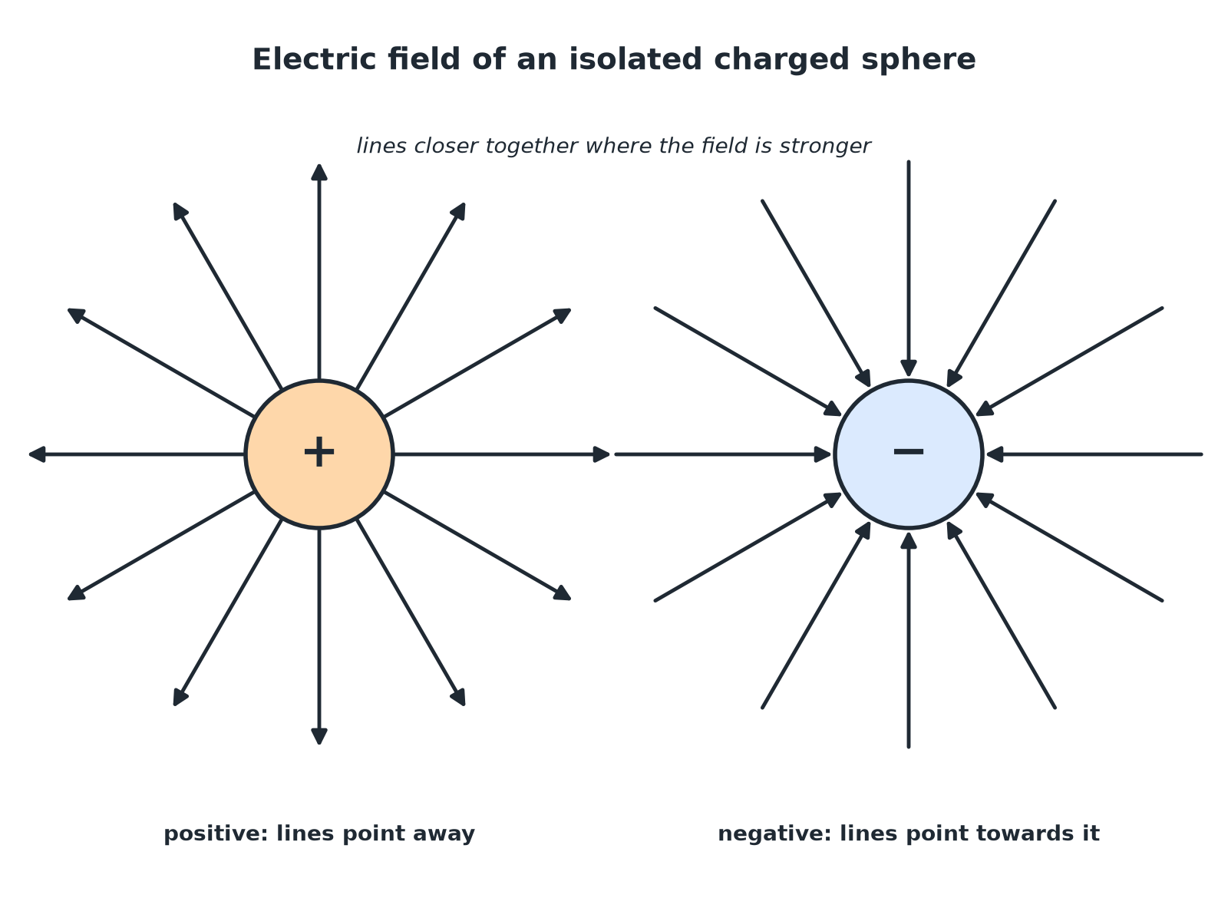
Arrows show the direction of the force on a positive charge.
Radial electric field lines pointing out of a positive sphere and into a negative sphere.
Drawing the Field of an Isolated Sphere
Follow the rules.
1  Draw the sphere  A circle with plus or minus signs. | 2  Draw straight lines  At least 8 lines, evenly spaced, starting at the surface and going radially. | 3  Add arrows  Away from a positive sphere; towards a negative sphere. | 4  Show the strength  Lines are closer together near the sphere, where the field is stronger.
Force in a Field
A small positive charge is placed near a positively charged sphere. Describe the force on it and how it changes as the charge is moved closer.

1. Direction
The charge is repelled: the force is away from the sphere
2. As it moves closer
The field is stronger, so the force gets stronger
Answer: The force is repulsive and increases as the distance decreases.
Explaining a Spark
Explain how the idea of an electric field helps to explain sparking.

1. Charged object
Creates a strong electric field around itself
2. Air
The strong field can make air molecules lose electrons (ionise)
3. Charge flows
The ionised air conducts, so charge flows as a spark
Answer: A strong electric field ionises the air so charge can flow: a spark.
Non-Contact Forces
Fields explain forces at a distance.
▸ Field. A charged object does not touch the other object, but its field acts on it.
▸ Distance. The further away, the weaker the field and the force.
▸ Direction. Field lines show the direction of the force on a positive charge.
Key Terms
Electric field  The region around a charged object where another charge feels a force. | Field lines  Lines showing the direction of the force on a positive charge.
Isolated sphere  A charged sphere far from any other charges. | Ionise  Remove or add electrons to make ions.
Non-contact force  A force between objects that are not touching. | Field strength  How large the force on a charge is at a point.
Your Task: Draw the Field
12 minutes
Draw the electric field around (a) a positively charged sphere and (b) a negatively charged sphere. Show the arrows and how the strength varies.
1. Draw at least eight lines.
2. Add arrows in the right direction.
A good answer shows: (a) Radial lines with arrows pointing away, closer together at the sphere. (b) Radial lines with arrows pointing towards the sphere.
Note: Check that the lines do not cross and are straight.
Can I...?
☐ Define an electric field.
☐ Draw the field around a positive sphere.
☐ Draw the field around a negative sphere.
☐ Say how strength changes with distance.
☐ Explain non-contact force with fields.
☐ Explain sparking with fields.
☐ Use arrows correctly.
☐ Draw evenly spaced lines.
Summary
✓ An electric field surrounds a charged object.
✓ Field lines point away from positive and towards negative.
✓ The field is strongest close to the object.
✓ A strong field can ionise air and cause a spark.

EXAM FOCUS
Draw the electric field pattern around an isolated negatively charged sphere. (2 marks)
Straight lines, arrows pointing towards the sphere.
Exam Practice: Electric fields
Answer all questions. Use the mark allocation as a guide to how much to write. · 14 minutes
▸ Question 1 · 2 marks · Draw. Draw the electric field pattern of an isolated negatively charged sphere.
▸ Question 2 · 3 marks · Complete the diagram. The diagram shows a positively charged sphere with two field lines drawn. Complete the diagram to show the electric field. Explain what the…
▸ Question 3 · 2 marks · Explain. A small positive charge is moved towards a positively charged sphere. Explain how the force on the small charge changes.
▸ Question 4 · 3 marks · Explain. Explain how the idea of an electric field helps to explain how a charged comb can pick up small pieces of paper without touching them.
▸ Question 5 · 3 marks · Explain. Explain, using the idea of an electric field, how a spark can jump between a charged sphere and a metal rod.
Question 1 · 2 marks · Draw
“Draw the electric field pattern of an isolated negatively charged sphere.”
HOW TO ANSWER IT Command word: Draw. Worth 2 marks, so plan before writing.
Question 1 · mark scheme
2 marks available. Award a mark for each point made.
▸ Straight radial lines. 1 mark
▸ Arrows pointing towards the sphere. 1 mark
▸ Model answer. At least four straight lines going radially towards the sphere with arrows pointing towards it.
Question 2 · 3 marks · Complete the diagram
The diagram shows a positively charged sphere with two field lines drawn. Complete the diagram to show the electric field. Explain what the diagram shows about the field strength. (3 marks) | 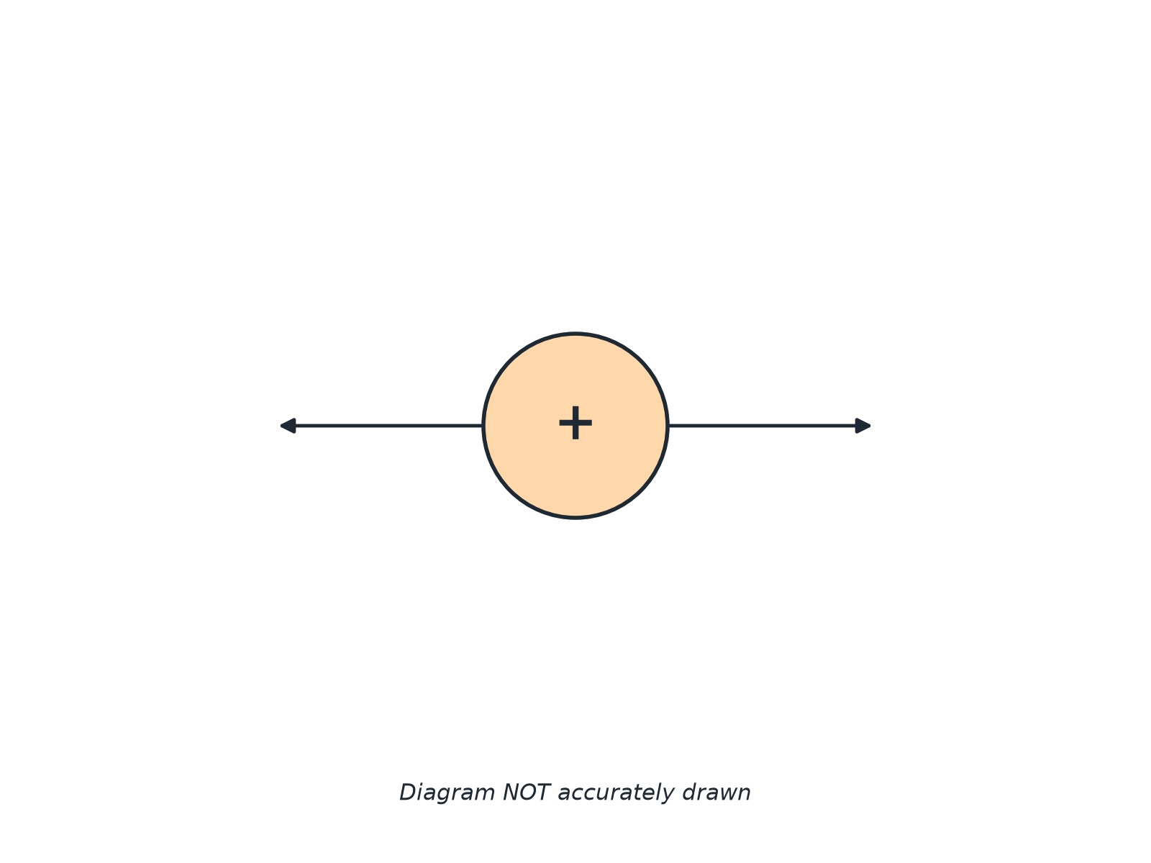

Question 2 · mark scheme
3 marks available. Award a mark for each point made.
▸ Additional radial straight lines evenly spaced. 1 mark
▸ Arrows pointing away. 1 mark
▸ Field strongest close to the sphere. 1 mark
▸ Model answer. Add at least six more radial lines with arrows pointing away from the sphere, evenly spaced. The lines are closer together near the sphere, so the field is stronger close to the sphere.
Question 3 · 2 marks · Explain
“A small positive charge is moved towards a positively charged sphere. Explain how the force on the small charge changes.”
HOW TO ANSWER IT Command word: Explain. Worth 2 marks, so plan before writing.
Question 3 · mark scheme
2 marks available. Award a mark for each point made.
▸ Force increases as the distance decreases. 1 mark
▸ The field is stronger closer to the sphere. 1 mark
▸ Model answer. The force is repulsive and increases as the charge gets closer, because the field is stronger closer to the sphere.
Question 4 · 3 marks · Explain
“Explain how the idea of an electric field helps to explain how a charged comb can pick up small pieces of paper without touching them.”
HOW TO ANSWER IT Command word: Explain. Worth 3 marks, so plan before writing.
Question 4 · mark scheme
3 marks available. Award a mark for each point made.
▸ Charged object has an electric field. 1 mark
▸ The field exerts a force on other objects. 1 mark
▸ Non-contact force of attraction. 1 mark
▸ Model answer. The charged comb has an electric field around it. The field exerts a non-contact force on the paper pieces, so they are attracted without touching.
Question 5 · 3 marks · Explain
“Explain, using the idea of an electric field, how a spark can jump between a charged sphere and a metal rod.”
HOW TO ANSWER IT Command word: Explain. Worth 3 marks, so plan before writing.
Question 5 · mark scheme
3 marks available. Award a mark for each point made.
▸ Strong field near the sphere. 1 mark
▸ Ionises the air. 1 mark
▸ Charge flows through the air as a spark. 1 mark
▸ Model answer. The charged sphere creates a strong electric field. When the field is strong enough it ionises the air between the sphere and the rod, making the air conduct, so charge flows as a spark.

