AQA GCSE PHYSICS · PAPER 1 · FOUNDATION & HIGHER
Current, resistance and potential difference
Electricity · Lesson 2 of 10
Teacher copy - includes the notes for whoever is teaching from it.
Warm-up
Answer each one, then check.
1. Write the unit of resistance.
Ohm (Ω)
2. What is the unit of potential difference?
Volt (V)
3. Where is a voltmeter connected?
In parallel across the component
4. What does a longer wire do to resistance?
Increases it
5. What is a current?
A flow of charge
Learning Objectives
1. Explain that current depends on resistance and potential difference.
2. Recall and apply V = IR.
3. Describe how to investigate the resistance of a wire and of combinations of resistors (Required Practical 3).
4. Interpret graphs of resistance against length.
V = Ir
potential difference = current × resistance V = IR
The greater the resistance of a component, the smaller the current for a given potential difference across it. Questions use the term potential difference; voltage also gains credit.
Required Practical 3: Resistance of a Wire
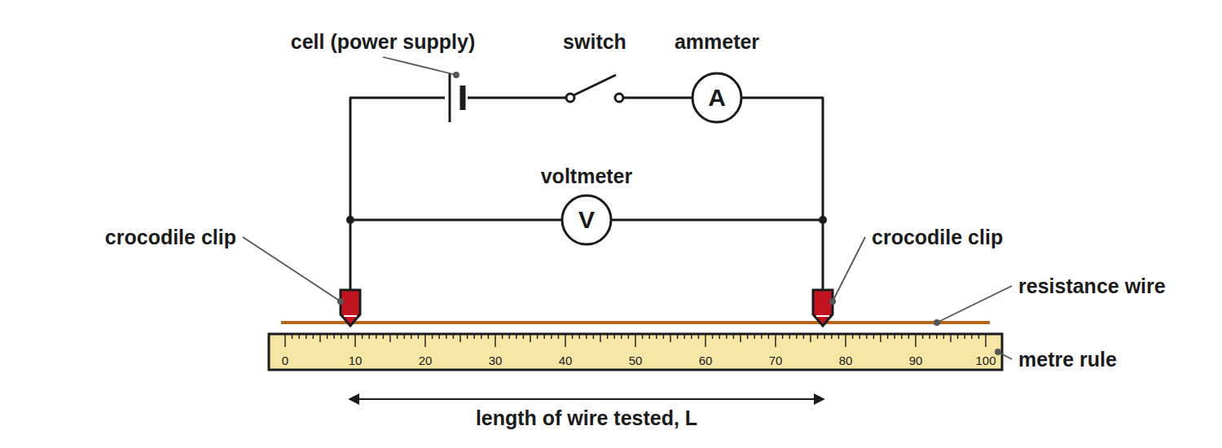
Change only the length of wire between the clips.
A circuit with a cell, switch and ammeter in series with a wire on a metre rule, and a voltmeter across the length of wire being tested.
Method: Resistance and Length of a Wire
Required Practical 3, part 1.
1  Set up  Connect the circuit with the ammeter in series and the voltmeter across the wire. | 2  Set the length  Clip the crocodile clips at 0.20 m, and record the pd and current. | 3  Switch off between readings  This keeps the wire at a constant temperature. | 4  Repeat  Take readings at 0.40 m, 0.60 m, 0.80 m and 1.00 m. | 5  Calculate  For each length R = V ÷ I. | 6  Plot  Draw a graph of resistance against length: a straight line through the origin.
Method: Resistors in Series and Parallel
Required Practical 3, part 2.
1  Series  Connect known resistors in series, measure V and I, calculate R = V ÷ I. | 2  Parallel  Repeat with the same resistors in parallel. | 3  Compare  The series combination has a larger resistance than either resistor; the parallel combination has a smaller one.
Calculating Current
A 12 V battery is connected across a 4.0 Ω resistor. Calculate the current.

1. Rearrange
I = V ÷ R
2. Substitute
I = 12 ÷ 4.0
3. Answer
I = 3.0 A
Answer: 3.0 A
Calculating Potential Difference
A current of 0.50 A flows through a 20 Ω resistor. Calculate the potential difference across it.

1. Write the equation
V = IR
2. Substitute
V = 0.50 × 20
3. Answer
V = 10 V
Answer: 10 V
Calculating Resistance
A voltmeter reads 6.0 V and an ammeter reads 20 mA. Calculate the resistance.

1. Convert the current
20 mA = 0.020 A
2. Rearrange
R = V ÷ I
3. Substitute
R = 6.0 ÷ 0.020
4. Answer
R = 300 Ω
Answer: 300 Ω
Getting Good Results
Why we switch off between readings.
▸ Heating. A current makes the wire hotter, and a hotter metal wire has a higher resistance.
▸ Constant temperature. Use a low current and switch off between readings.
▸ Zero errors. Check the meters read zero before starting.
▸ Repeat. Repeat and average to reduce random errors.
Key Terms
Resistance  How much a component opposes the flow of current. | Ohm  The unit of resistance (Ω).
Potential difference  The energy transferred per coulomb; measured in volts. | Voltmeter  Measures pd; connected in parallel.
Constant temperature  Kept the same so the resistance does not change for other reasons. | Directly proportional  Doubling one quantity doubles the other.
Your Task: Predict the Graph
10 minutes
A student measures the resistance of 20 cm, 40 cm, 60 cm, 80 cm and 100 cm of a wire. What does the graph of resistance against length look like? A 30 cm length has a resistance of 1.8 Ω; what is the resistance of 90 cm?
1. Sketch the axes.
2. Use the ratio of lengths.
A good answer shows: A straight line through the origin: resistance is directly proportional to length. 90 cm is three times as long, so R = 5.4 Ω.
Note: Ask what happens if the wire heats up.
Can I...?
☐ Recall V = IR.
☐ Rearrange for I or R.
☐ Convert mA to A.
☐ Describe the resistance of wire method.
☐ Explain why the wire is switched off between readings.
☐ Draw a graph of R against length.
☐ Say what happens to resistance in series and parallel.
☐ Use the correct units.
Summary
✓ V = IR.
✓ Ammeter in series, voltmeter in parallel.
✓ Longer wire means greater resistance.
✓ Switch off between readings to keep the temperature constant.

EXAM FOCUS
A potential difference of 9.0 V is applied across a resistor and the current is 0.30 A. Calculate the resistance. (2 marks)
State the equation, substitute and give the unit Ω.
Exam Practice: Current, resistance and potential difference
Answer all questions. Use the mark allocation as a guide to how much to write. · 21 minutes
▸ Question 1 · 2 marks · Calculate. The potential difference across a resistor is 9.0 V and the current through it is 0.30 A. Calculate the resistance of the resistor. Use the…
▸ Question 2 · 2 marks · Calculate. A current of 0.15 A flows through a 40 Ω resistor. Calculate the potential difference across the resistor.
▸ Question 3 · 4 marks · Use the graph. A student investigates how the resistance of a wire depends on its length. The graph shows the results. (a) Describe the relationship shown…
▸ Question 4 · 6 marks · Describe. Describe an investigation to show how the resistance of a wire depends on its length. Your answer should include a circuit diagram…
▸ Question 5 · 3 marks · Explain. Two identical resistors are connected first in series and then in parallel. Explain, without calculation, how the total resistance of each…
▸ Question 6 · 3 marks · Calculate. A voltmeter reads 6.0 V and an ammeter reads 20 mA. Calculate the resistance of the component.
Question 1 · 2 marks · Calculate
“The potential difference across a resistor is 9.0 V and the current through it is 0.30 A. Calculate the resistance of the resistor. Use the equation: potential difference = current × resistance”
HOW TO ANSWER IT Command word: Calculate. Worth 2 marks, so plan before writing.
Question 1 · mark scheme
2 marks available. Award a mark for each point made.
▸ Correct substitution. 1 mark
▸ 30 Ω. 1 mark
▸ Model answer. R = V ÷ I = 9.0 ÷ 0.30 = 30 Ω
Question 2 · 2 marks · Calculate
“A current of 0.15 A flows through a 40 Ω resistor. Calculate the potential difference across the resistor.”
HOW TO ANSWER IT Command word: Calculate. Worth 2 marks, so plan before writing.
Question 2 · mark scheme
2 marks available. Award a mark for each point made.
▸ Correct substitution. 1 mark
▸ 6.0 V. 1 mark
▸ Model answer. V = IR = 0.15 × 40 = 6.0 V
Question 3 · 4 marks · Use the graph
A student investigates how the resistance of a wire depends on its length. The graph shows the results. (a) Describe the relationship shown by the graph. (b) Use the graph to find the resistance of 70 cm of the wire. (c) Suggest why the student switched off the current between readings. (4 marks) | 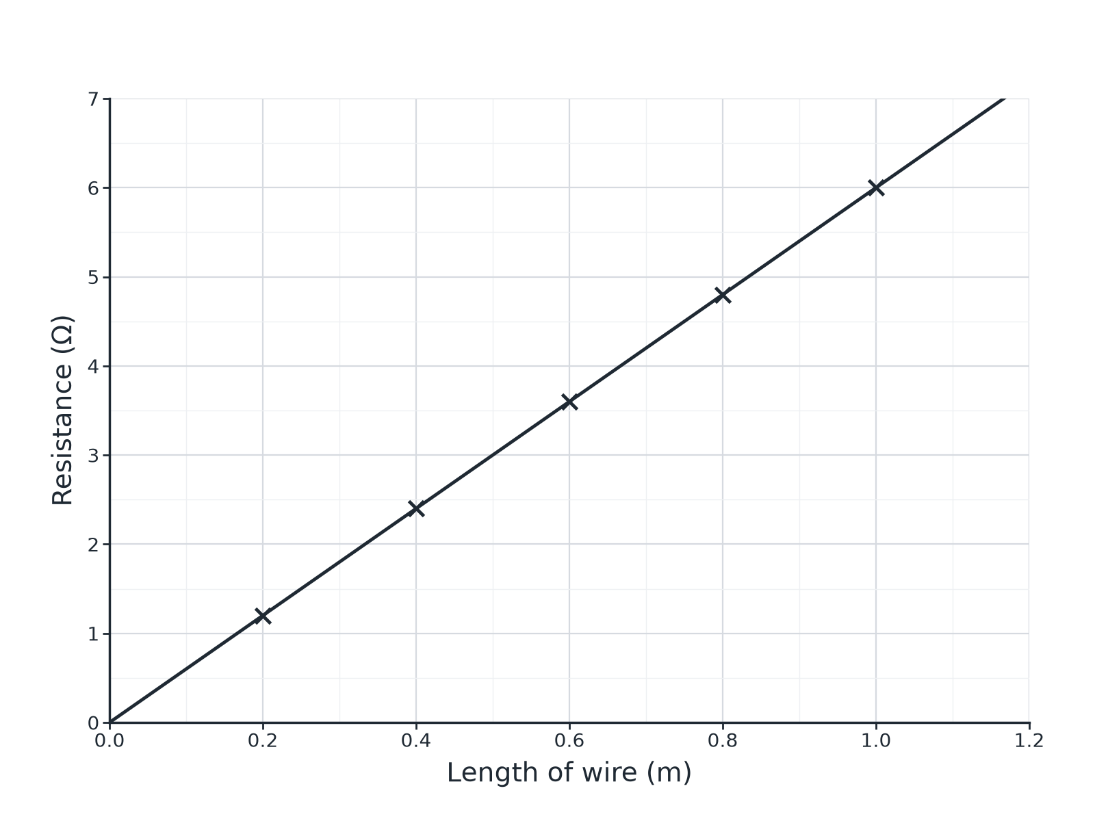

Question 3 · mark scheme
4 marks available. Award a mark for each point made.
▸ Straight line through the origin, or directly proportional. 1 mark
▸ 4.2 Ω (accept 4.1 to 4.3). 1 mark
▸ To keep the temperature constant or stop the wire heating. 1 mark
▸ Because temperature affects resistance. 1 mark
▸ Model answer. (a) The resistance is directly proportional to the length (a straight line through the origin). (b) 4.2 Ω. (c) To stop the wire heating up, because a hotter wire has a higher resistance.
Question 4 · 6 marks · Describe
“Describe an investigation to show how the resistance of a wire depends on its length. Your answer should include a circuit diagram description, the measurements you would take, and how you would keep the test fair and safe.”
HOW TO ANSWER IT Command word: Describe. Worth 6 marks, so plan before writing.
Question 4 · mark scheme
6 marks available. Award a mark for each point made.
▸ Level 3 (5 to 6 marks): a complete method with a correct circuit (ammeter in series, voltmeter across the wire), several lengths, calculation of R = V ÷ I for each, a graph, and control of temperature or safety. 5 to 6 marks
▸ Level 2 (3 to 4 marks): a method with most of the equipment and measurements, but with gaps in the detail or control. 3 to 4 marks
▸ Level 1 (1 to 2 marks): simple statements about measuring current and pd for wires. 1 to 2 marks
▸ Model answer. See levels-of-response scheme.
Question 5 · 3 marks · Explain
“Two identical resistors are connected first in series and then in parallel. Explain, without calculation, how the total resistance of each arrangement compares with the resistance of one resistor.”
HOW TO ANSWER IT Command word: Explain. Worth 3 marks, so plan before writing.
Question 5 · mark scheme
3 marks available. Award a mark for each point made.
▸ Series greater. 1 mark
▸ Parallel less. 1 mark
▸ A reason for either. 1 mark
▸ Model answer. In series the total resistance is greater than one resistor because the current has to pass through both. In parallel the total resistance is less than one resistor because there are two paths for the current.
Question 6 · 3 marks · Calculate
“A voltmeter reads 6.0 V and an ammeter reads 20 mA. Calculate the resistance of the component.”
HOW TO ANSWER IT Command word: Calculate. Worth 3 marks, so plan before writing.
Question 6 · mark scheme
3 marks available. Award a mark for each point made.
▸ Converts 20 mA to 0.020 A. 1 mark
▸ Correct substitution. 1 mark
▸ 300 Ω. 1 mark
▸ Model answer. I = 0.020 A; R = 6.0 ÷ 0.020 = 300 Ω

