AQA GCSE PHYSICS · PAPER 1 · FOUNDATION & HIGHER
Resistors and I–V characteristics
Electricity · Lesson 3 of 10
Warm-up
Answer each one, then check.
1. What is an ohmic conductor?
A conductor with constant resistance at constant temperature
2. What does I–V stand for?
Current against potential difference
3. What is a straight line graph through the origin?
Directly proportional
4. What happens to a metal when its temperature rises?
Its resistance rises
5. What does LDR stand for?
Light-dependent resistor
Learning Objectives
1. Describe the I–V graphs of a resistor, filament lamp and diode.
2. Explain the changes in resistance of a filament lamp, diode, thermistor and LDR.
3. Describe how to investigate I–V characteristics (Required Practical 4).
4. Use graphs to say whether a component is linear or non-linear.
I–V Characteristics
The current through an ohmic conductor at constant temperature is directly proportional to the potential difference across it, so its resistance is constant.
The resistance of a filament lamp, diode, thermistor and LDR is not constant.
I–V Graphs
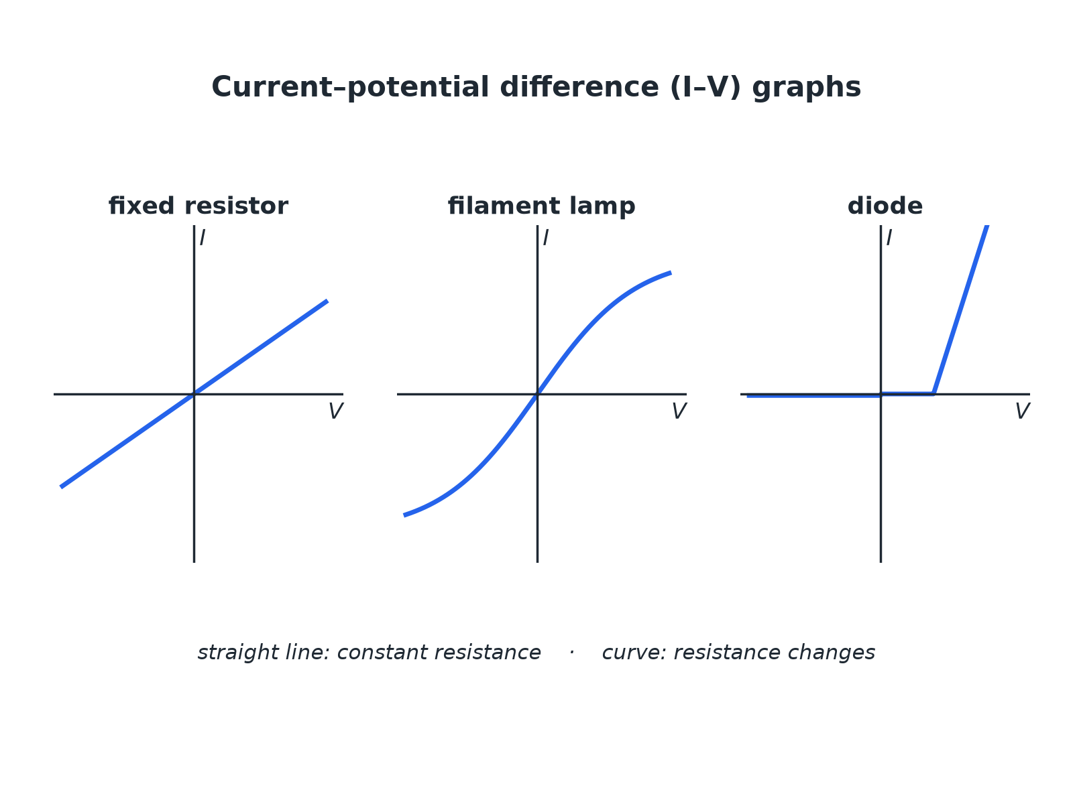
Straight line: constant resistance. Curve: changing resistance.
I-V graphs for a fixed resistor, a filament lamp and a diode.
Thermistor and LDR
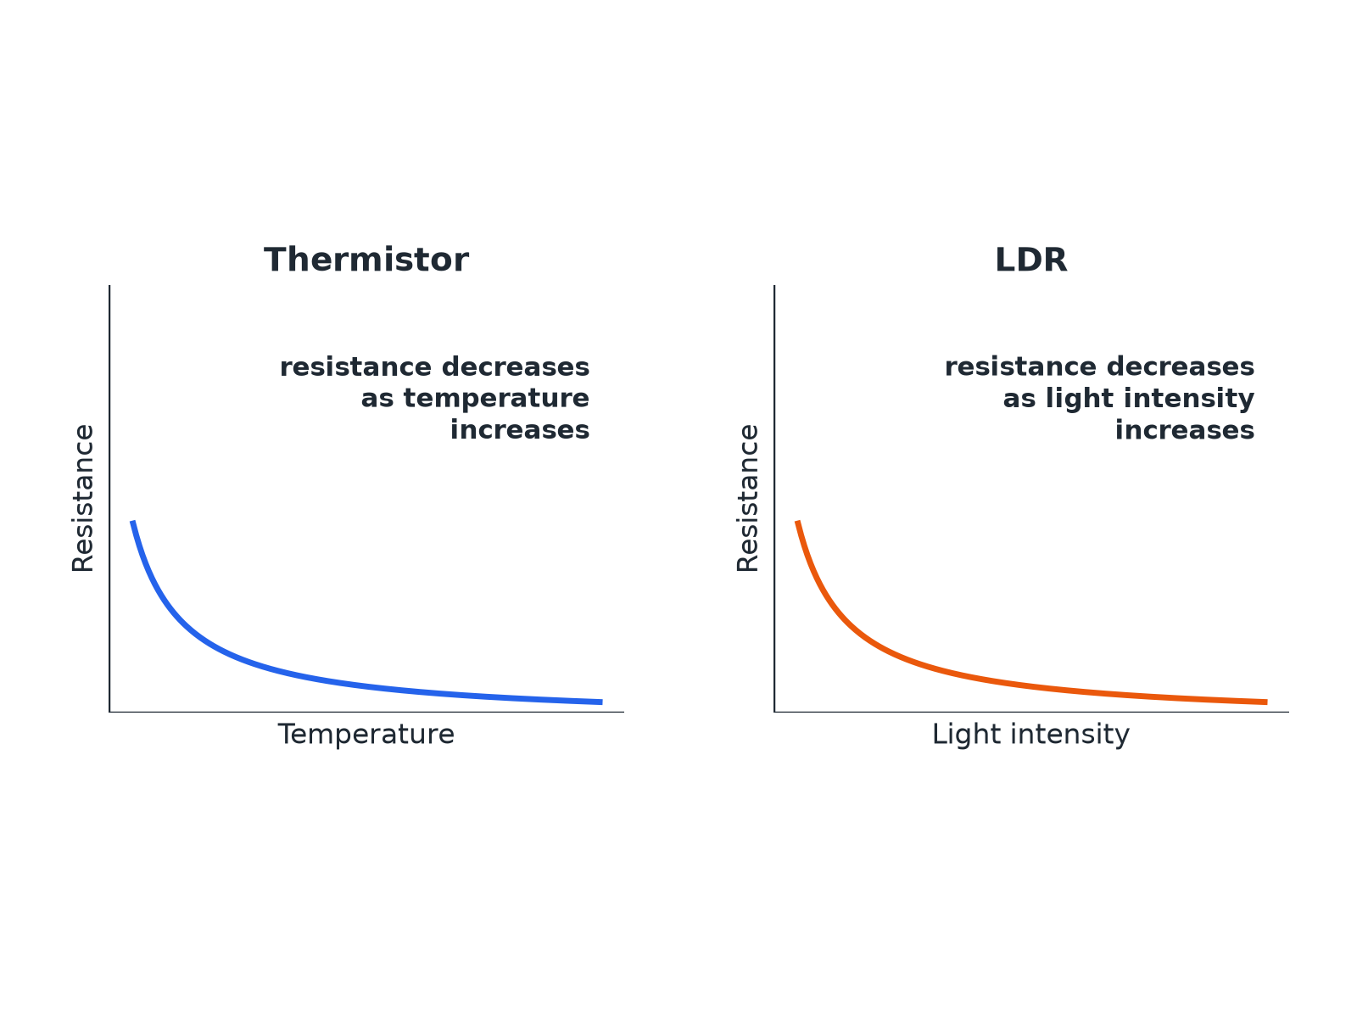
Both fall as the quantity increases.
Graphs showing the resistance of a thermistor falling as temperature rises and the resistance of an LDR falling as light intensity rises.
Required Practical 4: I–V Circuit
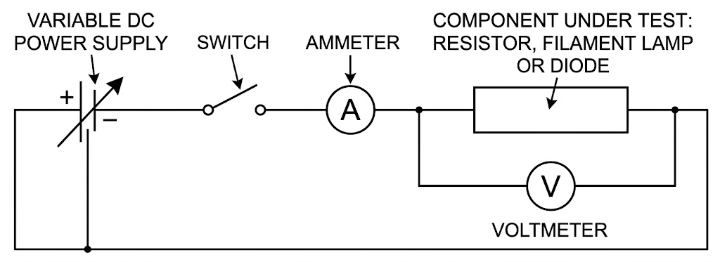
Vary the pd and measure the current each time.
A circuit with a variable resistor, ammeter in series with the test component and a voltmeter across it.
Component Behaviour
Learn each description.
Component | Resistance | Graph or behaviour
Fixed resistor | Constant at constant temperature | Straight line through the origin
Filament lamp | Increases as the filament gets hotter | Curve that flattens; gradient decreases
Diode | Very high in the reverse direction | Current flows in one direction only
Thermistor | Decreases as temperature increases | Used in thermostats and temperature sensors
LDR | Decreases as light intensity increases | Used in automatic lights
Required Practical 4: Method
Find the I–V characteristic of a component.
1  Set up  Connect the component in series with the ammeter and variable resistor, and the voltmeter across the component. | 2  Vary  Change the variable resistor to get different pds. | 3  Record  For each setting record V and I. | 4  Reverse  Swap the connections and repeat to get negative values (not for a diode with a protective resistor). | 5  Plot  Draw current against pd and draw a smooth line. | 6  Repeat  For the filament lamp and the diode.
Resistance of a Filament Lamp
The current through a filament lamp is 0.34 A at 2.0 V and 0.62 A at 6.0 V. Calculate the resistance at each pd and explain the difference.

1. At 2.0 V
R = 2.0 ÷ 0.34 = 5.9 Ω
2. At 6.0 V
R = 6.0 ÷ 0.62 = 9.7 Ω
3. Explain
At the higher pd the current is greater, so the filament is hotter and its resistance is higher
Answer: 5.9 Ω and 9.7 Ω; the resistance increases as the filament gets hotter.
Uses in Circuits
Applications you need to know.
▸ Thermistor. In a thermostat: as the temperature rises the resistance falls, changing the pd across it to switch heating off.
▸ LDR. In automatic lights: as it gets dark the resistance rises, which switches the light on.
▸ Diode. Allows current in one direction only, protecting circuits from being connected the wrong way round.
Key Terms
Ohmic conductor  A conductor whose resistance is constant at constant temperature. | Filament lamp  A lamp with a thin wire that gets hot and glows.
Diode  A component that lets current flow in one direction only. | Thermistor  A resistor whose resistance decreases when the temperature increases.
LDR  A resistor whose resistance decreases when the light intensity increases. | Linear  Following a straight line graph.
Your Task: Match the Graph
10 minutes
Match each component to its I–V graph description: resistor, filament lamp, diode. (1) Curve that flattens as pd increases. (2) Straight line through the origin. (3) Almost no current one way, then a rapid increase the other way.
1. Look at the shape.
2. Explain the resistance change.
A good answer shows: Resistor: (2). Filament lamp: (1). Diode: (3).
Can I...?
☐ Draw and describe the I–V graph of a resistor.
☐ Describe the I–V graph of a filament lamp.
☐ Describe the I–V graph of a diode.
☐ Explain why a filament lamp's resistance increases.
☐ Describe how a thermistor behaves.
☐ Describe how an LDR behaves.
☐ Describe Required Practical 4.
☐ Give one use each of a thermistor and an LDR.
Summary
✓ Resistor: constant resistance, straight line through the origin.
✓ Filament lamp: resistance increases with temperature.
✓ Diode: current in one direction only.
✓ Thermistor and LDR resistances decrease as temperature or light increases.

EXAM FOCUS
Explain why the resistance of a filament lamp increases as the current increases. (3 marks)
Say the filament gets hotter and link it to resistance.

