AQA GCSE PHYSICS · PAPER 1 · FOUNDATION & HIGHER
Resistors and I–V characteristics
Electricity · Lesson 3 of 10
Teacher copy - includes the notes for whoever is teaching from it.
Warm-up
Answer each one, then check.
1. What is an ohmic conductor?
A conductor with constant resistance at constant temperature
2. What does I–V stand for?
Current against potential difference
3. What is a straight line graph through the origin?
Directly proportional
4. What happens to a metal when its temperature rises?
Its resistance rises
5. What does LDR stand for?
Light-dependent resistor
Learning Objectives
1. Describe the I–V graphs of a resistor, filament lamp and diode.
2. Explain the changes in resistance of a filament lamp, diode, thermistor and LDR.
3. Describe how to investigate I–V characteristics (Required Practical 4).
4. Use graphs to say whether a component is linear or non-linear.
I–V Characteristics
The current through an ohmic conductor at constant temperature is directly proportional to the potential difference across it, so its resistance is constant.
The resistance of a filament lamp, diode, thermistor and LDR is not constant.
I–V Graphs
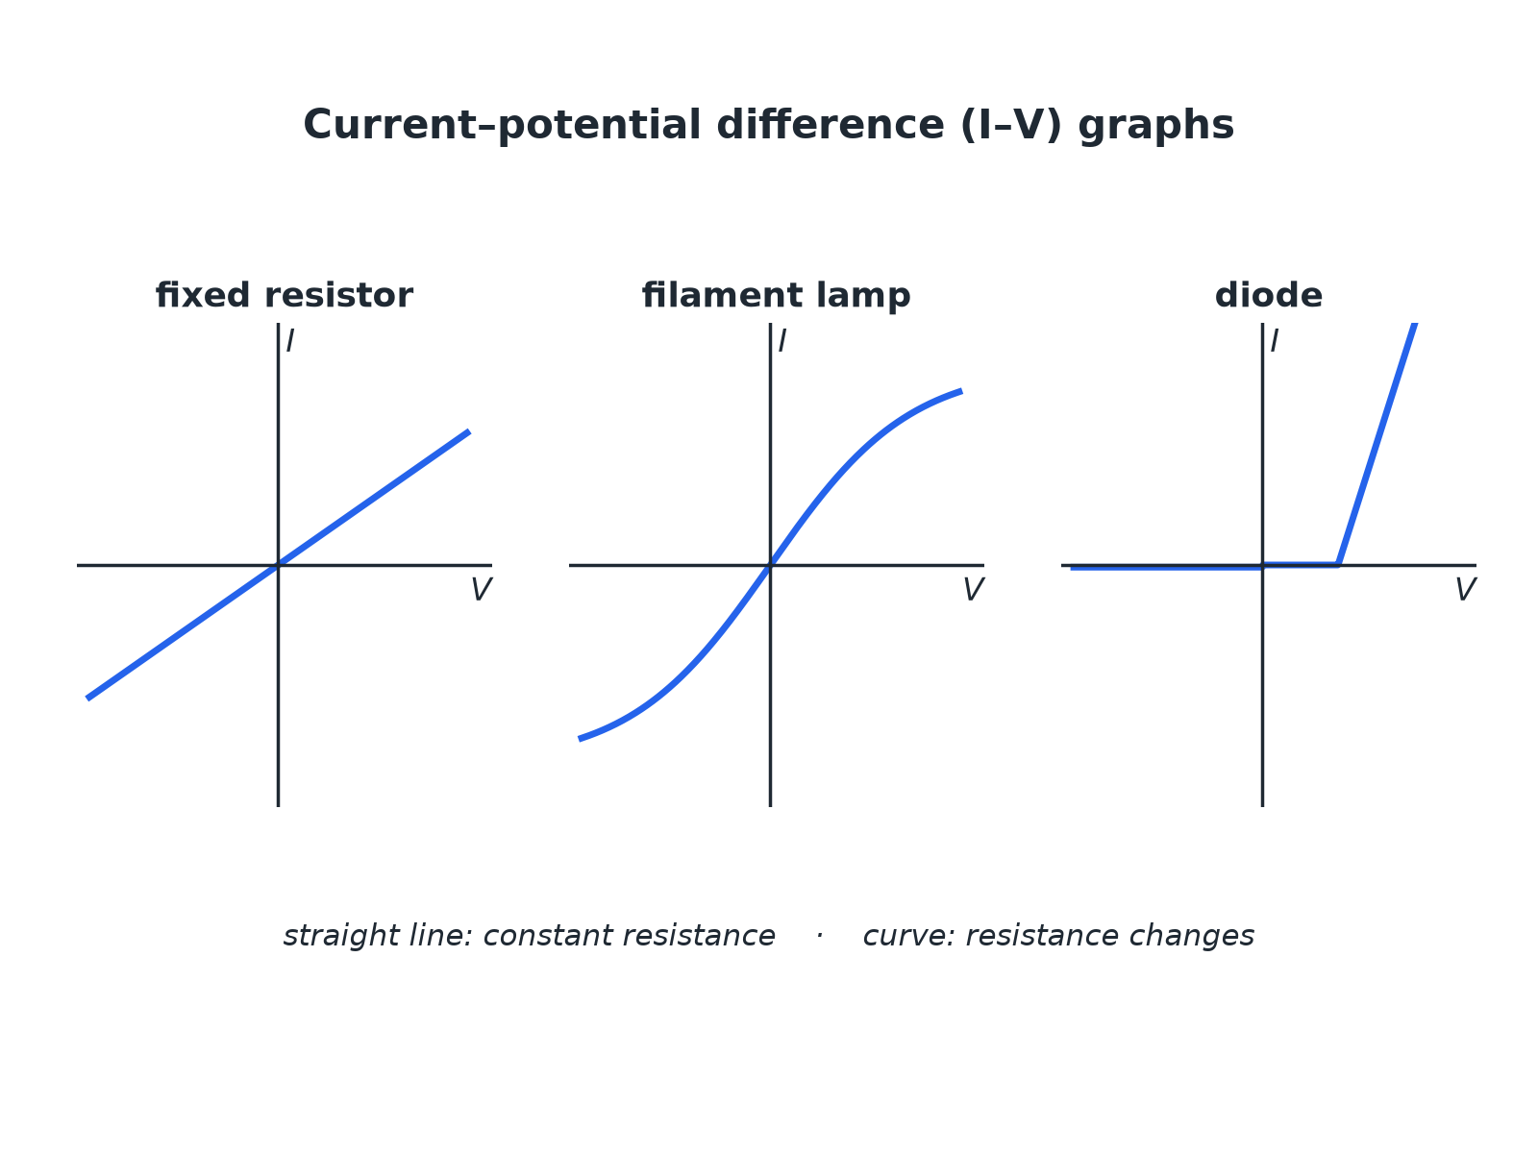
Straight line: constant resistance. Curve: changing resistance.
I-V graphs for a fixed resistor, a filament lamp and a diode.
Thermistor and LDR
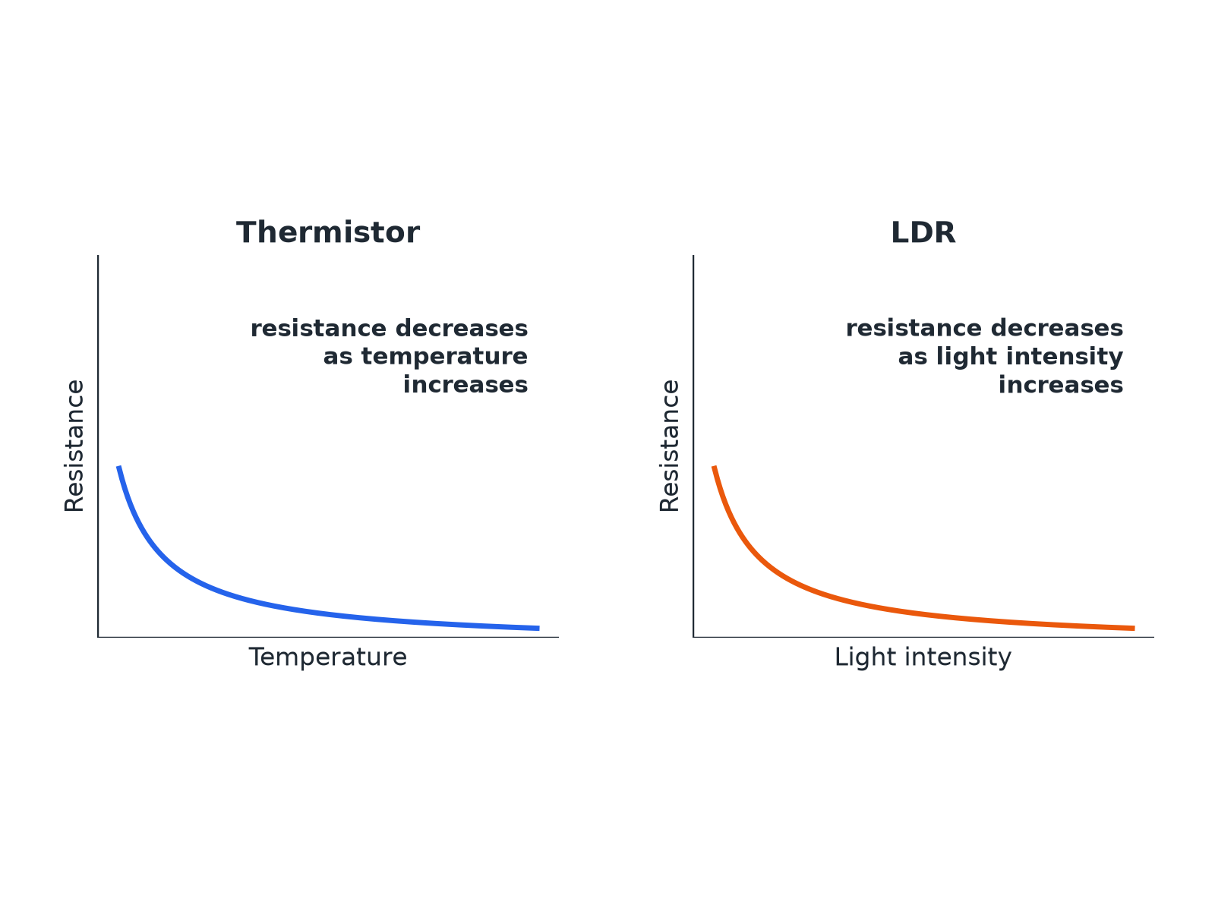
Both fall as the quantity increases.
Graphs showing the resistance of a thermistor falling as temperature rises and the resistance of an LDR falling as light intensity rises.
Required Practical 4: I–V Circuit
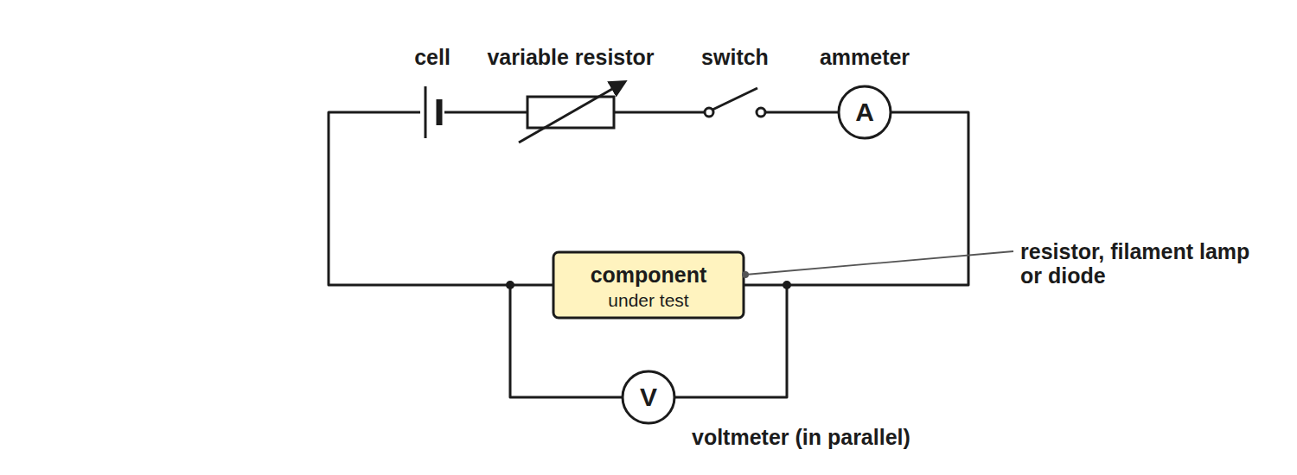
Vary the pd and measure the current each time.
A circuit with a variable resistor, ammeter in series with the test component and a voltmeter across it.
Component Behaviour
Learn each description.
Component | Resistance | Graph or behaviour
Fixed resistor | Constant at constant temperature | Straight line through the origin
Filament lamp | Increases as the filament gets hotter | Curve that flattens; gradient decreases
Diode | Very high in the reverse direction | Current flows in one direction only
Thermistor | Decreases as temperature increases | Used in thermostats and temperature sensors
LDR | Decreases as light intensity increases | Used in automatic lights
Required Practical 4: Method
Find the I–V characteristic of a component.
1  Set up  Connect the component in series with the ammeter and variable resistor, and the voltmeter across the component. | 2  Vary  Change the variable resistor to get different pds. | 3  Record  For each setting record V and I. | 4  Reverse  Swap the connections and repeat to get negative values (not for a diode with a protective resistor). | 5  Plot  Draw current against pd and draw a smooth line. | 6  Repeat  For the filament lamp and the diode.
Resistance of a Filament Lamp
The current through a filament lamp is 0.34 A at 2.0 V and 0.62 A at 6.0 V. Calculate the resistance at each pd and explain the difference.

1. At 2.0 V
R = 2.0 ÷ 0.34 = 5.9 Ω
2. At 6.0 V
R = 6.0 ÷ 0.62 = 9.7 Ω
3. Explain
At the higher pd the current is greater, so the filament is hotter and its resistance is higher
Answer: 5.9 Ω and 9.7 Ω; the resistance increases as the filament gets hotter.
Uses in Circuits
Applications you need to know.
▸ Thermistor. In a thermostat: as the temperature rises the resistance falls, changing the pd across it to switch heating off.
▸ LDR. In automatic lights: as it gets dark the resistance rises, which switches the light on.
▸ Diode. Allows current in one direction only, protecting circuits from being connected the wrong way round.
Key Terms
Ohmic conductor  A conductor whose resistance is constant at constant temperature. | Filament lamp  A lamp with a thin wire that gets hot and glows.
Diode  A component that lets current flow in one direction only. | Thermistor  A resistor whose resistance decreases when the temperature increases.
LDR  A resistor whose resistance decreases when the light intensity increases. | Linear  Following a straight line graph.
Your Task: Match the Graph
10 minutes
Match each component to its I–V graph description: resistor, filament lamp, diode. (1) Curve that flattens as pd increases. (2) Straight line through the origin. (3) Almost no current one way, then a rapid increase the other way.
1. Look at the shape.
2. Explain the resistance change.
A good answer shows: Resistor: (2). Filament lamp: (1). Diode: (3).
Note: Ask learners to explain each in terms of resistance.
Can I...?
☐ Draw and describe the I–V graph of a resistor.
☐ Describe the I–V graph of a filament lamp.
☐ Describe the I–V graph of a diode.
☐ Explain why a filament lamp's resistance increases.
☐ Describe how a thermistor behaves.
☐ Describe how an LDR behaves.
☐ Describe Required Practical 4.
☐ Give one use each of a thermistor and an LDR.
Summary
✓ Resistor: constant resistance, straight line through the origin.
✓ Filament lamp: resistance increases with temperature.
✓ Diode: current in one direction only.
✓ Thermistor and LDR resistances decrease as temperature or light increases.

EXAM FOCUS
Explain why the resistance of a filament lamp increases as the current increases. (3 marks)
Say the filament gets hotter and link it to resistance.
Exam Practice: Resistors and I–V characteristics
Answer all questions. Use the mark allocation as a guide to how much to write. · 22 minutes
▸ Question 1 · 3 marks · Complete. Name the component whose I–V characteristic shows current flowing in one direction only, and the component whose resistance decreases as…
▸ Question 2 · 4 marks · Use the graph. The graph shows the I–V characteristic of a filament lamp. (a) Calculate the resistance of the lamp when the potential difference is 6.0 V…
▸ Question 3 · 3 marks · Explain. A thermistor is used in a circuit to control a heating system. Explain how the resistance of the thermistor changes as the room warms up.
▸ Question 4 · 6 marks · Describe. Describe how you would investigate the relationship between the current through a filament lamp and the potential difference across it…
▸ Question 5 · 2 marks · Explain. A student measures the resistance of a diode. Explain why the resistance is very high when the diode is connected the other way round.
▸ Question 6 · 3 marks · Suggest. An automatic outdoor light contains an LDR. Explain how the light switches on when it gets dark.
Question 1 · 3 marks · Complete
“Name the component whose I–V characteristic shows current flowing in one direction only, and the component whose resistance decreases as the temperature increases. Then state what happens to the resistance of an LDR in bright light.”
HOW TO ANSWER IT Command word: Complete. Worth 3 marks, so plan before writing.
Question 1 · mark scheme
3 marks available. Award a mark for each point made.
▸ Diode. 1 mark
▸ Thermistor. 1 mark
▸ LDR resistance decreases. 1 mark
▸ Model answer. A diode; a thermistor; the resistance of an LDR decreases in bright light.
Question 2 · 4 marks · Use the graph
The graph shows the I–V characteristic of a filament lamp. (a) Calculate the resistance of the lamp when the potential difference is 6.0 V. (b) The resistance at 2.0 V is 5.9 Ω. Explain why the resistance at 6.0 V is different. (4 marks) | 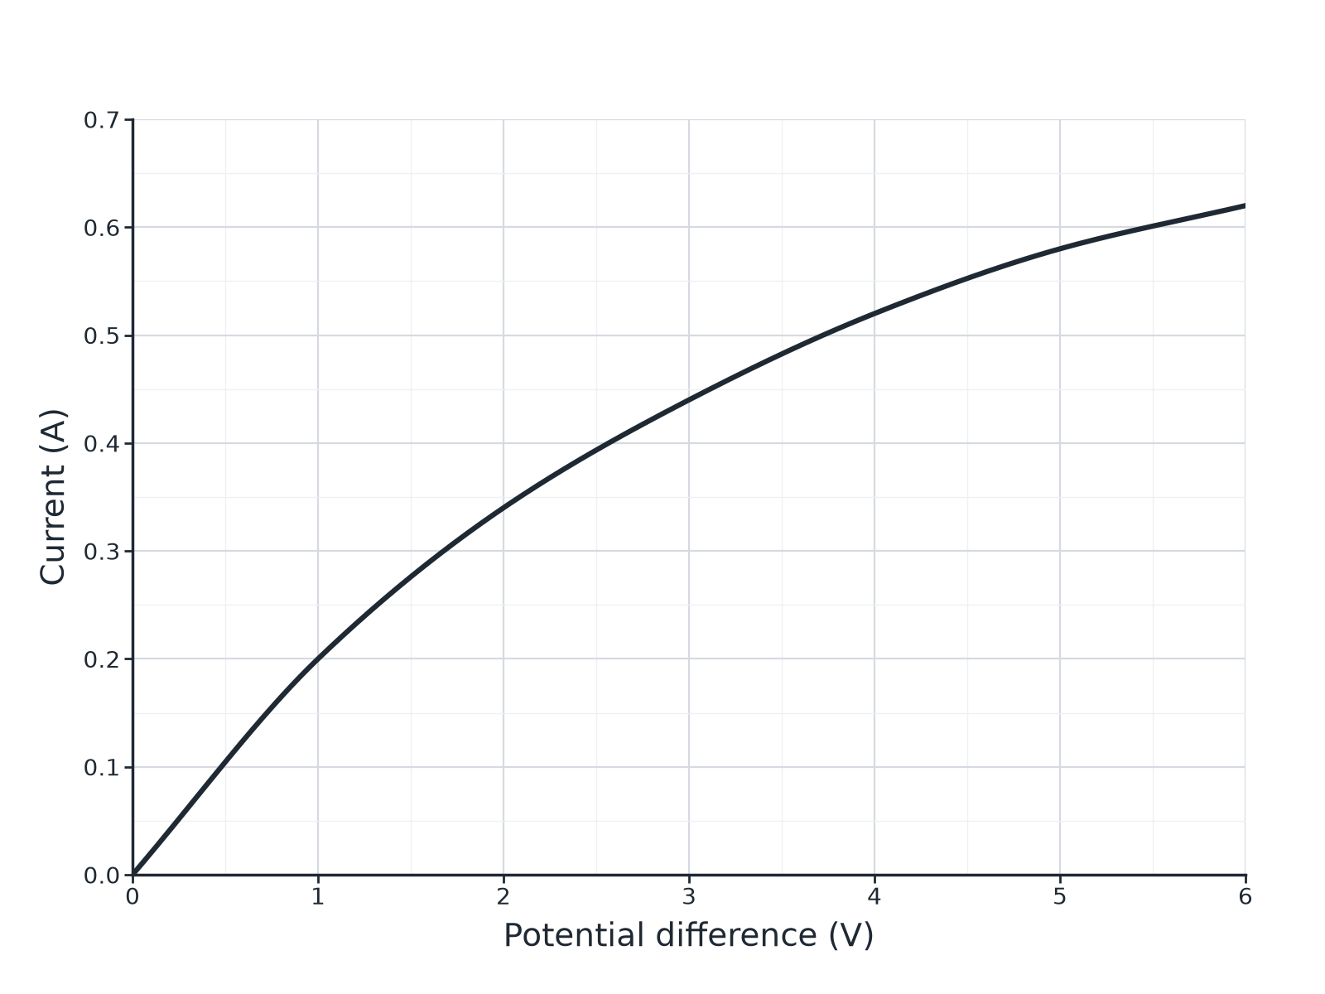

Question 2 · mark scheme
4 marks available. Award a mark for each point made.
▸ Reads 0.62 A. 1 mark
▸ 9.7 Ω. 1 mark
▸ Higher current means higher temperature. 1 mark
▸ Resistance increases with temperature. 1 mark
▸ Model answer. (a) At 6.0 V the current is 0.62 A. R = 6.0 ÷ 0.62 = 9.7 Ω. (b) At 6.0 V the current is greater so the filament is hotter, and the resistance of the filament increases with temperature.
Question 3 · 3 marks · Explain
“A thermistor is used in a circuit to control a heating system. Explain how the resistance of the thermistor changes as the room warms up.”
HOW TO ANSWER IT Command word: Explain. Worth 3 marks, so plan before writing.
Question 3 · mark scheme
3 marks available. Award a mark for each point made.
▸ Resistance decreases as temperature increases. 1 mark
▸ Current or potential difference changes in the circuit. 1 mark
▸ Used to switch the heating off. 1 mark
▸ Model answer. As the temperature increases the resistance of the thermistor decreases, so the current through it increases and the potential difference across it changes; this is used to switch the heating off.
Question 4 · 6 marks · Describe
“Describe how you would investigate the relationship between the current through a filament lamp and the potential difference across it. Include a circuit diagram description, the readings to take and how you would present and use the results.”
HOW TO ANSWER IT Command word: Describe. Worth 6 marks, so plan before writing.
Question 4 · mark scheme
6 marks available. Award a mark for each point made.
▸ Level 3 (5 to 6 marks): a correct circuit (ammeter in series, voltmeter across the lamp, variable resistor or supply), a range of pd values and matching currents, a graph of I against V and a description of its shape or the changing gradient. 5 to 6 marks
▸ Level 2 (3 to 4 marks): a method with the main apparatus and some readings; the graph is mentioned. 3 to 4 marks
▸ Level 1 (1 to 2 marks): simple statements about measuring current and pd. 1 to 2 marks
▸ Model answer. See levels-of-response scheme.
Question 5 · 2 marks · Explain
“A student measures the resistance of a diode. Explain why the resistance is very high when the diode is connected the other way round.”
HOW TO ANSWER IT Command word: Explain. Worth 2 marks, so plan before writing.
Question 5 · mark scheme
2 marks available. Award a mark for each point made.
▸ Very high resistance in reverse. 1 mark
▸ Almost no current flows. 1 mark
▸ Model answer. A diode has a very high resistance in the reverse direction, so almost no current flows.
Question 6 · 3 marks · Suggest
“An automatic outdoor light contains an LDR. Explain how the light switches on when it gets dark.”
HOW TO ANSWER IT Command word: Suggest. Worth 3 marks, so plan before writing.
Question 6 · mark scheme
3 marks available. Award a mark for each point made.
▸ Resistance of LDR increases in the dark. 1 mark
▸ Change in pd or current in the circuit. 1 mark
▸ Circuit switches the light on. 1 mark
▸ Model answer. When it gets dark the resistance of the LDR increases. The pd across the LDR increases (or current decreases), which triggers the circuit that switches the light on.

