AQA GCSE PHYSICS · PAPER 1 · FOUNDATION & HIGHER
Internal energy
Particle model of matter · Lesson 3 of 6
Teacher copy - includes the notes for whoever is teaching from it.
Warm-up
Answer each one, then check.
1. What is kinetic energy?
Energy stored in moving objects
2. What is the equation for a change in thermal energy?
ΔE = mcΔθ
3. What is temperature a measure of?
How hot something is
4. What is a system?
An object or group of objects
5. What is potential energy?
Stored energy due to position or bonds
Learning Objectives
1. Define internal energy.
2. Explain how heating changes the energy stored within a system.
3. Use ΔE = mcΔθ to calculate the energy for a temperature change.
4. Distinguish temperature from internal energy.
Internal Energy
Internal energy is the total kinetic energy and potential energy of all the particles that make up a system.
Heating increases the energy of the particles. This either raises the temperature of the system or produces a change of state.
Where the Energy Goes
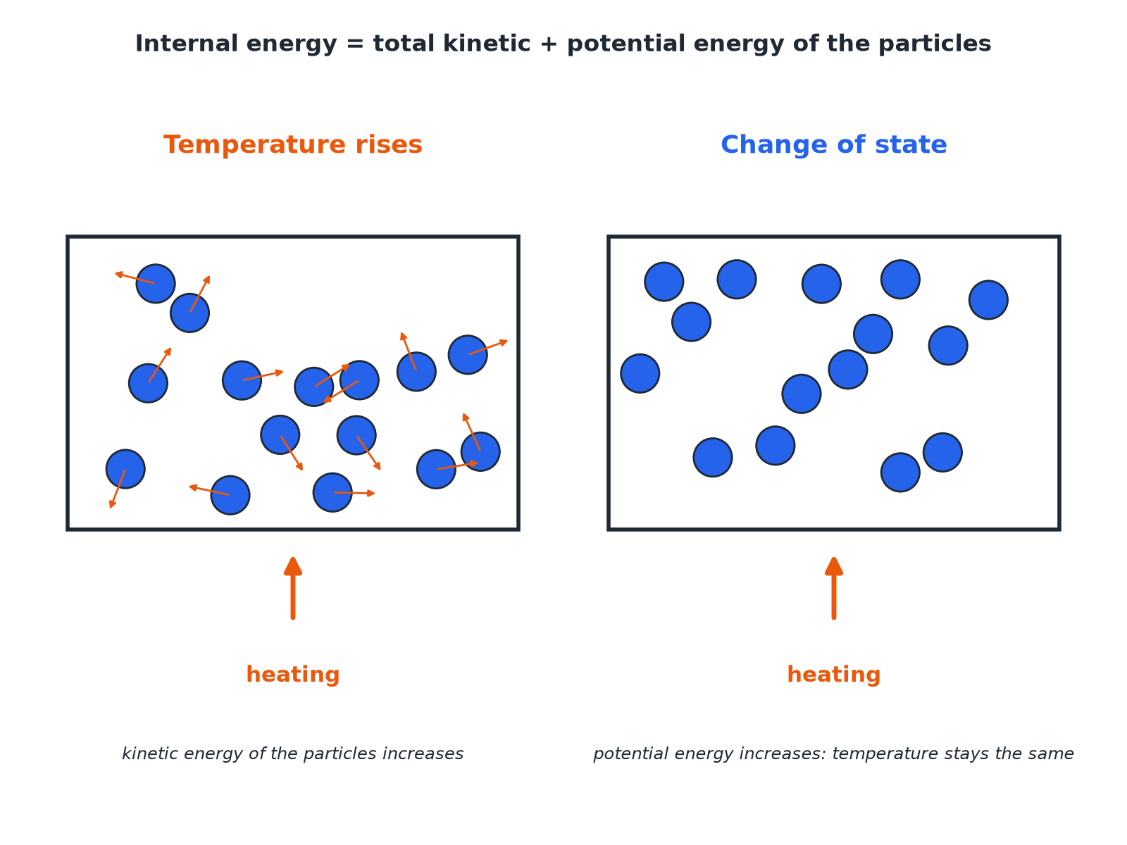
Kinetic energy relates to temperature.
Heating raises either the kinetic energy of particles, raising temperature, or their potential energy, changing state.
Temperature or Change of State?
TEMPERATURE RISES | STATE CHANGES
▸ The kinetic energy of the particles increases.  ▸ The average speed of the particles increases.  ▸ Calculate with ΔE = mcΔθ. | ▸ The potential energy of the particles increases.  ▸ The particles move further apart or become free.  ▸ The temperature stays the same.
Energy for a Temperature Rise
Calculate the energy needed to raise the temperature of 0.50 kg of water from 20 °C to 60 °C. c = 4200 J/kg °C.

1. Temperature change
60 − 20 = 40 °C
2. Substitute
ΔE = 0.50 × 4200 × 40
3. Answer
ΔE = 84 000 J
Answer: 84 000 J (84 kJ)
Comparing Internal Energy
Which has more internal energy: 1.0 kg of water at 50 °C or 2.0 kg of water at 50 °C?

1. Same temperature
The particles have the same average kinetic energy
2. Different mass
2.0 kg has twice as many particles, so twice as much total energy
Answer: 2.0 kg of water has more internal energy.
Key Ideas
Learn the links.
▸ Temperature. Related to the average kinetic energy of the particles.
▸ Internal energy. The total, including potential energy.
▸ Heating. Increases internal energy by raising temperature or changing state.
▸ Cooling. Decreases internal energy.
Key Terms
Internal energy  The total kinetic and potential energy of all the particles in a system. | Kinetic energy  Energy of movement.
Potential energy  Energy stored because of forces between particles. | Specific heat capacity  Energy needed to raise 1 kg by 1 °C.
Temperature  A measure of the average kinetic energy of particles. | System  An object or group of objects.
Your Task: More Energy
10 minutes
Explain what happens to the internal energy and the temperature of a beaker of water as it is heated (a) from 20 °C to 60 °C (b) while ice at 0 °C is melting.
1. Say what changes in the particles.
2. Say what happens to temperature.
A good answer shows: (a) Internal energy increases, mainly kinetic energy, so the temperature rises. (b) Internal energy increases as potential energy rises, but the temperature stays at 0 °C.
Note: Ask what happens to the kinetic energy in (b).
Can I...?
☐ Define internal energy.
☐ Say heating increases internal energy.
☐ Link kinetic energy to temperature.
☐ Link potential energy to change of state.
☐ Use ΔE = mcΔθ.
☐ Compare two objects.
☐ Explain cooling.
☐ Use correct units.
Summary
✓ Internal energy = total kinetic + potential energy of the particles.
✓ Heating raises temperature or changes state.
✓ Temperature relates to kinetic energy.
✓ ΔE = mcΔθ.

EXAM FOCUS
What is meant by the internal energy of a system? (2 marks)
The total kinetic and potential energy of all the particles.
Exam Practice: Internal energy
Answer all questions. Use the mark allocation as a guide to how much to write. · 15 minutes
▸ Question 1 · 2 marks · State. What is meant by the internal energy of a system?
▸ Question 2 · 3 marks · Explain. A beaker of water is heated. Explain what happens to the energy stored within the water and to its temperature.
▸ Question 3 · 3 marks · Calculate. Calculate the energy needed to raise the temperature of 0.50 kg of water from 20 °C to 60 °C. Specific heat capacity of water = 4200 J/kg…
▸ Question 4 · 2 marks · Explain. 1.0 kg of water and 2.0 kg of water are both at 50 °C. Which has more internal energy? Explain your answer.
▸ Question 5 · 4 marks · Explain. Ice at 0 °C is heated and melts to water at 0 °C. Explain what happens to the internal energy and to the temperature during melting.
Question 1 · 2 marks · State
“What is meant by the internal energy of a system?”
HOW TO ANSWER IT Command word: State. Worth 2 marks, so plan before writing.
Question 1 · mark scheme
2 marks available. Award a mark for each point made.
▸ Total of kinetic energy. 1 mark
▸ and potential energy of all the particles. 1 mark
▸ Model answer. The total kinetic energy and potential energy of all the particles that make up the system.
Question 2 · 3 marks · Explain
“A beaker of water is heated. Explain what happens to the energy stored within the water and to its temperature.”
HOW TO ANSWER IT Command word: Explain. Worth 3 marks, so plan before writing.
Question 2 · mark scheme
3 marks available. Award a mark for each point made.
▸ Internal energy increases. 1 mark
▸ Particles gain kinetic energy. 1 mark
▸ Temperature rises. 1 mark
▸ Model answer. Heating increases the energy of the particles, so the internal energy increases. The kinetic energy of the particles increases, so the temperature rises.
Question 3 · 3 marks · Calculate
“Calculate the energy needed to raise the temperature of 0.50 kg of water from 20 °C to 60 °C. Specific heat capacity of water = 4200 J/kg °C.”
HOW TO ANSWER IT Command word: Calculate. Worth 3 marks, so plan before writing.
Question 3 · mark scheme
3 marks available. Award a mark for each point made.
▸ Temperature change 40 °C. 1 mark
▸ Correct substitution. 1 mark
▸ 84 000 J. 1 mark
▸ Model answer. 0.50 × 4200 × 40 = 84 000 J
Question 4 · 2 marks · Explain
“1.0 kg of water and 2.0 kg of water are both at 50 °C. Which has more internal energy? Explain your answer.”
HOW TO ANSWER IT Command word: Explain. Worth 2 marks, so plan before writing.
Question 4 · mark scheme
2 marks available. Award a mark for each point made.
▸ 2.0 kg of water. 1 mark
▸ More particles so more total energy. 1 mark
▸ Model answer. 2.0 kg, because it has twice as many particles at the same average kinetic energy, so its total energy is greater.
Question 5 · 4 marks · Explain
“Ice at 0 °C is heated and melts to water at 0 °C. Explain what happens to the internal energy and to the temperature during melting.”
HOW TO ANSWER IT Command word: Explain. Worth 4 marks, so plan before writing.
Question 5 · mark scheme
4 marks available. Award a mark for each point made.
▸ Internal energy increases. 1 mark
▸ Potential energy of particles increases. 1 mark
▸ Kinetic energy does not increase. 1 mark
▸ Temperature stays constant. 1 mark
▸ Model answer. The internal energy increases because energy is supplied. The energy increases the potential energy of the particles as bonds are weakened, but does not increase their average kinetic energy, so the temperature stays the same.

