AQA GCSE PHYSICS · PAPER 1 · FOUNDATION & HIGHER
Specific latent heat
Particle model of matter · Lesson 4 of 6
Teacher copy - includes the notes for whoever is teaching from it.
Warm-up
Answer each one, then check.
1. What happens to temperature during melting?
It stays constant
2. What is the unit of energy?
Joule
3. What is the equation for a temperature change?
ΔE = mcΔθ
4. Name the change from liquid to gas.
Boiling / evaporating
5. What is internal energy?
Total kinetic and potential energy of the particles
Learning Objectives
1. Define specific latent heat and distinguish fusion from vaporisation.
2. Apply E = mL.
3. Interpret heating and cooling graphs that include changes of state.
4. Distinguish specific heat capacity from specific latent heat.
Specific Latent Heat
The specific latent heat of a substance is the energy needed to change the state of 1 kg of the substance with no change in temperature.
E = mL is given on the equation sheet. Specific latent heat of fusion: solid to liquid. Specific latent heat of vaporisation: liquid to gas. L is in J/kg.
A Heating Curve
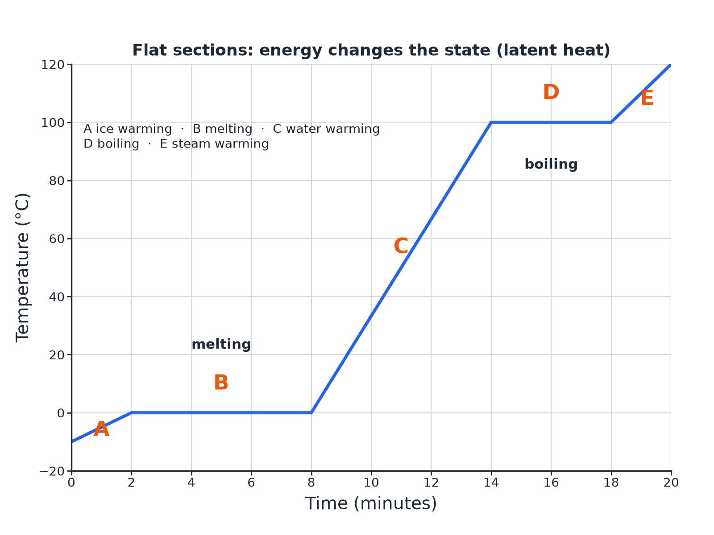
Flat sections show a change of state.
A temperature-time graph for ice heated to steam, with flat sections at 0 and 100 degrees Celsius where the state changes.
Two Different Ideas
SPECIFIC HEAT CAPACITY | SPECIFIC LATENT HEAT
▸ Energy to raise the temperature of 1 kg by 1 °C.  ▸ The temperature changes.  ▸ ΔE = mcΔθ; J/kg °C. | ▸ Energy to change the state of 1 kg with no temperature change.  ▸ The temperature stays the same.  ▸ E = mL; J/kg.
Melting Ice
Calculate the energy needed to melt 0.20 kg of ice at 0 °C. Specific latent heat of fusion of water = 334 000 J/kg.

1. Write the equation
E = mL
2. Substitute
E = 0.20 × 334 000
3. Answer
E = 66 800 J
Answer: 66 800 J
Boiling Water
Calculate the energy to change 0.50 kg of water at 100 °C into steam. Specific latent heat of vaporisation = 2 260 000 J/kg.

1. Substitute
E = 0.50 × 2 260 000
2. Answer
E = 1 130 000 J
Answer: 1 130 000 J (1.13 MJ)
Reading the Graph
Explain why the temperature stays constant during section B of the heating curve.

1. Energy is still supplied
The particles are gaining energy
2. Where it goes
It increases the potential energy of the particles as the bonds are broken
3. So
The average kinetic energy, and the temperature, stay the same
Answer: The energy supplied breaks the bonds (changing potential energy) so the temperature does not rise.
Why Steam Burns More
A favourite exam idea.
▸ Condensing. Steam at 100 °C condenses to water at 100 °C and releases a lot of latent heat.
▸ Then. The water then cools and releases more energy.
▸ So. Steam transfers more energy to skin than boiling water at the same temperature.
Key Terms
Specific latent heat  Energy to change the state of 1 kg with no temperature change. | Latent heat of fusion  For solid to liquid.
Latent heat of vaporisation  For liquid to gas. | Heating curve  A temperature-time graph for a heated substance.
Constant temperature  Temperature that does not change during a change of state. | Potential energy  Energy stored due to the forces between particles.
Your Task: Read the Curve
12 minutes
On a heating curve for water there are flat sections at 0 °C and 100 °C. Explain what is happening in each and why the second is longer.
1. Name each change.
2. Compare the latent heats.
A good answer shows: At 0 °C the ice is melting; at 100 °C the water is boiling. The boiling section is longer because the latent heat of vaporisation is much greater than the latent heat of fusion.
Note: Ask what would happen to the slope if the heater were more powerful.
Can I...?
☐ State what specific latent heat is.
☐ Distinguish fusion from vaporisation.
☐ Use E = mL.
☐ Read a heating curve.
☐ Explain flat sections.
☐ Distinguish c from L.
☐ Explain steam burns.
☐ Give units of L.
Summary
✓ E = mL.
✓ Temperature is constant during a change of state.
✓ Heating curves have flat sections at melting and boiling points.
✓ Distinguish c and L.

EXAM FOCUS
Calculate the energy needed to melt 0.35 kg of ice at 0 °C. Specific latent heat of fusion = 334 000 J/kg. (2 marks)
Multiply mass by L.
Exam Practice: Specific latent heat
Answer all questions. Use the mark allocation as a guide to how much to write. · 15 minutes
▸ Question 1 · 2 marks · Calculate. Calculate the energy needed to melt 0.35 kg of ice at 0 °C. The specific latent heat of fusion of water is 334 000 J/kg. Use the equation…
▸ Question 2 · 4 marks · Use the graph. The graph shows how the temperature of a solid changes as it is heated at a steady rate until it is a gas. (a) State the melting point. (b)…
▸ Question 3 · 2 marks · Distinguish. Describe the difference between specific heat capacity and specific latent heat.
▸ Question 4 · 3 marks · Calculate. Calculate the energy needed to change 0.50 kg of water at 100 °C into steam. The specific latent heat of vaporisation of water is 2 260 000…
▸ Question 5 · 3 marks · Explain. Steam at 100 °C causes a more serious burn than boiling water at 100 °C. Explain why.
Question 1 · 2 marks · Calculate
“Calculate the energy needed to melt 0.35 kg of ice at 0 °C. The specific latent heat of fusion of water is 334 000 J/kg. Use the equation: energy for a change of state = mass × specific latent heat”
HOW TO ANSWER IT Command word: Calculate. Worth 2 marks, so plan before writing.
Question 1 · mark scheme
2 marks available. Award a mark for each point made.
▸ Correct substitution. 1 mark
▸ 116 900 J. 1 mark
▸ Model answer. 0.35 × 334 000 = 116 900 J
Question 2 · 4 marks · Use the graph
The graph shows how the temperature of a solid changes as it is heated at a steady rate until it is a gas. (a) State the melting point. (b) What is happening between 2 and 8 minutes? (c) Explain why the temperature stays constant during this time. (4 marks) | 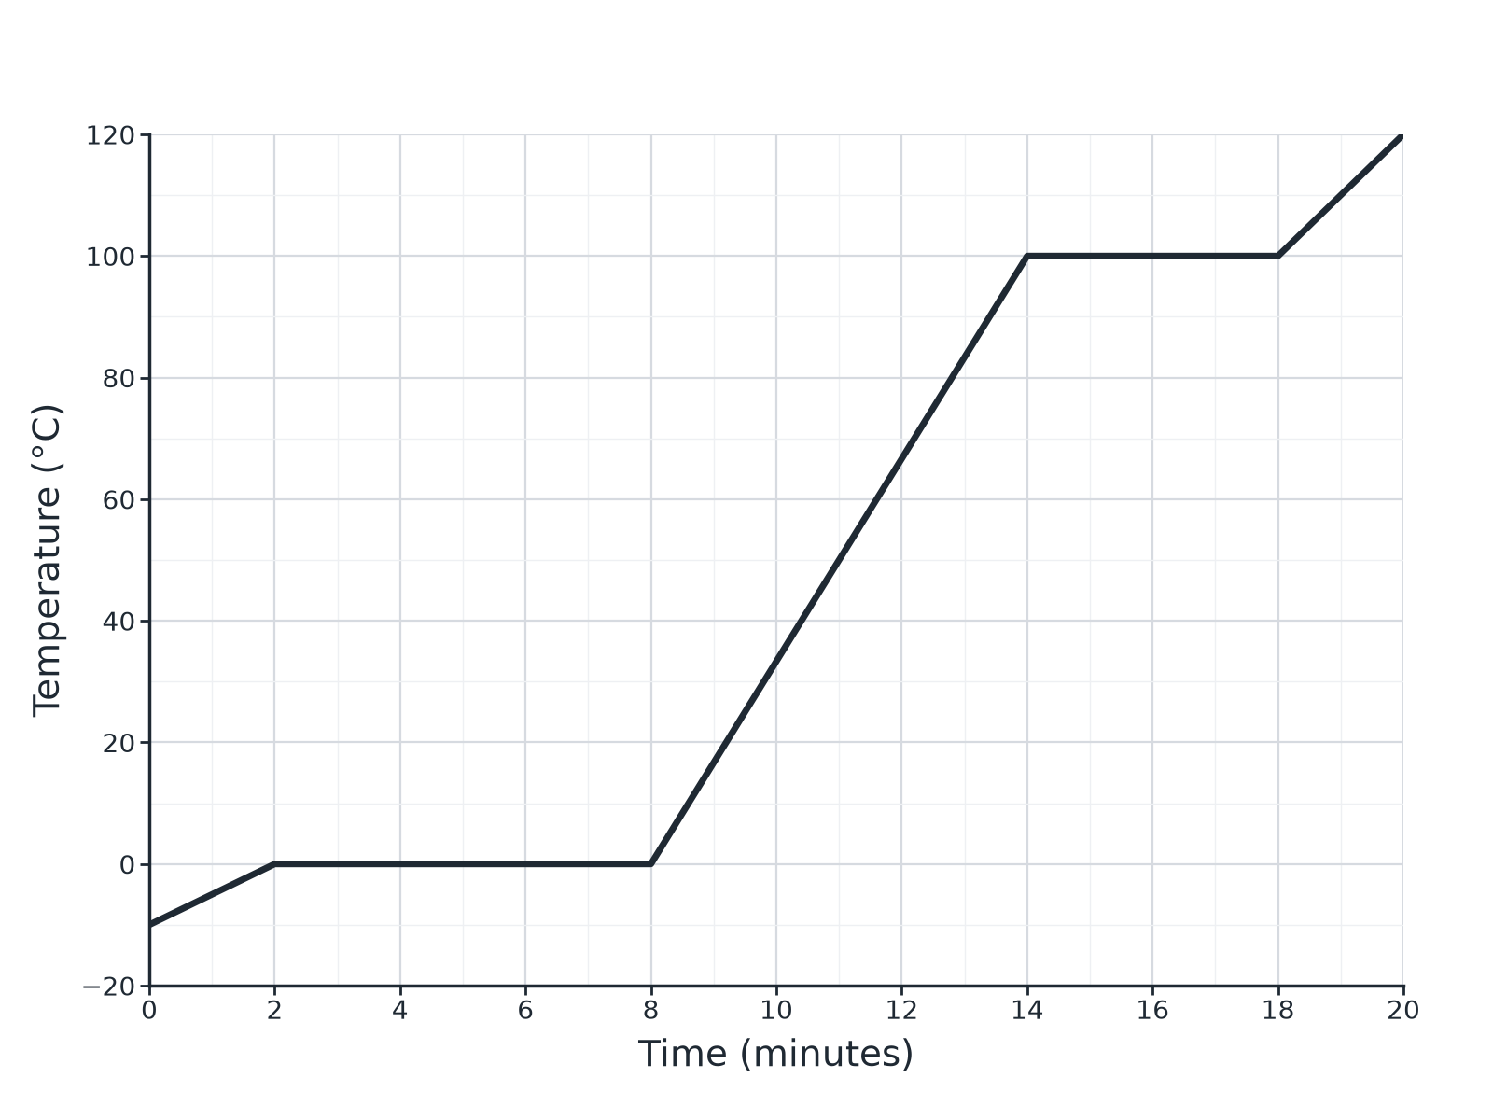

Question 2 · mark scheme
4 marks available. Award a mark for each point made.
▸ 0 °C. 1 mark
▸ Melting. 1 mark
▸ Energy used to break bonds or change potential energy. 1 mark
▸ Kinetic energy or temperature does not increase. 1 mark
▸ Model answer. (a) 0 °C. (b) The solid is melting (changing state to liquid). (c) The energy supplied changes the potential energy of the particles (breaking bonds), not their kinetic energy, so the temperature does not rise.
Question 3 · 2 marks · Distinguish
“Describe the difference between specific heat capacity and specific latent heat.”
HOW TO ANSWER IT Command word: Distinguish. Worth 2 marks, so plan before writing.
Question 3 · mark scheme
2 marks available. Award a mark for each point made.
▸ Specific heat capacity: temperature change. 1 mark
▸ Specific latent heat: change of state, no temperature change. 1 mark
▸ Model answer. Specific heat capacity is the energy needed to raise the temperature of 1 kg by 1 °C. Specific latent heat is the energy needed to change the state of 1 kg with no change in temperature.
Question 4 · 3 marks · Calculate
“Calculate the energy needed to change 0.50 kg of water at 100 °C into steam. The specific latent heat of vaporisation of water is 2 260 000 J/kg.”
HOW TO ANSWER IT Command word: Calculate. Worth 3 marks, so plan before writing.
Question 4 · mark scheme
3 marks available. Award a mark for each point made.
▸ Correct substitution. 1 mark
▸ 1 130 000 J. 1 mark
▸ Unit J. 1 mark
▸ Model answer. 0.50 × 2 260 000 = 1 130 000 J
Question 5 · 3 marks · Explain
“Steam at 100 °C causes a more serious burn than boiling water at 100 °C. Explain why.”
HOW TO ANSWER IT Command word: Explain. Worth 3 marks, so plan before writing.
Question 5 · mark scheme
3 marks available. Award a mark for each point made.
▸ Steam condenses on the skin. 1 mark
▸ Releases latent heat. 1 mark
▸ So more energy is transferred than from the water alone. 1 mark
▸ Model answer. When steam condenses it releases a large amount of energy (latent heat) to the skin, in addition to the energy released as the water cools, so more energy is transferred to the skin.

