AQA GCSE PHYSICS · PAPER 1 · FOUNDATION & HIGHER
The structure of an atom
Atomic structure · Lesson 1 of 10
Teacher copy - includes the notes for whoever is teaching from it.
Warm-up
Answer each one, then check.
1. What is an atom?
The smallest part of an element that can exist
2. What charge does an electron have?
Negative
3. What charge does a proton have?
Positive
4. What is standard form?
A number written as a × 10ⁿ
5. What is electromagnetic radiation?
Waves such as light and X-rays
Learning Objectives
1. Describe the basic structure of an atom.
2. Recall the size of an atom and how it compares with the size of a nucleus.
3. State the relative charge and mass of protons, neutrons and electrons.
4. Explain how electrons change energy levels by absorbing or emitting electromagnetic radiation.
The Atom
Atoms have a radius of about 1 × 10⁻¹⁰ m. The nucleus has a radius of less than 1/(10 000) of the atom's radius but contains most of the mass.
The nucleus is positively charged (protons and neutrons) and is surrounded by negatively charged electrons at different distances (energy levels).
Inside an Atom
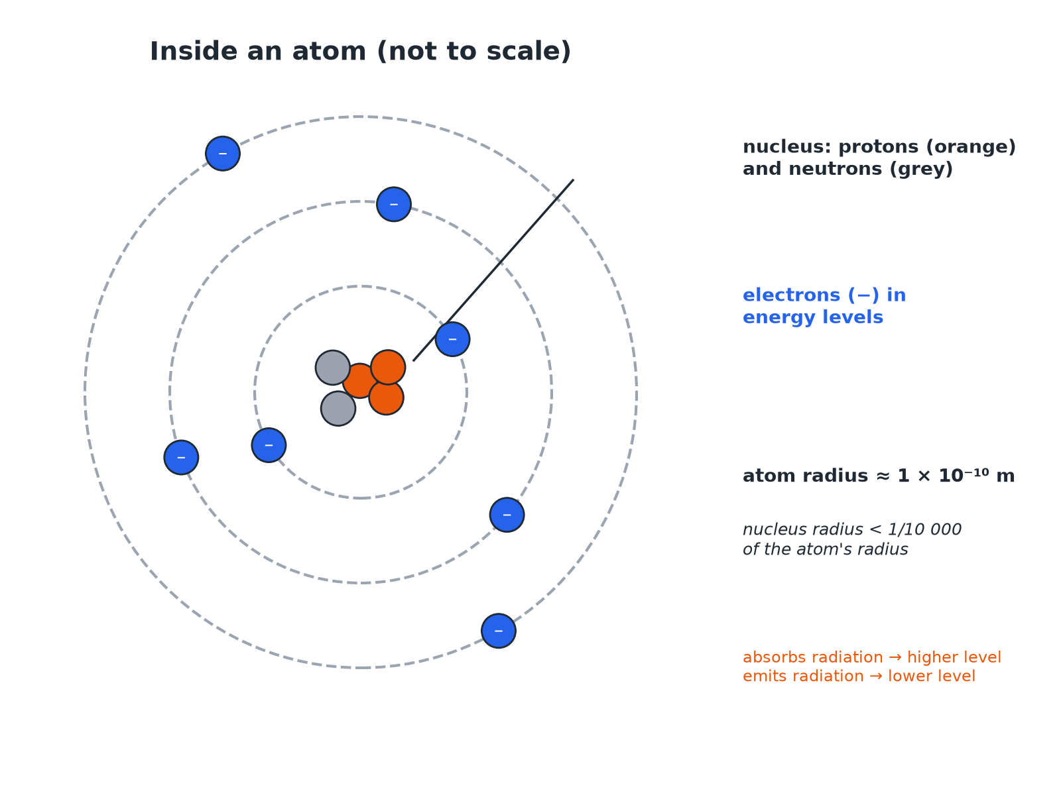
The nucleus is tiny compared with the whole atom.
An atom with a nucleus of protons and neutrons and electrons in energy levels around it.
Particles in an Atom
Learn the relative charge and mass.
Particle | Relative charge | Relative mass | Where
Proton | +1 | 1 | Nucleus
Neutron | 0 | 1 | Nucleus
Electron | −1 | Very small (about 1/2000) | Energy levels around the nucleus
Size of the Nucleus
The radius of an atom is about 1 × 10⁻¹⁰ m. The radius of its nucleus is less than 1/10 000 of this. Calculate the largest possible radius of the nucleus.

1. Divide
(1 × 10⁻¹⁰)/(10 000)
2. Write 10 000 as a power of ten
10 000 = 1 × 10⁴
3. Answer
1 × 10⁻¹⁴ m
Answer: The nucleus has a radius of less than 1 × 10⁻¹⁴ m.
Electron Energy Levels
Describe what happens when an electron absorbs electromagnetic radiation.

1. Energy
The electron gains energy from the radiation
2. Movement
It moves to a higher energy level, further from the nucleus
3. Reverse
If it emits radiation it falls to a lower energy level, closer to the nucleus
Answer: Absorbing radiation moves an electron further from the nucleus; emitting radiation moves it closer.
Key Facts
Points examiners ask about.
▸ Neutral atoms. The number of electrons equals the number of protons, so there is no overall charge.
▸ Mass. Most of the mass of an atom is in the nucleus.
▸ Space. Most of an atom is empty space.
▸ Positive ions. An atom that loses one or more outer electrons becomes a positive ion.
Key Terms
Atom  The smallest part of an element that can exist. | Nucleus  The positively charged centre of an atom containing protons and neutrons.
Proton  A positive particle in the nucleus. | Neutron  A neutral particle in the nucleus.
Electron  A negative particle that orbits the nucleus. | Energy level  A distance from the nucleus at which an electron can be.
Your Task: Atom Sizes
10 minutes
An atom has a radius of 1 × 10⁻¹⁰ m and a nucleus of radius 1 × 10⁻¹⁵ m. How many times larger is the atom's radius than the nucleus's radius? Where is most of the mass?
1. Divide the two radii.
2. Use powers of ten.
A good answer shows: The atom is 100 000 times larger (10⁻¹⁰ ÷ 10⁻¹⁵ = 10⁵). Most of the mass is in the nucleus.
Note: Ask why the atom is mostly empty space.
Can I...?
☐ Describe the parts of an atom.
☐ Give the size of an atom.
☐ Compare atom and nucleus sizes.
☐ State charges and masses.
☐ Explain why atoms are neutral.
☐ Describe electron energy levels.
☐ Say what happens when radiation is absorbed.
☐ Use standard form.
Summary
✓ Atoms are about 1 × 10⁻¹⁰ m in radius.
✓ The nucleus is less than 1/10 000 of the atom's radius.
✓ Protons +1, neutrons 0, electrons −1.
✓ Electrons move to higher levels by absorbing radiation.

EXAM FOCUS
Describe the structure of an atom. (3 marks)
Nucleus with protons and neutrons; electrons around it.
Exam Practice: The structure of an atom
Answer all questions. Use the mark allocation as a guide to how much to write. · 15 minutes
▸ Question 1 · 3 marks · Describe. Describe the structure of an atom.
▸ Question 2 · 3 marks · Complete. Complete the table to show the relative charge of a proton, a neutron and an electron.
▸ Question 3 · 3 marks · Calculate. The radius of an atom is 1 × 10⁻¹⁰ m. The radius of its nucleus is less than 1/10 000 of the radius of the atom. Calculate the largest…
▸ Question 4 · 2 marks · Explain. An atom has no overall electrical charge. Explain why.
▸ Question 5 · 3 marks · Explain. An electron in an atom absorbs electromagnetic radiation. Describe what happens to the electron. Then say what happens when the electron…
Question 1 · 3 marks · Describe
“Describe the structure of an atom.”
HOW TO ANSWER IT Command word: Describe. Worth 3 marks, so plan before writing.
Question 1 · mark scheme
3 marks available. Award a mark for each point made.
▸ Small central nucleus. 1 mark
▸ Nucleus contains protons and neutrons. 1 mark
▸ Electrons around the nucleus. 1 mark
▸ Model answer. A small central nucleus containing protons and neutrons, with electrons arranged at different distances (energy levels) from the nucleus.
Question 2 · 3 marks · Complete
“Complete the table to show the relative charge of a proton, a neutron and an electron.”
HOW TO ANSWER IT Command word: Complete. Worth 3 marks, so plan before writing.
Question 2 · mark scheme
3 marks available. Award a mark for each point made.
▸ +1. 1 mark
▸ 0. 1 mark
▸ −1. 1 mark
▸ Model answer. Proton +1; neutron 0; electron −1.
Question 3 · 3 marks · Calculate
“The radius of an atom is 1 × 10⁻¹⁰ m. The radius of its nucleus is less than 1/10 000 of the radius of the atom. Calculate the largest possible radius of the nucleus. Give your answer in standard form.”
HOW TO ANSWER IT Command word: Calculate. Worth 3 marks, so plan before writing.
Question 3 · mark scheme
3 marks available. Award a mark for each point made.
▸ Divides by 10 000. 1 mark
▸ Correct power. 1 mark
▸ 1 × 10⁻¹⁴ m. 1 mark
▸ Model answer. 1 × 10⁻¹⁰ ÷ 10 000 = 1 × 10⁻¹⁴ m
Question 4 · 2 marks · Explain
“An atom has no overall electrical charge. Explain why.”
HOW TO ANSWER IT Command word: Explain. Worth 2 marks, so plan before writing.
Question 4 · mark scheme
2 marks available. Award a mark for each point made.
▸ Number of electrons equals number of protons. 1 mark
▸ Charges cancel. 1 mark
▸ Model answer. The number of electrons is equal to the number of protons, so the negative and positive charges cancel.
Question 5 · 3 marks · Explain
“An electron in an atom absorbs electromagnetic radiation. Describe what happens to the electron. Then say what happens when the electron emits radiation.”
HOW TO ANSWER IT Command word: Explain. Worth 3 marks, so plan before writing.
Question 5 · mark scheme
3 marks available. Award a mark for each point made.
▸ Absorbs radiation: moves to higher energy level or further from nucleus. 1 mark
▸ Emits radiation: moves to lower energy level. 1 mark
▸ Closer to the nucleus. 1 mark
▸ Model answer. It moves to a higher energy level, further from the nucleus. When it emits radiation it moves to a lower energy level, closer to the nucleus.

