AQA GCSE PHYSICS · PAPER 1 · FOUNDATION & HIGHER
Half-lives and the random nature of radioactive decay
Atomic structure · Lesson 6 of 10
Teacher copy - includes the notes for whoever is teaching from it.
Warm-up
Answer each one, then check.
1. What does random mean?
Cannot be predicted
2. What is half of 800?
400
3. What is activity measured in?
Becquerel (Bq)
4. What is a count rate?
Number of counts per second
5. What does exponential decay look like on a graph?
A curve that falls quickly then more slowly
Learning Objectives
1. Define half-life.
2. Explain half-life in terms of the random nature of radioactive decay.
3. Determine the half-life of an isotope from a graph or table.
4. Calculate the net decline as a ratio after a given number of half-lives (Higher tier).
Half-Life
The half-life of a radioactive isotope is the time it takes for the number of nuclei of the isotope in a sample to halve, or the time it takes for the count rate (or activity) to fall to half its initial level.
Radioactive decay is random: we cannot say when any one nucleus will decay, but for a large number of nuclei the half-life is predictable.
A Decay Curve
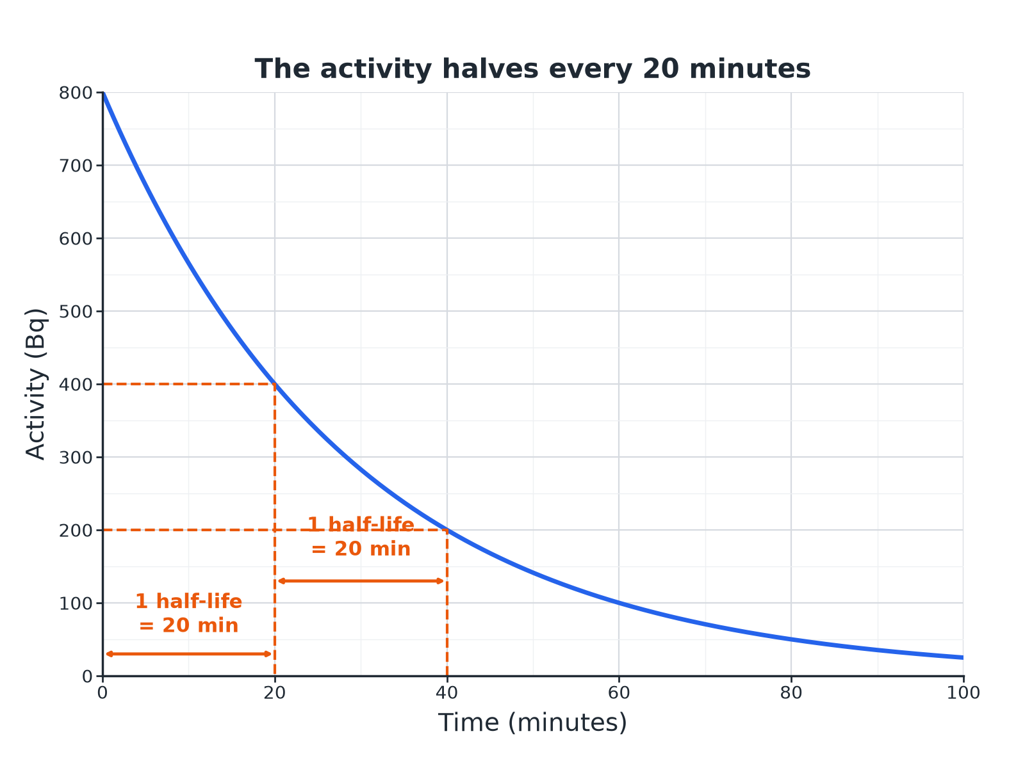
Each half-life the activity halves.
A graph of activity against time with dashed lines showing that the activity halves every 20 minutes.
Number of Half-Lives
Higher tier: net decline as a ratio.
Half-lives | Fraction left | Ratio of final to initial
0 | 1 | 1 : 1
1 | 1/2 | 1 : 2
2 | 1/4 | 1 : 4
3 | 1/8 | 1 : 8
4 | 1/16 | 1 : 16
Finding a Half-Life from a Graph
The activity of a sample falls from 800 Bq to 400 Bq in 20 minutes and to 200 Bq after 40 minutes. What is the half-life?

1. 800 to 400
Halved in 20 minutes
2. 400 to 200
Halved again in the next 20 minutes
Answer: The half-life is 20 minutes.
Activity After Several Half-Lives
A source has an activity of 800 Bq and a half-life of 6 hours. Find its activity after 24 hours.

1. Number of half-lives
24 ÷ 6 = 4
2. Halve four times
800 → 400 → 200 → 100 → 50
Answer: 50 Bq
Net Decline as a Ratio (Higher)
Calculate the ratio of the final activity to the initial activity after 3 half-lives.

1. Each half-life
Halve the activity
2. After 3
(½)³ = ⅛
Answer: The activity falls to 1/8 of its initial value, a ratio of 1 : 8.
Random Decay
How to explain it.
▸ One nucleus. It is impossible to predict when a particular nucleus will decay.
▸ Many nuclei. The number decaying in a given time follows a pattern, so half-life is a reliable measure.
▸ Count rate. Count rate is also random, so it varies slightly between measurements.
▸ Background. Correct for background radiation to find the true count rate.
Key Terms
Half-life  The time for the number of nuclei (or the activity) to halve. | Random  Cannot be predicted for a single nucleus.
Count rate  The number of decays detected each second. | Activity  The rate of decay of a source, in becquerel.
Decay curve  A graph showing how activity falls with time. | Background  The radiation that is always around us.
Your Task: Halve It
10 minutes
A sample has a count rate of 640 counts per minute. Its half-life is 3 hours. What is the count rate after 12 hours? What is the ratio of final to initial count rate?
1. Work out the number of half-lives.
2. Halve each time.
A good answer shows: 12 ÷ 3 = 4 half-lives: 640 → 320 → 160 → 80 → 40 counts per minute. The ratio is 1 : 16.
Note: Ask what would happen after 30 hours.
Can I...?
☐ Define half-life.
☐ Explain random decay.
☐ Find half-life from a graph.
☐ Halve repeatedly.
☐ Work out the number of half-lives.
☐ State the ratio after several half-lives.
☐ Explain why decay is random.
☐ Use correct units.
Summary
✓ Half-life: time for activity to halve.
✓ Random decay but a predictable half-life for many nuclei.
✓ After n half-lives: fraction (1/2)ⁿ.
✓ Read half-life from a graph.

EXAM FOCUS
A radioactive source has a half-life of 20 minutes and an activity of 800 Bq. Find its activity after 60 minutes. (2 marks)
Three half-lives: halve three times.
Exam Practice: Half-lives and the random nature of radioactive decay
Answer all questions. Use the mark allocation as a guide to how much to write. · 15 minutes
▸ Question 1 · 2 marks · State. What is meant by the half-life of a radioactive isotope?
▸ Question 2 · 4 marks · Use the graph. The graph shows how the activity of a radioactive source changes with time. (a) Determine the half-life of the source. (b) Calculate the…
▸ Question 3 · 3 marks · Calculate. A radioactive sample has an activity of 800 Bq. Its half-life is 6 hours. Calculate the activity after 24 hours.
▸ Question 4 · 3 marks · Calculate. The count rate from a radioactive source falls to one eighth of its original value in 15 hours. Calculate the half-life of the source. Also…
▸ Question 5 · 2 marks · Explain. Radioactive decay is a random process. Explain what this means.
Question 1 · 2 marks · State
“What is meant by the half-life of a radioactive isotope?”
HOW TO ANSWER IT Command word: State. Worth 2 marks, so plan before writing.
Question 1 · mark scheme
2 marks available. Award a mark for each point made.
▸ Time for the number of nuclei to halve. 1 mark
▸ or activity or count rate falls to half. 1 mark
▸ Model answer. The time it takes for the number of nuclei in a sample to halve, or the time for the count rate (activity) to fall to half its initial value.
Question 2 · 4 marks · Use the graph
The graph shows how the activity of a radioactive source changes with time. (a) Determine the half-life of the source. (b) Calculate the activity after 100 minutes. (4 marks) | 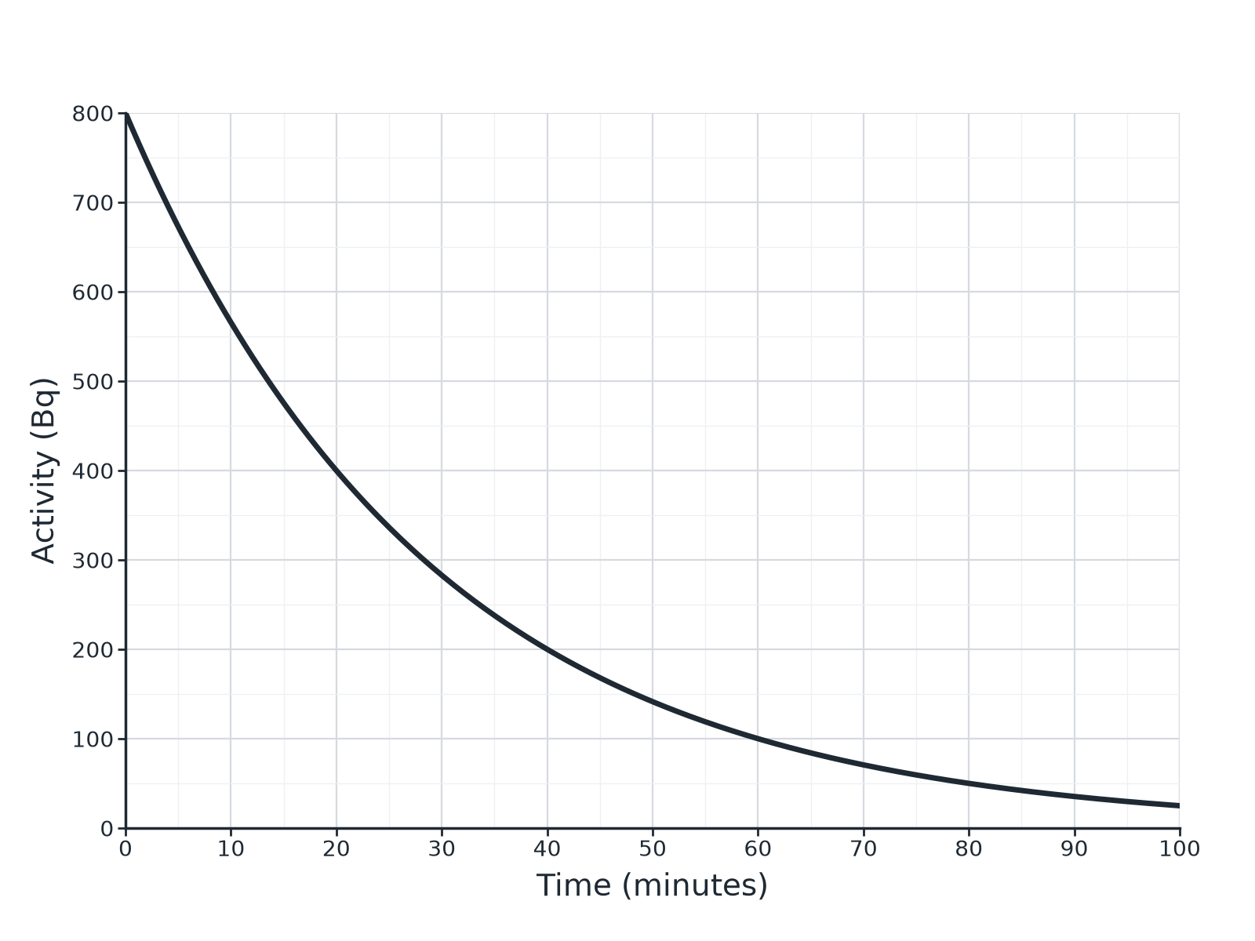

Question 2 · mark scheme
4 marks available. Award a mark for each point made.
▸ Reads 400 Bq at half of 800. 1 mark
▸ 20 minutes. 1 mark
▸ 5 half-lives. 1 mark
▸ 25 Bq. 1 mark
▸ Model answer. (a) The activity halves from 800 Bq to 400 Bq in 20 minutes, so the half-life is 20 minutes. (b) 100 minutes is 5 half-lives: 800 → 400 → 200 → 100 → 50 → 25 Bq.
Question 3 · 3 marks · Calculate
“A radioactive sample has an activity of 800 Bq. Its half-life is 6 hours. Calculate the activity after 24 hours.”
HOW TO ANSWER IT Command word: Calculate. Worth 3 marks, so plan before writing.
Question 3 · mark scheme
3 marks available. Award a mark for each point made.
▸ 4 half-lives. 1 mark
▸ Halves four times. 1 mark
▸ 50 Bq. 1 mark
▸ Model answer. 24 ÷ 6 = 4 half-lives; 800 ÷ 16 = 50 Bq
Question 4 · 3 marks · Calculate
“The count rate from a radioactive source falls to one eighth of its original value in 15 hours. Calculate the half-life of the source. Also state the net decline as a ratio.”
HOW TO ANSWER IT Command word: Calculate. Worth 3 marks, so plan before writing.
Question 4 · mark scheme
3 marks available. Award a mark for each point made.
▸ 1/8 means 3 half-lives. 1 mark
▸ 5 hours. 1 mark
▸ Ratio 1 : 8. 1 mark
▸ Model answer. 1/8 is 3 half-lives, so 15 ÷ 3 = 5 hours. The ratio of final to initial count rate is 1 : 8.
Question 5 · 2 marks · Explain
“Radioactive decay is a random process. Explain what this means.”
HOW TO ANSWER IT Command word: Explain. Worth 2 marks, so plan before writing.
Question 5 · mark scheme
2 marks available. Award a mark for each point made.
▸ Cannot predict which nucleus. 1 mark
▸ Or when it will decay. 1 mark
▸ Model answer. It is not possible to predict when a particular nucleus will decay.

