AQA GCSE PHYSICS · PAPER 1 · FOUNDATION & HIGHER
Radioactive contamination and irradiation
Atomic structure · Lesson 7 of 10
Teacher copy - includes the notes for whoever is teaching from it.
Warm-up
Answer each one, then check.
1. What is ionising radiation?
Radiation that can knock electrons off atoms
2. What are alpha, beta and gamma?
Types of nuclear radiation
3. Which radiation is most penetrating?
Gamma
4. What is a hazard?
Something that could cause harm
5. What does peer review mean?
Checking by other scientists before results are accepted
Learning Objectives
1. Define radioactive contamination and irradiation.
2. Compare the hazards of contamination and irradiation.
3. Describe precautions when handling sources.
4. Explain why studies on the effects of radiation are published and peer reviewed.
CONTAMINATION vs IRRADIATION
Radioactive contamination is the unwanted presence of materials containing radioactive atoms on other materials. Irradiation is exposing an object to nuclear radiation: the irradiated object does not become radioactive.
The hazard from contamination is due to the decay of the contaminating atoms; the type of radiation emitted affects the level of hazard.
Contamination and Irradiation
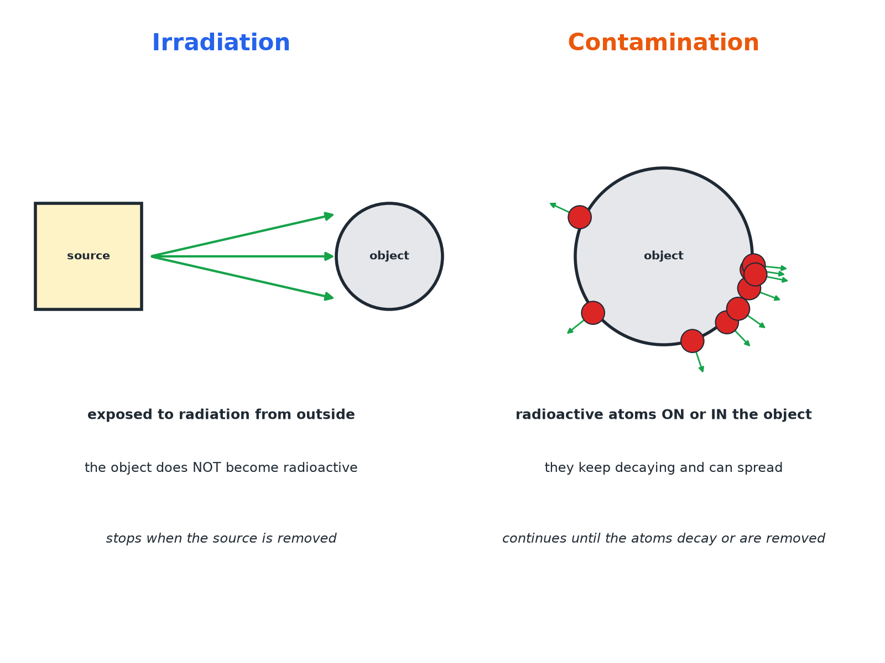
Contamination puts radioactive atoms on the object itself.
Irradiation by an external source compared with contamination by radioactive atoms on an object.
Which Is More Hazardous?
IRRADIATION | CONTAMINATION
▸ The object is exposed from outside.  ▸ It stops when the source is removed or shielded.  ▸ The object does not become radioactive.  ▸ Hazard depends on the type of radiation and time exposed. | ▸ Radioactive atoms are on or in the object.  ▸ Radiation continues until the atoms decay or are removed.  ▸ Alpha sources inside the body are very dangerous.  ▸ Can spread to other objects.
Precautions When Using Sources
Protect against irradiation and contamination.
1  Distance  Handle sources with tongs; keep away. | 2  Time  Keep exposure times short. | 3  Shielding  Store sources in lead-lined containers. | 4  Protective clothing  Gloves and coats stop contamination. | 5  Hygiene  No eating or drinking; wash hands.
Comparing Hazards
Explain why an alpha source is not very hazardous outside the body but is very hazardous if swallowed.

1. Outside
Alpha is stopped by air, paper or skin
2. Inside
Contamination puts the source in contact with living cells
3. Ionising
Alpha is strongly ionising and damages cells
Answer: Outside, alpha cannot penetrate skin; inside it is contamination and its strong ionising damages cells.
Peer Review
Why it matters.
▸ Publish and share. Findings on the effects of radiation on humans must be published so that other scientists can check them.
▸ Peer review. Other scientists check the methods and conclusions before they are accepted.
▸ Trust. This makes conclusions more reliable and helps set safety rules.
Key Terms
Contamination  The unwanted presence of radioactive atoms on or in other materials. | Irradiation  Exposure to nuclear radiation without radioactive atoms being transferred.
Shielding  Material used to absorb radiation. | Peer review  Checking of scientific work by other scientists.
Hazard  Something that could cause harm. | Precaution  An action to reduce a risk.
Your Task: Compare the Hazards
12 minutes
A worker handles a gamma source with tongs and a worker accidentally spills a solution containing radioactive iodine on their skin. Say which is irradiation and which is contamination, and compare the hazards.
1. Name each.
2. Compare how long exposure lasts.
A good answer shows: The gamma source: irradiation (they are exposed while nearby, they do not become radioactive). The spill: contamination (radioactive atoms are on the skin and keep decaying). Contamination can continue and be spread or absorbed, so is more serious unless removed.
Note: Ask what should be done immediately.
Can I...?
☐ Define contamination.
☐ Define irradiation.
☐ Explain irradiated objects are not radioactive.
☐ Compare the hazards.
☐ Give precautions.
☐ Explain why peer review matters.
☐ Explain why alpha is dangerous inside the body.
☐ Choose safe handling.
Summary
✓ Contamination: radioactive atoms on or in the object.
✓ Irradiation: exposed to radiation; not radioactive.
✓ Hazard depends on the type of radiation.
✓ Peer review checks findings.

EXAM FOCUS
State the difference between contamination and irradiation. (2 marks)
Contamination involves radioactive atoms on the object; irradiation is exposure without the object becoming radioactive.
Exam Practice: Radioactive contamination and irradiation
Answer all questions. Use the mark allocation as a guide to how much to write. · 13 minutes
▸ Question 1 · 2 marks · State. Explain the difference between radioactive contamination and irradiation.
▸ Question 2 · 3 marks · Explain. A student says that a person who has been irradiated by a gamma source is now radioactive. Explain why the student is wrong.
▸ Question 3 · 2 marks · Suggest. Give two precautions that should be taken when a teacher handles a radioactive source.
▸ Question 4 · 3 marks · Compare. Compare the hazards of contamination and irradiation from an alpha source.
▸ Question 5 · 2 marks · Explain. Scientists who study the effects of radiation on humans publish their findings. Explain why it is important that the findings are peer…
Question 1 · 2 marks · State
“Explain the difference between radioactive contamination and irradiation.”
HOW TO ANSWER IT Command word: State. Worth 2 marks, so plan before writing.
Question 1 · mark scheme
2 marks available. Award a mark for each point made.
▸ Contamination: radioactive atoms present on other materials. 1 mark
▸ Irradiation: exposure and the object does not become radioactive. 1 mark
▸ Model answer. Contamination is the unwanted presence of radioactive atoms on or in another material. Irradiation is exposing an object to radiation; the object does not become radioactive.
Question 2 · 3 marks · Explain
“A student says that a person who has been irradiated by a gamma source is now radioactive. Explain why the student is wrong.”
HOW TO ANSWER IT Command word: Explain. Worth 3 marks, so plan before writing.
Question 2 · mark scheme
3 marks available. Award a mark for each point made.
▸ Irradiation is exposure. 1 mark
▸ No radioactive atoms transferred. 1 mark
▸ So the person is not radioactive. 1 mark
▸ Model answer. Irradiation means exposure to radiation from outside. The person has not received radioactive atoms, so they do not become radioactive.
Question 3 · 2 marks · Suggest
“Give two precautions that should be taken when a teacher handles a radioactive source.”
HOW TO ANSWER IT Command word: Suggest. Worth 2 marks, so plan before writing.
Question 3 · mark scheme
2 marks available. Award a mark for each point made.
▸ First precaution. 1 mark
▸ Second precaution. 1 mark
▸ Model answer. Any two from: use tongs; keep the source in a lead-lined box; keep exposure time short; keep away from the body; wear gloves.
Question 4 · 3 marks · Compare
“Compare the hazards of contamination and irradiation from an alpha source.”
HOW TO ANSWER IT Command word: Compare. Worth 3 marks, so plan before writing.
Question 4 · mark scheme
3 marks available. Award a mark for each point made.
▸ Irradiation by alpha: low hazard, absorbed. 1 mark
▸ Contamination inside the body: high hazard. 1 mark
▸ Alpha strongly ionising. 1 mark
▸ Model answer. Outside the body, irradiation by alpha is not hazardous because alpha is absorbed by air or skin. If contamination puts the alpha source inside the body it is very hazardous because alpha is strongly ionising and damages cells.
Question 5 · 2 marks · Explain
“Scientists who study the effects of radiation on humans publish their findings. Explain why it is important that the findings are peer reviewed.”
HOW TO ANSWER IT Command word: Explain. Worth 2 marks, so plan before writing.
Question 5 · mark scheme
2 marks available. Award a mark for each point made.
▸ Findings checked by other scientists. 1 mark
▸ So more reliable or valid. 1 mark
▸ Model answer. Other scientists can check the methods and conclusions, so the results are more reliable.

