AQA GCSE PHYSICS · PAPER 1 · FOUNDATION & HIGHER
Background radiation
Atomic structure · Lesson 8 of 10
Teacher copy - includes the notes for whoever is teaching from it.
Warm-up
Answer each one, then check.
1. What is radiation?
Energy emitted as waves or particles
2. Name a rock that contains radioactive material.
Granite
3. What does mSv stand for?
Millisievert
4. Where do cosmic rays come from?
Space
5. What is a Geiger-Müller tube?
A detector of radiation
Learning Objectives
1. Describe the sources of background radiation.
2. Explain why radiation dose varies with location and occupation.
3. Use data on radiation dose in millisieverts.
Background Radiation
Background radiation is around us all of the time. It comes from natural sources such as rocks and cosmic rays and from man-made sources such as fallout from nuclear weapon tests and accidents.
Radiation dose is measured in sieverts (Sv). 1000 millisieverts (mSv) = 1 sievert. You do not need to recall the unit.
Sources of Background Radiation
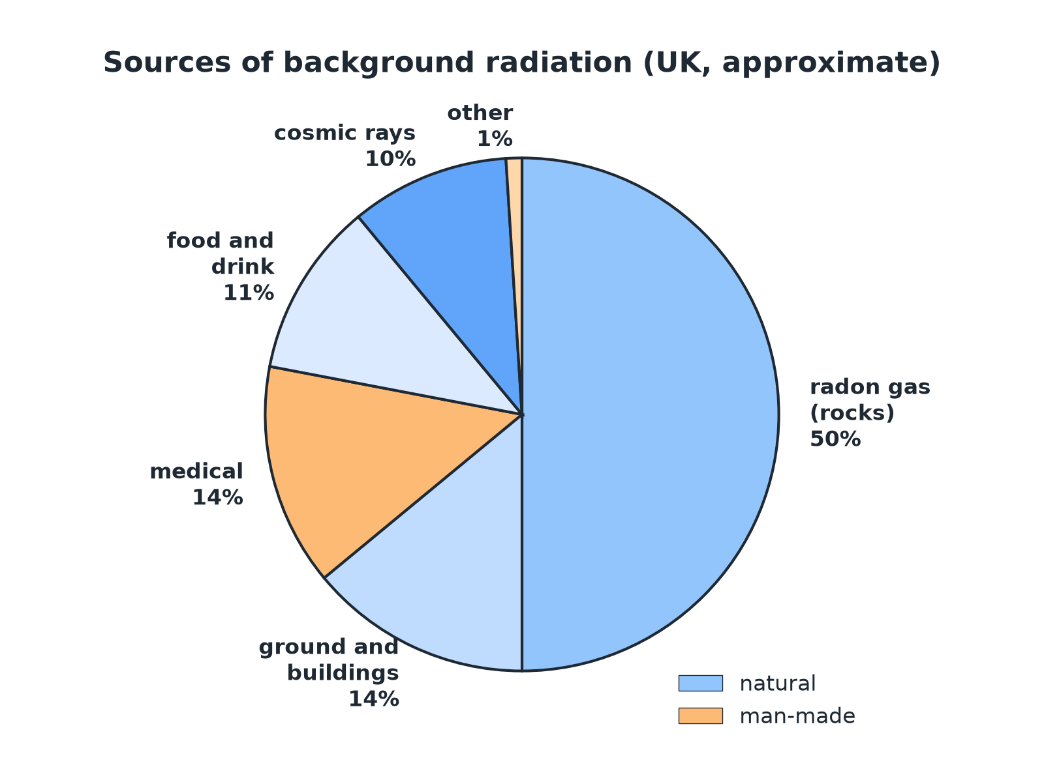
Most background radiation is natural.
A pie chart of background radiation sources: radon, ground and buildings, medical, food and drink, cosmic rays and other.
Where Does It Come From?
Natural: rocks  Radioactive isotopes in rocks such as granite release radon gas. | Natural: cosmic rays  High-energy particles from space; stronger at altitude.
Natural: food and air  Small amounts in food, drink and the air. | Man-made  Fallout from nuclear weapon testing and accidents, and medical procedures.
Why Dose Varies
Location and occupation.
Factor | Effect
Location | Areas with granite rock have higher radon levels; high altitudes have more cosmic rays.
Occupation | Airline crews (cosmic rays), radiographers and nuclear workers receive higher doses.
Medical treatments | X-rays and scans add to a person's dose.
Using a Pie Chart
The typical annual dose is 2.7 mSv. Radon is 50% of this. Calculate the dose from radon.

1. Fraction
50% = 0.50
2. Multiply
0.50 × 2.7
3. Answer
1.35 mSv
Answer: 1.35 mSv (about 1.4 mSv)
Converting Units
Convert 2.7 mSv to sieverts.

1. 1000 mSv = 1 Sv
2.7 ÷ 1000
2. Answer
0.0027 Sv (2.7 × 10⁻³ Sv)
Answer: 2.7 × 10⁻³ Sv
Measuring It
How background is found.
▸ Detector. A Geiger-Müller tube and counter measures the count rate.
▸ Correct. Subtract the background count rate from measurements on a source.
▸ Vary. Background changes with place and time, so measure it in the same place.
Key Terms
Background radiation  Radiation that is around us all the time. | Cosmic rays  High-energy particles from space.
Radon  A radioactive gas from rocks. | Radiation dose  A measure of the risk of harm from radiation, in sieverts.
Millisievert  One thousandth of a sievert. | Man-made  Produced by human activity.
Your Task: Why Does It Differ?
10 minutes
Explain why the background radiation is higher in Cornwall (granite) than in London, and why an airline pilot receives a higher dose than an office worker.
1. Name the source.
2. Link it to location or job.
A good answer shows: Granite rocks contain radioactive isotopes and release radon gas, so background is higher. Pilots fly at high altitude where there are more cosmic rays.
Note: Ask how a house could be protected from radon.
Can I...?
☐ List natural sources.
☐ List man-made sources.
☐ Explain location effects.
☐ Explain occupation effects.
☐ Use a pie chart.
☐ Convert mSv to Sv.
☐ Correct for background.
☐ Explain why background varies.
Summary
✓ Natural: rocks, cosmic rays, food.
✓ Man-made: fallout, medical procedures.
✓ Dose varies with location and occupation.
✓ 1000 mSv = 1 Sv.

EXAM FOCUS
Give two natural sources of background radiation. (2 marks)
Any two: rocks, cosmic rays, food.
Exam Practice: Background radiation
Answer all questions. Use the mark allocation as a guide to how much to write. · 13 minutes
▸ Question 1 · 2 marks · State. Give two natural sources of background radiation.
▸ Question 2 · 2 marks · State. Give one man-made source of background radiation.
▸ Question 3 · 3 marks · Use the chart. The pie chart shows the sources of background radiation. The total annual dose is 2.7 mSv. Radon is 50% of the total. (a) Calculate the…
▸ Question 4 · 2 marks · Explain. The background radiation is higher in some parts of the UK than others. Suggest one reason.
▸ Question 5 · 3 marks · Explain. Airline pilots receive a higher radiation dose than office workers. Explain why. Also state how background radiation is taken into account…
Question 1 · 2 marks · State
“Give two natural sources of background radiation.”
HOW TO ANSWER IT Command word: State. Worth 2 marks, so plan before writing.
Question 1 · mark scheme
2 marks available. Award a mark for each point made.
▸ First source. 1 mark
▸ Second source. 1 mark
▸ Model answer. Any two from: rocks (including radon gas), cosmic rays, food and drink.
Question 2 · 2 marks · State
“Give one man-made source of background radiation.”
HOW TO ANSWER IT Command word: State. Worth 2 marks, so plan before writing.
Question 2 · mark scheme
2 marks available. Award a mark for each point made.
▸ One correct source. 1 mark
▸ Man-made linked to human activity. 1 mark
▸ Model answer. Fallout from nuclear weapons testing or nuclear accidents (or medical procedures).
Question 3 · 3 marks · Use the chart
The pie chart shows the sources of background radiation. The total annual dose is 2.7 mSv. Radon is 50% of the total. (a) Calculate the dose from radon. (b) Is most of the background radiation natural or man-made? Give a reason. (3 marks) | 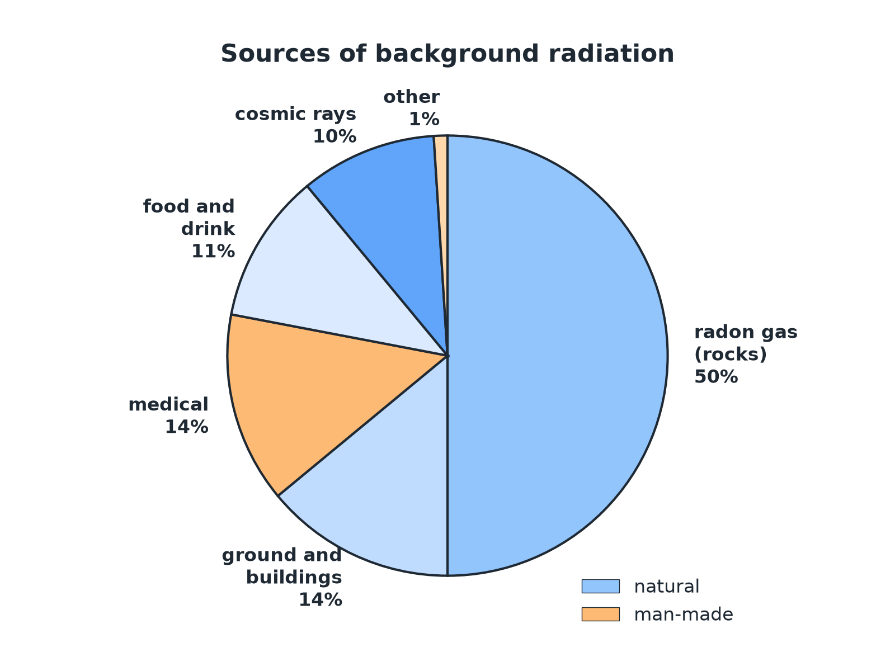

Question 3 · mark scheme
3 marks available. Award a mark for each point made.
▸ 1.35 mSv. 1 mark
▸ Natural. 1 mark
▸ Reason from the chart. 1 mark
▸ Model answer. (a) 0.50 × 2.7 = 1.35 mSv. (b) Natural, because the natural sources (radon, ground, food, cosmic rays) make up most of the chart.
Question 4 · 2 marks · Explain
“The background radiation is higher in some parts of the UK than others. Suggest one reason.”
HOW TO ANSWER IT Command word: Explain. Worth 2 marks, so plan before writing.
Question 4 · mark scheme
2 marks available. Award a mark for each point made.
▸ Type of rock or radon. 1 mark
▸ Linked to higher levels in that location. 1 mark
▸ Model answer. Some areas have rocks such as granite that contain radioactive isotopes and release radon gas.
Question 5 · 3 marks · Explain
“Airline pilots receive a higher radiation dose than office workers. Explain why. Also state how background radiation is taken into account when measuring the radiation from a radioactive source.”
HOW TO ANSWER IT Command word: Explain. Worth 3 marks, so plan before writing.
Question 5 · mark scheme
3 marks available. Award a mark for each point made.
▸ Cosmic rays at altitude. 1 mark
▸ Measure background count rate. 1 mark
▸ Subtract from the reading. 1 mark
▸ Model answer. Pilots fly at high altitude where cosmic rays are stronger. The background count rate is measured without the source and subtracted from the reading with the source.

