AQA GCSE PHYSICS · PAPER 1 · FOUNDATION & HIGHER
Half-lives, hazards and uses of nuclear radiation
Atomic structure · Lesson 9 of 10
Warm-up
Answer each one, then check.
1. What is half-life?
The time for activity to halve
2. What is a tracer?
A substance that can be followed inside the body
3. Which radiation is most penetrating?
Gamma
4. Give one danger of ionising radiation.
It can damage or kill cells
5. What is standard form?
A number written as a × 10ⁿ
Learning Objectives
1. Explain why the hazards of a radioactive material differ with its half-life.
2. Describe and evaluate the use of nuclear radiation in exploring internal organs and treating unwanted tissue.
3. Evaluate the perceived risks of nuclear radiation using data.
4. Use data given in standard form.
Half-Life And Hazard
Radioactive isotopes have a very wide range of half-lives. Short half-lives are very active but decay quickly; long half-lives stay radioactive for a very long time.
In medicine, nuclear radiations are used to explore internal organs and to control or destroy unwanted tissue.
Nuclear Radiation in Medicine
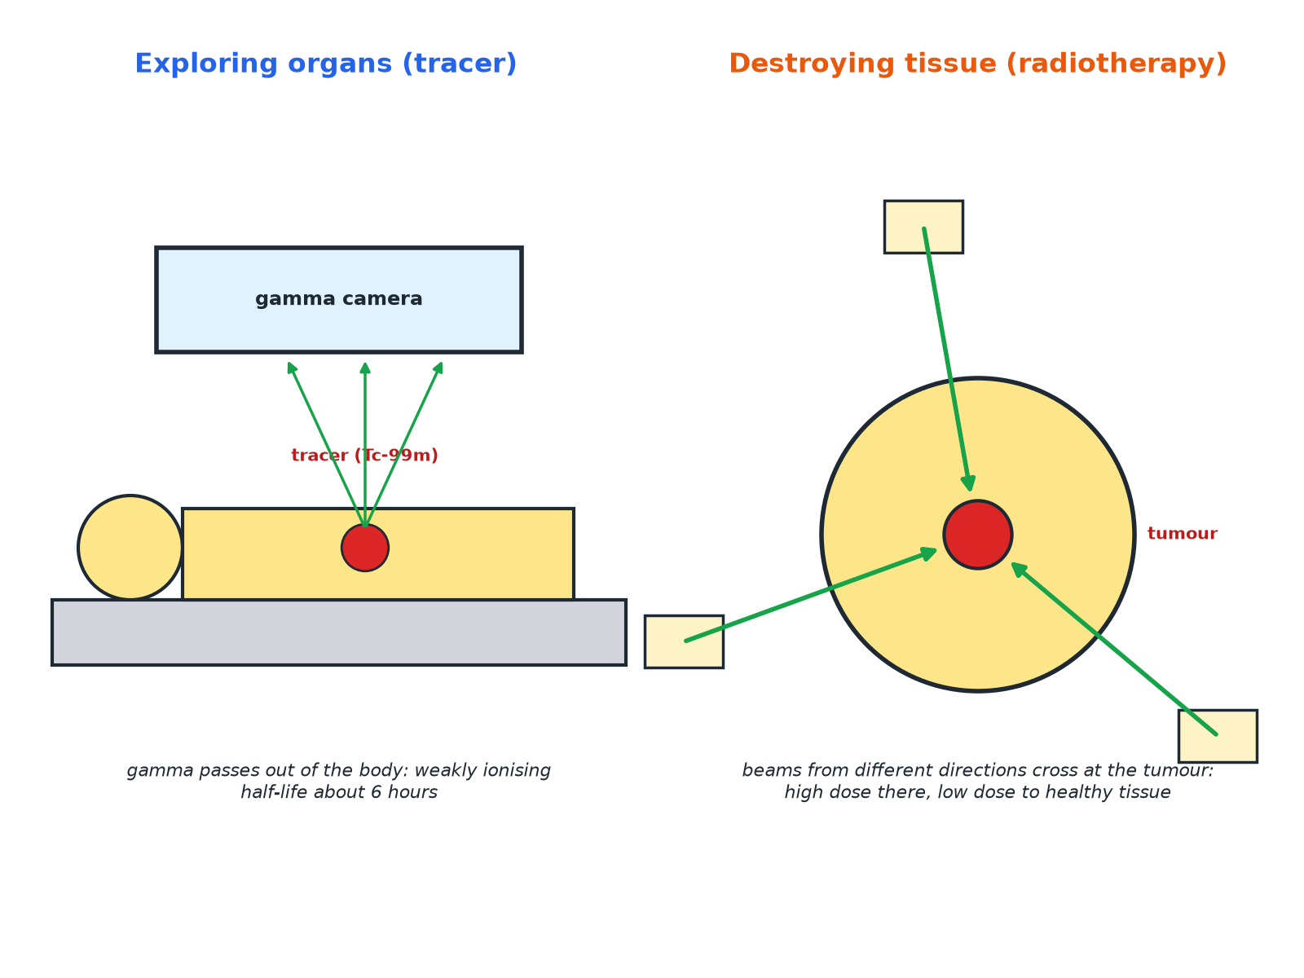
The radiation is chosen for its penetration and half-life.
A patient scanned with a gamma camera after a tracer, and radiotherapy beams from several directions focused on a tumour.
Half-Life and Hazard
Data (approximate).
Isotope | Half-life | Comment
Technetium-99m | 6 hours | Gamma emitter used as a medical tracer; gone from the body quickly
Iodine-131 | 8 days | Used to treat the thyroid; decays within weeks
Cobalt-60 | 5 years | Gamma source for radiotherapy
Uranium-238 | 4.5 × 10⁹ years | Stays radioactive for billions of years
Why Half-Life Matters
Explain why a source with a very long half-life is a hazard for a long time, and why a source with a very short half-life is a hazard mainly at first.

1. Very long half-life
The activity falls extremely slowly, so it remains radioactive for a very long time
2. Very short half-life
It is very active at first but decays quickly, so it is a hazard for only a short time
Answer: Long half-life: long-term hazard, low activity. Short half-life: intense at first but soon gone.
Choosing a Medical Tracer
Explain why technetium-99m is suitable as a tracer to explore organs in the body.

1. Gamma
Penetrating, so it passes out of the body to the detector, and weakly ionising, so it does little damage
2. Half-life 6 hours
Long enough to take the scan but decays quickly so the patient is not radioactive for long
Answer: It emits gamma rays, which pass out of the body and are weakly ionising, and its half-life is short.
Evaluating Risk
Balance benefits and risks.
▸ Benefits. Diagnose disease without surgery; destroy tumours.
▸ Risks. Ionising radiation can damage healthy cells and cause cancer.
▸ Reduce risk. Use small doses, short half-lives and beams from different directions.
▸ Judging. Use the data on dose and consequences to say whether the risk is acceptable.
Key Terms
Tracer  A radioactive substance used to follow a process in the body. | Radiotherapy  Treating cancer using nuclear radiation.
Half-life  The time for the activity to halve. | Gamma camera  A device that detects gamma rays from a tracer.
Unwanted tissue  Tissue such as a tumour. | Risk  The chance of harm.
Your Task: Evaluate the Scan
12 minutes
A doctor uses technetium-99m (half-life 6 hours, gamma) to scan a patient's kidneys. Give two reasons why it is suitable and one risk.
1. Consider penetration.
2. Consider half-life.
A good answer shows: Reasons: gamma passes out of the body; short half-life. Risk: ionising radiation may damage cells (small).
Can I...?
☐ Explain hazard and half-life.
☐ Explain why gamma tracers are used.
☐ Explain why a short half-life suits a tracer.
☐ Describe radiotherapy.
☐ Explain beams from different directions.
☐ Evaluate risks and benefits.
☐ Read standard form data.
☐ Use data in an answer.
Summary
✓ Half-lives range from fractions of a second to billions of years.
✓ Tracers: gamma, short half-life.
✓ Radiotherapy: focus beams to destroy tumours.
✓ Weigh benefits and risks.

EXAM FOCUS
Explain why a radioactive tracer used inside the body should emit gamma radiation and have a short half-life. (4 marks)
Gamma passes out of the body and short half-life means it does not remain long.

