AQA GCSE PHYSICS · PAPER 1 · FOUNDATION & HIGHER
Half-lives, hazards and uses of nuclear radiation
Atomic structure · Lesson 9 of 10
Teacher copy - includes the notes for whoever is teaching from it.
Warm-up
Answer each one, then check.
1. What is half-life?
The time for activity to halve
2. What is a tracer?
A substance that can be followed inside the body
3. Which radiation is most penetrating?
Gamma
4. Give one danger of ionising radiation.
It can damage or kill cells
5. What is standard form?
A number written as a × 10ⁿ
Learning Objectives
1. Explain why the hazards of a radioactive material differ with its half-life.
2. Describe and evaluate the use of nuclear radiation in exploring internal organs and treating unwanted tissue.
3. Evaluate the perceived risks of nuclear radiation using data.
4. Use data given in standard form.
Half-Life And Hazard
Radioactive isotopes have a very wide range of half-lives. Short half-lives are very active but decay quickly; long half-lives stay radioactive for a very long time.
In medicine, nuclear radiations are used to explore internal organs and to control or destroy unwanted tissue.
Nuclear Radiation in Medicine
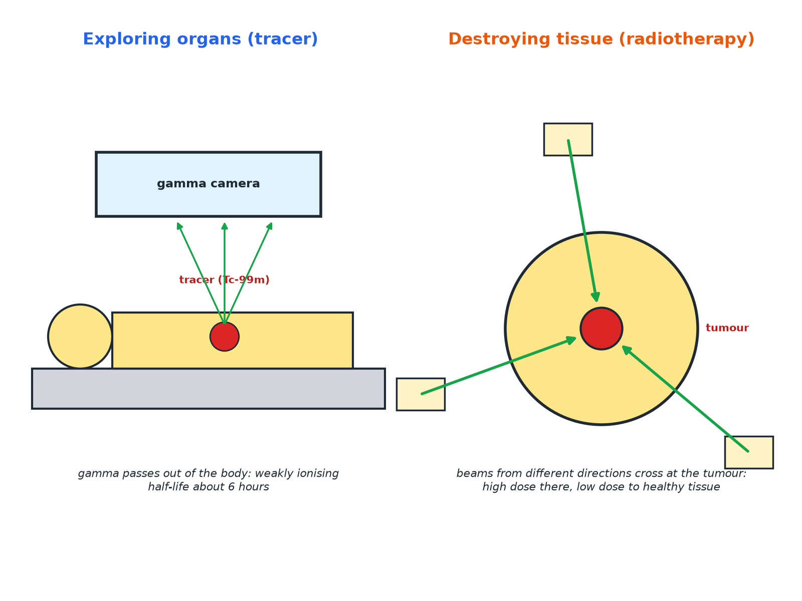
The radiation is chosen for its penetration and half-life.
A patient scanned with a gamma camera after a tracer, and radiotherapy beams from several directions focused on a tumour.
Half-Life and Hazard
Data (approximate).
Isotope | Half-life | Comment
Technetium-99m | 6 hours | Gamma emitter used as a medical tracer; gone from the body quickly
Iodine-131 | 8 days | Used to treat the thyroid; decays within weeks
Cobalt-60 | 5 years | Gamma source for radiotherapy
Uranium-238 | 4.5 × 10⁹ years | Stays radioactive for billions of years
Why Half-Life Matters
Explain why a source with a very long half-life is a hazard for a long time, and why a source with a very short half-life is a hazard mainly at first.

1. Very long half-life
The activity falls extremely slowly, so it remains radioactive for a very long time
2. Very short half-life
It is very active at first but decays quickly, so it is a hazard for only a short time
Answer: Long half-life: long-term hazard, low activity. Short half-life: intense at first but soon gone.
Choosing a Medical Tracer
Explain why technetium-99m is suitable as a tracer to explore organs in the body.

1. Gamma
Penetrating, so it passes out of the body to the detector, and weakly ionising, so it does little damage
2. Half-life 6 hours
Long enough to take the scan but decays quickly so the patient is not radioactive for long
Answer: It emits gamma rays, which pass out of the body and are weakly ionising, and its half-life is short.
Evaluating Risk
Balance benefits and risks.
▸ Benefits. Diagnose disease without surgery; destroy tumours.
▸ Risks. Ionising radiation can damage healthy cells and cause cancer.
▸ Reduce risk. Use small doses, short half-lives and beams from different directions.
▸ Judging. Use the data on dose and consequences to say whether the risk is acceptable.
Key Terms
Tracer  A radioactive substance used to follow a process in the body. | Radiotherapy  Treating cancer using nuclear radiation.
Half-life  The time for the activity to halve. | Gamma camera  A device that detects gamma rays from a tracer.
Unwanted tissue  Tissue such as a tumour. | Risk  The chance of harm.
Your Task: Evaluate the Scan
12 minutes
A doctor uses technetium-99m (half-life 6 hours, gamma) to scan a patient's kidneys. Give two reasons why it is suitable and one risk.
1. Consider penetration.
2. Consider half-life.
A good answer shows: Reasons: gamma passes out of the body; short half-life. Risk: ionising radiation may damage cells (small).
Note: Ask why a beta source would be less suitable.
Can I...?
☐ Explain hazard and half-life.
☐ Explain why gamma tracers are used.
☐ Explain why a short half-life suits a tracer.
☐ Describe radiotherapy.
☐ Explain beams from different directions.
☐ Evaluate risks and benefits.
☐ Read standard form data.
☐ Use data in an answer.
Summary
✓ Half-lives range from fractions of a second to billions of years.
✓ Tracers: gamma, short half-life.
✓ Radiotherapy: focus beams to destroy tumours.
✓ Weigh benefits and risks.

EXAM FOCUS
Explain why a radioactive tracer used inside the body should emit gamma radiation and have a short half-life. (4 marks)
Gamma passes out of the body and short half-life means it does not remain long.
Exam Practice: Half-lives, hazards and uses of nuclear radiation
Answer all questions. Use the mark allocation as a guide to how much to write. · 17 minutes
▸ Question 1 · 3 marks · Explain. Different radioactive isotopes have different half-lives. Explain why radioactive waste with a very long half-life is a problem.
▸ Question 2 · 4 marks · Explain. Technetium-99m is a radioactive isotope with a half-life of 6 hours. It emits gamma radiation. It is injected into a patient so that…
▸ Question 3 · 3 marks · Explain. In radiotherapy, narrow beams of gamma radiation are directed at a tumour from several different directions. Explain why.
▸ Question 4 · 2 marks · Compare. Uranium-238 has a half-life of 4.5 × 10⁹ years. Iodine-131 has a half-life of 8 days. State which isotope stays radioactive for longer and…
▸ Question 5 · 4 marks · Evaluate. Some people are worried about using radioactive materials in medicine. Evaluate the risks and benefits of using a radioactive tracer.
Question 1 · 3 marks · Explain
“Different radioactive isotopes have different half-lives. Explain why radioactive waste with a very long half-life is a problem.”
HOW TO ANSWER IT Command word: Explain. Worth 3 marks, so plan before writing.
Question 1 · mark scheme
3 marks available. Award a mark for each point made.
▸ Long half-life means it stays radioactive. 1 mark
▸ For a very long time. 1 mark
▸ So it must be stored safely. 1 mark
▸ Model answer. A very long half-life means the material remains radioactive for a very long time (many thousands or millions of years), so it must be stored safely for a long time.
Question 2 · 4 marks · Explain
“Technetium-99m is a radioactive isotope with a half-life of 6 hours. It emits gamma radiation. It is injected into a patient so that internal organs can be explored. Explain why technetium-99m is suitable for this use.”
HOW TO ANSWER IT Command word: Explain. Worth 4 marks, so plan before writing.
Question 2 · mark scheme
4 marks available. Award a mark for each point made.
▸ Gamma passes out of the body. 1 mark
▸ Detected outside the body. 1 mark
▸ Weakly ionising: little damage. 1 mark
▸ Short half-life: decays quickly. 1 mark
▸ Model answer. Gamma radiation can pass out of the body so it can be detected outside. It is weakly ionising so causes little damage. A half-life of 6 hours is long enough to complete the scan but short enough that the radioactivity soon decays.
Question 3 · 3 marks · Explain
“In radiotherapy, narrow beams of gamma radiation are directed at a tumour from several different directions. Explain why.”
HOW TO ANSWER IT Command word: Explain. Worth 3 marks, so plan before writing.
Question 3 · mark scheme
3 marks available. Award a mark for each point made.
▸ High dose where the beams cross at the tumour. 1 mark
▸ Healthy tissue receives low dose. 1 mark
▸ Reduces damage to healthy cells. 1 mark
▸ Model answer. Where the beams cross at the tumour the dose is high, which destroys the cancer cells. Healthy tissue only receives one beam at a time, so the dose is low and less damage is done.
Question 4 · 2 marks · Compare
“Uranium-238 has a half-life of 4.5 × 10⁹ years. Iodine-131 has a half-life of 8 days. State which isotope stays radioactive for longer and give a reason.”
HOW TO ANSWER IT Command word: Compare. Worth 2 marks, so plan before writing.
Question 4 · mark scheme
2 marks available. Award a mark for each point made.
▸ Uranium-238. 1 mark
▸ Much longer half-life. 1 mark
▸ Model answer. Uranium-238, because its half-life is much longer.
Question 5 · 4 marks · Evaluate
“Some people are worried about using radioactive materials in medicine. Evaluate the risks and benefits of using a radioactive tracer.”
HOW TO ANSWER IT Command word: Evaluate. Worth 4 marks, so plan before writing.
Question 5 · mark scheme
4 marks available. Award a mark for each point made.
▸ Benefit described. 1 mark
▸ Risk described. 1 mark
▸ Small dose or short half-life reduces risk. 1 mark
▸ A conclusion. 1 mark
▸ Model answer. Benefits: organs can be explored without surgery, and diagnosis can be quicker and more accurate. Risks: ionising radiation can damage cells and could cause cancer, but the dose is small and the tracer has a short half-life, so the benefit usually outweighs the risk.

