AQA GCSE PHYSICS · PAPER 1 · FOUNDATION & HIGHER
Nuclear fission and fusion
Atomic structure · Lesson 10 of 10
Teacher copy - includes the notes for whoever is teaching from it.
Warm-up
Answer each one, then check.
1. What is a nucleus?
The centre of an atom, made of protons and neutrons
2. What is an isotope?
An atom with the same protons but different neutrons
3. What is energy conserved?
Energy cannot be created or destroyed
4. What happens to mass in E = mc²?
It can be converted to energy
5. What is a chain reaction?
A reaction that keeps itself going
Learning Objectives
1. Describe nuclear fission and how a chain reaction occurs.
2. Explain how the chain reaction is controlled in a nuclear reactor and uncontrolled in a nuclear weapon.
3. Draw and interpret diagrams of fission and chain reactions.
4. Describe nuclear fusion.
Fission And Fusion
Nuclear fission is the splitting of a large and unstable nucleus, such as uranium or plutonium. Nuclear fusion is the joining of two light nuclei to form a heavier nucleus.
In both, energy is released. In fusion some of the mass is converted into the energy of radiation.
A Fission Chain Reaction
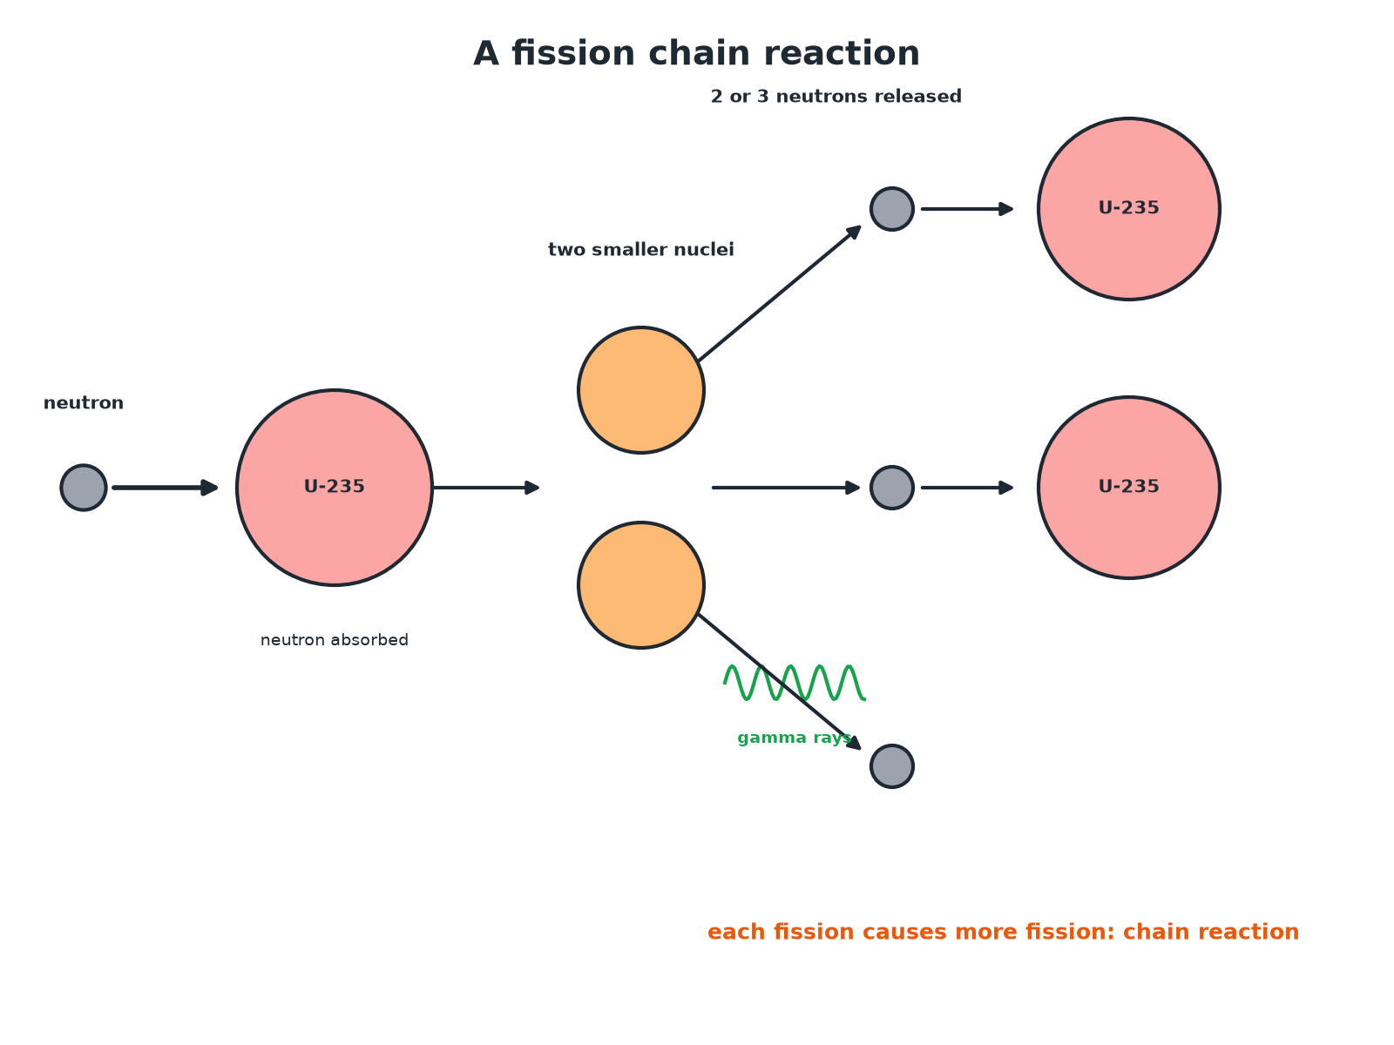
Each fission produces neutrons that cause more fission.
A neutron splitting a uranium-235 nucleus into two smaller nuclei and more neutrons, which go on to split more nuclei in a chain reaction.
Nuclear Fusion
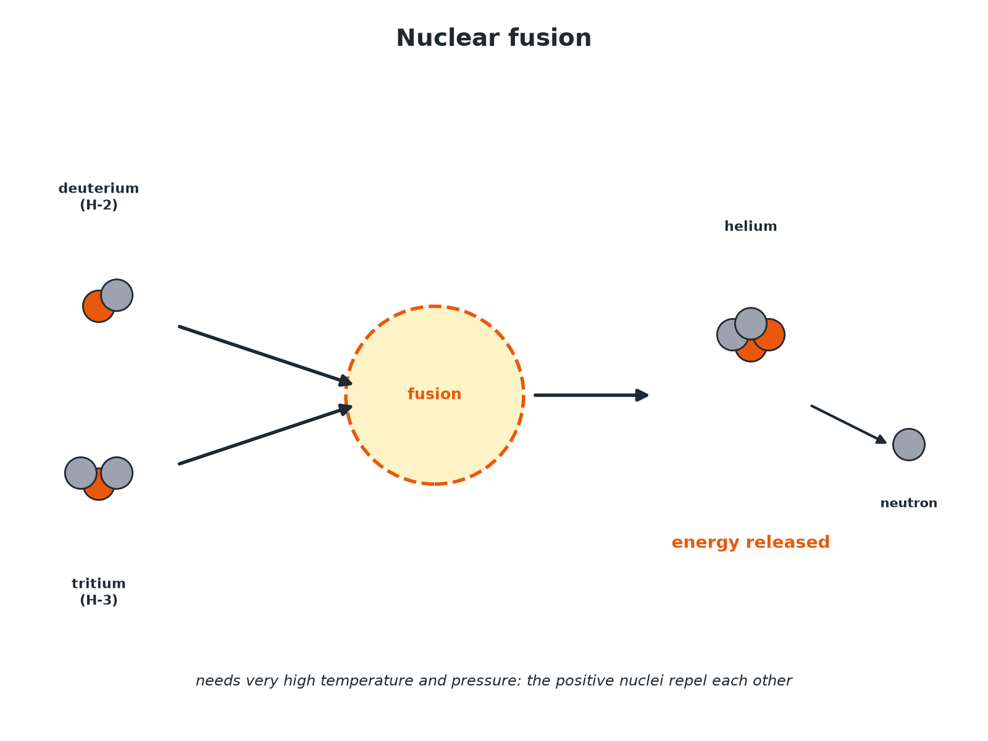
Two light nuclei join to make a heavier one.
Deuterium and tritium nuclei fusing to make a helium nucleus and a neutron, releasing energy.
Nuclear Fission
Follow the steps.
1  A neutron is absorbed  An unstable nucleus such as uranium-235 absorbs a neutron. | 2  The nucleus splits  Into two smaller nuclei, roughly equal in size. | 3  Two or three neutrons are released  Also gamma rays. | 4  Energy is released  All the fission products have kinetic energy. | 5  Chain reaction  The neutrons go on to cause further fission.
Controlled or Uncontrolled?
IN A NUCLEAR REACTOR | IN A NUCLEAR WEAPON
▸ The chain reaction is controlled.  ▸ Control rods absorb excess neutrons so only one neutron from each fission causes another.  ▸ Energy is released steadily to heat water. | ▸ The chain reaction is uncontrolled.  ▸ Neutrons cause many more fissions each time.  ▸ A huge amount of energy is released in an instant: an explosion.
Describing a Chain Reaction
Explain how a chain reaction occurs in a fission reactor.

1. Start
A neutron is absorbed by a uranium-235 nucleus which splits
2. Neutrons released
2 or 3 neutrons are released
3. Continues
These neutrons are absorbed by more nuclei, which also split, so the reaction keeps going
Answer: The neutrons released in each fission cause further fissions, so the reaction sustains itself.
Fusion
Describe what happens in nuclear fusion.

1. Two light nuclei
Join together to form a heavier nucleus
2. Mass
Some of the mass is converted to energy released as radiation
3. Conditions
Very high temperature and pressure are needed to overcome the repulsion between the positive nuclei
Answer: Light nuclei join to form a heavier nucleus, releasing energy.
Comparing Them
Points to remember.
▸ Fission. A large nucleus splits into two smaller ones; releases neutrons; chain reaction.
▸ Fusion. Two small nuclei join; needs very high temperature; powers the Sun.
▸ Both. Release energy; fusion releases more per kilogram of fuel than fission.
▸ Waste. Fission produces radioactive waste; fusion products are largely not radioactive for long.
Key Terms
Nuclear fission  The splitting of a large, unstable nucleus. | Nuclear fusion  The joining of two light nuclei to form a heavier nucleus.
Chain reaction  A reaction in which the products cause more of the same reaction. | Control rods  Rods that absorb neutrons to control a reactor.
Fission products  The smaller nuclei produced by fission. | Nuclear reactor  A device in which fission is controlled.
Your Task: Fission or Fusion?
10 minutes
State whether each is fission or fusion: (a) uranium-235 absorbs a neutron and splits (b) hydrogen nuclei join to make helium (c) a chain reaction in a reactor (d) the process in the Sun.
1. Decide if a nucleus splits or joins.
A good answer shows: (a) Fission (b) Fusion (c) Fission (d) Fusion.
Note: Ask why fusion needs such a high temperature.
Can I...?
☐ Define fission.
☐ Define fusion.
☐ Describe a chain reaction.
☐ Describe control in a reactor.
☐ Describe uncontrolled fission.
☐ Draw and interpret a fission diagram.
☐ Describe fusion conditions.
☐ Compare fission and fusion.
Summary
✓ Fission: large nucleus splits into two smaller nuclei plus 2 to 3 neutrons and gamma.
✓ Chain reaction: neutrons cause further fission.
✓ Controlled in a reactor, uncontrolled in a weapon.
✓ Fusion: two light nuclei join, releasing energy.

EXAM FOCUS
Describe what happens in nuclear fission. (3 marks)
Neutron absorbed, nucleus splits, neutrons and energy released.
Exam Practice: Nuclear fission and fusion
Answer all questions. Use the mark allocation as a guide to how much to write. · 16 minutes
▸ Question 1 · 2 marks · State. What is meant by nuclear fission?
▸ Question 2 · 3 marks · Complete the diagram. The diagram shows part of a fission chain reaction. (a) Name the particle labelled X. (b) Explain how the diagram shows that a chain…
▸ Question 3 · 3 marks · Explain. Explain how the chain reaction is controlled in a nuclear reactor.
▸ Question 4 · 3 marks · Describe. Describe what happens in nuclear fusion, and state one condition needed for it to happen.
▸ Question 5 · 4 marks · Compare. Compare nuclear fission and nuclear fusion.
Question 1 · 2 marks · State
“What is meant by nuclear fission?”
HOW TO ANSWER IT Command word: State. Worth 2 marks, so plan before writing.
Question 1 · mark scheme
2 marks available. Award a mark for each point made.
▸ Splitting of a large unstable nucleus. 1 mark
▸ Into two smaller nuclei. 1 mark
▸ Model answer. The splitting of a large and unstable nucleus (such as uranium or plutonium) into two smaller nuclei.
Question 2 · 3 marks · Complete the diagram
The diagram shows part of a fission chain reaction. (a) Name the particle labelled X. (b) Explain how the diagram shows that a chain reaction can happen. (3 marks) | 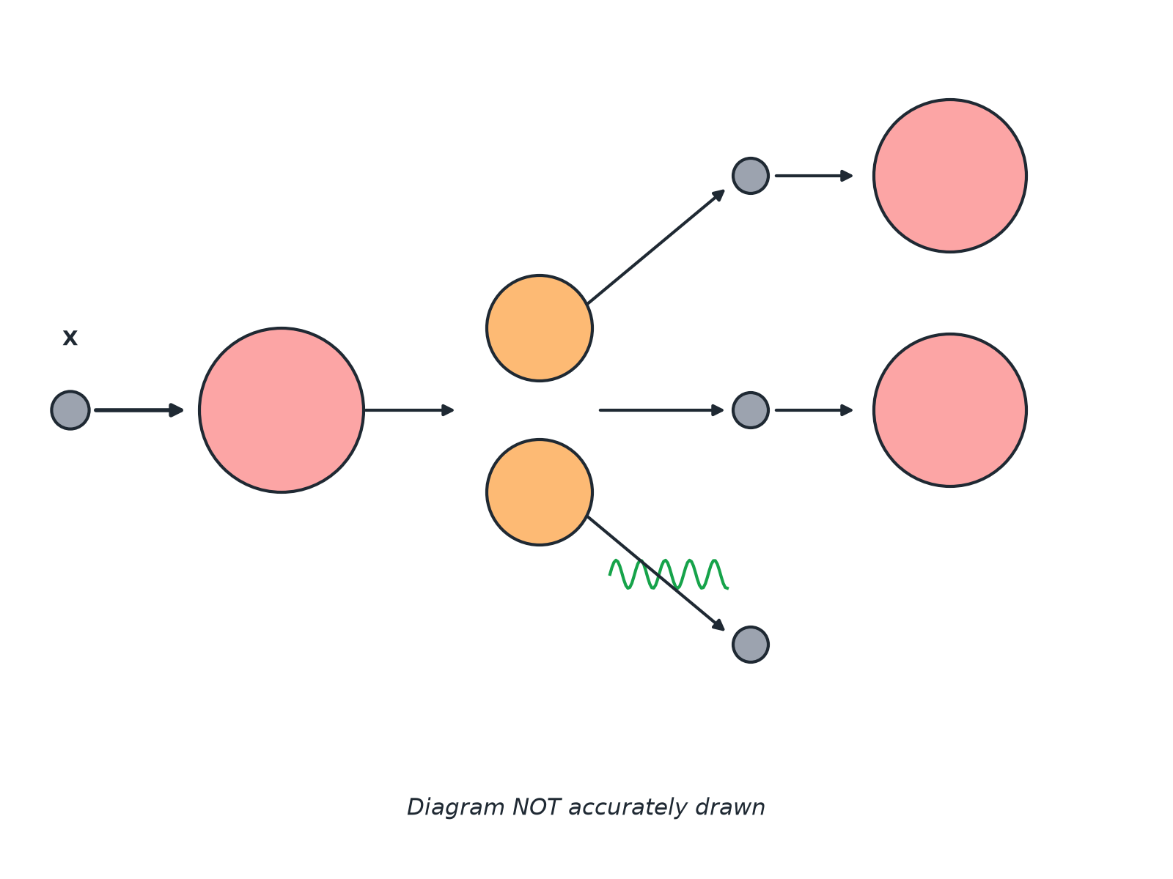

Question 2 · mark scheme
3 marks available. Award a mark for each point made.
▸ X is a neutron. 1 mark
▸ Each fission releases more than one neutron. 1 mark
▸ These cause more nuclei to split. 1 mark
▸ Model answer. (a) A neutron. (b) Each fission releases two or three neutrons, which cause further nuclei to split, so the reaction continues.
Question 3 · 3 marks · Explain
“Explain how the chain reaction is controlled in a nuclear reactor.”
HOW TO ANSWER IT Command word: Explain. Worth 3 marks, so plan before writing.
Question 3 · mark scheme
3 marks available. Award a mark for each point made.
▸ Control rods absorb neutrons. 1 mark
▸ Only one neutron from each fission goes on to cause fission. 1 mark
▸ So the rate of energy release is steady. 1 mark
▸ Model answer. Control rods absorb some of the neutrons produced. This means on average only one neutron from each fission causes another fission, so the reaction continues steadily without getting out of control.
Question 4 · 3 marks · Describe
“Describe what happens in nuclear fusion, and state one condition needed for it to happen.”
HOW TO ANSWER IT Command word: Describe. Worth 3 marks, so plan before writing.
Question 4 · mark scheme
3 marks available. Award a mark for each point made.
▸ Two light nuclei join. 1 mark
▸ Energy released. 1 mark
▸ Very high temperature or pressure needed. 1 mark
▸ Model answer. Two light nuclei join to form a heavier nucleus, and some of the mass is converted to energy. Very high temperature (and pressure) is needed to overcome the repulsion between the nuclei.
Question 5 · 4 marks · Compare
“Compare nuclear fission and nuclear fusion.”
HOW TO ANSWER IT Command word: Compare. Worth 4 marks, so plan before writing.
Question 5 · mark scheme
4 marks available. Award a mark for each point made.
▸ Fission: splitting. 1 mark
▸ Fusion: joining. 1 mark
▸ Both release energy. 1 mark
▸ A difference in conditions or products. 1 mark
▸ Model answer. Fission is the splitting of a large unstable nucleus into two smaller nuclei; fusion is the joining of two light nuclei to make a heavier one. Both release energy. Fission releases neutrons that cause a chain reaction; fusion needs very high temperature and pressure.

