AQA GCSE PHYSICS · PAPER 2 · FOUNDATION & HIGHER
Gravity, mass and weight
Forces · Lesson 2 of 20
Teacher copy - includes the notes for whoever is teaching from it.
Warm-up
Answer each one, then check.
1. What is the unit of mass?
Kilogram
2. What is the unit of weight?
Newton
3. What does g stand for?
Gravitational field strength
4. What is gravity?
An attractive force between objects with mass
5. What instrument measures force?
A newtonmeter (spring balance)
Learning Objectives
1. Define weight and explain how it depends on gravitational field strength.
2. Recall and apply W = mg.
3. Explain that weight and mass are directly proportional.
4. Describe the centre of mass.
Weight
weight = mass × gravitational field strength W = mg
Weight is the force on an object due to gravity. On Earth g is about 9.8 N/kg, but in any calculation the value of g will be given.
Weight Against Mass
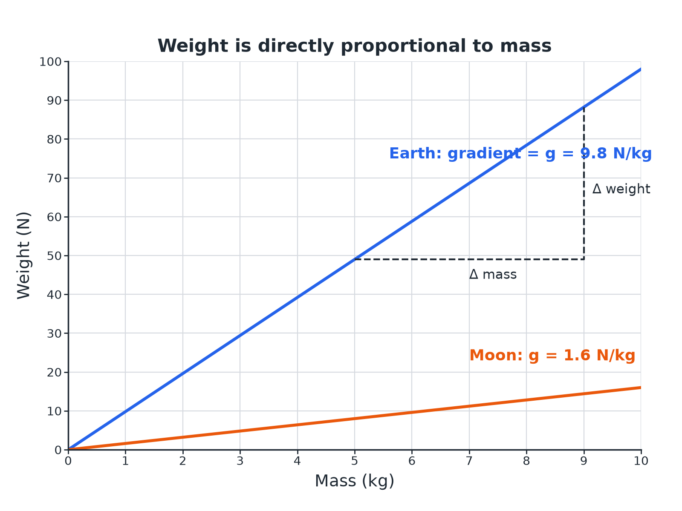
Weight is directly proportional to mass.
A straight line graph of weight against mass through the origin, steeper for Earth than for the Moon.
Gravitational Field Strength
g varies from place to place.
Place | g (N/kg)
Earth | 9.8
Moon | 1.6
Mars | 3.7
Jupiter | 25
Weight on Earth
A person has a mass of 60 kg. Calculate their weight on Earth. g = 9.8 N/kg.

1. Write the equation
W = mg
2. Substitute
W = 60 × 9.8
3. Answer
W = 588 N
Answer: 588 N
Weight on the Moon
The same person goes to the Moon, where g = 1.6 N/kg. Calculate their mass and weight.

1. Mass
Mass does not change: 60 kg
2. Weight
W = 60 × 1.6 = 96 N
Answer: Mass 60 kg; weight 96 N.
Finding g
An object of mass 3.0 kg has a weight of 12 N on a planet. Calculate g.

1. Rearrange
g = W ÷ m
2. Substitute
g = 12 ÷ 3.0
3. Answer
g = 4.0 N/kg
Answer: 4.0 N/kg
Key Ideas
Mass and weight are different.
▸ Mass. The amount of matter in an object; in kg; does not change with place.
▸ Weight. A force in newtons; depends on g; measured with a newtonmeter.
▸ Proportional. W ∝ m: doubling the mass doubles the weight.
▸ Centre of mass. The single point at which the weight of an object may be considered to act.
Key Terms
Weight  The force acting on an object due to gravity. | Mass  The amount of matter in an object.
Gravitational field strength  The force per kilogram near a planet. | Newtonmeter  A calibrated spring balance for measuring force.
Centre of mass  The point where the weight of an object may be considered to act. | Directly proportional  Doubling one quantity doubles the other.
Your Task: Weigh It
10 minutes
A rock has a mass of 5.0 kg. Calculate its weight on Earth (g = 9.8 N/kg), on the Moon (g = 1.6 N/kg) and on Jupiter (g = 25 N/kg).
1. Use W = mg.
2. Compare the answers.
A good answer shows: Earth 49 N; Moon 8.0 N; Jupiter 125 N. The mass is 5.0 kg everywhere.
Note: Ask which quantity changes and which does not.
Can I...?
☐ Define weight.
☐ Use W = mg.
☐ Rearrange for g or m.
☐ Say why weight changes but mass does not.
☐ Recall the unit of weight.
☐ Describe a newtonmeter.
☐ Explain proportionality.
☐ Describe the centre of mass.
Summary
✓ W = mg.
✓ Mass in kg; weight in N.
✓ Weight is proportional to mass.
✓ Mass is the same everywhere; weight depends on g.

EXAM FOCUS
A person has a mass of 60 kg. Calculate their weight. g = 9.8 N/kg. (2 marks)
Substitute into W = mg and include N.
Exam Practice: Gravity, mass and weight
Answer all questions. Use the mark allocation as a guide to how much to write. · 15 minutes
▸ Question 1 · 2 marks · Calculate. A person has a mass of 60 kg. Gravitational field strength = 9.8 N/kg. Calculate the weight of the person. Use the equation: weight = mass…
▸ Question 2 · 3 marks · Explain. An astronaut travels from Earth to the Moon. Explain what happens to the astronaut's mass and weight.
▸ Question 3 · 4 marks · Use the graph. The graph shows how the weight of objects on a planet depends on their mass. (a) Describe the relationship between weight and mass. (b) Use…
▸ Question 4 · 3 marks · Calculate. A rock has a weight of 12 N on a planet. Its mass is 3.0 kg. Calculate the gravitational field strength of the planet.
▸ Question 5 · 2 marks · Explain. A newtonmeter is used to measure the weight of an object. State what the newtonmeter actually measures and the unit used.
Question 1 · 2 marks · Calculate
“A person has a mass of 60 kg. Gravitational field strength = 9.8 N/kg. Calculate the weight of the person. Use the equation: weight = mass × gravitational field strength”
HOW TO ANSWER IT Command word: Calculate. Worth 2 marks, so plan before writing.
Question 1 · mark scheme
2 marks available. Award a mark for each point made.
▸ Correct substitution. 1 mark
▸ 588 N. 1 mark
▸ Model answer. 60 × 9.8 = 588 N
Question 2 · 3 marks · Explain
“An astronaut travels from Earth to the Moon. Explain what happens to the astronaut's mass and weight.”
HOW TO ANSWER IT Command word: Explain. Worth 3 marks, so plan before writing.
Question 2 · mark scheme
3 marks available. Award a mark for each point made.
▸ Mass unchanged. 1 mark
▸ Weight decreases. 1 mark
▸ Moon has a weaker gravitational field. 1 mark
▸ Model answer. The mass stays the same because it is the amount of matter. The weight decreases because the gravitational field strength on the Moon is less than on Earth.
Question 3 · 4 marks · Use the graph
The graph shows how the weight of objects on a planet depends on their mass. (a) Describe the relationship between weight and mass. (b) Use the graph to calculate the gravitational field strength of the planet. (4 marks) | 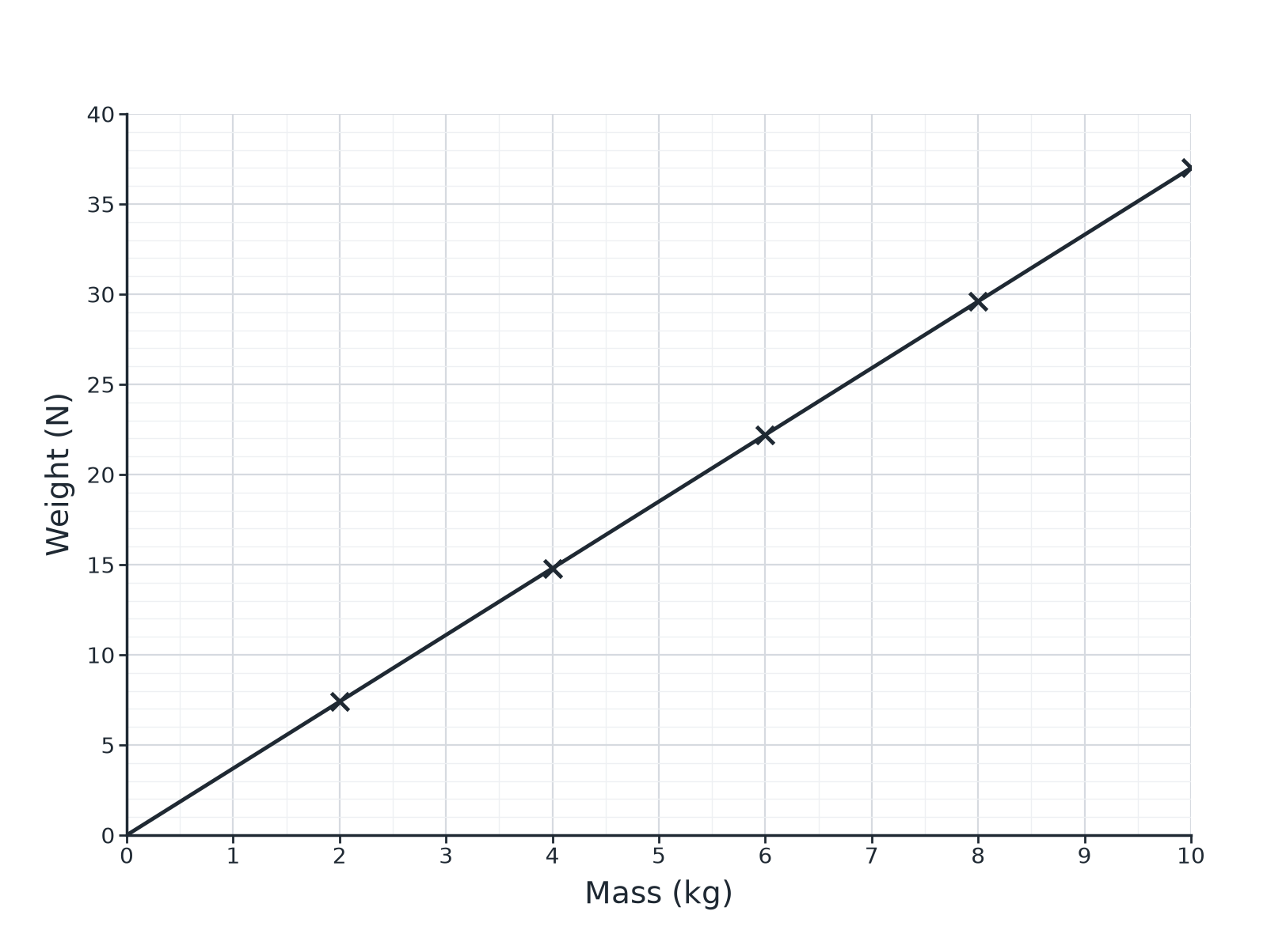

Question 3 · mark scheme
4 marks available. Award a mark for each point made.
▸ Straight line through the origin. 1 mark
▸ Directly proportional. 1 mark
▸ Uses the gradient. 1 mark
▸ 3.7 N/kg (accept 3.5 to 3.9). 1 mark
▸ Model answer. (a) Weight is directly proportional to mass (a straight line through the origin). (b) Gradient = 18.5 ÷ 5.0 = 3.7 N/kg
Question 4 · 3 marks · Calculate
“A rock has a weight of 12 N on a planet. Its mass is 3.0 kg. Calculate the gravitational field strength of the planet.”
HOW TO ANSWER IT Command word: Calculate. Worth 3 marks, so plan before writing.
Question 4 · mark scheme
3 marks available. Award a mark for each point made.
▸ Rearranges to g = W ÷ m. 1 mark
▸ Correct substitution. 1 mark
▸ 4.0 N/kg. 1 mark
▸ Model answer. g = W ÷ m = 12 ÷ 3.0 = 4.0 N/kg
Question 5 · 2 marks · Explain
“A newtonmeter is used to measure the weight of an object. State what the newtonmeter actually measures and the unit used.”
HOW TO ANSWER IT Command word: Explain. Worth 2 marks, so plan before writing.
Question 5 · mark scheme
2 marks available. Award a mark for each point made.
▸ Force or weight. 1 mark
▸ In newtons. 1 mark
▸ Model answer. The force (weight) acting on the object due to gravity, in newtons.

