AQA GCSE PHYSICS · PAPER 2 · HIGHER TIER ONLY
Pressure in a column of liquid and upthrust
Forces · Lesson 8 of 20
Teacher copy - includes the notes for whoever is teaching from it.
Warm-up
Answer each one, then check.
1. What is density?
Mass per unit volume
2. Write the equation for pressure.
p = F ÷ A
3. What unit is pressure in?
Pascal
4. What is g?
Gravitational field strength, 9.8 N/kg
5. What is a fluid?
A liquid or gas
Learning Objectives
1. Explain why pressure at a point in a liquid increases with depth and with density.
2. Apply p = hρg and calculate pressure differences at different depths.
3. Explain why a submerged object experiences an upward force called upthrust.
4. Describe the factors that influence floating and sinking.
Pressure In A Liquid
pressure = height of column × density × gravitational field strength p = hρg
The equation is given on the Physics equation sheet. In any calculation g will be given. Pressure is in pascals (Pa), h in metres, ρ in kg/m³ and g in N/kg.
Pressure Increases with Depth
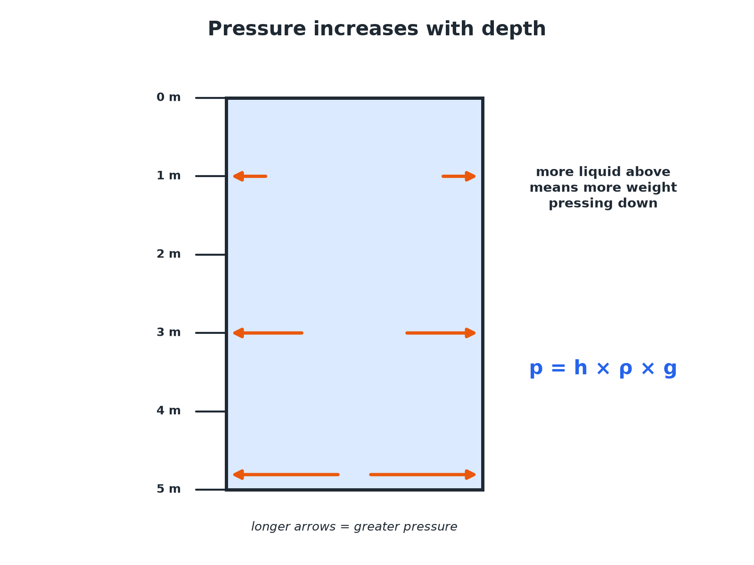
More liquid above means more pressure.
A tank of water with arrows showing that pressure increases with depth.
Upthrust
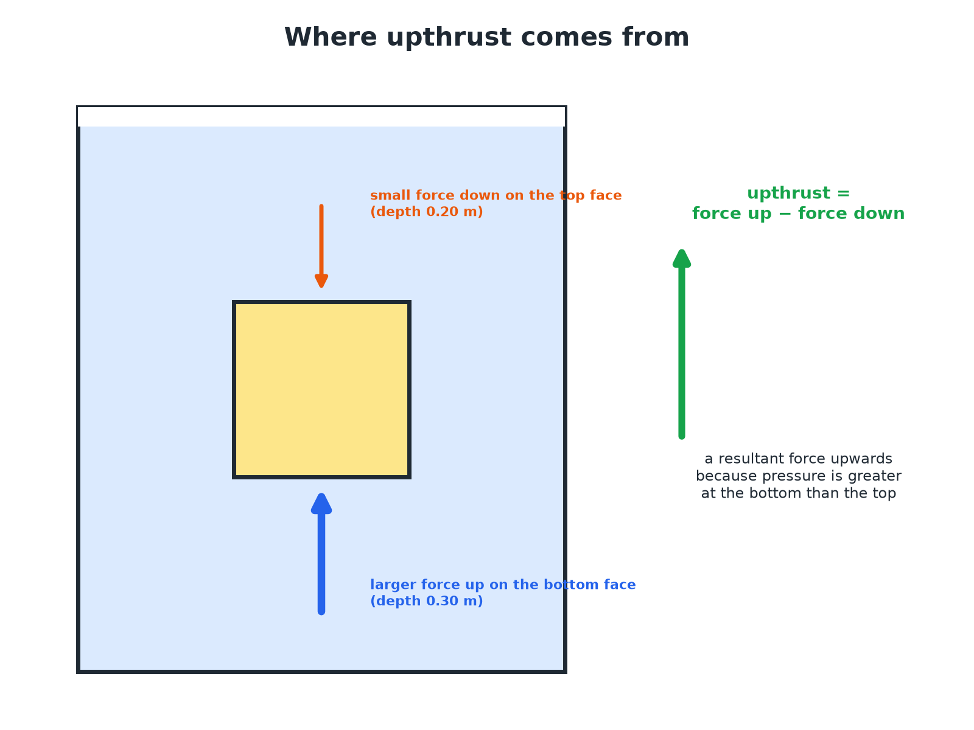
Pressure is greater at the bottom than the top.
A submerged cube with a bigger upward force on its bottom face than the downward force on its top face, giving an upthrust.
Pressure at a Depth
Calculate the pressure due to the sea water at a depth of 20 m. Density of sea water = 1030 kg/m³; g = 9.8 N/kg.

1. Write the equation
p = hρg
2. Substitute
p = 20 × 1030 × 9.8
3. Answer
p = 201 880 Pa, about 2.0 × 10⁵ Pa
Answer: About 2.0 × 10⁵ Pa
Pressure Difference
Calculate the difference in pressure between depths of 2.0 m and 5.0 m in fresh water (density 1000 kg/m³). g = 9.8 N/kg.

1. Difference in depth
5.0 − 2.0 = 3.0 m
2. Substitute
p = 3.0 × 1000 × 9.8
3. Answer
29 400 Pa
Answer: 29 400 Pa
Upthrust on a Cube
A cube of side 0.10 m is submerged with its top face at a depth of 0.20 m. Calculate the upthrust. Density of water = 1000 kg/m³; g = 9.8 N/kg.

1. Pressure difference between bottom and top
0.10 × 1000 × 9.8 = 980 Pa
2. Area of a face
0.10 × 0.10 = 0.010 m²
3. Force difference
F = pA = 980 × 0.010 = 9.8 N
Answer: Upthrust = 9.8 N, upwards.
Floating and Sinking
Compare upthrust with weight.
▸ Float. Upthrust equals weight when an object floats; its average density is less than the liquid's.
▸ Sink. If the weight is greater than the maximum upthrust, the object sinks.
▸ Ships. A steel ship floats because its shape displaces a lot of water, giving it a low average density.
▸ Submarines. Change their average density by taking in or pushing out water.
Key Terms
Upthrust  The resultant upward force on a submerged object due to pressure. | Column of liquid  The liquid above a point.
Density  Mass per unit volume. | Submerged  Completely under the surface.
Displaced  Pushed out of the way. | Average density  Total mass divided by total volume.
Your Task: Dive Down
12 minutes
A diver is 15 m deep in water (density 1000 kg/m³, g = 9.8 N/kg). Calculate the pressure due to the water. Explain why the pressure is greater than at 5 m.
1. Use p = hρg.
2. Explain with depth.
A good answer shows: p = 15 × 1000 × 9.8 = 147 000 Pa. There is more water above the diver, so its weight produces a greater pressure.
Note: Ask how dense liquid changes the answer.
Can I...?
☐ State p = hρg.
☐ Calculate pressure at a depth.
☐ Find a pressure difference.
☐ Explain why pressure increases with depth.
☐ Explain why pressure increases with density.
☐ Explain upthrust.
☐ Explain floating.
☐ Explain sinking.
Summary
✓ p = hρg.
✓ Pressure increases with depth and density.
✓ Upthrust = difference in force on bottom and top.
✓ Floats if upthrust equals weight.

EXAM FOCUS
Calculate the pressure due to the sea at a depth of 20 m. Density = 1030 kg/m³; g = 9.8 N/kg. (2 marks)
Substitute into p = hρg.
Exam Practice: Pressure in a column of liquid and upthrust
Answer all questions. Use the mark allocation as a guide to how much to write. · 17 minutes
▸ Question 1 · 3 marks · Calculate. A submarine is at a depth of 20 m in sea water of density 1030 kg/m³. Gravitational field strength = 9.8 N/kg. Calculate the pressure on…
▸ Question 2 · 3 marks · Explain. Explain why the pressure at the bottom of a swimming pool is greater than the pressure near the surface.
▸ Question 3 · 3 marks · Calculate. Calculate the difference in pressure between depths of 2.0 m and 5.0 m in fresh water. Density of water = 1000 kg/m³; g = 9.8 N/kg.
▸ Question 4 · 3 marks · Explain. A brick is completely submerged in water. Explain why it experiences an upward force called upthrust.
▸ Question 5 · 4 marks · Explain. A steel ship floats but a steel ball of the same mass sinks. Explain why.
Question 1 · 3 marks · Calculate
“A submarine is at a depth of 20 m in sea water of density 1030 kg/m³. Gravitational field strength = 9.8 N/kg. Calculate the pressure on the submarine due to the water.”
HOW TO ANSWER IT Command word: Calculate. Worth 3 marks, so plan before writing.
Question 1 · mark scheme
3 marks available. Award a mark for each point made.
▸ Correct equation. 1 mark
▸ Correct substitution. 1 mark
▸ 201 880 Pa. 1 mark
▸ Model answer. p = 20 × 1030 × 9.8 = 201 880 Pa (about 2.0 × 10⁵ Pa)
Question 2 · 3 marks · Explain
“Explain why the pressure at the bottom of a swimming pool is greater than the pressure near the surface.”
HOW TO ANSWER IT Command word: Explain. Worth 3 marks, so plan before writing.
Question 2 · mark scheme
3 marks available. Award a mark for each point made.
▸ Pressure due to the weight of water above. 1 mark
▸ More water above at the bottom. 1 mark
▸ So greater pressure. 1 mark
▸ Model answer. The pressure is caused by the weight of the water above. At the bottom there is more water above, so the weight and therefore the pressure is greater.
Question 3 · 3 marks · Calculate
“Calculate the difference in pressure between depths of 2.0 m and 5.0 m in fresh water. Density of water = 1000 kg/m³; g = 9.8 N/kg.”
HOW TO ANSWER IT Command word: Calculate. Worth 3 marks, so plan before writing.
Question 3 · mark scheme
3 marks available. Award a mark for each point made.
▸ Height difference 3.0 m. 1 mark
▸ Correct substitution. 1 mark
▸ 29 400 Pa. 1 mark
▸ Model answer. p = 3.0 × 1000 × 9.8 = 29 400 Pa
Question 4 · 3 marks · Explain
“A brick is completely submerged in water. Explain why it experiences an upward force called upthrust.”
HOW TO ANSWER IT Command word: Explain. Worth 3 marks, so plan before writing.
Question 4 · mark scheme
3 marks available. Award a mark for each point made.
▸ Pressure greater on the bottom. 1 mark
▸ Force greater on the bottom surface. 1 mark
▸ Resultant upward force. 1 mark
▸ Model answer. The pressure increases with depth, so the pressure on the bottom surface is greater than on the top surface. The force on the bottom is larger, giving a resultant upward force.
Question 5 · 4 marks · Explain
“A steel ship floats but a steel ball of the same mass sinks. Explain why.”
HOW TO ANSWER IT Command word: Explain. Worth 4 marks, so plan before writing.
Question 5 · mark scheme
4 marks available. Award a mark for each point made.
▸ Ship displaces a large volume. 1 mark
▸ Upthrust equals weight for the ship. 1 mark
▸ Ball: upthrust less than weight. 1 mark
▸ Comparison of average density. 1 mark
▸ Model answer. The ship's shape displaces a large volume of water, so the upthrust equals the ship's weight and its average density is less than water. The ball has a small volume so the upthrust is less than its weight and it sinks.

