AQA GCSE PHYSICS · PAPER 2 · FOUNDATION & HIGHER
Atmospheric pressure
Forces · Lesson 9 of 20
Warm-up
Answer each one, then check.
1. What is air made of?
Gas molecules, mostly nitrogen and oxygen
2. What causes gas pressure?
Collisions of particles with surfaces
3. What is pressure?
Force per unit area
4. What is density?
Mass per unit volume
5. What is altitude?
Height above sea level
Learning Objectives
1. Describe a simple model of the atmosphere.
2. Explain how air molecules colliding with a surface create atmospheric pressure.
3. Explain why atmospheric pressure decreases with increasing height.
Atmospheric Pressure
The atmosphere is a thin layer of air round the Earth that gets less dense with altitude. Air molecules colliding with a surface create atmospheric pressure.
As height increases there is less air above a surface, so the weight of air above falls and the atmospheric pressure decreases.
The Atmosphere
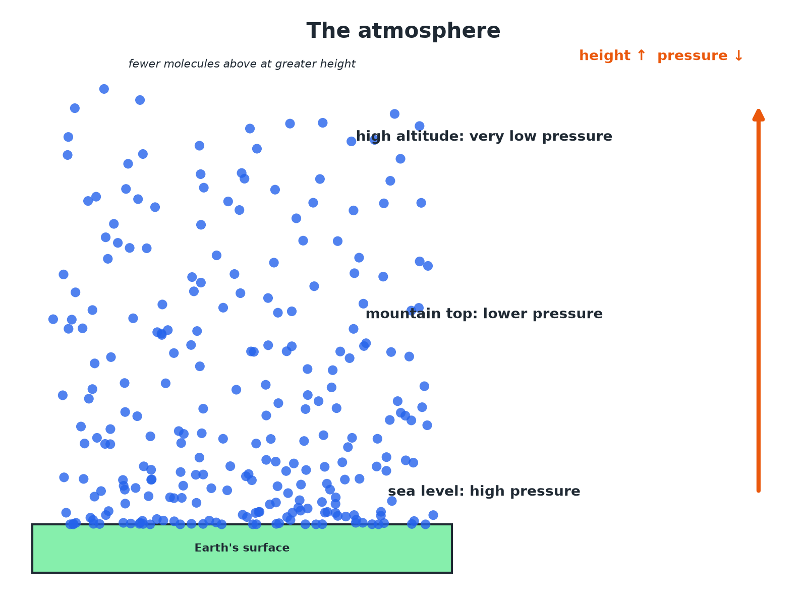
Less air above means lower pressure.
Air particles getting less dense with height above the Earth's surface, with atmospheric pressure decreasing.
Why Pressure Falls with Height
Explain why atmospheric pressure is lower at the top of a mountain than at sea level.

1. Air above
At the top there is less air above the surface
2. Weight
So the weight of air pressing down is less
3. Molecules
There are fewer molecules, so fewer collisions with a surface each second
Answer: Fewer air molecules and less weight of air above lead to lower atmospheric pressure.
Using a Graph
At sea level the atmospheric pressure is about 101 kPa. At 5 km it is about 55 kPa. Describe the trend.

1. Height increases
5 km above sea level
2. Pressure
Falls from 101 kPa to 55 kPa
Answer: Atmospheric pressure decreases as height increases, at first quite quickly.
Key Points
Learn these.
▸ Thin layer. The atmosphere is thin compared with the size of the Earth.
▸ Density. The air gets less dense with altitude.
▸ Collisions. Atmospheric pressure is caused by molecules colliding with surfaces.
▸ No sharp edge. The pressure falls gradually to almost zero in space.
Key Terms
Atmosphere  The layer of air around the Earth. | Atmospheric pressure  The pressure caused by air molecules colliding with a surface.
Altitude  Height above the ground or sea level. | Air molecule  A particle of nitrogen, oxygen or another gas.
Less dense  Fewer particles in each cubic metre. | Collision  Particles hitting a surface.
Your Task: Mountain Pressure
10 minutes
Explain why a sealed bag of crisps bulges when taken up a mountain.
1. Compare inside and outside pressure.
2. Explain the bulge.
A good answer shows: The pressure outside falls with height, but the pressure inside the bag stays the same, so the bag expands.
Can I...?
☐ Describe the atmosphere.
☐ Say air gets less dense with height.
☐ Explain atmospheric pressure.
☐ Explain the fall in pressure with height.
☐ Read a graph of pressure.
☐ Use the particle model.
☐ Describe collisions.
☐ Explain a bulging bag.
Summary
✓ The atmosphere gets less dense with altitude.
✓ Pressure: collisions of air molecules.
✓ Less air above means a smaller weight of air.
✓ Pressure decreases with height.

EXAM FOCUS
Explain why atmospheric pressure decreases as height above the ground increases. (3 marks)
Less air above, fewer collisions.

