AQA GCSE PHYSICS · PAPER 2 · FOUNDATION & HIGHER
Atmospheric pressure
Forces · Lesson 9 of 20
Teacher copy - includes the notes for whoever is teaching from it.
Warm-up
Answer each one, then check.
1. What is air made of?
Gas molecules, mostly nitrogen and oxygen
2. What causes gas pressure?
Collisions of particles with surfaces
3. What is pressure?
Force per unit area
4. What is density?
Mass per unit volume
5. What is altitude?
Height above sea level
Learning Objectives
1. Describe a simple model of the atmosphere.
2. Explain how air molecules colliding with a surface create atmospheric pressure.
3. Explain why atmospheric pressure decreases with increasing height.
Atmospheric Pressure
The atmosphere is a thin layer of air round the Earth that gets less dense with altitude. Air molecules colliding with a surface create atmospheric pressure.
As height increases there is less air above a surface, so the weight of air above falls and the atmospheric pressure decreases.
The Atmosphere
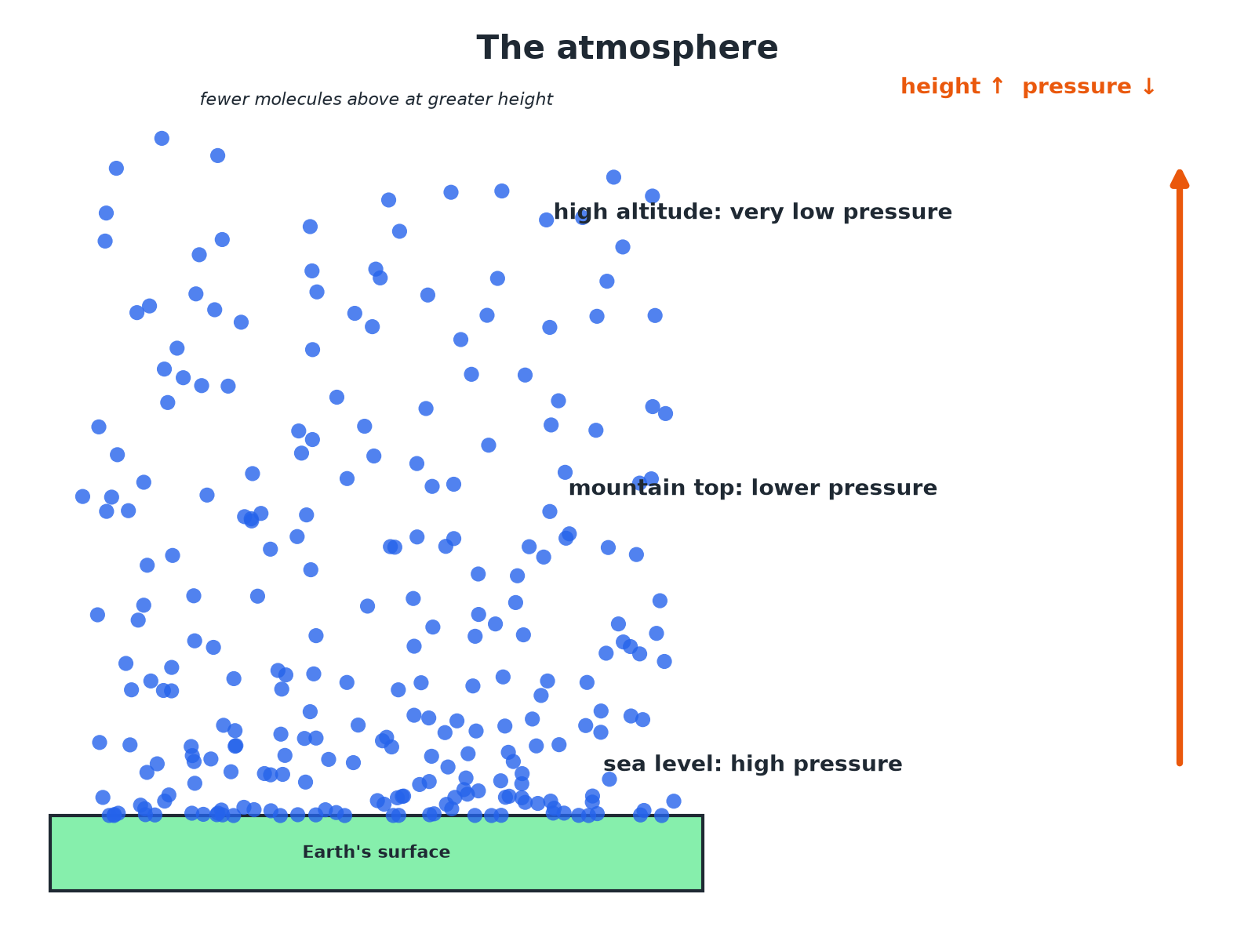
Less air above means lower pressure.
Air particles getting less dense with height above the Earth's surface, with atmospheric pressure decreasing.
Why Pressure Falls with Height
Explain why atmospheric pressure is lower at the top of a mountain than at sea level.

1. Air above
At the top there is less air above the surface
2. Weight
So the weight of air pressing down is less
3. Molecules
There are fewer molecules, so fewer collisions with a surface each second
Answer: Fewer air molecules and less weight of air above lead to lower atmospheric pressure.
Using a Graph
At sea level the atmospheric pressure is about 101 kPa. At 5 km it is about 55 kPa. Describe the trend.

1. Height increases
5 km above sea level
2. Pressure
Falls from 101 kPa to 55 kPa
Answer: Atmospheric pressure decreases as height increases, at first quite quickly.
Key Points
Learn these.
▸ Thin layer. The atmosphere is thin compared with the size of the Earth.
▸ Density. The air gets less dense with altitude.
▸ Collisions. Atmospheric pressure is caused by molecules colliding with surfaces.
▸ No sharp edge. The pressure falls gradually to almost zero in space.
Key Terms
Atmosphere  The layer of air around the Earth. | Atmospheric pressure  The pressure caused by air molecules colliding with a surface.
Altitude  Height above the ground or sea level. | Air molecule  A particle of nitrogen, oxygen or another gas.
Less dense  Fewer particles in each cubic metre. | Collision  Particles hitting a surface.
Your Task: Mountain Pressure
10 minutes
Explain why a sealed bag of crisps bulges when taken up a mountain.
1. Compare inside and outside pressure.
2. Explain the bulge.
A good answer shows: The pressure outside falls with height, but the pressure inside the bag stays the same, so the bag expands.
Note: Ask what would happen at the top of a very high mountain.
Can I...?
☐ Describe the atmosphere.
☐ Say air gets less dense with height.
☐ Explain atmospheric pressure.
☐ Explain the fall in pressure with height.
☐ Read a graph of pressure.
☐ Use the particle model.
☐ Describe collisions.
☐ Explain a bulging bag.
Summary
✓ The atmosphere gets less dense with altitude.
✓ Pressure: collisions of air molecules.
✓ Less air above means a smaller weight of air.
✓ Pressure decreases with height.

EXAM FOCUS
Explain why atmospheric pressure decreases as height above the ground increases. (3 marks)
Less air above, fewer collisions.
Exam Practice: Atmospheric pressure
Answer all questions. Use the mark allocation as a guide to how much to write. · 14 minutes
▸ Question 1 · 3 marks · Explain. Explain why atmospheric pressure decreases as the height above the ground increases.
▸ Question 2 · 3 marks · Use the graph. The graph shows how atmospheric pressure changes with height above sea level. (a) Use the graph to find the atmospheric pressure at a…
▸ Question 3 · 2 marks · Describe. Describe a simple model of the Earth's atmosphere.
▸ Question 4 · 3 marks · Explain. A sealed bag of crisps is taken up a mountain and bulges. Explain why.
▸ Question 5 · 2 marks · Explain. Explain what causes atmospheric pressure.
Question 1 · 3 marks · Explain
“Explain why atmospheric pressure decreases as the height above the ground increases.”
HOW TO ANSWER IT Command word: Explain. Worth 3 marks, so plan before writing.
Question 1 · mark scheme
3 marks available. Award a mark for each point made.
▸ Air less dense at greater height. 1 mark
▸ Fewer collisions with a surface. 1 mark
▸ Less weight of air above. 1 mark
▸ Model answer. The atmosphere is less dense at greater height, so there are fewer air molecules colliding with a surface. There is also less air above, so the weight of air pressing down is less.
Question 2 · 3 marks · Use the graph
The graph shows how atmospheric pressure changes with height above sea level. (a) Use the graph to find the atmospheric pressure at a height of 5 km. (b) Describe how the pressure changes as the height increases. (3 marks) | 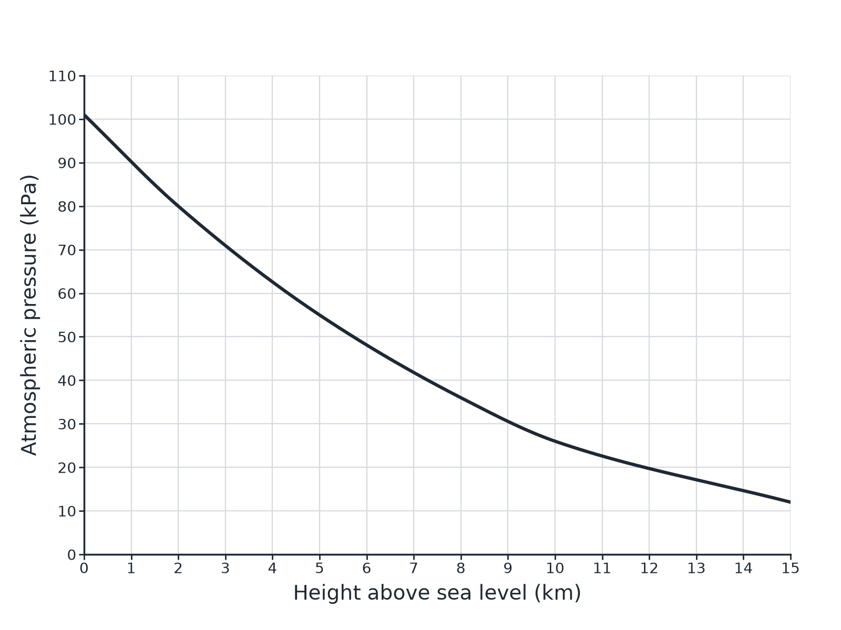

Question 2 · mark scheme
3 marks available. Award a mark for each point made.
▸ 55 kPa. 1 mark
▸ Decreases. 1 mark
▸ Falls faster at first (curved). 1 mark
▸ Model answer. (a) About 55 kPa (accept 52 to 58). (b) The pressure decreases as the height increases; it falls more quickly at low heights.
Question 3 · 2 marks · Describe
“Describe a simple model of the Earth's atmosphere.”
HOW TO ANSWER IT Command word: Describe. Worth 2 marks, so plan before writing.
Question 3 · mark scheme
2 marks available. Award a mark for each point made.
▸ Thin layer of air around the Earth. 1 mark
▸ Less dense with height. 1 mark
▸ Model answer. A thin layer of air around the Earth that is densest at the ground and gets less dense with increasing height.
Question 4 · 3 marks · Explain
“A sealed bag of crisps is taken up a mountain and bulges. Explain why.”
HOW TO ANSWER IT Command word: Explain. Worth 3 marks, so plan before writing.
Question 4 · mark scheme
3 marks available. Award a mark for each point made.
▸ Outside pressure is lower. 1 mark
▸ Pressure inside is greater than outside. 1 mark
▸ Bag expands. 1 mark
▸ Model answer. The atmospheric pressure outside the bag is lower at the top of the mountain, but the pressure of the air inside the bag is the same as at the bottom, so the bag expands.
Question 5 · 2 marks · Explain
“Explain what causes atmospheric pressure.”
HOW TO ANSWER IT Command word: Explain. Worth 2 marks, so plan before writing.
Question 5 · mark scheme
2 marks available. Award a mark for each point made.
▸ Collisions of air molecules with surfaces. 1 mark
▸ Force per unit area. 1 mark
▸ Model answer. Air molecules collide with a surface and exert a force on it; the force per unit area is the pressure.

