AQA GCSE PHYSICS · PAPER 2 · FOUNDATION & HIGHER
Distance–time graphs
Forces · Lesson 11 of 20
Teacher copy - includes the notes for whoever is teaching from it.
Warm-up
Answer each one, then check.
1. What is the gradient of a graph?
Change in y divided by change in x
2. What does a horizontal line on a distance-time graph mean?
The object is stationary
3. What is speed?
Distance divided by time
4. What is acceleration?
Rate of change of velocity
5. What does a steeper line mean?
A faster speed
Learning Objectives
1. Draw distance–time graphs from measurements.
2. Interpret lines and slopes of distance–time graphs.
3. Calculate speed from the gradient of a distance–time graph.
4. Find the speed of an accelerating object at an instant using a tangent (Higher tier).
Distance–Time Graphs
The gradient of a distance–time graph is the speed of the object.
A straight line means constant speed, a horizontal line means stationary, and a curve means the speed is changing.
Reading a Distance–Time Graph
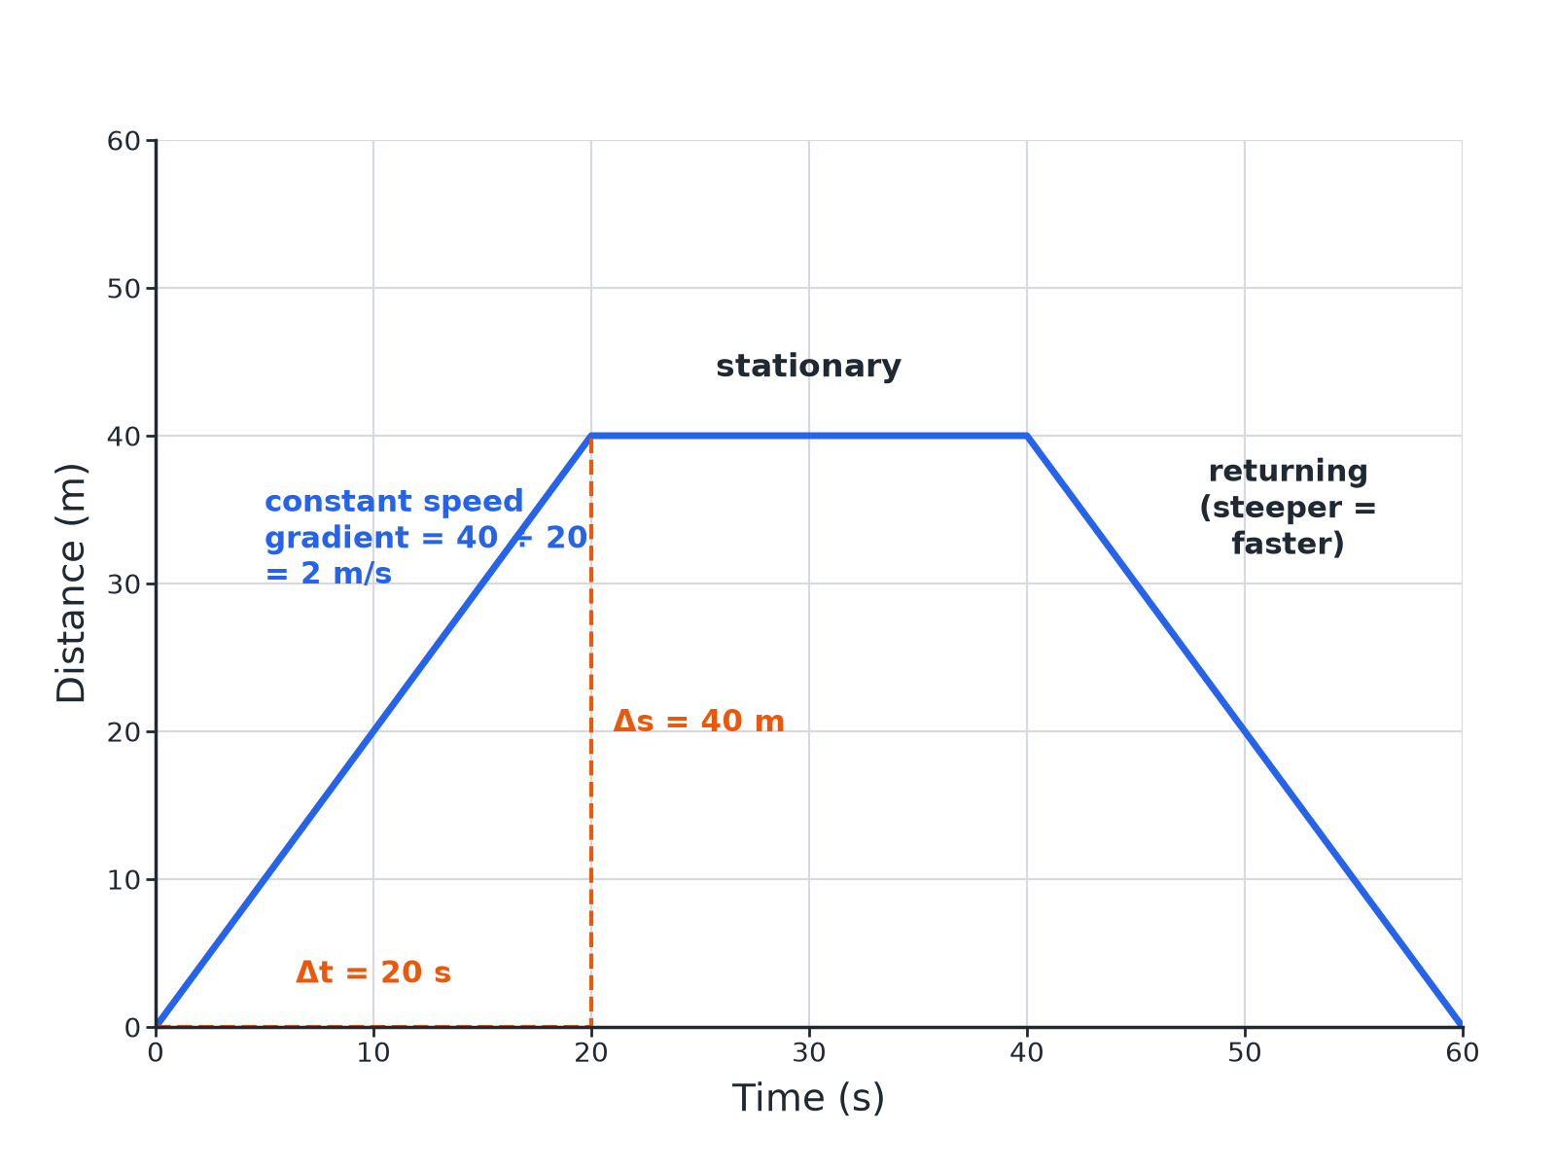
Gradient = change in distance ÷ change in time.
A distance-time graph with constant speed, stationary and returning sections, and a gradient triangle.
What the Graph Shows
Learn these.
Shape | Meaning
Straight line sloping up | Constant speed
Horizontal line | Stationary
Steeper line | Higher speed
Curve getting steeper | Accelerating
Curve getting shallower | Decelerating
Speed from a Gradient
An object travels 40 m in the first 20 s. Calculate its speed from the graph.

1. Gradient
(change in distance)/(change in time)
2. Substitute
40/20
3. Answer
2.0 m/s
Answer: 2.0 m/s
Describing a Journey
Describe the motion shown from 20 s to 40 s where the line is horizontal.

1. Distance
Does not change
2. Speed
Zero
Answer: The object is stationary.
Tangent (Higher)
The distance is given by s = 0.5t² (in metres, t in seconds). Find the speed at t = 6 s using a tangent.

1. Draw a tangent
Touching the curve at t = 6 s
2. Gradient of the tangent
Δs/Δt from two points on the tangent: about 6 m/s
3. Check
The speed is t = 6 m/s from s = 0.5t²
Answer: About 6 m/s.
Drawing Graphs
Good practice.
▸ Axes. Time on the x-axis, distance on the y-axis, with units.
▸ Points. Plot from a table, then join with a ruler (or a smooth curve if the speed changes).
▸ Gradient. Use a large triangle for accuracy.
▸ Units. m/s if distance in m and time in s.
Finding a Gradient Accurately
Use the same method for every straight section.
1  Pick two points  Choose points far apart on the line, where it crosses grid lines. | 2  Draw a triangle  Make it as large as the section allows. | 3  Read the sides  Change in distance (up) and change in time (across), with units. | 4  Divide  Speed = change in distance ÷ change in time, in m/s.
Case Study
CASE STUDY
The Walk to School
A student walks 600 m to a shop in 300 s, waits 120 s, then walks 400 m more in 400 s. On the graph the first section is the steepest, the wait is a flat line and the last section is shallower. The average speed for the whole trip is the total distance divided by the total time, including the stop.

2.0 m/s  Speed for the first 600 m | 1000 m ÷ 820 s  Average speed of about 1.2 m/s
Common Mistakes
Where marks are lost on these graphs.
▸ Reading a stop as slow. A horizontal line means the object is not moving at all; the distance is not changing.
▸ Using one point. Speed is the gradient, not the distance divided by the time at a single point, unless the line starts at the origin.
▸ Forgetting the tangent. On a curve the speed changes, so for the speed at one instant draw a tangent and find its gradient.
Key Terms
Distance–time graph  A graph of distance against time. | Gradient  How steep a line is.
Stationary  Not moving. | Tangent  A straight line that touches a curve at one point.
Constant speed  The same speed all the time. | Accelerating  Speeding up.
Decelerating  Slowing down; on a distance–time graph the curve gets shallower. | Instantaneous speed  The speed at one particular moment.
Your Task: Story Graph
12 minutes
A cyclist travels 100 m in 20 s, stops for 20 s and then travels 60 m in 20 s. Sketch the graph and calculate the speed in each part.
1. Plot the three sections.
2. Gradient for each.
A good answer shows: Part 1: 5.0 m/s. Part 2: 0 m/s. Part 3: 3.0 m/s.
Note: Ask about the average speed for the whole journey.
Can I...?
☐ Draw a distance–time graph.
☐ Say what a horizontal line means.
☐ Calculate speed from a gradient.
☐ Compare speeds from slopes.
☐ Describe a journey.
☐ Describe a curve.
☐ Draw a tangent.
☐ Use units.
Summary
✓ Gradient = speed.
✓ Horizontal line = stationary.
✓ Steeper = faster.
✓ Higher: tangent to a curve gives instantaneous speed.
✓ Average speed = total distance ÷ total time, including any stops.

EXAM FOCUS
The graph shows 100 m in 20 s. Calculate the speed in the first 20 s. (2 marks)
Speed is the gradient: change in distance ÷ change in time = 100 ÷ 20 = 5.0 m/s. Read the values off the axes carefully and include the unit.
Exam Practice: Distance–time graphs
Answer all questions. Use the mark allocation as a guide to how much to write. · 15 minutes
▸ Question 1 · 4 marks · Use the graph. The graph shows the distance travelled by a cyclist. (a) Calculate the speed in the first 20 s. (b) Describe the motion between 20 s and 40…
▸ Question 2 · 2 marks · State. Describe what the gradient of a distance–time graph represents and what a horizontal line shows.
▸ Question 3 · 3 marks · Calculate. A car travels 120 m in 10 s at constant speed. Sketch a distance–time graph for this and calculate the gradient.
▸ Question 4 · 2 marks · Explain. The distance–time graph for a runner is a curve that gets steeper. Describe the motion.
▸ Question 5 · 3 marks · Determine. The graph shows the distance of a car from a starting point against time as a curve. Describe how to find the speed at a particular time.
Question 1 · 4 marks · Use the graph
The graph shows the distance travelled by a cyclist. (a) Calculate the speed in the first 20 s. (b) Describe the motion between 20 s and 40 s. (c) Calculate the speed between 40 s and 60 s. (4 marks) | 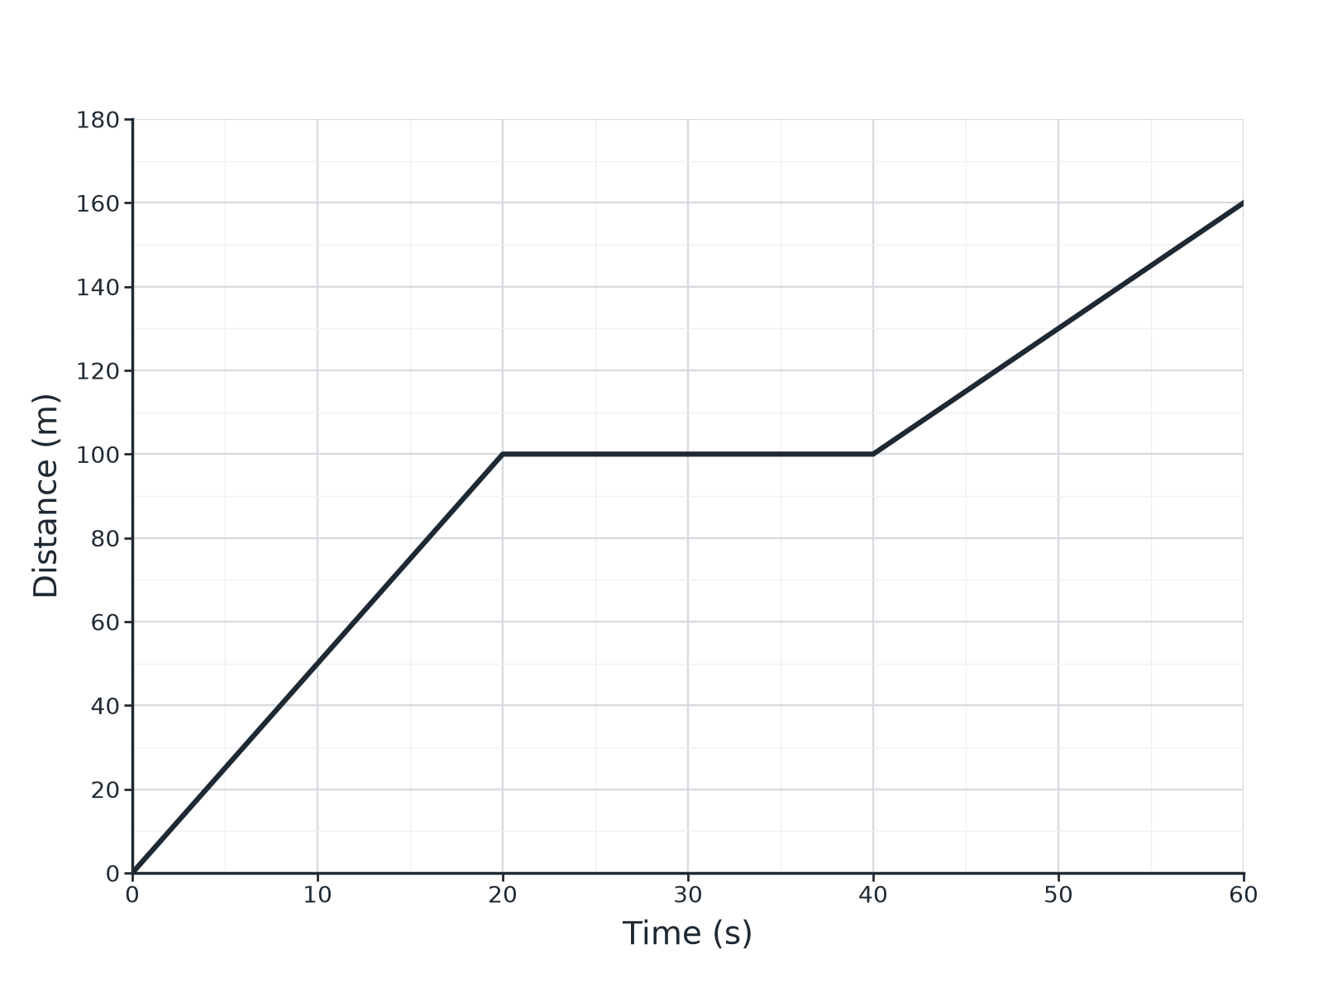

Question 1 · mark scheme
4 marks available. Award a mark for each point made.
▸ 5.0 m/s. 1 mark
▸ Stationary. 1 mark
▸ Correct distance and time. 1 mark
▸ 3.0 m/s. 1 mark
▸ Model answer. (a) 100 ÷ 20 = 5.0 m/s. (b) Stationary. (c) 60 ÷ 20 = 3.0 m/s.
Question 2 · 2 marks · State
“Describe what the gradient of a distance–time graph represents and what a horizontal line shows.”
HOW TO ANSWER IT Command word: State. Worth 2 marks, so plan before writing.
Question 2 · mark scheme
2 marks available. Award a mark for each point made.
▸ Gradient is speed. 1 mark
▸ Horizontal line: stationary. 1 mark
▸ Model answer. The gradient is the speed. A horizontal line shows the object is stationary.
Question 3 · 3 marks · Calculate
“A car travels 120 m in 10 s at constant speed. Sketch a distance–time graph for this and calculate the gradient.”
HOW TO ANSWER IT Command word: Calculate. Worth 3 marks, so plan before writing.
Question 3 · mark scheme
3 marks available. Award a mark for each point made.
▸ Straight line from the origin. 1 mark
▸ Correct end point. 1 mark
▸ 12 m/s. 1 mark
▸ Model answer. A straight line from the origin to (10 s, 120 m). Gradient = 120 ÷ 10 = 12 m/s.
Question 4 · 2 marks · Explain
“The distance–time graph for a runner is a curve that gets steeper. Describe the motion.”
HOW TO ANSWER IT Command word: Explain. Worth 2 marks, so plan before writing.
Question 4 · mark scheme
2 marks available. Award a mark for each point made.
▸ Accelerating. 1 mark
▸ Gradient or speed increases. 1 mark
▸ Model answer. The runner is accelerating (the speed is increasing).
Question 5 · 3 marks · Determine
“The graph shows the distance of a car from a starting point against time as a curve. Describe how to find the speed at a particular time.”
HOW TO ANSWER IT Command word: Determine. Worth 3 marks, so plan before writing.
Question 5 · mark scheme
3 marks available. Award a mark for each point made.
▸ Draw a tangent. 1 mark
▸ Choose two points on the tangent. 1 mark
▸ Gradient = change in distance ÷ change in time. 1 mark
▸ Model answer. Draw a tangent to the curve at that time and calculate its gradient (change in distance ÷ change in time).

