AQA GCSE PHYSICS · PAPER 2 · FOUNDATION & HIGHER
Terminal velocity
Forces · Lesson 13 of 20
Teacher copy - includes the notes for whoever is teaching from it.
Warm-up
Answer each one, then check.
1. What is weight?
The force of gravity on an object
2. What is air resistance?
A force opposing motion through the air
3. What does balanced mean?
Forces equal and opposite
4. What is acceleration?
Rate of change of velocity
5. What is the gradient of a v-t graph?
Acceleration
Learning Objectives
1. Describe the forces on an object falling through a fluid.
2. Explain why the object reaches a terminal velocity.
3. Draw and interpret velocity–time graphs for terminal velocity.
4. Explain the effect of opening a parachute.
Terminal Velocity
An object falling through a fluid initially accelerates due to gravity. As its speed increases, the resistive force increases until the resultant force is zero and the object moves at its terminal velocity.
At terminal velocity the weight and the resistive force (air resistance or drag) are balanced, so there is no acceleration.
Falling to Terminal Velocity
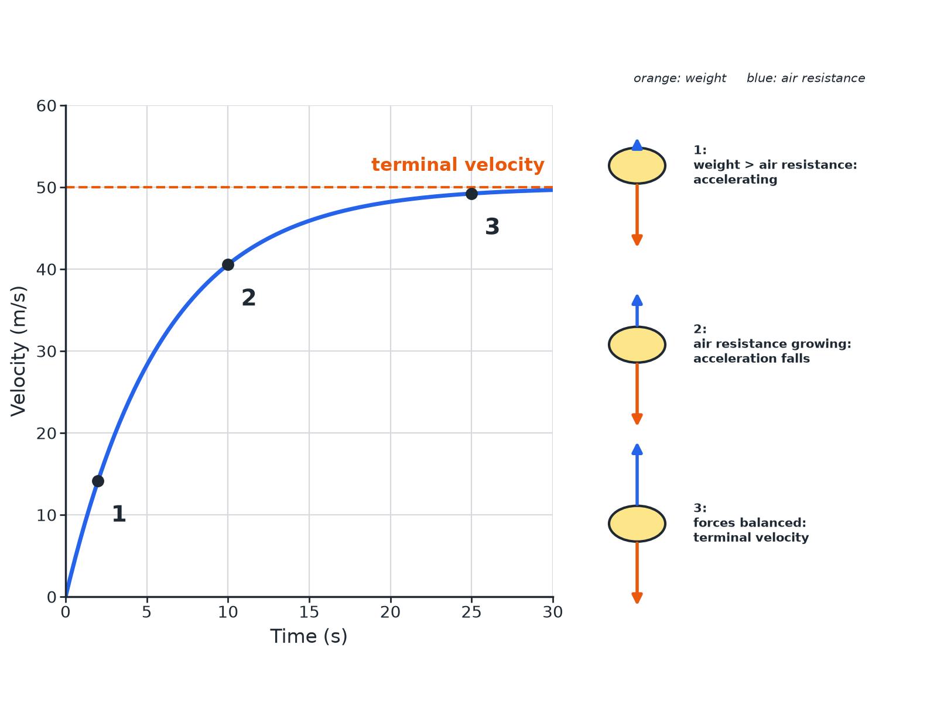
As speed rises, air resistance rises until the forces balance.
A velocity-time graph levelling off at terminal velocity with force diagrams of a skydiver at three stages.
What Happens to a Skydiver
Stage by stage.
1  Start  Only weight acts (almost no air resistance): large downward resultant, acceleration about 9.8 m/s². | 2  Speeding up  Air resistance increases with speed, so the resultant force and acceleration decrease. | 3  Terminal velocity  Air resistance equals weight: resultant zero, constant velocity. | 4  Parachute opens  Large increase in air resistance: upward resultant, skydiver decelerates. | 5  New terminal velocity  A lower speed where air resistance again equals weight.
Resultant Force
A skydiver weighs 700 N. At one instant the air resistance is 400 N. Find the resultant force. What is the air resistance at terminal velocity?

1. Resultant
700 − 400 = 300 N downwards
2. At terminal velocity
The resultant is zero, so air resistance = weight = 700 N
Answer: 300 N downwards; 700 N at terminal velocity.
Why a Parachute Helps
Explain why opening a parachute reduces the terminal velocity.

1. Area
A large surface area is opened
2. Air resistance
It is much larger at the same speed
3. Forces balance
At a much lower speed, so the new terminal velocity is lower
Answer: The greater air resistance balances the weight at a lower speed.
Reading the Graph
Common exam features.
▸ Gradient. Decreases as the object falls faster.
▸ Flat section. Terminal velocity: zero acceleration.
▸ Steep fall after parachute. Deceleration.
▸ Shape. Explain each part with the forces.
Key Terms
Terminal velocity  The constant velocity reached when the resistive force equals the driving force. | Air resistance  A force opposing motion through air.
Drag  A resistive force in a fluid. | Resultant force  The single force equal to all the forces combined.
Surface area  The size of the surface. | Fluid  A liquid or gas.
Your Task: Parachute Test
10 minutes
A parachutist reaches 50 m/s before opening a parachute. After opening, their speed falls to 5 m/s. Explain both terminal velocities.
1. Compare air resistance and weight.
2. Say when resultant is zero.
A good answer shows: Before: air resistance on the body equals the weight at 50 m/s. After: the parachute gives much larger air resistance, so the speed falls until it equals the weight again at 5 m/s.
Note: Ask about the forces just after the parachute opens.
Can I...?
☐ State the forces on a falling object.
☐ Explain acceleration at the start.
☐ Explain why acceleration falls.
☐ Define terminal velocity.
☐ Interpret a graph.
☐ Explain a parachute.
☐ Find the resultant.
☐ Use force balance.
Summary
✓ At the start weight is greater than air resistance.
✓ Air resistance increases with speed.
✓ Terminal velocity: forces balanced, resultant zero.
✓ Parachute: greater air resistance, lower terminal velocity.

EXAM FOCUS
Explain why a skydiver reaches a terminal velocity. (3 marks)
Air resistance rises until it equals the weight.
Exam Practice: Terminal velocity
Answer all questions. Use the mark allocation as a guide to how much to write. · 16 minutes
▸ Question 1 · 3 marks · Explain. A skydiver jumps from a plane. Explain why the skydiver reaches a terminal velocity.
▸ Question 2 · 5 marks · Use the graph. The graph shows the velocity of a parachutist. (a) State what happens to the velocity between A and B. (b) Explain why the velocity is…
▸ Question 3 · 2 marks · Calculate. A skydiver has a weight of 700 N. The air resistance is 400 N. Calculate the resultant force on the skydiver and state its direction.
▸ Question 4 · 3 marks · Explain. A parachute increases the air resistance on a skydiver. Explain why the skydiver's terminal velocity is lower with the parachute open.
▸ Question 5 · 2 marks · State. State the size of the resultant force on a skydiver falling at terminal velocity and what this means for the acceleration.
Question 1 · 3 marks · Explain
“A skydiver jumps from a plane. Explain why the skydiver reaches a terminal velocity.”
HOW TO ANSWER IT Command word: Explain. Worth 3 marks, so plan before writing.
Question 1 · mark scheme
3 marks available. Award a mark for each point made.
▸ Weight greater than air resistance at first. 1 mark
▸ Air resistance increases with speed. 1 mark
▸ Forces balance: constant speed. 1 mark
▸ Model answer. At first the weight is greater than the air resistance so the skydiver accelerates. As the speed increases the air resistance increases. Eventually the air resistance equals the weight, the resultant force is zero and the speed is constant.
Question 2 · 5 marks · Use the graph
The graph shows the velocity of a parachutist. (a) State what happens to the velocity between A and B. (b) Explain why the velocity is constant between B and C. (c) At C the parachute opens. Explain what happens between C and D. (5 marks) | 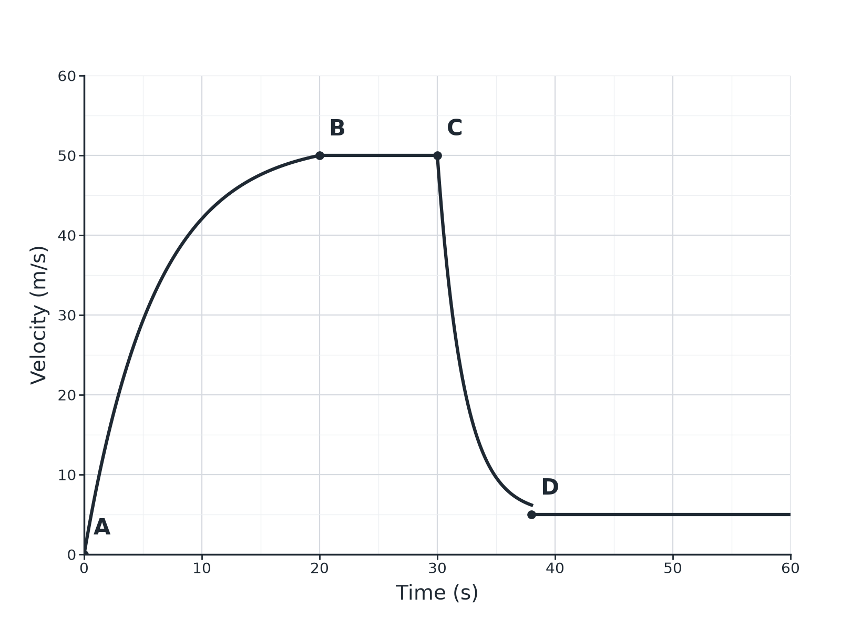

Question 2 · mark scheme
5 marks available. Award a mark for each point made.
▸ A to B: accelerating, getting less. 1 mark
▸ B to C: air resistance equals weight. 1 mark
▸ Resultant force zero. 1 mark
▸ C to D: air resistance greater than weight. 1 mark
▸ Decelerates to a lower terminal velocity. 1 mark
▸ Model answer. (a) The velocity increases (accelerates), but by less and less. (b) Air resistance equals weight, so the resultant is zero (terminal velocity). (c) The parachute increases the air resistance so it is greater than the weight; the parachutist decelerates until air resistance equals weight at a lower velocity.
Question 3 · 2 marks · Calculate
“A skydiver has a weight of 700 N. The air resistance is 400 N. Calculate the resultant force on the skydiver and state its direction.”
HOW TO ANSWER IT Command word: Calculate. Worth 2 marks, so plan before writing.
Question 3 · mark scheme
2 marks available. Award a mark for each point made.
▸ 300 N. 1 mark
▸ Downwards. 1 mark
▸ Model answer. 700 − 400 = 300 N downwards.
Question 4 · 3 marks · Explain
“A parachute increases the air resistance on a skydiver. Explain why the skydiver's terminal velocity is lower with the parachute open.”
HOW TO ANSWER IT Command word: Explain. Worth 3 marks, so plan before writing.
Question 4 · mark scheme
3 marks available. Award a mark for each point made.
▸ Larger area means greater air resistance. 1 mark
▸ Forces balance at a lower speed. 1 mark
▸ So lower terminal velocity. 1 mark
▸ Model answer. With a large surface area the air resistance is much greater at any speed. The air resistance equals the weight at a lower speed, so the terminal velocity is lower.
Question 5 · 2 marks · State
“State the size of the resultant force on a skydiver falling at terminal velocity and what this means for the acceleration.”
HOW TO ANSWER IT Command word: State. Worth 2 marks, so plan before writing.
Question 5 · mark scheme
2 marks available. Award a mark for each point made.
▸ Zero resultant force. 1 mark
▸ Zero acceleration. 1 mark
▸ Model answer. The resultant force is zero, so the acceleration is zero (constant velocity).

